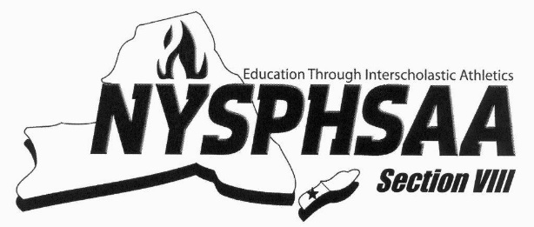
Official Recruitment Incentive
The Official Recruitment Incentive is designed to encourage current sport officials to recruit new officials to the various officials’ groups in Section VIII. Section VIII will pay any current official a fee of $100 to recruit a new official. The fee will be paid once the recruiting official submits this form below after the newly recruited official works the required number of games for Section VIII in the sport certified to officiate. An official is limited to 5 recruitment incentive officials per year.
To be Filled out by Recruiting Official
Recruiting Officials Name: _________________________________________ BOCES #: __________
Address: __________________________________________________________________________
Email Address: _____________________________________ Cell # ___________________________
To be filled out by President or Secretary of the Sport Officials Association the date when enrolled in class
I attest that the candidate ___________________________________ was recruited by _____________________________________, BOCES # ________,
a current official in good standing for the sport of ________________________.
Name: _____________________________Signature: ____________________________ Date______
President or Secretary
SPORT | REQUIRED # OF GAMES | SPORT | REQUIRED # OF GAMES
BASEBALL | 10 | LACROSSE | 8
BASKETBALL | 10 | SOCCER | 8
CHEERLEADING | 6 | SOFTBALL | 10
FENCING | 10 | SWIMMING | 8
FIELD HOCKEY | 8 | TRACK & FIELD | 8
FOOTBALL | 4 | VOLLEYBALL | 10
GYMNASTICS | 8 | WRESTLING | 10
Please return form and copy of the recruited officials schedule to:
Mr. Patrick Pizzarelli, Section VIII Athletics 71 Clinton Road, Garden City, New York 11530

