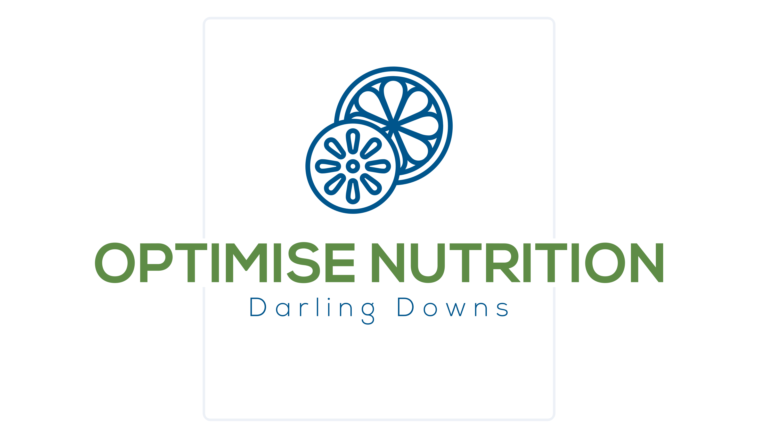

NDIS Model of Service

1. Introduction
National Disability Insurance Scheme (NDIS) Program supports people under the age of 65 who have a permanent and significant disability, to help them in their daily life, participate in the community and reach their personal goals. Considerable knowledge has accumulated over the last two decades concerning the significance of exercise and nutrition interventions in the treatment of many chronic diseases. It is well established that the costs associated with these diseases are placing a substantial burden on the Australian healthcare system and that appropriate exercise and nutrition interventions can reduce these costs.

2. Scope

Optimise Nutrition Darling Downs design and deliver Medical Nutrition Therapy (MNT) which forms an integral part of the management of people with chronic and complex diseases. The aim of the intervention is to facilitate long term behaviour change by encouraging the self-management of health through nutrition, diet and other lifestyle modifications, with a view to preventing and treating disease.

3. Principles of Medical Nutritional Therapy
Medical nutrition therapy is a clinical intervention delivered by dietitians. This intervention builds on general nutrition advice to achieve improved clinical and health outcomes appropriate to disease status (e.g. HbA1c, renal function etc) through nutrition assessment, dietary advice, knowledge and skill development and behavioural counselling. Medical nutrition therapy is evidence based and includes a detailed individualised nutrition assessment, setting individual goals and priorities, practical dietary advice, and counselling with followup for the purpose of disease management to improve quality of life. The advice and counselling provided considers the patients’ goals, readiness to change, knowledge, skills, and access to resources.

4. Nutritional Intervention Groups
Nutritional Intervention may benefit participants with:
- disordered eating patterns, body image concerns, anorexia, bulimia, binge eating behaviours
- a new diagnosis requiring specific dietary modification, for example, Coeliac disease, Diabetes
- failing to meet nutrition needs such as in anaemia, osteoporosis
- having significant unintentional weight change – either weight loss or gain, e.g. in COPD
- recent poor food intake, poor appetite, dysphagia (swallowing difficulties), or difficulty preparing or eating food, which can occur with conditions such as multiple sclerosis, motor neurone disease and Parkinson’s disease
- a deterioration of symptoms or a change in care needs
- a medication that may affect dietary intake such as psychotropic medications or chemotherapy
- post-bariatric surgery, needing a periodic dietary review

5. Nutritional Care Process

Assessment
- Medical history
- Chronic disease history e.g. diabetes, cardiovascular disease
- Previous care/education
- Biomedical profile e.g. (lipids/HbA1c/BP)
- Anthropometry
- Current activity level
- Smoking/alcohol status
- Medications
- Current self-care
- Special needs

Behavioural History & Readiness for Change
- Motivational interviewing
- Readiness for change
- Goal setting
- Barriers and enablers to change with respect to diet & exercise

Diet History
- Previous APD input?
- Previous dietary modifications/hx
- Detailed eating pattern
- Food types/brands
- Detailed serving sizes
- Food frequency
- Cooking methods/skills
- Limitations/practical issues
- GIT conditions
- Food insecurity?

Medical Nutrition Therapy

Detailed eating pattern including timing of meals

Food types/brands

Detailed serving sizes and amounts, frequency

Foods to avoid or limit

Cooking methods/skills

Practical solutions

Reducing the risk of complications (acute & chronic)

Treating complications e.g. hypoglycaemia

Provision of appropriate health information and resources

Documentation
Documentation of the assessment and goal setting is made in secure PowerDiary program.

Resources
https://www.ndis.gov.au/about-us/policies/privacy/privacy-easy-read

