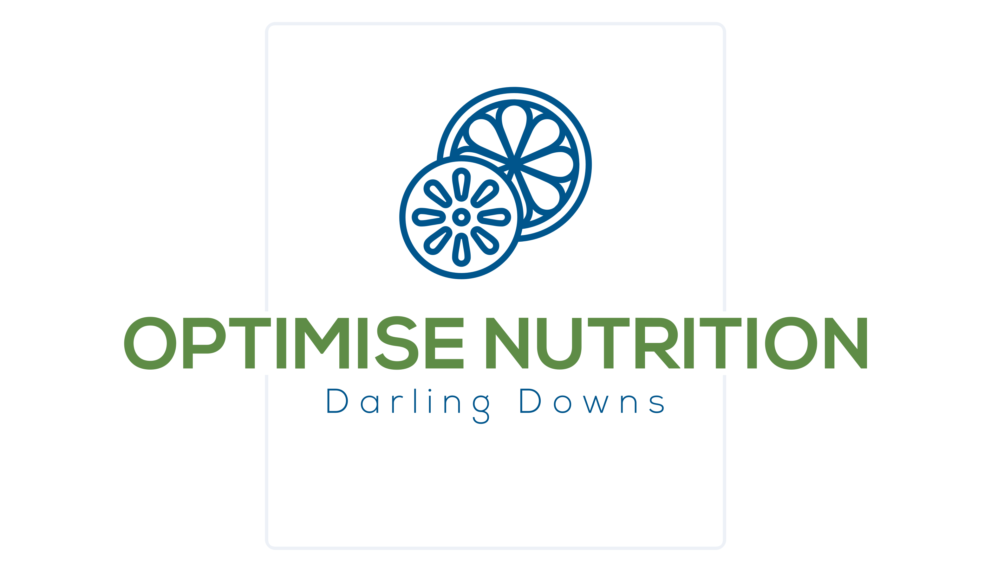

Privacy and Consent Procedure

1. Purpose
Optimise Nutrition Darling Downs, as part of our commitment to providing clients with the best nutrition care, acknowledges that it is essential that your health information is accurate and kept up to date. Information about you, your health and medical/nutrition diagnosis is collected to thoroughly assess, diagnose, and plan, to enable quality nutritional care provision and therapy. Laws to protect your personal information.

2. Scope
Optimise Nutrition Darling Downs collects information about you for the primary purpose of providing a quality service to you. This information will also be used for:
• The administrative purpose of running the practice,
• Billing either directly or through NDIS, Medicare or Health funds; and
• If ethically required or as agreed, disclosure of information may be provided your doctor, medical specialists, allied health professionals, providers and/or others involved in treatment, e.g., teachers.

3. Principles
Optimise Nutrition Darling Downs will ensure privacy of information collected.
It is the participants choice what information they provide and accept that that withholding or falsifying information might act against the best interests of your assessment, therapy planning and/or progress,
Access to participants personal and treatment information is available on request and if necessary, they may correct information that I believe to be inaccurate; and
If, in exceptional circumstances, access is denied for legitimate purposes, that the reasons for this and possible remedies will be discussed with me.

3.1. Email and Text Message Communication Consent`
Optimise Nutrition Darling Downs will not use email and text messages without participant consent. The risks of communicating by email and / or text message include:
- Email and text can be circulated, forwarded, and stored in paper and electronic files.
- Backup copies of email/text may exist even after the sender or the recipient has deleted his/her copy,
- Email/text senders can easily misaddress an email or email can be received by unintended recipients,
- Email/text can be intercepted, altered, forwarded, or used without authorization or detection,
- Employers and online services have a right to archive and inspect emails transmitted through their systems,
- Emails and texts may not be secure and therefore it is possible that the confidentiality of such communications may be breached by a third party.

3.2 Terms and conditions for privacy and consent:
- Participation is voluntary, and they give consent to receive nutritional care from Optimise Nutrition Darling Downs
- Optimise Nutrition Darling Downs will collect information about any previous or existing medical conditions, allergies or other conditions which may impact or affect the assessment, diagnosis, intervention and/or monitoring of my health and nutrition / dietetic care.
- Consent will be provided for communication via email and text message where practical for administrative purposes and/or clinical care, understanding the risks of communicating via email and text message and that Optimise Nutrition Darling Downs cannot guarantee confidentiality of information transferred in these ways.
- The sharing of information in relation to treatment is as per the service agreement.
- Optimise Nutrition Darling Downs will take reasonable steps to ensure my privacy and confidentiality throughout all methods of communication and correspondence.
- Participants have the right to withdraw consent and cease consultations at any stage, as per the service agreement.
- The notes taken, as a requirement by the professional or funding body, are done so privately and stored within a secure platform.
- This consent is for a period of care which may involve several consultations.

4. How we keep personal information safe
Electronic records are kept in a password protected secure environment.
The Optimise Nutrition office has secure key access.
Information is shared in accordance with the service agreement.

Resources
https://www.ndis.gov.au/about-us/policies/privacy/privacy-easy-read

