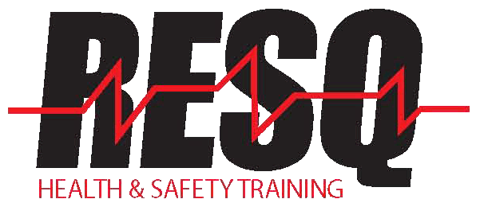ISDH QMA Insulin Administration Facility and RESQ Agreement
Student’s Name:_____________________________ Class Date:___________________

_____________________________________________________________________________________
(Facility Name and Corporate Name)
is an approved site for conducting the ISDH QMA Insulin Administration competencies listed below; under the direct supervision of a designated registered nurse at the student’s facility- the student must perform these with 100% accuracy.
___ ISDH Insulin Adm. Competency Checklist Form-Preparing an Insulin Pen & Administering Insulin By Subcutaneous Injection- 100% Accuracy Required
___ ISDH Insulin Adm. Competency Checklist Form-Withdrawing Insulin from a Vial and Administering Insulin by Subcutaneous Injection- 100% Accuracy Required
Under the direction of Nancy Adams at the ISDH, please provide to RESQ the designated contact name, email address and phone number for the student’s facility.
Contact Name:__________________________ Email _______________________ Phone No. ________________
I HAVE READ AND UNDERSTAND THIS AGREEMENT AND I ACCEPT AND AGREE TO CONTACT RESQ IF THE STUDENT IS NOT ABLE TO COMPLETE THE COMPETENCIES TRAINING AT THIS FACILITY. PLEASE NOTIFY US ASAP AT INFO@RESQTRAINING.COM
_______________________________________________________ ____________________ Facility D.O.N. or Administrator Signature Date
____________________________________________________________________________ Print Name and Title (D.O.N. or Administrator)
____________________________________________________________________________ RESQ Representative Signature Date

Donna LaCroix-McRee, R.N.
CNA/QMA Program Director

1/2020

