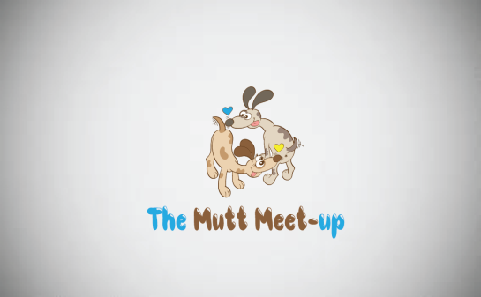
18636 Gunn Hwy., Odessa, Fl 33556
813-777-8434
themuttmeetup@gmail.com

Adoption Application
Name of dog(s) applying for: ________________________________________________
Full Name:_________________________________ Age:_________________
Phone Number: _____________________________Email: ____________________________
Address: _____________________________________________________________________ _____________________________________________________________________________ _____________________________________________________________________________
Employer, job title and years at current job:__________________________________________
List everyone who lives in the house with you along with their ages & occupation if applicable:
- _______________________________________________________________________

- _______________________________________________________________________

- _______________________________________________________________________

- _______________________________________________________________________

- _______________________________________________________________________

Answer the following questions to the best of your ability:
- Do you Rent or Own your home? ________If you rent, list the name and phone number of your landlord. If you own do you have an HOA and are there breed restrictions?____________________________________________________________
- Do you have a fenced in yard & how tall is the fence? __________________________
- Please list all current and previous pets and reason you no longer have them? _____________________________________________________________________
_____________________________________________________________________
______________________________________________________________________
- Are your current pets spayed/neutered?________________________________________
- Are your current pets up to date on all vaccines and heartworm prevention?___________
- On average, how many hours a day will your dog be home alone? __________________
- Where will the dog be kept while you aren’t home? _____________________________
- Where will the dog sleep at night?____________________________________________
- Where will your dog go while you’re out of town?_______________________________
- Are you willing to hire a professional trainer if necessary?_________________________
- Please list a Veterinary reference. ________________________________________________________________________
- Are you prepared to provide necessary medical treatment including regularly scheduled vaccinations?______________
- Are you prepared to supply your dog with monthly heartworm and flea/tick preventatives? _______________
- Have you ever turned a pet into a shelter or rehomed one? If yes, please explain and provide details.
____________________________________________________________________________________________________________________________________________________
- If something were to happen to you, who would take on the responsibility of caring for your dog? List name/contact info. ____________________________________________
- Do you expect any major life changes in the next year, moving, job change, adding children to your family? If yes please explain. __________________________________________________________________

By signing this I am certifying that the above information is true and understand that any false information may result in nullifying this adoption. In the event that an omission or untruth is discovered after an adoption takes place, I understand that The Mutt Meetup Inc, reserves the right to annul the adoption and reclaim the dog. I give The Mutt Meetup Inc, permission to fully investigate the provided information as well as contact veterinarians, landlords, etc. I give permission for my veterinarian to release any information asked by The Mutt Meetup Inc. If the application passes review, I agree to a home visit before an adoption decision is made.

X_____________________________________________________ Date:__________________

