

**Person-Centered Expressive Arts Institute**

**Certificate Program**

**Expressive Arts for Healing & Social Change:**

**A Person-Centered Approach**

* Starting in August 2025 we will offer three in-person and 3 virtual Residential Intensive Courses over 15 months. Each Residential Intensive Course is 6 days long.
* Course 1: Aug. 6 - Aug. 11, 2025

Course 2: Oct. 8 - Oct. 13, 2025

* Course 3: Jan 7 - Jan. 12, 2026
* Course 4: April 2 - April 7, 2026
* Course 5: July 30 - Aug. 4, 2026
* Course 6: Oct. 8 - Oct. 13, 2026
* For more information, please visit [www.personcenteredexpressivearts.com](http://www.personcenteredexpressivearts.com) or contact the Executive Director of the program, Dr. Sue Ann Herron: sueannherron@comcast.net.

Applications are accepted year around. **Space is limited, so please apply early.**

To apply please fill out this ***Initial Application*** and the ***Confidential Questionnaire*** below and email them to Dr. Sue Ann Herron, at [sueannherron@comcast.net](mailto:sueannherron@comcast.net) .

Upon receipt of the completed forms, Dr. Herron will contact you to set up a telephone or Zoom interview and also answer any questions you may have. After you have successfully completed the interview, you will receive an acceptance letter into the program and later you will receive an overview of the program and the Course 1 Learning Guide/Syllabus.

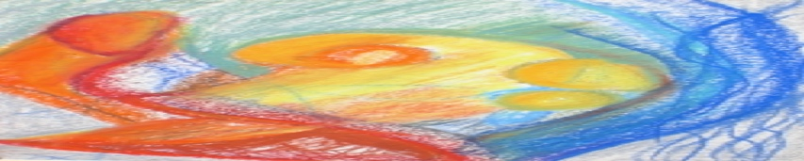**EXPRESSIVE ARTS CERTIFICATE PROGRAM**

**Application for Expressive Arts Certificate Program**

* **Please Complete the Following:**
* **Your Name:**

**Preferred Personal Pronoun:**

* **Complete Mailing Address:**

**Complete Home address:**

* + 1. **Home Telephone:**

**Cell Phone:**

* **Email address:**
* **Educational Background:** Please include all post-secondary schools, degrees and dates received.
* **What are your personal or professional goals for taking this program?**
* + - * 1. **At the completion of this program, what would you like to have gained for yourself?**
* **How do you plan to use expressive arts in the future?**



**Confidential Questionnaire for the  
Expressive Arts Certificate Program**

Thank you for your application. We are delighted to know of your interest in our Certificate Program: *Expressive Arts for Healing and Social Change: A Person-Centered Approach* offered through PCEAI.

This is a 15-month program which begins August, 2025. The enrollment is limited so please apply early. If you have questions please contact the Executive Director, Dr. Sue Ann Herron: [sueannherron@comcast.net](mailto:sueannherron@comcast.net).

Please complete the following Confidential Questionnaire and email it to Dr. Herron, at [sueannherron@comcast.net](mailto:sueannherron@comcast.net). Upon receiving your questionnaire, Dr. Herron will contact you for a brief interview and to answer any questions you may have.

1. Your Name (first and last):
2. Complete Mailing Address:
3. Email address:
4. Telephone numbers:

Home:

Cell:

1. Emergency contact: (name and phone number, relationship)
2. Your occupation:
3. A brief description of your background in psychology and the arts:



**Confidential Questionnaire for the  
Expressive Arts Certificate Program (cont’d.)**

1. Please tell us about three strengths that you see in yourself:
2. What gives you joy in life?
3. Are you currently in individual or group psychotherapy?
4. Have you ever been in individual or group psychotherapy?
5. What is important for the faculty/facilitators to know about you as a member of this group?
6. Please Confirm the Following:

____ I understand that this program consists of three in-person and 3 virtual weeklong Residential Intensive Courses taught over 15-months. I have planned for and saved the dates in advance.

____I understand that this is a drug-free program. No illegal drugs or excessive use of alcohol is permitted.

14. Are there any additional matters, needs, or requests that you would like to communicate with us prior to the beginning of this program?

______________________

Please email your completed application and confidential questionnaire to Dr. Herron at [sueannherron@comcast.net](mailto:sueannherron@comcast.net) and feel free to contact her with any questions you may have. We hope you can join us!