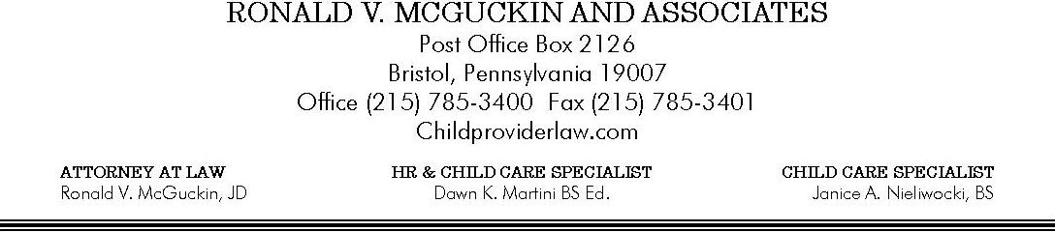

Imagination Station Too
COVID-19 PUBLIC HEALTH EMERGENCY
SPECIAL PROGRAM ATTENDANCE
ACKNOWLEDGMENT AND DISCLOSURE

FAMILY/CHILD VERSION: This should be initialed and signed by parents.
Please read and initial each statement below.

- I understand that during this COVID-19 Public Health Emergency I will NOT be permitted to enter the facility beyond the designated drop-off and pick-up area. I understand that this procedure change is for the safety of all persons present in the facility and to limit to the extent possible everyone’s risk of exposure. I understand that it is my responsibility to inform any Emergency Contact persons of the information contained herein.

- I understand that IF there is an emergency requiring me to enter the facility beyond the designated drop-off and pick-up area I MUST wash my hands before entering, and wear a mask. While in the facility I must practice social distancing and remain 6ft from all other people, except for my own child.

- I understand that to enter upon the facility premises my child must be free from COVID-19 symptoms. If, during the day, any of the following symptoms appear my child will be separated from the rest of the people in the center. I will be contacted, and my child MUST be pick-ed up from the facility within 30 minutes of being notified.
Symptoms include,
    - fever of 100.4 degrees Fahrenheit or higher
    - dry cough
    - Shortness of Breath
    - Chills
    - Loss of taste or smell
    - Sore Throat
    - Muscle aches
While we understand that many of these symptoms can also be related to non-COVID-19 related issues we must proceed with an abundance of caution during this Public Health Emergency. These symptoms typically appear 2-7 days after being infected so please take them seriously. Your child will need to be symptom free without any medications for 72 hours before returning to the facility.

- I understand that my child’s temperature will be taken every day to enter facility premises.

- I understand that my child will be required to wash their hands using CDC recommended handwashing procedures throughout the day using warm running water and rubbing with soap for at least 20 seconds.

- I understand that outside of care, in order to control my child’s exposure in the community, I will comply with any and all state, county or local stay-at-home orders, will limit my child’s contact outside of care to persons living in my household. I will not take my child out to stores unless it is absolutely necessary and then only to shop for essential items like food, medicines and toiletries and will follow any recommendations from the CDC that limits my child’s risk for exposure including wearing a mask in all public areas and remaining 6ft from all other people.

- I will immediately notify Imagination Station Too management if I become aware of any person with whom my child or I have had contact exhibits any of the symptoms listed in Number 1 above, is advised to self-isolate, quarantine, or has tested positive, or is presumed positive for COVID-19. Further, I will immediately notify Imagination Station Too management if anyone from my place of employment is presumed positive or tests positive for COVID-19 whether or not I have had direct contact with that person.

- I understand that while present in the facility each day my child will be in contact with children, families and other employees who are also at risk of community exposure. I understand that no list of restrictions, guidelines or practices will remove 100% of the risk of exposure to COVID-19 as the virus can be transmitted by persons who are asymptomatic and before some people show signs of infection. I understand that I play a crucial role in keeping everyone in the facility safe and reducing the risk of exposure by following the practices outlined herein.

I, certify that I have read, understand, and agree to comply with the provisions listed herein. I acknowledge that failure to act in accordance with the provisions listed herein, or with any other policy or procedure outlined by Imagination Station Too will result in my child being disenrolled. I acknowledge that my childcare will be terminated if it is determined that my actions, or lack of action unnecessarily exposes any employee, child, or their family member to COVID-19.

Child’s Name: DOB:
Parent’s Name:

Parent Signature Date
Parent’s Name:

Parent Signature Date

