Shipmate’s Report

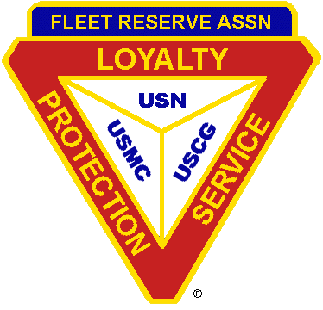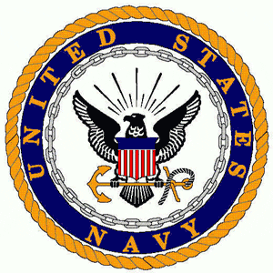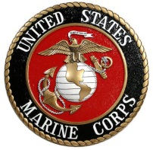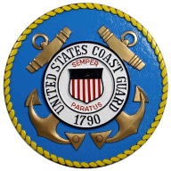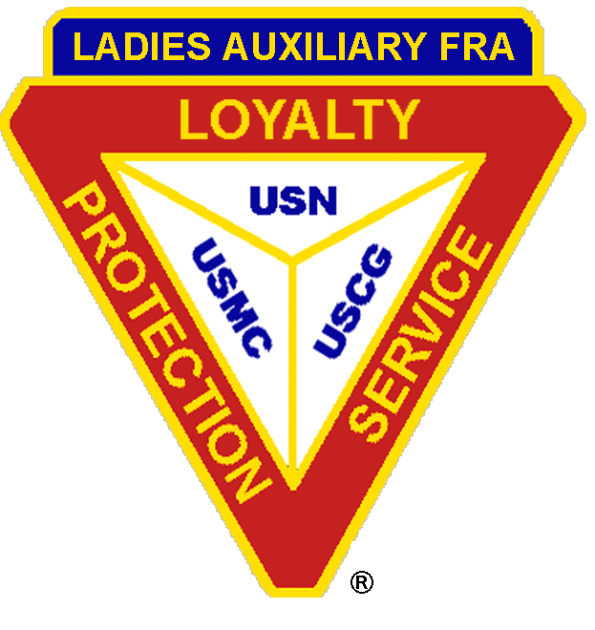

FRA Branch 99 Newsletter

SERVING ACTIVE DUTY, FORMER ACTIVE DUTY AND RETIRED MEMBERS OF
THE UNITED STATES NAVY, MARINE CORPS AND COAST GUARD SINCE 1967
DAYTIME OFFICE PHONES: 499-6650/499-1155 BRANCH WEB SITE: www.fra99.org

Branch Officers: Corporation Officers: LAFRA Unit-99 Officers:
President – Gabriel Falu Chairman- C.R. Holmes President- Joyce Meeker
(499-6650 -gabrielfalu@cox.net (499-1155 – contact@fra99.org 499-6650 -joycemeeker@cox.net
Vice President – Arthur Bailey Vice Chairman-Joe Conner Vice President- Mary Kenney
(499-6650- arthur.L.bailey8.civ@mail.mil (499-1155 – contact@fra99.org 499-6650 -catlady1ofva@cox.net
Secretary Paula Falu Secretary- Michael L.T. Quinn Secretary- Dorothy Smiley
(343-2423-fra99sec@gmail.com (376-8698- mlt_quinn@verizon.net 499-6650 -candlesamist@yahoo.com
Treasurer- Venetta Charles Treasurer-Robert Meeker Treasurer- Julie Wood
(499-6650) veetif@yahoo.com (499-1155 – contact@fra99.org 499-6650 -mgw1812@verizon.net
Chaplain- Adrian Knight
439-2606 – revknight@cox.net
Newsletter Editor- Michael L.T. Quinn
376-8698 mlt_quinn@verizon.net
Website Mgr- Edward O. Rainey
373-3454 - docofpain@hotmail.com

Volume 34 Issue No 5 Sept-Oct 2018

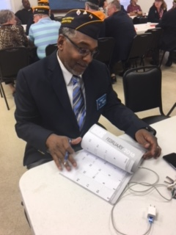
The Prez Sez:

Shipmates:

We had a very successful 4th of July picnic, if you missed it you missed one of the best, these seem to get better every year. Well Done to all of the Volunteers for making this work! Our Ladies Auxiliary has been hard at work and we wish them continued success. We continue to face major problems in our Branch, the ongoing decline in Membership and the Bingo Volunteer shortage. If you have ideas, please share them with me or any of our Officers.

Gabriel Falu

From the Vice President
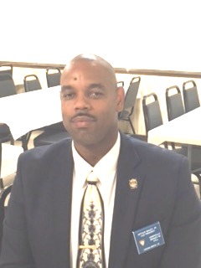

I’m still very confident that we will overcome the problems facing our Branch and the FRA in general if we all work together to solve them. We have a lot of talented individuals in our Branch. We need to take notice of what our newly formed Auxiliary is doing and copy some of their enthusiasm and volunteerism, they are motivated and eager to grow and DO something! I’ll continue to do my best to live up to the high standards you all expect and deserve. Branch 99 (as well as the FRA in general) continue the decrease in membership, we NEED to do something to stop this trend. If you have any ideas or suggestions please advise me or any of your Officers. There is no such thing as an unsolvable problem, we’re just missing the correct approach and maybe You have the answer!

Art Bailey


Chaplains Corner

Shipmates:

This time of year, our children and grandchildren are getting ready to return to school, we need to be a little more watchful as we drive around town, take extra care. As we think about the younger people we also need to remind ourselves that we are (as a group) aging rapidly and we need to be mindful of that fact. I’d like to also remind everyone that we now have a Dedicated Veteran Service Officer who has a wealth of information that applies directly to most of us.
if you’re aware of any Shipmates in ill health or distress please advise me at the soonest.

God Bless,
Rev Adrian

S/M Chaplain, Adrian Knight
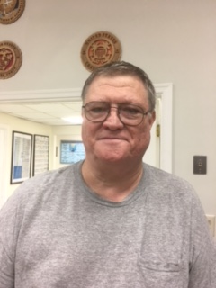

Veteran Service Officer:
Shipmates:
Here are some benefits afforded to you from the Commonwealth of Virginia:
Commonwealth of Virginia pro-vides several veteran benefits This page explains those benefits.

Virginia Veterans Homes
Virginia has two Veterans homes in Richmond and Roanoke.
Honorably discharged veterans who are residents of Virginia are eligible for admission. There may be a cost.

Virginia Veteran Financial Benefits

Income Tax
Up to $15,000 of military basic pay may be exempted from Virginia income tax.
For every $1.00 of income over $15,000, the maximum sub-traction is reduced by $1.00. For example, if your basic pay is $16,000, you are entitled to deduct only $14,000. You are not eligible for the subtraction if your military basic pay is $30,000 or more
For VA National Guard, up to 39 calendar days of service or $3,000 (whichever is less) may be deducted from your income when filing. This deduction is only available for O-3 and below.

Disabled Veterans Real Estate Tax Exemption
Veterans with a VA 100 percent disability are exempt from property taxes on their home.
The surviving spouse may also be eligible.

Virginia Veterans Preference For State Jobs
Veterans seeking state employ-ment can get a 5 percent addition to their test score. Disabled veterans can get a 10 percent addition.

Virginia Military Survivors and Dependents Education Program
The Military Survivors and Dependents Program provides educations benefits to spouses and children of military service members killed, missing in action, taken prisoner, or who became at least 90 percent disabled as a result of military service in an armed conflict. This program may pay for tuition and fees at any state-supported college or university in Virginia. Benefits are available for up to 36 months.

Virginia Veterans Recreation Benefits

Disabled Veteran Hunting & Fishing Licenses
Virginia offers a free lifetime hunting and fishing license, and a discounted saltwater license for Virginia resident veterans who are permanently and totally service-connected disabled.
Veterans with at least 70 percent VA disability can get dis-counted hunting and fresh-water fishing licenses

Active Duty Hunting & Fishing License
Active duty members stationed in Virginia can get hunting and fishing licenses for the resident rate.

State Park Admission
Veterans with 100 percent VA disability are eligible for free admission and parking and admission for the pass holder and anyone needed to assist them at Virginia state parks.
The pass also covers boat launch and horse trailer parking and a 50 percent discount on camping, swimming, shelters and equip-ment rental.
You do not need to be a Virginia resident to qualify.

Virginia Veterans Cemeteries
Virginia has three Veterans Cemeteries located in Amelia, Dublin, and Suffolk.
Honorably discharged veterans may be buried at no cost, there is a small cost for their eligible family members.
Visit the Virginia Department a Veterans Services website for more information on any of these programs

Here are important numbers and web page for Veterans and Tricare benefits:

Main Webpage Tricare.mil
Humana East Region
(select & prime) 1-800-444-5445
Tricare for Life 1-866-773-0404
Tricare Dental Retiree 1-888-838-8737
VA Medical Center Hampton VA 757-722-9961
VA homeless hotline 877-424-3838
VA crisis line 800-273-8255
VA volunteer 757-728-3124

If you have any questions, please contact me at the branch home or by my email.
mgw1812@verizon.net.
Martin G Wood

Woody



A note from Your Editor:
We have a New Web Page, S/M Ed Raney has worked diligently to revise our Branch Web Page. I encourage everyone to check it out, you’ll find a wealth of information.
Bravo Zulu ED!

Well Done to S/M Becky Wentworth and her Band of intrepid Volunteers for their efforts in coordinating our 4th of July picnic. A huge success, You’ve outdone yourself!

A reminder, if you are tasked with providing an input for the newsletter, I need to have it 2 weeks prior to publication!

Michael L. T. Quinn
Newsletter Editor

Q

COMMITTEE REPORTS:

- Membership

A Warm Welcome to all new members of Branch 99. Come to the next Branch meeting on September 12th to meet your new Shipmates. Meetings are held at 1900 on the second Wednesday of each month. Please check your calendar. If you come you may win a free meal.

S/M Vice President Art Bailey reported there were 3 newly joined, for a total of 643 active members.

- TAPS

None Reported

- Hospital and Welfare

Past President, Dan Kenney was briefly hospitalized for Heart problems, he has been released and is at home, please keep him your prayers. S/M Long is in Norfolk General Hospital, more information as it becomes available. S/M Dan Cheche is in Rehab after suffering a stroke, S/M Bill Griffith is undergoing treatment for cancer, Members urged to contact the President or Chaplain for members hospital-ized. There is a board in the Mess that will be used for Hosp-italizations, Sick, and Rehab notifications if you know of someone and haven’t heard the word put out please put the information there so that everyone can be informed. Also, S/M Chaplain Knight reminds us all that Shipmates learning of one of our fellow Shipmates illness or need of assistance to please contact him.

- BINGO
Bingo is in dire need of additional managers to allow us to continue. We’ve been relying on ONE Manager for too long. We’re getting close to actually lose our BINGO owing to a lack of a manager. BINGO is our primary moneymaker and we can’t afford to let it die. we’re always looking for volunteers to help. If you have time, stop by and give them a hand! Thank you to S/M Joe Conner for stepping and volunteering as a BINGO Manager, we still need one more.

- BUDGET and FINANCE

The Budget is balanced and the Branch is in Good Financial Shape.

KEMPSVILLE BRANCH 99

A TWO BELL CEREMONY Was held, by S/M Chaplain Adrian Knight and S/M MAA Dave Moser, in Honor of S/M Owens who has joined the Staff of the Supreme Commander.

GOOD OF THE ORDER.

Comments from Guest/Members
S/M T. White volunteered to be the Merchandise Manager
S/M N. Anderson volunteered to be the Mess Manager
We appreciate their efforts and for stepping forward to help!

- Coming Events:

03 Sep- Labor Day
12 Sep- Branch Meeting at Branch 7PM
12 Sep- Auxiliary Meeting at Branch 7PM
21 Sep- First Day of Autumn

08 Oct- Columbus Day
10 Oct- Branch Meeting at Branch 7PM
10 Oct-Auxiliary Meeting at Branch 7PM
31 Oct- Halloween

04 Nov- Daylight Saving Time ends
11 Nov- Veteran’s Day
12 Nov- Veteran’s Day observed
14 Nov-Branch Meeting at Branch 7PM
14 Nov-Auxiliary Meeting at Branch 7PM
22 Nov- Thanksgiving Day

In a program initiated by our Past President, Charlie Baldwin, local Restaurants are providing donations of dinner meal gift certificates to encourage attendance at Branch General Membership meetings. These certificates are presented as prizes in drawings held at Branch meetings. The restaurants’ support of our non-profit veterans association is greatly appreciated. Those that are currently participating are:

Cheeseburger In Paradise
739 Lynnhaven Pkwy. Virginia Beach.
Texas Road House
South Independence Blvd, Virginia Beach
Waffle Town USA
Pleasure House Road at Shore Drive, Virginia Beach
Virginia Steakhouse
620 First Colonial Rd, Virginia Beach
Golden Corral
Independence Blvd, Virginia Beach, VA
Pembroke Pizza
633 Independence Blvd

We appreciate the support of these participating restaurants, so when you are dining out, patronize them. And if you go to one of them with a free meal coupon, remember to tip the waiter for the full value of the check, before the discount. (he/she is working hard for a living and is not the one donating the free meal.) Remember to thank the manager on your way out, on behalf of Kempsville Branch 99, FRA.

Other Merchants supporting this program are:
Priority Ford, North Military Hwy, Norfolk, VA

News from the LAFRA Unit 99

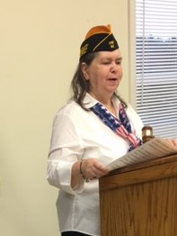

President LAFRA-Unit 99

Our ladies have been very busy the last few months. And we continue to grow in membership. Our cookbook has been published and is almost Sold Out, if you want one you’ll have to hurry- the prices is $15.00, if there is enough demand we may go with a Second Printing.

Hope to see you next month, which will be 12 September.

Joyce Meeker

SHIPMATES' REPORT
Published bi-monthly by Kempsville Branch 99, Inc. Fleet Reserve Association. It is distributed free of charge to Branch 99 members, East Coast Regional Branch Secretaries, and the FRA National Executive Secretary. Articles may be repro-duced with acknowledgement of the source.
Editor: Michael L T. Quinn
Tel. (757)376-8698
email: mlt_quinn@verizon.net
The Branch Home is at 357 Edwin Drive, Virginia Beach, VA 23462 next to Lake Trashmore.

Tel: 757-499-6650 and 499-1155. Internet: www.fra99.org Monthly meetings are held on the Second Wednesday of the month

News of Interest to Veterans

Historic Defense Bill Signed Into Law:
President Donald Trump signed the John S. McCain National Defense Authorization Act for Fiscal Year 2019. The FRA thanks the conferees and the more than 7,000 veterans and supporters who responded to the Alert opposing a provision that would have dramatically increased TRICARE fees for current retirees. The final bill does not include the misguided proposal, but does include several provisions to improve the financial viability of the Armed Forces Retirement Home, such as authorizing the home to accept financial gifts, and expanding eligibility to disabled veterans and spouses who are not currently eligible. The bill will postpone the fee increase that was scheduled to be implemented in October 2018, but applies only to those who were residents as of April 9, 2018, and authorizes gradual fee increases over the next three years. The bill will also authorize a 2.6 percent pay increase for America’s service members, the highest pay raise in nearly a decade; grant disabled veterans access to commissaries and Morale, Welfare, and Recreation facilities; require DOD to design, produce and award a certificate for veterans exposed to radiation (Atomic Veterans); improve reporting, investigation and prosecution of sexual assault cases; expand eligibility for Military OneSource to one year after discharge; and require DOD to conduct an assessment on ways to enhance and reform Taiwan's military forces..
Europe Fact-finding Trip: The itinerary included meetings with U.S. military and diplomats assigned to NATO headquarters, Supreme Headquarters Allied Powers Europe, U.S. Army Garrison Bavaria, U.S. Africa Command, U.S. European Command, U.S. Air Forces Europe/Africa, and U.S. Army Europe. The firsthand look at the situation in Europe provides invaluable insight into the challenges our service members, retirees, and their families are facing there and helps the VSOs shape its advocacy efforts.

Forever GI Bill 1-year Anniversary: This week the FRA celebrated the 1-year anniversary of the Forever GI Bill which brought much needed changes to the education benefits provided to veterans, service members, and their families. The FRA championed many of the upgrades in the law for years and thanks Congress for passing this important bill. Many of the changes are being implemented for this upcoming fall school semester.
VA Updates Skin Conditions Disability Rating: VA is currently updating multiple categories of the Schedule for Rating Disabilities, including conditions related to the skin. No conditions have been removed from the skin rating, though several were restructured. Claims that were pending before Aug. 13 will be considered under both the new and old rating criteria. The more favorable criteria for the veteran will be used for claims pending before Aug. 13. Claims filed after Aug. 13 will be rated under the new schedule. For assistance with filing a claim, contact our Veteran Service Office.
Army Credentialing Assistance Program:
The Army announced that it will begin piloting its Credentialing Assistance Program beginning this fall, with full implementation set for FY20. The program will provide soldiers up to $4,000 per year to pay for certifications and credentials that will help prepare them for gainful employment after their transition from the military. Upon full implement-ation, the program will give soldiers the ability to choose from more than 1,600 programs offered through the Army’s Credentialing Opportunities On-line website, and better prepare them for jobs in industries such as health care, information technology, and aviation repair. This new pilot expands on the current Army Credentialing Pro-gram, but gives soldiers the ability to gain certifications that are outside their military occupational specialties.
Combat Controller to Receive Medal of Honor Posthumously: The White House announced that an Air Force combat controller killed in a battle with al-Qaida militants in the early months of the war in Afghanistan will be awarded the Medal of Honor posthumously for his actions during that 2002 fight. The president presented the nation’s highest military honor to Tech. Sgt. John A. Chapman’s spouse, Valerie Nessel, in a ceremony on Aug. 22. The award is an upgrade of the Air Force Cross that Chapman initially received posthumously for his actions on Roberts Ridge in March 2002. Chapman was part of an elite special operations team charged with locating and targeting al-Qaida fighters entrenched on Takur Ghar mountain in eastern Afghanistan along the Pakistan border. He is the first airman to receive the Medal of Honor since the Vietnam War, and just the 19th in the service’s history.
MIA Update: The Defense POW/MIA Accounting Agency has announced four new ident-ifications, and burial dates and locations for five previously identified servicemen. Returning home with full military honors are:
Navy Machinist’s Mate 1st Class Arthur Glenn, 43, of Fort Wayne, Ind., whose remains were previously accounted for, was buried Aug. 21 in the National Memorial Cemetery of the Pacific in Honolulu. On Dec. 7, 1941, Glenn was assigned to the USS Oklahoma, which was moored at Ford Island, Pearl Harbor, when the ship sustained multiple torpedo hits and quickly capsized, resulting in the deaths of 429 crewmen, including Glenn.
.
Marine Corps Pfc. Robert K. Holmes, 19, of Wichita, Kan., whose remains were previously accounted for, was buried Aug. 20 in Salt Lake City. On Dec. 7, 1941, Holmes was assigned to the USS Oklahoma, which was moored at Ford Island, Pearl Harbor, when the ship sustained multiple torpedo hits and quickly capsized, resulting in the deaths of 429 crewmen, including Holmes.
Army Air Forces Capt. George Van Vleet, Jr., 35, of Fresno, Calif., whose remains were previously accounted for, was buried August 18 in his hometown. Van Vleet was a member of the 38th Bombard-ment Squadron, (Heavy), 30th Bombardment Group, stationed at Hawkins Field, Betio Island, Tarawa Atoll, Gilbert Islands. On Jan. 21, 1944, the B-24J bomber aircraft he was aboard crashed shortly after takeoff, killing all six crewmembers, including Van Vleet
Marine Corps Reserve Pfc. Herman W. Mulligan, Jr., 21, of West Greenville, S.C., whose remains were previously accounted for, was buried Aug. 21 in Arlington National Cemetery, near Washington, D.C. On May 30, 1945, Mulligan was a member of Company L, 3rd Battalion, 22nd Marine Regiment, 6th Marine Division, engaged in heavy fighting against Japanese forces on Hill 27. A large cache of ammunition exploded during the battle, wounding dozens and killing Mulligan.
.
Army Pfc. Joe S. Elmore, 20, of Seminary, Ky., whose remains were previously accounted for, will be buried Aug. 18 in Albany, Ky. Elmore was a member of Company A, 1st Battalion, 32nd Infantry Regiment, 7th Infantry Division. In late November 1950, his unit was assembled with South Korean soldiers in the 31st Regimental Combat Team on the east side of the Chosin River, North Korea, when his unit was attacked by Chinese forces. Elmore was among more than 1,000 members of the RCT killed or captured in enemy territory and was declared missing on Dec. 2, 1950.
Navy Aviation Chief Ordnanceman Otis E. Ingram was a turret gunner aboard a torpedo bomber from U.S. Navy Torpedo Squadron Fifty One (VT-51). On July 27, 1944, Ingram’s aircraft was the lead of four Avengers on a mission targeting the Japanese base at Malakal Harbor when it went missing. All three crewmembers, including Ingram were reported missing in action, and subse-quently reported killed in action on Feb. 4, 1946. Interment services are pending.
.
Army Pfc. Leo J. Duquette was a member of Company L, 3rd Battalion, 21st Infantry Reg-iment, 24th Infantry Division. In July 1950, his unit was engaged in combat operations against North Korean forces near Choch’iwon, South Korea. Duquette could not be accounted for and was declared missing in action on July 11, 1950. Interment services are pending.
Army Pfc. Mathis O. Ball, Jr. was a member of Company M, 3rd Battalion, 21st Infantry Regiment, 24th Infantry Div-ision. In July 1950, his unit was engaged in combat operations against North Korean forces near Choch’iwon, South Korea. Ball could not be accounted for and was declared missing in action on July 12, 1950. Interment services are pending
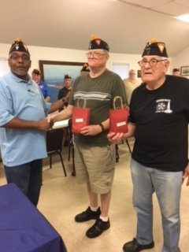
S/M Wood and S/M Moser get
Awards from S/M President Falu
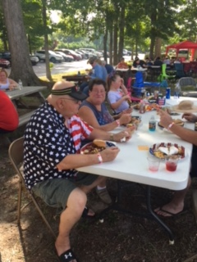
Enjoying the 4th of July Picnic
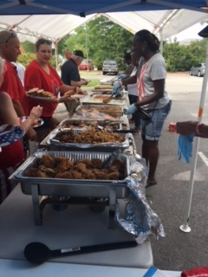
S/M Secretary Falu is Hard at work serving up meals

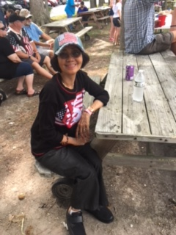
Enjoying the 4th of July Picnic

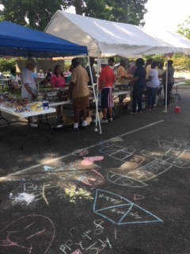
Chow Line
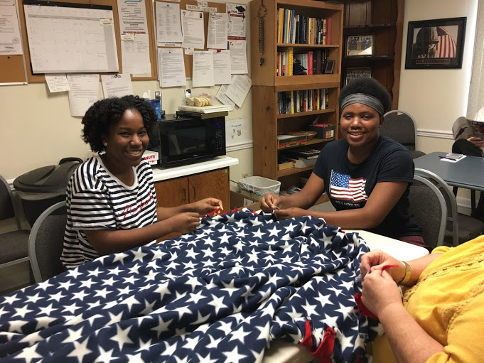
LAFRA Members making Blankets to be sold and to be donated to wheelchair bound Veterans.
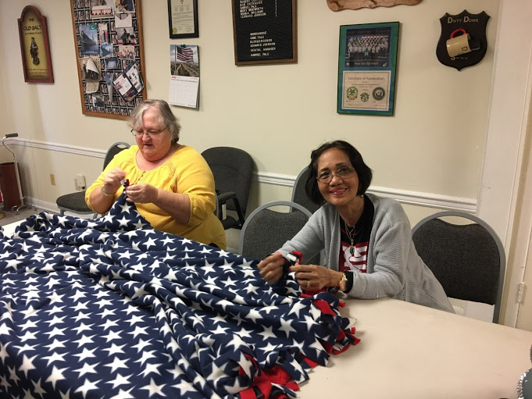
More LAFRA members working on Blankets

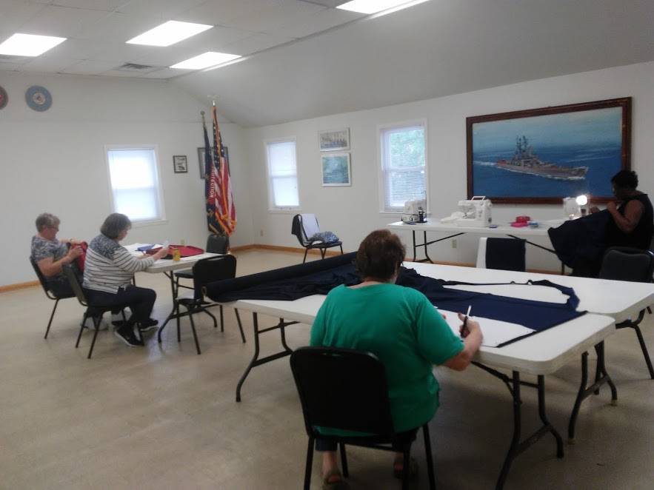
LAFRA Tuesday Work Shop

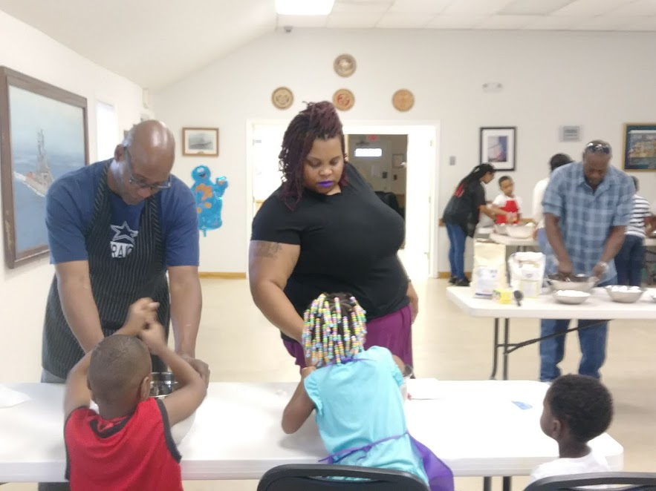
LAFRA Members working at the first Community Bakeshop teaching 25 children to make cookies from scratch oatmeal raisin and sugar cookies. Coolies were donated to the homebound. They also provided School Supplies to all of the children. Special Thanks to the Volunteers from: Endtime United Church

