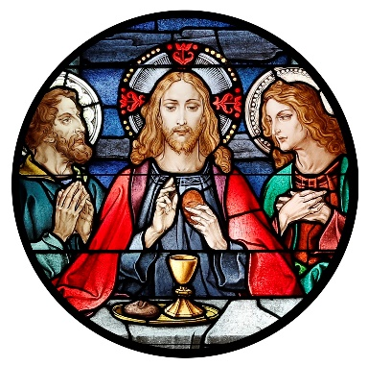
Blessed Sacrament Church
4500 Jackson Blvd.
Rapid City, SD 57702-4972
Phone: (605) 342-3336
Fax: (605) 341-5668
bsc@blessedsacramentchurch.org

BLESSED SACRAMENT PASTORAL COUNCIL MEETING MINUTES
10/10/2021, 12:30 PM, Parish Rectory
Call to Order: David DiMaria called the meeting to order at 12:30pm
Present: Father Tim Hoag, Father Collins Igwilo, David DiMaria, Jon Schaack, Bill Colson, Tim Callahan, Dave Richardson, Dave Raml, Justin Wermers, and Katie Wermers.
Approval of minutes: The minutes of the board meeting conducted on September 9, 2021 were presented. A motion to approve the minutes as presented by Tim Callahan and seconded by Justin Wermers. Motion carried.
Election of officers: A motion to elect David DiMaria as President and Jon Schaack as Vice President was presented by Tim Callahan and seconded by Justin Wermers. Motion carried.
Presentation of Reports:
- President report
  - Welcomed new council members - Justin Wermers, Katie Wermers, and Dave Raml.
  - Thank you to members whose terms have expired – Dave Richardson (present), Amy Thompson, and Catherine Chicoine.
  - Reviewed role of the council, meetings, directory, and liaison roles.
- Pastor’s Report
  - Introduced Father Collins to the council
  - Recap of William Graham event
  - Announced formation of renovation committee, outlined rough timeline and action steps, and reviewed architect visit.
  - Announced that parishioner stepped forward to donate cost of choir loft window (actually several parishioners volunteered to donate)
- Standing Committee/ Liaison reports
  - Youth/School – Jon Schaack
    - He will work on a monthly bulletin announcement on school events
    - Fr. Tim stated that BSC is working closer with the school regarding altar servers
  - Ministry Liaisons – No other reports
- November meeting date changed to Sunday November 14 at 12:30pm at the Rectory
- Meeting adjourned at 2pm.

