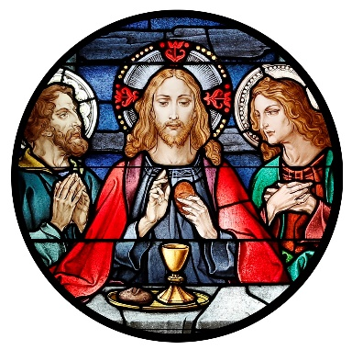
Blessed Sacrament Church
4500 Jackson Blvd.
Rapid City, SD 57702-4972
Phone: (605) 342-3336
Fax: (605) 341-5668
bsc@blessedsacramentchurch.org

BLESSED SACRAMENT PASTORAL COUNCIL MEETING MINUTES
11/14/2021, 12:30 PM, Parish Rectory
Call to Order: David DiMaria called the meeting to order at 12:30pm
Present: Father Tim Hoag, Father Collins Igwilo, David DiMaria, Bill Colson, Jaime Munoz, Dave Raml, Justin Wermers, and Katie Wermers.
Approval of minutes: The minutes of the board meeting conducted on October 10, 2021 were presented. A motion to approve the minutes as presented by Tim Callahan and seconded by Justin Wermers. Motion carried.
Presentation of Reports:
- Pastor’s Report
  - Reviewed Diocesan Strategic Plan and asked for feedback especially on the Values section.
    - Attach Powerpoint outline to minutes
    - Two town halls will be setup for some time in January
  - Clarified stance on renting hall to Citizens for Liberty
    - The hall is being rented not used for free
    - Hall Rental guidelines are being followed
    - They are not a political party
    - Basically, anyone can rent the hall as long as the purpose does not go against church teachings, i.e. we will not rent to Planned Parenthood
- New Business
  - Nursery
    - Need speaker that works
    - Possibility of putting tv in there to stream 9am mass
    - Can/should we put a Reserve sign on pews in gathering area for people with small children?

