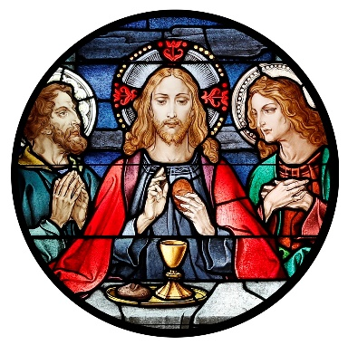
Blessed Sacrament Church
4500 Jackson Blvd.
Rapid City, SD 57702-4972
Phone: (605) 342-3336
Fax: (605) 341-5668
bsc@blessedsacramentchurch.org

BLESSED SACRAMENT PASTORAL COUNCIL MEETING MINUTES
3/23/2022, 7:00 PM, Parish Office
Call to Order: David DiMaria called the meeting to order at 7:00pm
Present: Father Collins Igwilo, Deacon Greg Palmer, David DiMaria, Tim Callahan, Bill Colson, Jon Schaak, Greg Forstner, Dave Raml, Justin Wermers, and Katie Wermers.
Approval of minutes: The minutes of the board meeting conducted on January 13, 2022 were presented. A motion to approve the minutes as presented by Tim Callahan and seconded by Justin Wermers. Motion carried.
Presentation of Reports:
- President’s Report
  - Renovation – Grotto/Statues
    - At January meeting, the renovation liaison presented the preliminary proposal for the grotto and statues
    - Tim Callahan made a motion that the Pastoral Council is in agreement with and supports the plan. Dave Raml seconded the motion and it passed unanimously.
  - Discussion on Parishioner feedback
    - Why are people leaving
      - Length of Homilies, Mass
      - Music
    - What is the process to select Pastoral Council members
      - Add something to website- process and application
  - Synod on Synodality Questions
    - David DiMaria presented questions to council members. Review and answer for next meeting
- Liaison Reports
  - Youth – Katie Wermers
    - Nothing to report
  - Hispanic – Jaimie Munoz
    - Not in attendance
  - Renovation – Bill Colson
    - Choir window on order and should be installed by end of Feb/beginning of March
    - Reviewed parishioner feedback from Sunday
    - Invited council members to sit in on next Renovation Committee meeting if interested
  - Adult Faith Formation – Bill Colson
    - Bible Timeline has about 60 participants
    - Beloved Married Couples only a couple of couples
  - Parish Festival – Dave Raml
    - Date for 2022 festival is Saturday August 13
  - Knights of Columbus – David DiMaria
    - Knight of Wine is coming up on February 25th
    - Pancake Breakfast this Sunday 2/13
    - Donut Day is the 4th Sunday of the month
- Old Business
  - Nursery – Speaker/TV Who can turn it on? Sometimes the door is locked
    - Tim Callahan said that he would do it as he is sacristan for 7am Mass
Meeting Adjourned at 8:00pm

