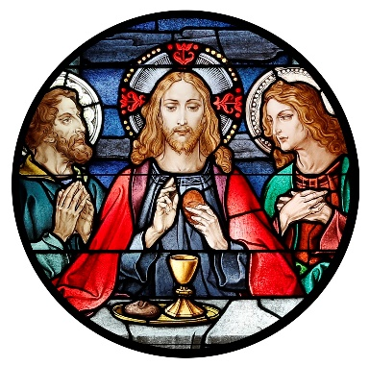
Blessed Sacrament Church
4500 Jackson Blvd.
Rapid City, SD 57702-4972
Phone: (605) 342-3336
Fax: (605) 341-5668
bsc@blessedsacramentchurch.org

BLESSED SACRAMENT PASTORAL COUNCIL MEETING MINUTES
5/12/2022, 6:30 PM, Parish Office
Call to Order: David DiMaria called the meeting to order at 6:30pm
Present: Father Tim Hoag, David DiMaria, Bill Colson, Jaime Munoz, Dave Raml, Justin Wermers, and Katie Wermers.
Approval of minutes: There were no minutes to be approved from March.
Presentation of Reports:
- Pastor’s Report
  - Synod on Synod’s Questionnaire – This does in fact need to be completed by BSC. Each council member should answer two questions and send back to Father Tim asap
  - Greg Schweiss will present next fiscal year budget at next meeting
  - Alpha begins next month

- President’s Report
  - Parishioner Feedback
    - There was no feedback from Parishioners after the masses
    - Perhaps have a table next month so that members can be easily recognized. If that doesn’t work, forego this effort.
    - Put up suggestion box
  - Cyndi Fisher has resigned from the council
  - Need to communicate to the Parish how council members are selected and what is their role
    - Do we need to change application at all?
    - Put app on website
  - Council Members whose term is up in September
    - David DiMaria (first term)
    - Jaime Munoz (first term)
    - Greg Forstner (first term)
- Liaison Reports
  - Youth – Katie Wermers
    - Year ended, good year for Life Teen and all programs
    - Kudos to Matt for doing a great job
  - Hispanic – Jaime Munoz
    - Leadership committee is trying to organize a speaker
  - Renovation – Bill Colson
    - Choir window has been shipped
    - Grotto Project is being proposed to Diocesan Finance Commission
  - Adult Faith Formation – Bill Colson
    - Bible Timeline has a few more sessions, attendance at about 25-30
    - Other programs have ended
  - Parish Festival – Dave Raml
    - Date for 2022 festival is Saturday August 13
    - Sponsors are coming in well
    - Food plan is to purchase pork and smoke it ahead of time
  - Knights of Columbus – David DiMaria
    - One more pancake breakfast in June
    - Donuts still planned for May and June
    - New officers will be voted on in June and takeover in July
Meeting Adjourned at 7:45pm

