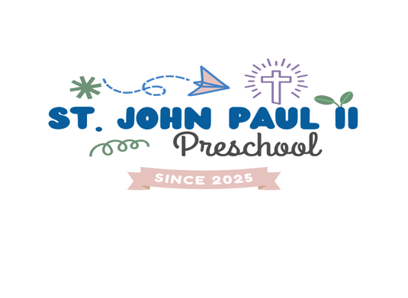

Health & Safety Guidelines Flu/Cold, RSV and COVID-19, Cold, Flu Symptoms
If your child has flu/cold symptoms, please keep them home until they have been fever free for 48 hours without medicine, symptoms have stopped, and you can see child improvement.

Too sick for school?
We know it can be hard deciding when a child is too sick to go to school, when trying to make this choice, use these guidelines to help make the best decision.
● Fever: Keep a child home if they have a temperature of 100 degrees Fahrenheit or higher.
● Sore throat: Be mindful of sore throats, especially those with a fever or swollen glands in the neck. If your child has strep throat, they can return to school after 24 hours of appropriate treatment.
● Diarrhea: Keep a child home if they’ve had loose, watery stool for a 24-hour period.
● Vomiting: Keep a child home if they've thrown up in a 24-hour period.
● Rash: Watch for rashes, especially those that cause a fever, itching or swelling.
● Chronic cough and/or green nose discharge: These conditions may be contagious and require treatment. Please visit your healthcare provider.
● Ear: Any ear pain with a fever should be evaluated by a physician. Untreated ear infections can cause permanent hearing loss.
● Eye Redness: Eyes that have matted or crust on the eyelids after sleep, mucus or pus drainage, redness, and pain should be evaluated by a health care professional for possible "pink eye" or conjunctivitis.
● Chicken Pox: Children with Chicken Pox must remain home for five days after the beginning of blisters, or until all pox are scabbed over and dry.
● Other Symptoms: Unusually tired, pale, lack of appetite, difficulty waking up, overly confused or irritable. If symptoms persist, contact your child’s doctor.

Communicable Disease control is an integral part of school health services. St. John Paul II follows the current health rules and regulations governing the control and prevention of communicable diseases that are set up by the state and county health departments.
Your child may not return to school until he or she has been fever free for 48 hours without medication. We ask that you follow the guidelines listed below when sending your child to school after an illness. Always call the school to notify us of illness or an injury (850)570-9002.
