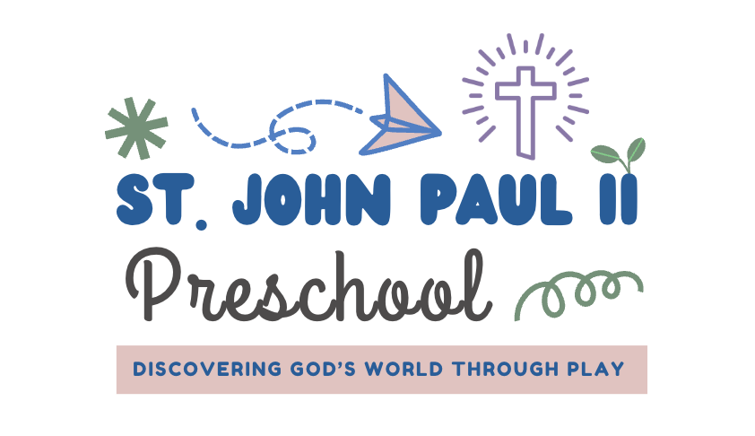
Children must be 18 months of age by September first to attend St. John Paul II Preschool. There is a registration fee of $150 (non-refundable) due after you have completed the registration forms. We will send you a payment link after receiving your enrollment forms.
A one-time supply fee of $400 is due on July 15, along with the tuition contract. Tuition and extended day payments are due/billed on the 1st day of the month, August through May. A late fee will be processed if payments are received after the 5th day of each month.
 | Days a Week
Our 2-day option is only available for 18 months to 35 months old
All ages can attend, 3- or 5-day options
Morning Program Only  2025-26 Monthly  8:45am – 12:15pm | 2 days (only for 18 month - 2 yr olds)  3 days – all ages  5 days – all ages  5 days – on VPK voucher | $350/month  $450/month  $575/month  $180/month
Full Day Program  8:45 am – 5:30 pm | 2 days (only for 18 month - 2 yr olds)  3 days – all ages  5 days – all ages | $675/month  $875/month  $1,115/month
Rise and Shine Program  (Early Drop Off)  7:30 am – 8:45am | 2 days a week  3 days a week  5 days a week. | Additional $55/month  Additional $75/month  Additional $95/month
Lunch Bunch Program  12:15 am – 2:00 pm | 2 Days a week  3 days a week.  5 days a week. | Additional $175/month  Additional $200/month  Additional $275/month
The registration option you choose is for the entire school year. Children in 3 years old class and older must be potty trained by the first day of class. Students’ immunization and physical forms must be turned in prior to the first day of school. St. John Paul II Preschool does not accept religious exemption on immunizations.
Our preschool will closely follow the school year calendar, August through May with the possibility of additional days for Catholic Holidays such as Good Friday, Easter Monday, etc. We will have a Summer Camp option, but plans are still being finalized for this.
All Fees/Amounts are shown as the monthly payment amount.

There are limited spots in Rise & Shine and Lunch Bunch, drop ins are not available. Placement is based on first come first serve basis so early registration is suggested to secure these add on hours.
Katie Williams – Preschool Director (850)201-1810 website – www.sjp2preschool.com

