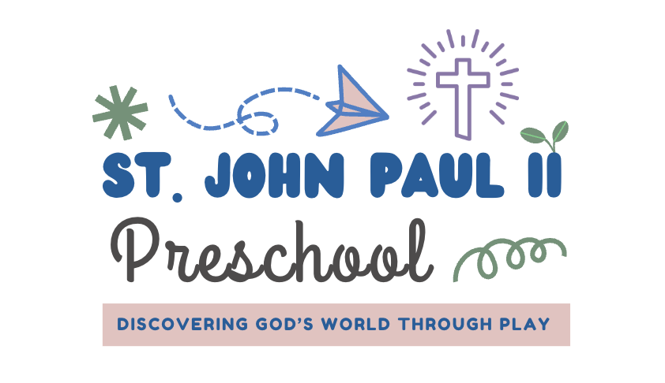
There is a registration fee of $150 (non-refundable) due after you have completed the registration forms. We will send you a payment link after receiving your enrollment forms.
A one-time supply fee of $400 is due on July 15, along with the tuition contract. There is no VPK wraparound supply fee. Tuition and extended day payments are due on the 1st day of the month, August through May. A late fee will be assessed if payments are received after the 5th day of each month.
Florida’s VPK voucher pays for 540 hours. There is an additional $180 monthly fee for VPK hours beyond what the state covers.
 | Days a Week
18 month old & 2’s 2 day option (T/TH) 3 day is M/W/F

Morning Program Only  2025-26 Monthly  8:45am – 12:15pm | 2 days (only for 18 month - 2 yr olds)  3 days – all ages  5 days – all ages  5 days – on VPK voucher | $350/month  $450/month  $575/month  $180/month
Full Day Program  8:45am – 5:30 | 2 days (only for 18 month - 2 yr olds)  3 days – all ages  5 days – all ages  5 days – on VPK voucher | $675/month  $875/month  $1,115/month  $750/Month
Rise and Shine Program  (Early Drop Off)  7:30 am – 8:45am | 2 days a week  3 days a week  5 days a week. | Additional $55/month  Additional $75/month  Additional $95/month
Lunch Bunch Program  12:15 am – 2:00 pm | 2 Days a week  3 days a week.  5 days a week. | Additional $175/month  Additional $200/month  Additional $275/month
The registration option you choose is for the entire school year. Children in 3 years old class and older must be potty trained by the first day of class. Students’ immunization and physical forms must be turned in prior to the first day of school. St. John Paul II Preschool does not accept religious exemption on immunizations.
Our preschool will closely follow the school year calendar, August through May with the possibility of additional days for Catholic Holidays such as Good Friday, Easter Monday, etc.
All Fees/Amounts are show as the monthly payment amount.
18 month olds must be18 months by Sept 30th 2025.
There are limited spots in Rise & Shine and Lunch Bunch, drop ins are not available. Placement is based on first come first serve basis so early registration is suggested to secure these add on hours.
Katie Williams – Preschool Director (850)201-1810 website – www.sjp2preschool.com

