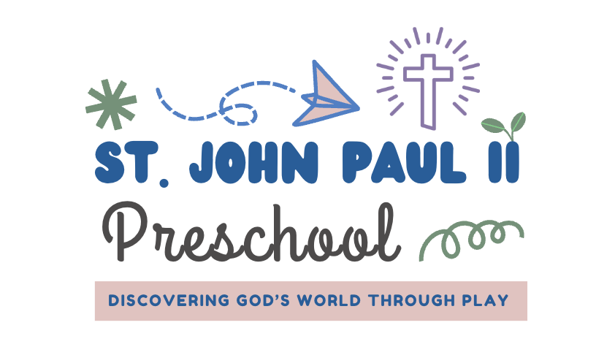
Children must be 18 months of age by September 1st to attend St. John Paul II Preschool. There is a registration fee of $150 (non-refundable) due after you have completed the registration forms. We will send you your payment link after receiving your enrollment forms.
A one-time supply fee of $400 is due on July 1, along with the tuition contract. Tuition and extended day payments are due on the 1st day of each month, August through May, we do not probate for day children are not in school for absence or school calendar days off. A late fee will be processed if payments are not received by the 1st of each month.
The registration option you choose is for the entire school year. Children in 3 years old class and older must be potty trained by the first day of class. Students’ immunization and physical forms must be turned in prior to the first day of school. St. John Paul II Preschool does not accept religious exemption on immunizations.
Our preschool closely follows the Leon County School calendar. We are open August through May. There are a few possible additional days off for Catholic Holidays such as Good Friday, Easter Monday, etc.
All Fees/Amounts are shown as the monthly payment amount.
 | Days a Week
Our 2-day option is only available for 18 months to 35 months old
All ages can attend, 3- or 5-day options
Morning Program Only  2026-27 Monthly  8:45am – 12:15pm | 2 days (only for 18 month - 2 yr olds)  3 days – all ages  5 days – all ages  5 days – On VPK Voucher | $350/month  $450/month  $575/month  $275/Month
Full Day Program  8:45 am – 5:30 pm | 2 days (only for 18 month - 2 yr olds)  3 days – all ages  5 days – all ages  5 days – On VPK Voucher | $675/month  $875/month  $1,115/month  $815/month
Rise and Shine Program  (Early Drop Off)  7:30 am – 8:45am | 2 days a week  3 days a week  5 days a week. | Additional $55/month  Additional $75/month  Additional $95/month
Lunch Bunch Program  12:15 am – 2:00 pm | 2 Days a week  3 days a week.  5 days a week. | Additional $175/month  Additional $200/month  Additional $275/month
4:00 Pick Up | 2 Days a week  3 Days a week  5 Days a week | Additional $350  Additional $375  Additional $450
There are limited spots in Rise & Shine and Lunch Bunch, drop ins are not available. Placement is based on first come first serve basis so early registration is suggested to secure these add on hours.
Katie Williams – Preschool Director (850)201-1810 website – www.sjp2preschool.com

