Qty | Description | Picture | Price | Status
ORNAMENTS
 | Christmas Ornament  Central Square | 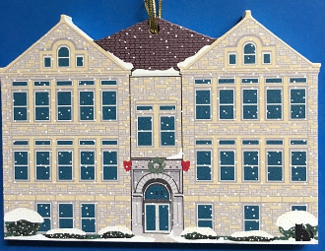 | 15.00 | In Stock!
 | 2019 Christmas Ornament  St. Joseph Ornament | 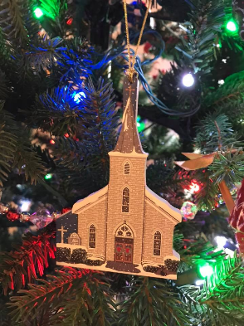 | 15.00 | In Stock!
 | Christmas Ornament  St. Dennis Church | 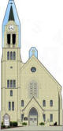 | 15.00 | In Stock!
 | 2017 Christmas Ornament  Boza's Hot Dogs | 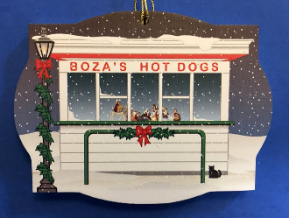 | 15.00 | In Stock!
 | 2019 Christmas Ornament  Lockport Township High School | 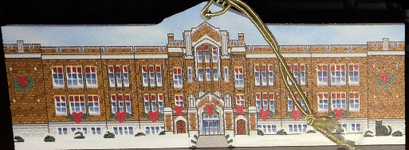 | 15.00 | In Stock!
 | Christmas Ornament  Texaco at Night | 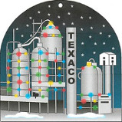 | 15.00 | In Stock!
REPLICAS – FULL SIZE (see dimensions on website)
 | Replica:  Norton Building  (2025) | 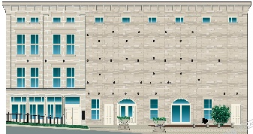 | 25.00 | Available August 2025
 | Replica:  St. John Episcopal Church | 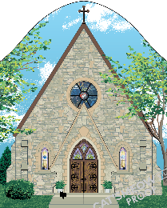 | 25.00 | In Stock!
 | Replica:  Roxy Theater | 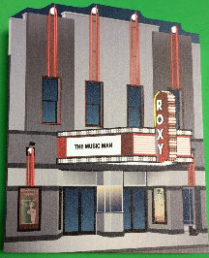 | 25.00 | In Stock!
 | Replica:  #12 Gaylord Building | 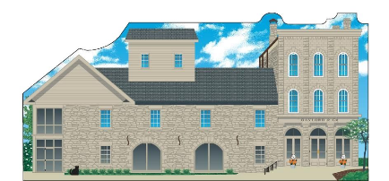 | 25.00 | In Stock!
 | Replica:  #11 Fire/Police/City Hall | 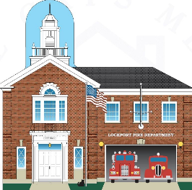 | 25.00 | In Stock!
 | Replica:  #10 Shepherd of the Hill | 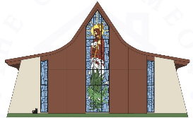 | 25.00 | Out of Stock!
 | Replica:  #09 Gladys Fox Museum | 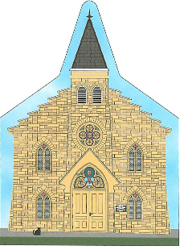 | 25.00 | In Stock!
 | Replica:  #08 Boyer House | 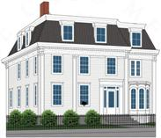 | 25.00 | In Stock!
 | Replica:  #07 White Oak Library |  | 25.00 | In Stock!
 | Replica:  #06 1st United Methodist Church | 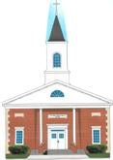 | 25.00 | In Stock!
 | Replica:  #05 St. Joseph Church | 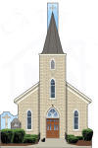 | 25.00 | In Stock!
 | Replica:  #04 St. Dennis Church |  | 25.00 | In Stock!
 | Replica:  #03 Train Station | 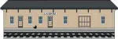 | 25.00 | In Stock!
 | Replica:  #02 Central Square | 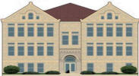 | 25.00 | In Stock!
 | Replica:  #01 Lockport Township  High School  Central Campus | 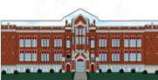 | 25.00 | In Stock!
 |  | Shipping: $11 for up to 3 items | $
 |  | total | $

Your Name: (required)
Your Address:
City:
State:
Zip:
Your Phone Number (required)
Your Email Address (required)

