**EZ-GO BRAKE LIGHT KIT**

**Mount the brake switch bracket to the floor with the micro switch compressed when the brake is off.**

**Drill the 2 holes in the floor and attach the bracket with the 2 screws and nuts provided in the kit.**

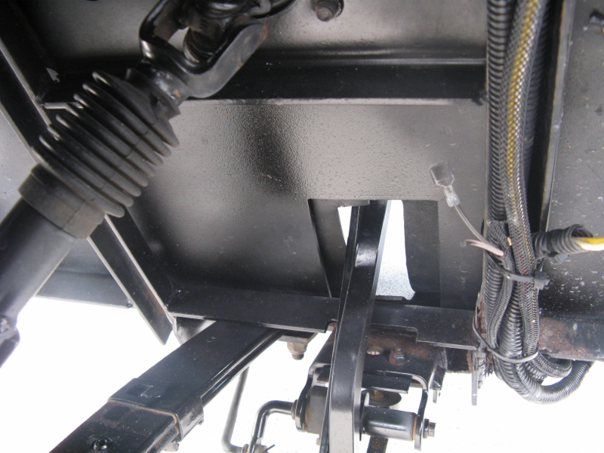

**MOUNT SWITCH BRACKET**

**HERE**

HERE

3