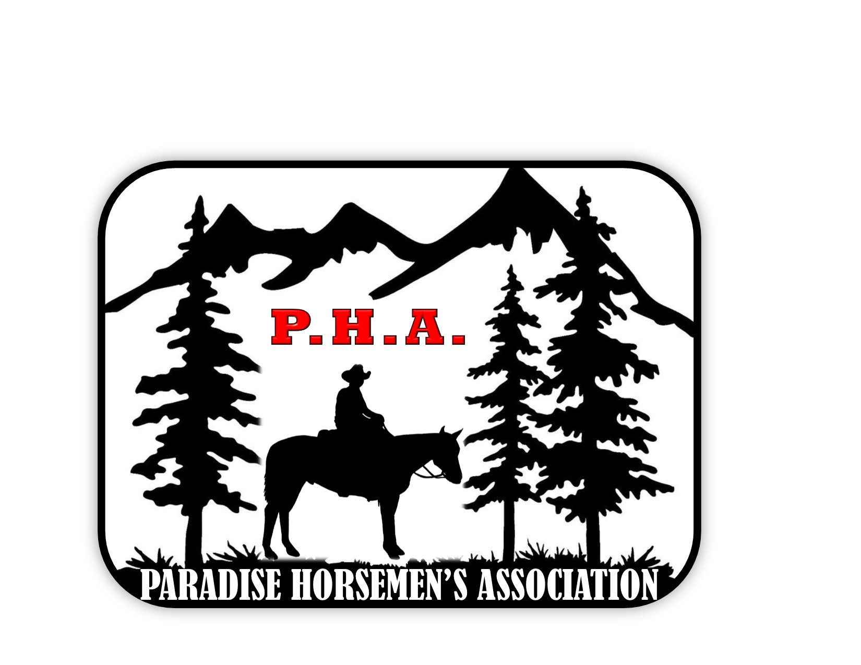
PARADISE HORSEMEN’S ASSOCIATION
“A-MAZE DAY” Type 2 SHOW

Rider name: ______________________________New member: Y or N

Horse Name:______________________________________

E-Mail address (If not already on file):_________________________________________

Address:______________________ City:_____________ Zip_______

Phone:_________________________ Birthdate(Required):______________

Division:(circle one) Leadline 25/-, 26-45, 46-65, 66/+, In-hand

Age divisions may be adjusted depending upon entries submitted
(Leadline and In-Hand divisions are non-competitive and not eligible for awards)
ENTRY FEE $6.00/event x_____ $_________
OR
ALL EVENTS: $30.00…………… $_________

LEADLINE: $3.00/event $_________
IN-HAND: $3.00/event
GROUND FEE: $5.00_____

PHA Membership- family $50 $________
Single $40
Junior $30
Series fee(4 show awards) $20.00 $________
PHA member series fee: $15.00 $________

SUBTOTAL FEES $_________

coupons redeemed _______
(Credits...if any) <_________>

TOTAL FEES DUE: $__________

Cash:______ Check #______ VM______ Rec’d by ______
SHOW EVENTS
Please mark each event you wish to ride in.

____The Big Z

____Tunnel Twist

____Pony Express

____Tail Spin

____Lefty-Righty

RELEASE OF LIABILITY: The Paradise Horsemen’s Association and Paradise Recreation and Park District will not be responsible for any accident that may occur to be caused by any horse competing at this show or for any article of any kind or nature that may be lost or destroyed or in any way damaged. Each competitor will be responsible for any injury that may be occasioned to any person or animal or damage to any property while on the grounds by any horse owned, or in his custody, or control and shall indemnify & hold harmless the Paradise Horsemen’s Association, and Paradise Recreation and Park District, clubs & arena owners, from & against all charges & expenses of every kind and nature whatsoever arising out of or which may be incurred by reason of any accident, injury, or damage to person or property caused by the ownership, competition or custody or control of any animal competition.

All riders under the age of 18 MUST wear a helmet at all times while mounted while in the arena.
Please note: PHA “DOES NOT” carry medical insurance for its members.
I Certify that I have read & agree to all of the above.

SIGNATURE (Parent or guardian if under age of 18)_______________________________________

