Dalhousie Sailing Team

2024/25 Annual Report

The Dalhousie Sailing Team placed 1st overall in Canada within the Canadian Collegiate Sailing Circuit.

# Table of Contents

- - - - X

| Season Review | 3 |
| --- | --- |
| Statement of Financial Position | 5 |
| Biggest Challenges Faced by Dal Sailing | 9 |
| Goals for Next Season | 11 |
| Thank you to our Sponsors and Partners | 13 |
| How to Support Dal Sailing | 15 |

# 

# Season Review

- - - - X

This year we participated in the vast majority of events in the CICSA circuit, hosting 1 of the 7 events we attended so far this season. Our team participated in regattas located in Kingston, Montreal, Toronto, New York, Vancouver and Halifax. This fall we were able to continue to develop our relationships with both the Royal Nova Scotia Yacht Squadron and the Waegwoltic Club. Our coach Chris Tully aided in our keelboat team's skill development throughout the season.

The dinghy team participated in 6 regattas this year. Our away events included UofT Invitational, Quebec Regionals, Team Racing Nationals and Fleet Racing Nationals, while we hosted both Maritime University Sailing Championships (MUSC) and Dal CHampionships. Dal placed second at Team Racing Nationals and placed first at MUSC, Quebec Regionals, and Fleet Racing Nationals. We are thrilled to have been able to attend many of the events and provide our sailors with lots of racing opportunities. Hosting two events added to this as we were able to have two Dal teams participate in MUSC. Sailors could race without the time and financial commitments of travel and we saw an increase in participation from our non-competitive sailors through both racing and volunteering. We hope to continue drafting most regattas in the future to remain competitive in the CICSA circuit as well as host events to help in increasing opportunities to participate in events beyond our competitive team.

Our Keelboat team competed in two regattas this fall, one in Larchmont New York on an Italia 11.98 (IOR) and Keelboat Nationals where the team placed 2nd on Sonar’s at The RCYC in Toronto and Third at IOR in PHRF Large. The Keelboat team has also participated in the Match Racing event in Vancouver where they came 2nd for CICSA on Elliot 6M’s at RVYC. For next season we are looking to send a team to Intercollegiate Offshore Regatta (IOR) in New York again as well as the Kellboat and Match racing nationals. These Regatta’s are co-hosted by local yacht clubs and by the Storm Trysail Club for college sailors in hopes to develop and give more opportunities for Keelboat sailing.

We spent a tremendous amount of time on the water with our new practice schedule out of the Waegwoltic Club and RNSYS. Our Keelboat sailors trained Tuesdays and Wednesday nights. Our dinghy team practiced an average of three times per week at the Waegwoltic club. With fitness and squash continuing past the regular season, we hope to continue our team training through the spring.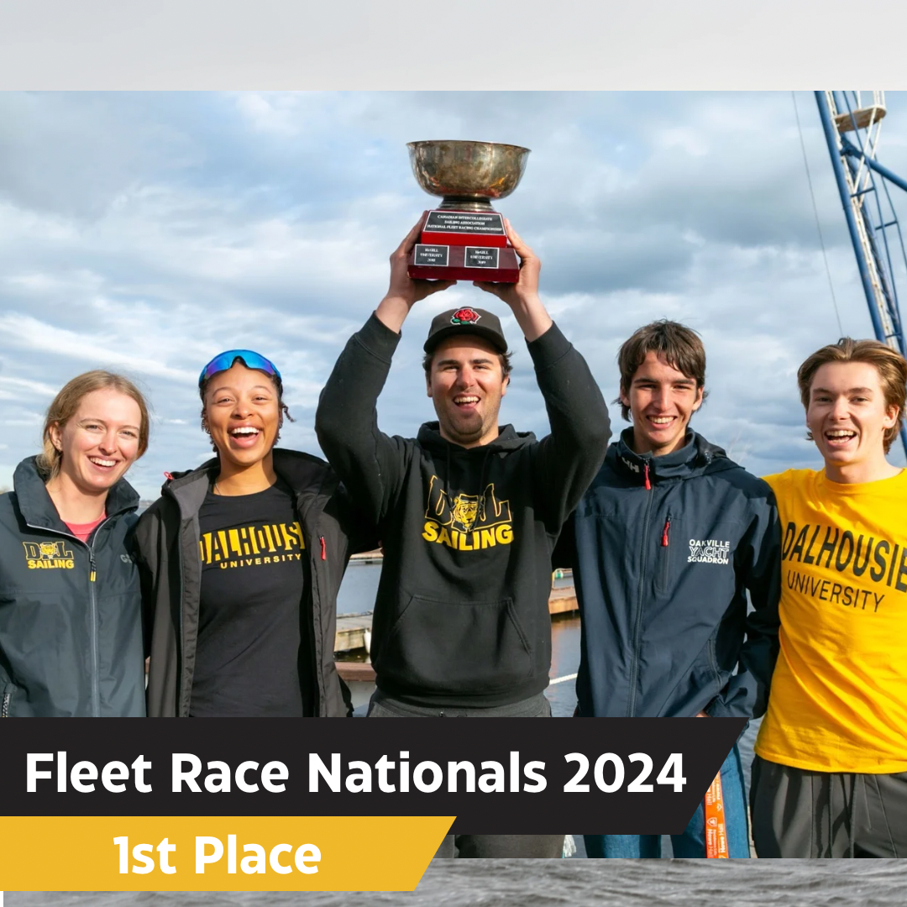

# Financial Statements

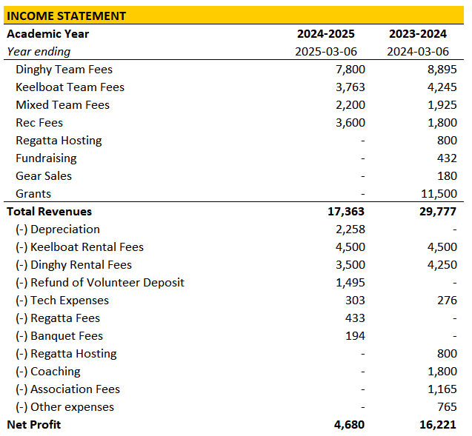

# 

# 

# 

# Summary of Financials

- - - - X

This year saw a substantial decrease in profits for the team, primarily due to no secured funding through Dalhousie or Sail Nova Scotia. Instead, we were forced to drive our cash flows through a 10-11% increase in team fees, though we saw a slight shrink in number of members. Strong Rec Sailing fees this year also helped offset the decrease with a 100% increase from CAD 1,800 to CAD 3,600 year over year. We were able to achieve this from bringing the program in house, rather than outsourcing as we did in the prior year.

On the expense side, we are beginning to see large costs from the depreciation of our new sails taking up a large chunk of our margin for the year. We were better able to negotiate our contract with the Waeg, providing some margin relief, and offset the cash flows for the keelboat team to RNSYS through the credit we had on hand from the prior year’s Rec Sailing fees.

Our budget continued to go towards the purchase of our 12 new sets of C420 sails. The purchase of the equipment has continued to run far over the allocated budget, dragging on the team’s cash flows. Currently, we are in a dispute with Fedex pending on approximately CAD 7,700 in duties and taxes, though we don’t believe this will be realized.

# 

# 

# 

# Biggest Challenges Faced by Dal Sailing

- - - - X

Transportation

A regular and ongoing challenge for DST is the ability to send sailors to competitions at a low cost. Many of the regattas we attend are outside of our province, requiring sailors to stay overnight in hotels or other accommodations. The major challenge with transportation is either having to fly (costly) or drive (long hours). We routinely travel to Montreal and Kingston during the season. Driving to these locations requires extensive amounts of time in the vehicle, as well, our sailors can only drive if one member of the team traveling has a car and is willing to take on this endeavor. This also means any sailor with a car attends most regattas, increasing their time and financial commitment while reducing the number of other sailors we are able to send. Only team members 21 and over can rent a car so we have had to forfeit regattas due to not having transportation. Flying, although not always practical, is generally a better solution to transportation. This however, is generally outside our operating budget to cover and is cost prohibitive for many of our sailors to pay for themselves. The long term solution is to promote the growth of other teams in the Maritimes to have more local racing opportunities in the collegiate circuit. Another solution is to receive more funding from a combination of grants, sponsors and other sources. To host more regattas, our team would require further support financially from our community or school, as the effort and costs add up to be unachievable. The DST would appreciate any additional support, advice, or ideas, that our community has to this regard.

Recreational Sailing Program

Previously we ran this program on chartered keelboats. Although this was a very accessible platform, the charter fee constituted a large expense which lowered our overall net profit from the program. Furthermore, we were not developing any of those sailors towards the team. To rectify this, we redesigned how our Recreational Sailing program was delivered with a goal of increasing our profit margin and providing a more solidified pathway for integration to the JV team. In Fall 2023 we launched our newly restructured Recreational Sailing Program! This year we utilized 420s that were already chartered for seasonal use by the team. We then ran a CanSail program on those boats using qualified volunteer coaches we had on our team. Sailor development happened even faster than expected, thanks to the mature students interested in learning. Thanks to this we certified 18 students for their CanSail 1 who can now join the JV team next year. This is over double the number from last year. This will lead to future synergetic cash flows. We also had a much lower operating costs for the program which helped increase our net profit for the program which will in turn support team activities. The biggest problem with the program is the fact we are limited to however many sailors can fit on our number of boats. This could be remedied with more sessions. To increase our capacity we would likely need to provide further incentives to attract coaches. Given the current high profit margins, we can likely afford this which would then further our overall profit and better meet our goal of furthering sailing within the Dalhousie community.

Fundraising

Fundraising is a challenge for many collegiate sports teams in Canada and Dal sailing is no different. Increasing funds could mean a lower cost in team fees or a higher amount we are able to offer our sailors in reimbursement for regatta expenses. We often get invited to international events, these events are simply out of our budget. It is not feasible to attend many of them. Typically each year we aim for a net income of around $2000. We can then tap into the fund every few years to subsidize the cost of sending sailors to a large international event, to represent the school and country. This season we had three successful, but small fundraisers for the team. We held a Bake Sale on the Dalhousie Campus which made us $69.00 and then we hosted our annual Bring A Friend Sailing Event which brought in $210.00. This year we had a new thrift shop which made $153.25. We plan to continue fundraising through the spring to raise money for the upcoming season and welcome any new fundraising ideas.

# Goals for Next Season

- - - - X

#1 Attend competitions in the USA Laser

Our team could benefit from exposure to further competition from sailing against teams from the United States such as within the NEISA Circuit. This year we drafted to participate in 2-3 competitions on the East Coast of the USA. Our hope is to send some of our more competitive sailors to these competitions for further racing development and new exposure to competition. This will open opportunities to our sailors who may not receive as much racing time over the course of the season.

#2 Expand Recreational Sailing

The recreational team was very successful, and provided a much needed income. There was great interest expressed, which led to there not being enough boats for every sailor to be sailing at all times - provided that all registered sailors attended. If the program expands next year; which it likely will, it would be worthwhile to look at the possibility of multiple sessions a week. This year, sessions were held on Sundays; they were accessible but the one practice a week meant that missing a practice could be a big deal. More available and qualified volunteers could lead to an increase in income as we would likely be able to take on more sailors and both current instructors have busy schedules during the week.

#3 Provide more team morale to ensure retention

Our team would benefit from more team spirit and morale. We spent a lot of time focusing on development this fall, by providing extra training. Further team bonding going forward could improve the morale and spirit of our team members beyond competition. This will be a goal we can accomplish by arranging more social activities throughout the winter semester.

#4 Develop more keelboat sailors

Our team would benefit from a stronger keelboat team and would like to help develop it over the summer by having on Mondays and/or Wednesday nights team members going on members boats.

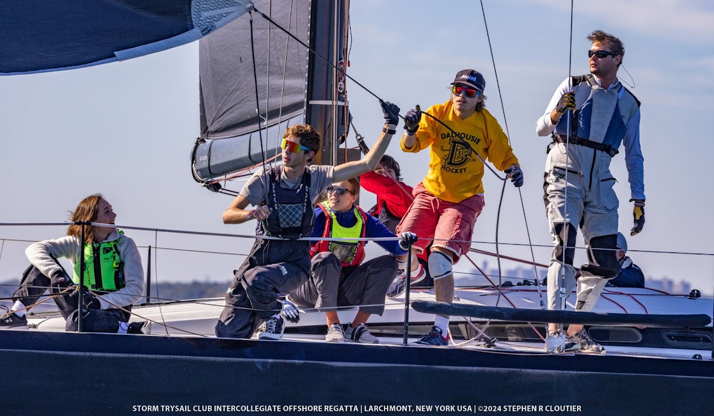

# 

# **Awards**

- - - - X

MUSC Trophy

Nicole Stovell, Laura Hupman, Harrison Bruce, Jack Carlson

Dalhousie Sailing Championship Trophy

Harry and Jack

Dinghy Rookie of the Year

Jonah Fy

Keelboat Rookie of the Year

Ben Margerison

Dinghy Most Valuable Sailor - Female

Nicole and Laura

Dinghy Most Valuable Sailor - Male

Harrison Bruce and Jack Carlson

Most Valuable Keelboat Sailor - Female

Madeline Singer

Most Valuable Keelboat Sailor - Male

Henry McCallum

Most Dedicated Sailor

Oliver Inglis

Most Shredded

Serra Hamilton

Rising star

Morag Matheson

Esprit de Corps

Zoey Pyz

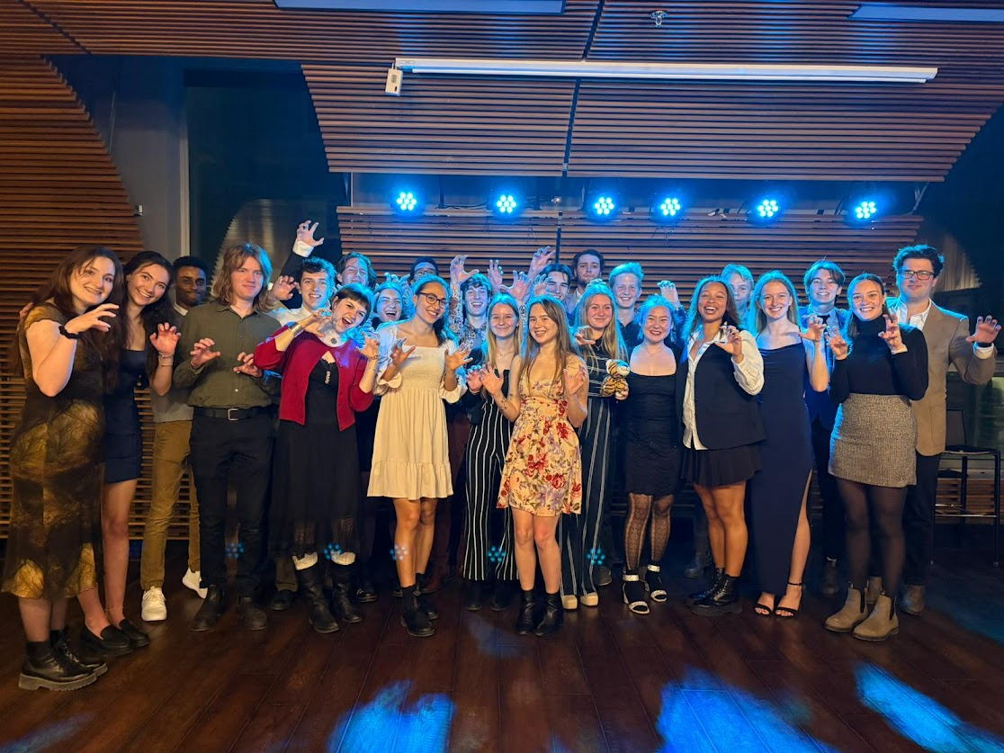

# Our Sponsors and Partners

- - - - X

We would like to thank the generous support of our sponsors, [Teak Life](https://teaklife.com/) and all of our community partners: [The Waegwoltic Club](https://waegwoltic.ca/), [Royal Nova Scotia Yacht Squadron](https://www.rnsys.com/), Under Armour, The Dalhousie Student Union, Sport Nova Scotia, Dalhousie University, Sail Nova Scotia, Sail Canada and Helly Hansen. Without them, the efforts of this team would not be possible.

# 

# 



# 

# How You Can Help

- - - - X

Should you wish to support the Dalhousie Sailing Team you can donate to us! Please contact us at [dalsailing@gmail.com](mailto:dalsailing@gmail.com) to discuss this opportunity further, or provide you with any additional information you may require.

The easiest way to donate is to go to the [Dalhousie Alumni and Online Giving website](https://alumniapps.dal.ca/giving/giving.php). From here you will enter a donation amount, select **SPECIFY** and enter “**Dalhousie Sailing Club**” in the space provided. Continue by filling out your personal information and mailing address so you may receive tax receipts by mail. Please be sure to inform us that you have made your donation so that we can make the most of it.

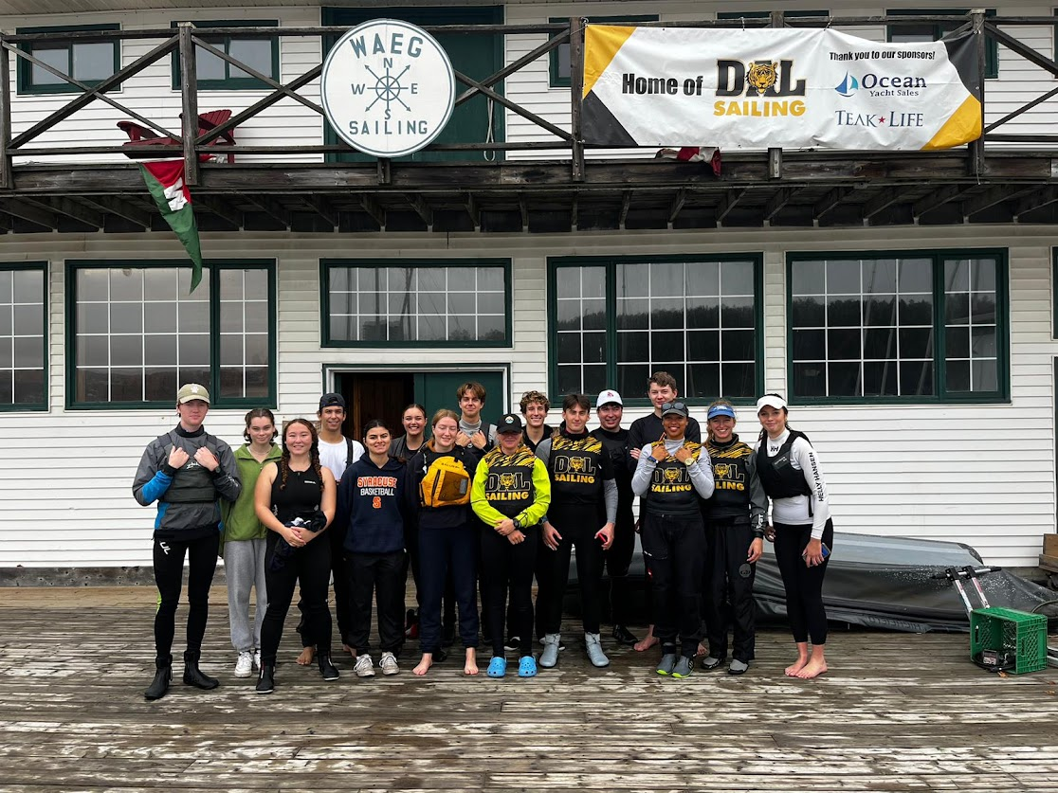<https://alumniapps.dal.ca/giving/giving.php>

All donations made to The Dalhousie Sailing Team are tax deductible! Thank you for your generosity in supporting our program!