Double Up Food Bucks  Frequently Asked Questions: Customers | 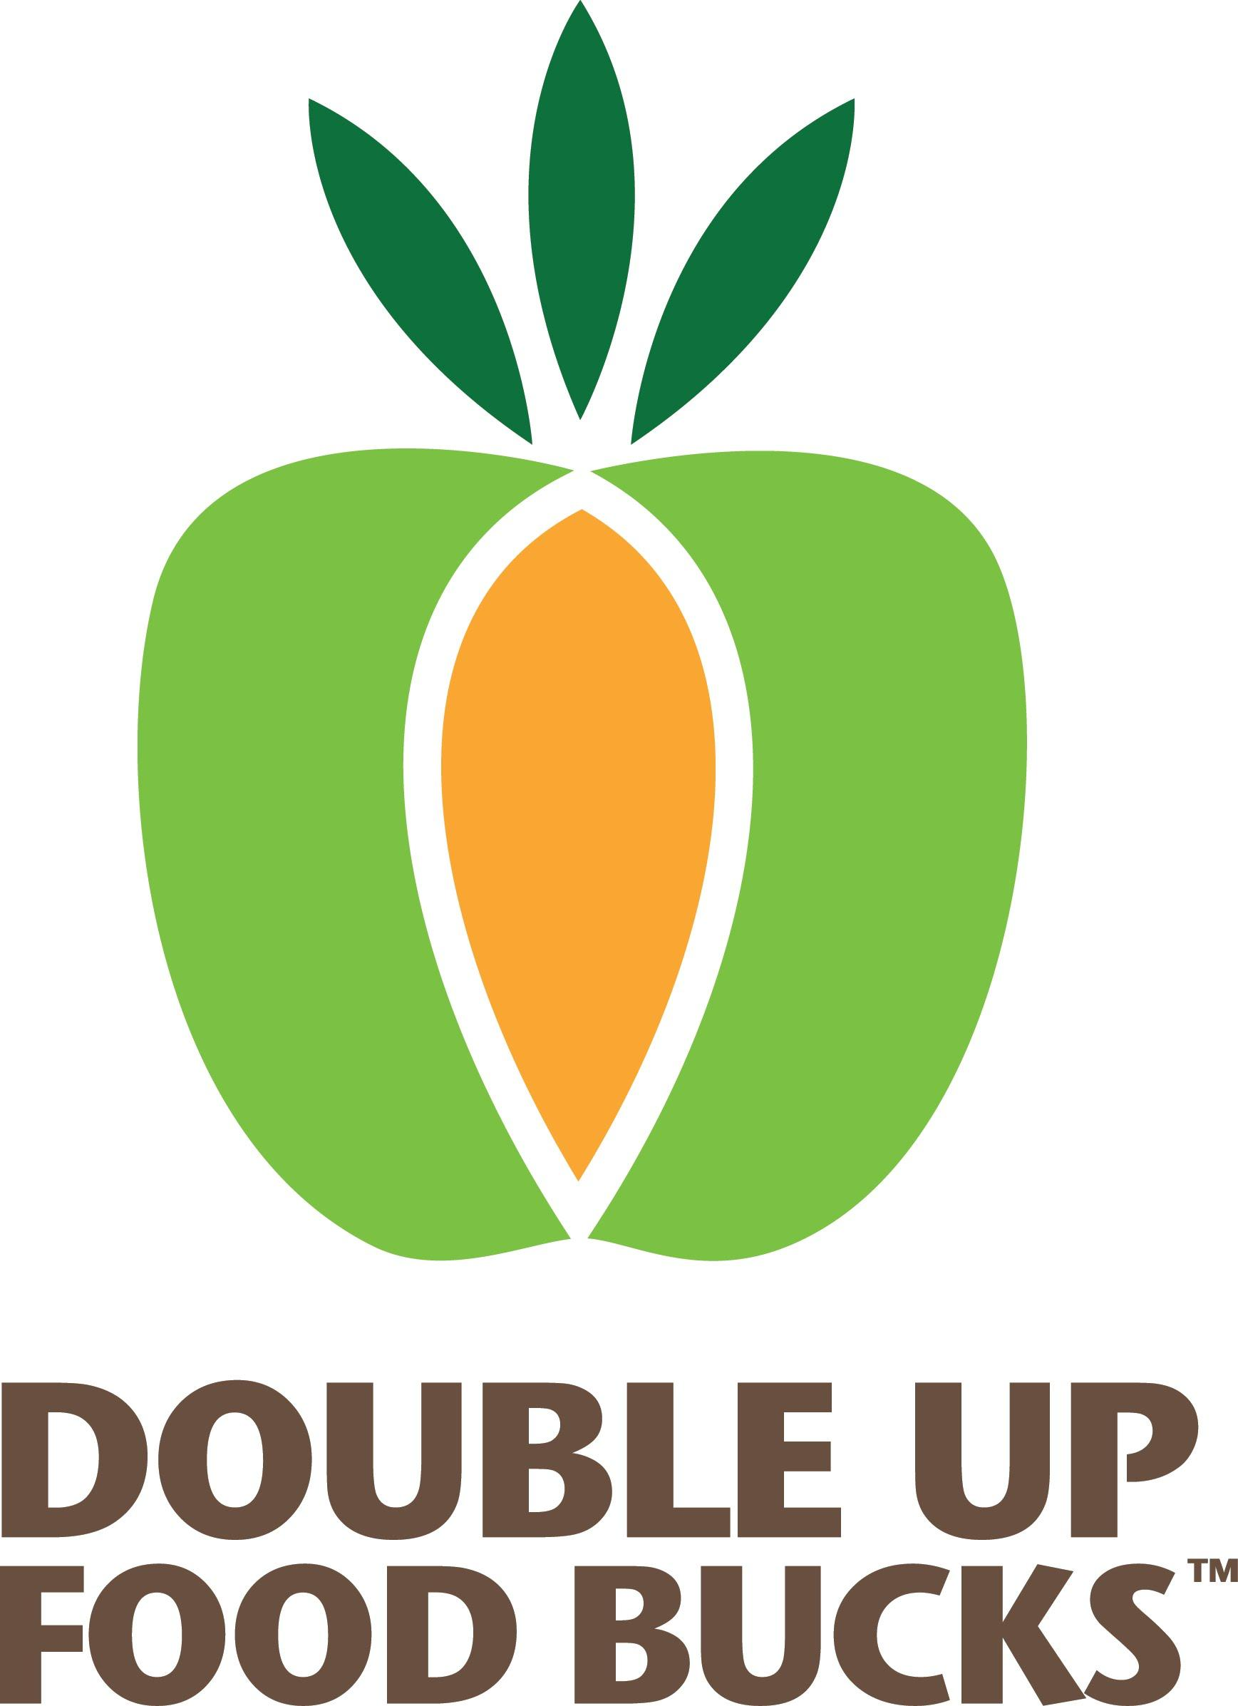  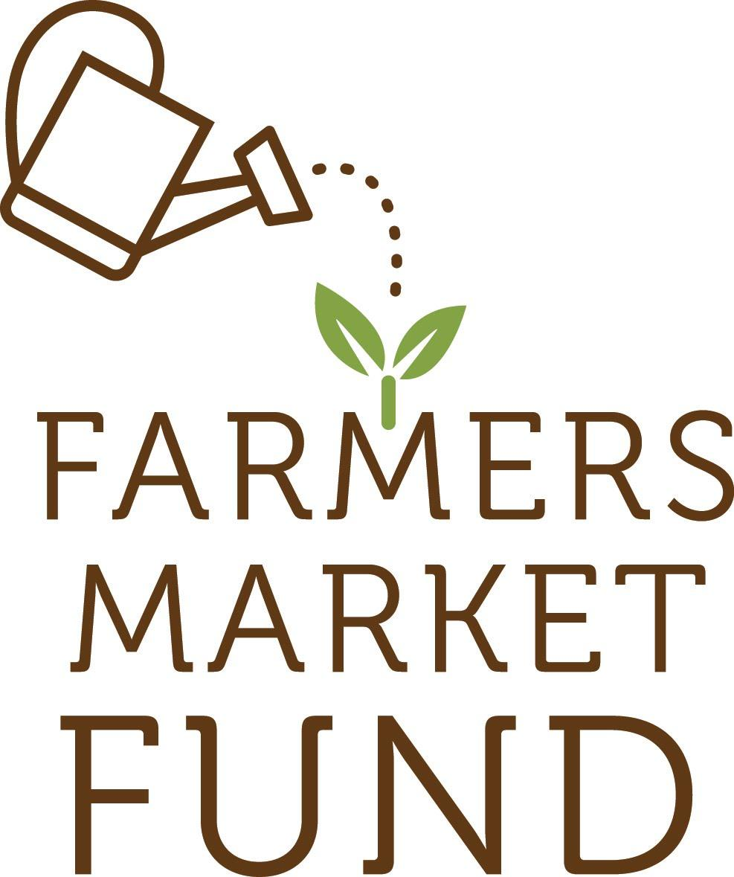

Q: What is Double Up Food Bucks?
A: Double Up Food Bucks (DUFB) is a program that “matches” SNAP benefits spent at participating farmers markets. For every $2 of SNAP benefits you choose to spend, you’ll get a match of up to $10 in DUFB that you can spend on fruits and vegetables. So, if you spend $10 in SNAP benefits, you’ll get an extra $10 – FREE – that you can use to buy more produce.

Q: How do I use my Oregon Trail Card at a farmers market?
Most markets have an Information Booth where a staff person can swipe your Oregon Trail Card. You’ll tell the staff person how much you want to spend in SNAP benefits, and you’ll get that amount of market currency that you spend like cash with the vendors that sell SNAP eligible food items (meat, cheese, eggs, bread, produce, etc.). Each farmers market issues its own unique SNAP currency - these are usually wooden tokens, typically worth $1 each, and are only good at the market where you received them.
Money is deducted from your SNAP balance the day you get the tokens, whether or not you spend the market currency that day. SNAP tokens can be spent any time during the entire market season. Vendors are not allowed to give you change for SNAP tokens.

Q: How do I get Double Up Food Bucks?
When you use your Oregon Trail Card SNAP benefits at a participating market, you’ll automatically get an equal value of DUFB, up to $10. DUFB are the look and size of a playing card, and are worth $2 each for fruits & vegetables.
Since DUFB are $2 each, Make sure you ask for an even number of SNAP benefits so we can give you the full match. If you ask for $5 in SNAP, you’ll only get $4 in DUFB, but if you ask for $6 from your SNAP Card, you’ll get $6 in DUFB.

Q: What can I buy with my Double Up Food Bucks and my SNAP tokens?
A: You can spend your DUFB on fresh, dried, or frozen whole or cut fruits and vegetables without added sugars, fats, oils, or salt. This includes mushrooms, fresh herbs, nuts, dried beans, and edible plant starts (i.e. tomato plants). You can spend your SNAP tokens on any SNAP eligible foods at the market, such as bread, cheese, meat, and produce.

Q: Why can I only buy fruits and vegetables with my DUFB?
A: State funding limits the eligible foods to fruits and vegetables only. In addition to making healthy, locally grown produce more affordable, DUFB also helps local farmers boost their incomes, and that is great for Oregon’s economy. You can still use your SNAP benefits for other fresh food items, like meats, cheeses, and breads from the other market vendors.

Q: Do I have to sign up for something?
A: No, just come to the market and use your Oregon Trail card at the Information Booth. Your personal information will not be recorded.

Q: What if I don’t want to spend all my DUFB today?
A: Keep them and use them next week! DUFB are not refundable because they’re free. Some people like to save up their DUFB for when their favorite fruit and vegetables are in season, and then buy large quantities to can or freeze. New DUFB currency is printed each calendar year, so be sure to use them before they expire December 31.

Q: Why can I only get $10 per market day?
A: DUFB has a limited budget. We want as many people as possible to get the benefit of doubling their fruit and vegetable purchasing power, and the best way to do that is to limit the amount of Food Bucks one person can get per market visit. You can come back every week to this market, and you can visit any other participating market, and you’ll get up to $10 matched at each visit.

Q: Can I use DUFB anywhere else?
A: You can! There are currently 8 markets across Oregon participating in DUFB from January – April 2020, and 40+ additional markets will join in May 2020. Go to www.doubleuporegon.org to find other locations.

Q: What fruits and vegetables can I find at Oregon farmers markets?
A: Depending on the time of year, you’ll often see these fruits and vegetables, and some you have never heard of!

Apples
Apricots
Blackberries
Blueberries
Cherries
Grapes
Melons
Nectarines
Peaches
Pears
Plums
Raspberries
Strawberries
Tomatoes
Asparagus
Beans
Broccoli
Brussel Sprouts
Cabbage
Carrots
Cauliflower
Corn
Cucumber
Eggplant
Garlic
Green Beans
Lettuce
Mushrooms
Onions
Peas
Peppers
Potatoes
Pumpkins
Radishes
Squash

And many more!

Q: Is it really free? Where does the money come from?
A: Yes, it’s really free. Double Up Food Bucks is partially funded by an appropriation from the State of Oregon, and also has support from private and community foundations and partners across Oregon. DUFB is administered by Farmers Market Fund, a Portland-based 501(c)3 nonprofit dedicated to making healthy, locally-grown food accessible to underserved Oregonians. To learn more, visit www.farmersmarketfund.org.

Q : What is SNAP, and how can I get it?
A: SNAP stands for Supplemental Nutrition Assistance Program, and is the new name for the federal food assistance program formerly called Food Stamps. SNAP benefits are issued monthly on the Oregon Trail Card, and can be used to buy eligible foods at most grocery stores and farmers markets.
To learn more about eligibility and how to apply, go to www.oregon.gov/dhs/assistance/food-benefits or dial 2-1-1 on any phone (211info is a toll-free service).

Q : I am practicing social distancing, can I preorder my produce online and pick it up at the market?
A: If your market has online ordering, then yes! Be sure to select only SNAP eligible and DUFB eligible foods when you are putting your order together. When you go to pick up your order, your EBT card will be charged, and the appropriate match amount will be deducted for your fresh fruits, vegetables, legumes, mushrooms, herbs, or plant starts.

Q: Why can’t i pay for my order online?
A: There are a couple of companies that are in a pilot program to process SNAP online, but generally, SNAP cannot be processed online per FNS rules. We hope that in the future we will be able to process your SNAP payments online, but for now, our best option is to have SNAP shoppers pay at pickup.

