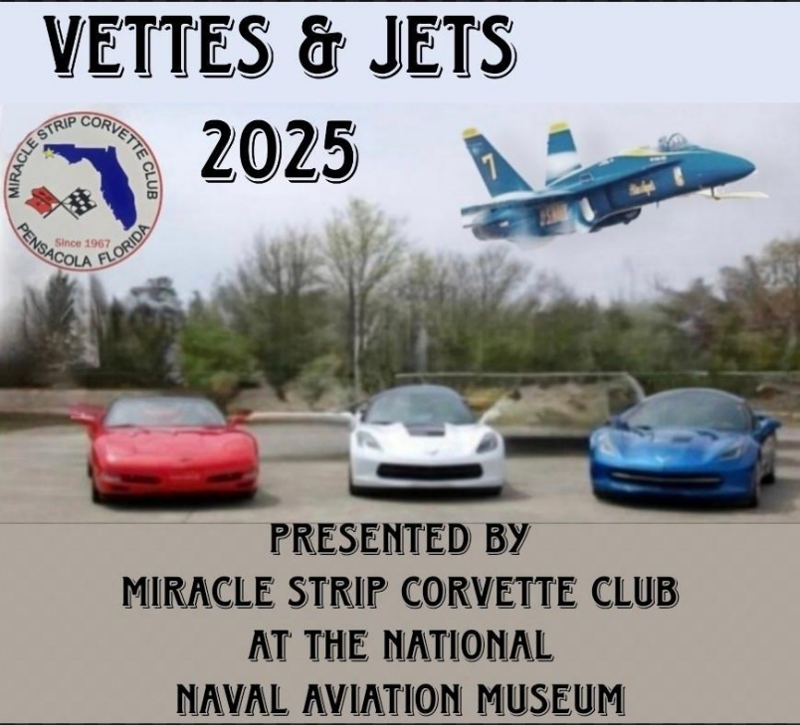

Vettes & Jets 2025 on the Grounds of the National Museum of Naval Aviation
1750 Radford Blvd, NAS Pensacola, FL 32508-5402
Access at “West Gate” off Blue Angel Parkway opens 9:00 AM
Saturday March 22nd, 2025
Registration 9 AM to 11 AM, Participant Votes counted at 1:00 PM
Donation $50.00, First 50 includes a Windshield Cling & T-Shirt
Photo of your Corvette with Blue Angel Display upon entrance to Show.
Best of Show, Farthest Distance Traveled, Top 20. Trophies at 2:30 PM
NO WEAPONS onboard NAS regardless of any permit you may have.
Hosted by: Miracle Strip Corvette Club Point of Contacts:
Gene Palladino gpalladino@msn.com (850) 463-2676
Ernie Martinez erniemar@yahoo.com (850) 723-7468

