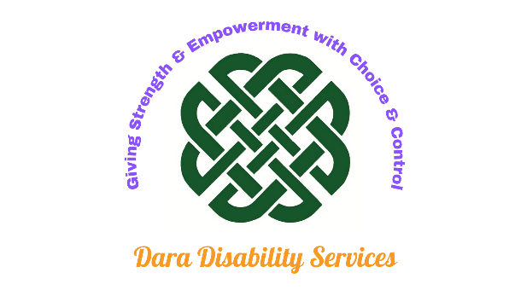
As an individual, you have many rights.

Dara Disability Services Pty Ltd will support and assist you in identifying and exercising these rights to help you to achieve your goals.

Dara Disability Services Pty Ltd adopts a policy of non-discrimination regarding eligibility and entry to our services, and when providing support services to you.

Your Rights

You have the right to:
- access supports that promote, uphold, and respect your legal and human rights
- exercise informed choice and control to maximise independence
- freedom of expression, self-determination and personal decision-making
- access supports that respect your culture, diversity, values and beliefs
- a support service that respects your right to privacy and dignity
- be supported to make informed choices which will maximise independence
- receive supports that are free from violence, abuse, neglect, exploitation or discrimination
- receive supports which are overseen by strong operational management
- receive services which are safeguarded by informed and compliant risk and incident management systems
- receive services from workers who are competent, appropriately qualified and have expertise in providing person-centred supports
- advise consent to the sharing of information between providers during the transition
- opt-out of providing information to government bodies, e.g. NDIS audit.

Your Responsibilities

As an individual receiving our support services, there are a few important things that we ask of you. The information below explains your responsibilities when using our services.
We ask that you:
- respect the rights of staff workers, to ensure their workplace is safe and healthy and free from harassment
- abide by the terms of your agreement with us
- understand that your needs may change, meaning your services may need to change
- accept responsibility for your actions and choices, even though some decisions may involve risk
- tell us if you have problems with the care or service you are receiving from us
- provide us with enough information to develop, deliver and review your support plan
- care for your health and wellbeing as much as you are able
- provide us with information that will help us to meet your needs
- provide us with a minimum of twenty-four (24) hours' notice if you need to cancel your service
- remember that our staff are only authorised to perform the agreed number of hours and tasks outlined in your service agreement
- participate in the safety assessment of your home
- ensure your pets are controlled during service provision
- provide a smoke-free working environment
- pay the agreed amount for the services provided
- tell us in writing (where able) and provide appropriate notice when you want to stop receiving our services
- inform a staff member (when asked) if you wish to opt-out of providing your information to government bodies like the NDIS.

Our Responsibilities

Dara Disability Services Pty Ltd will:
- provide the supports that meet your needs at your preferred times
- regularly review the provision of your supports with you
- communicate openly, honestly and promptly
- treat you with courtesy and respect
- discuss with you all decisions regarding your supports and how they are being provided
- listen to your complaints and feedback and address any problems that may arise
- provide you with twenty-four (24) hours' notice if we need to change a scheduled support provision appointment
- keep your personal information confidential
- implement policies and procedures to ensure your safety and the safety of others during service provision.

NDIS Code of Conduct

Dara Disability Services Pty Ltd employees follow the NDIS Code of Conduct by:
- acting with respect for your rights to freedom of expression, self-determination, and decision-making following relevant laws and conventions
- respecting your privacy
- providing supports and services safely and competently with care and skill, and acting with integrity, honesty, and transparency
- promptly taking steps to raise and act on concerns regarding matters that might have an impact on the quality and safety of supports provided to you
- taking all reasonable steps to prevent and respond to all forms of violence, exploitation, neglect, and abuse towards you
- taking all reasonable steps to prevent sexual misconduct towards you.

