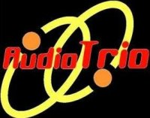 **Audio Trio DJ Service Event Form**

**Event Information**

Guest(s) of Honor name (if applicable): ______________________________________________

Host(s) name: ____________________________________________________________  
  
Event Date: _____________________________________________________________

Event Location: __________________________________________________________

DJ begins playing: ___________________(PM) Until: _____________________(AM/PM)

Which DJ package do you wish to choose (Please Circle): Premium Standard

**Song Requests**

Time has proven that variety is key, and nobody wants a steady diet of anything.

If you like, please use the “Top 10” space below to list the songs you’d most like to hear.

Special Requests:(please list artist/band and title for each)  
  
1  
  
2  
  
3  
  
4  
  
5  
  
6  
  
7  
  
8  
  
9  
  
10

**The following are games to choose for your event**

***Please indicate any games/traditions you would like to have at your event.***

**Trivia: (y/n) time: ___________________**

Everyone attending the event will be put into teams. Each team will come up with their own team names and go through 8 rounds of questions. A 1st place and consolation will be recognized. It is recommended that the event planner bring a 1st place prize and a consolation prize for “runner-up”.

**Back-to-back (y/n) time:_____________________**

Have people dance as singles on the dance floor. When the music stops, everyone finds a partner and interlocks their arms back-to-back. The last two people to form a pair are out. The music will start and stop the music until one remaining pair is on the dance floor.

**Chicken Dance with Unsuspecting Dance Partners (y/n) time: __________________**

Count the number of tables at the party. Place a number under a chair at each table. Make sure that each number has a duplicate number at another table (example two #1's, two #2's....). Have the DJ announce to look under the chairs for a number and call the number holders to the dance floor. Pair off the people with the matching numbers and have them dance the chicken dance with their unsuspecting dance partners !!!

**Additional game ideas**:

If you have any other special instructions, please list them here or attach another sheet:  
________________________________________________________________________________________________________________________________________________________________________________________________________________________________________________________________________________________________________________________________________________

**Please indicate by circling the types of music you prefer for your event:**

Dinner:

Classical: (Yes/No)  
Light Jazz: (Yes/No)  
Easy Listening: (Yes/No)

After Dinner:

Adult Favorites

Seasonal or other fitting theme:  
Please Circle the genres you want to be played most often

Please cross out those you Do Not want to be played at all

Note: Those that are not crossed off or circled might or might not be played

70’s Disco  
Country  
Classic Rock  
R & B / Motown / Soul  
50’s & 60’s & 70's

80's & 90's Retro  
Big Band and Swing

Theme Dances (Polkas, waltzes, twists, two steps etc)  
Alternative Rock  
Standards (Sinatra, etc)

Contemporary Christian

Reggae and Caribbean

Top 40 Current Radio hits  
Club & Techno/House

Rap & Hip Hop:

***Pl***

Please specify any songs you definitely *DO NOT WANT PLAYED* below.

**------You’re Finished! Do the happy dance ☺ -----**

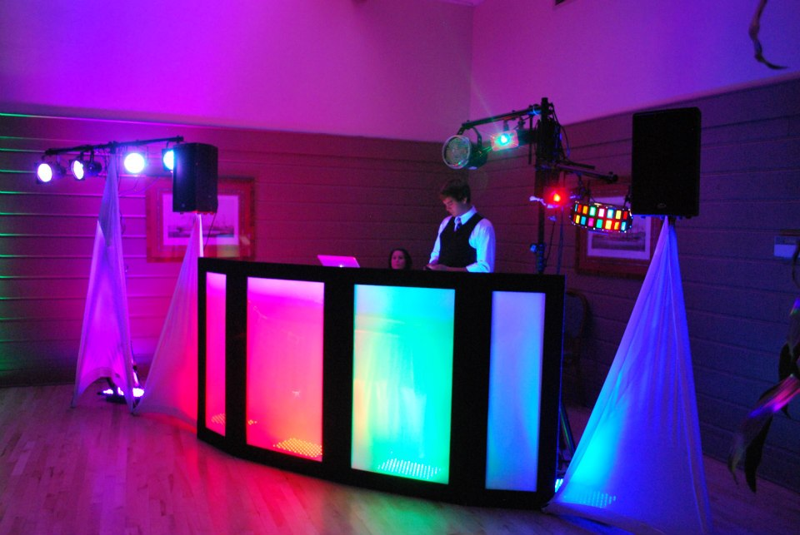

**Premium Package**

* $160 Per hour
* No setup or takedown charges
* No travel charges within the Milwaukee/Madison area
* 4-6 uplights
* Use of latest in DJ mixing technology (Numark Mixtrack 3 w/ Serato DJ)
* Dj Stand and Curtains to hide cords and create a chic presentation
* 2 high quality speakers
* Microphone/MC
* Choose between 4 LED Par Cans or Disco Ball **(circle desired option)**
* 4 “club-style” dancing lights (lights that move to the music)

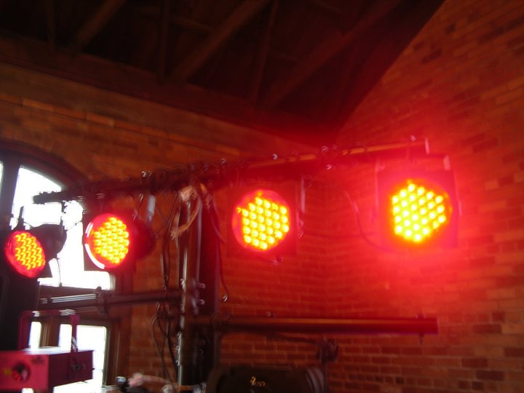

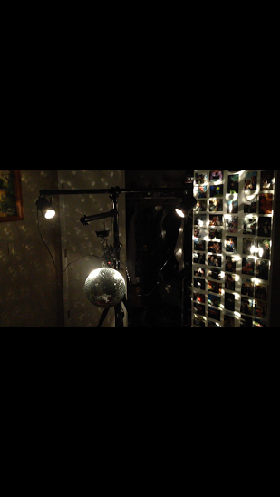

**4 Led Par Cans Disco Ball**

**Standard Package**

* $130 per hour
* No setup/takedown charges
* No travel charges between Milwaukee/Madison
* 2 Professional DJ Speakers
* Microphone/ MC
* 4 “club-style” dancing lights (lights that move to the music)

