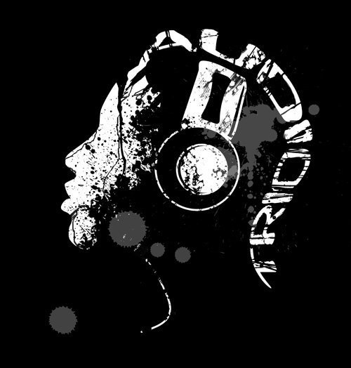
Audio Trio DJ Service Event Form

Event Information
Guest(s) of Honor name (if applicable): ______________________________________________

Host(s) name: ____________________________________________________________
Event Date: _____________________________________________________________

Event Location: __________________________________________________________

DJ begins playing: ___________________(PM) Until: _____________________(AM/PM)

Special Instructions (i.e. game ideas etc.): _________________________________________________

Any announcements needed: ________________________________________________

Song Requests

Time has proven that variety is key, and nobody wants a steady diet of anything.

If you like, please use the “Top 10” space below to list the songs you’d most like to hear.

Special Requests:(please list artist/band and title for each)
1
2
3
4
5
6
7
8
9
10
Please indicate by circling the types of music you prefer for your event:
Dinner:
Classical: (Yes/No)
Light Jazz: (Yes/No)
Easy Listening: (Yes/No)

After Dinner:

Adult Favorites
Seasonal or other fitting theme:
Please Circle the genres you want to be played most often
Please cross out those you Do Not want to be played at all
Note: Those that are not crossed off or circled might or might not be played
70’s Disco
Country
Classic Rock
R & B / Motown / Soul
50’s & 60’s & 70's
80's & 90's Retro
Big Band and Swing
Theme Dances (Polkas, waltzes, twists, two steps etc)
Alternative Rock
Standards (Sinatra, etc)
Contemporary Christian
Reggae and Caribbean
Top 40 Current Radio hits
Club & Techno/House
Rap & Hip Hop:

Pl

Please specify any songs you definitely DO NOT WANT PLAYED below.

------You’re Finished! Do the happy dance -----

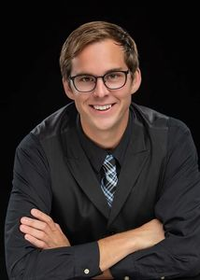
Audio Trios DJs

DJ Fitz, 14 Years

My favorite song to play is the Cupid Shuffle. It ALWAYS gets
people on the dance floor!
It is so exciting to see everyone in good spirits and together
to celebrate their special event!
If you hire me, I will ensure your event is extra special!

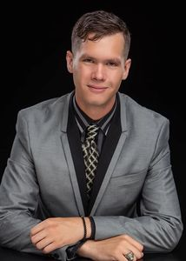
DJ Mitchell, 9 Years
Favorite Song to DJ to is Shout by the Isley Brothers!
I Dj because I get to be the life of the party even though it’s not my party. I love to understand what makes the energy of a group go through the roof! Celebrating with all different walks of life shows me how much fun and connection we can have through music. Plus, I LOVE to dance, so the closer to the music I can get; the better.
Hiring me will provide the ultimate custom show to your liking. I make it my mission to ensure total satisfaction of each guest and participant of your event. You can be sure that your entertainment will be fully prepared with all of your favorite selections, and ready to fit any needs at the press of a button!

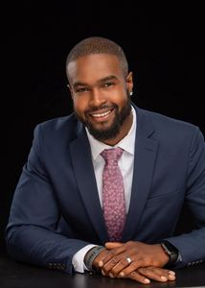
DJ Keith, 15 Years
My favorite song to play is Piano Man for the last song of the night.
I like to facilitate people having a great time and I’m a servant at heart
so I enjoy catering to newlyweds needs and helping ease the stress
of the night.
I think someone would hire me because of my personality I’m laid back,
organized and have no problems taking control or being led by a
wedding planner.

