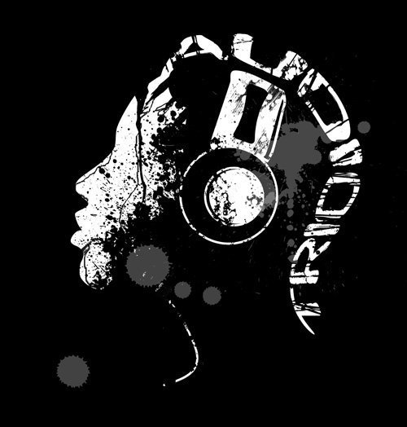

Audio Trio DJ Service Wedding Form

Would you like:
15 seconds of one song to be played for each set of persons announced during the wedding party: (y/n)
- If yes, place a song request next to each set of individuals being announced.

If no, you may have one song to be played during the whole Wedding party announcement (y/n)
-If yes, which song would you like played (ex: I Gotta Feeling Black Eyed Peas) Song to play (if applicable):________________________

Please complete the following information for the introduction of the wedding party...

The first bolded sets of individuals are completely optional for your wedding party. Please place a star* next to individuals from the bolded list that you would like announced during the wedding party (it is not required or necessary to have the grandparents or parents announced during the grand march)

Grandparents of the Bride: _______________________ and ______________________________
2nd set of Grandparents of the Bride (if applicable) : ___________________________ and ______________________________
Grandparents of the Groom: ______________________ and ______________________________
2nd set of Grandparents of the Groom (if applicable) : ___________________________ and ______________________________
Parents of the Bride: ____________________________ and ______________________________
2nd set of Parents of the Bride (if applicable) : ___________________________ and ______________________________
Parents of the Groom: ___________________________ and ______________________________
2nd set of Parents of the Groom (if applicable) : ___________________________ and ______________________________
Flower Girl: ____________________________________
Ring Bearer: ___________________________________
(1)Bridesmaid: ____________________________________ song (if applicable): ________________
Escorted by Groomsmen: ______________________________
(2)Bridesmaid: ____________________________________ song (if applicable): ________________
Escorted by Groomsmen: ______________________________
(3)Bridesmaid: ____________________________________ song (if applicable):________________
Escorted by Groomsmen: ______________________________
(4)Bridesmaid: ____________________________________ song (if applicable): ________________
Escorted by Groomsmen: ______________________________
(5)Bridesmaid: ____________________________________ song (if applicable): ________________
Escorted by Groomsmen: ______________________________

(6)Bridesmaid: ____________________________________ song (if applicable): ________________
Escorted by Groomsmen: ______________________________
(7)Bridesmaid: ____________________________________ song (if applicable): ________________
Escorted by Groomsmen: ______________________________
(8)Bridesmaid: ____________________________________ song (if applicable): ________________
Escorted by Groomsmen: ______________________________
Maid of Honor: __________________________________ song (if applicable): ________________
Escorted by Best Man: ____________________________
Ladies and Gentlemen, Please rise and welcome for their first public appearance as husband and wife,

Mr.______________________ and Mrs.____________________________
song (if applicable): _______________________

Bride and Groom head to cake table and cut the cake directly after wedding march (y/n)

Please indicate the traditions that you wish to celebrate:
Note* An estimated time for each tradition is fine. Need help coming up with the perfect song for each tradition? Check out the websites suggested for help!

Grand march: (y/n)
If yes, (before dinner/after dinner) time: ________________
Blessing by: (y/n) ___________________________________What time: ________________
First Dance: (y/n) Song:__________________________ What time: ________________
Cutting of the Cake: (y/n) _____________________________ What time: ________________
Toast by best man or other: (y/n) _______________________ What time: ________________
Bride’s Dance with Father: (y/n) Song:___________________ What time: ________________
Tossing of the Bouquet: (y/n) Song:_____________________ What time: ________________
Groom’s Dance with Mother: (y/n) Song:__________________ What time: ________________
Tossing of the Garter: (y/n) Song:_______________________ What time: _______________

Will you be using Audio Trio DJ Service for your ceremony (yes/no)

If yes,

What time will you need us to start playing music for the ceremony: ___________

Will the ceremony be held in a different room from the ceremony (yes/no)
Note: If yes, please note, we will need 20-30 minutes to move the speakers to the reception room

What songs would you like played before the procession?
____________________________________________________________________________________
________________________________________________________________________________________________________________________________________________________________________

What song would you like for the bridal party procession? ____________________________________
What song would you like for the bride procession? _________________________________________

Are there any songs you would like during the ceremony?
___________________________________________________________________________________

What song would you like for the recessional? _________________________________________

The following are common traditions/games played at weddings.
Please indicate any games/traditions you would like to have at your wedding.

Married Couple dance: (y/n) song: _____________________ time: ___________________

All married couples are invited on the dance floor. Couples are released from the dance floor based on how long they have been married for. The dancing continues until the longest married couple is the last couple remaining.
Song suggestions: http://www.weddingwire.com/wedding-forums/longest-married-couple-dance-suggestion-please/fafbe8297bb9cc26.html
Dollar dance: (y/n) song: ___________________ time: ________________________

The dollar dance is an opportunity for guests to dance with the bride and/or groom. Money raised from this dance go to the bride/groom. The maid of honor and best man are in charge of holding a pitcher in efforts to collect money from individuals who would like to dance with the bride or groom. The dollar dance is a great way for guests to congratulate the bride/groom and share memories.
Song suggestions: http://lmdjs.com/top-25-dollar-dance-songs/
The shoe game: (y/n) time: ________________
The shoe game is a game for the bride and groom. The bride and groom sit back-to-back holding one of their shoes in one hand and the others shoe in the other hand. A series of questions are asked such as “who will be in charge of the tv remote”. The bride and groom will raise a shoe in the air representing who they think the answer belongs to not being able to see each others responses. To get a better understanding of this game, check out the Youtube video:
http://www.youtube.com/watch?v=SkFJ0E83IfA&feature=fvwrel
Back-to-back (y/n)
Have people dance as singles on the dance floor. When the music stops, everyone finds a partner and interlocks their arms back-to-back. The last two people to form a pair are out. The music will start and stop the music until one remaining pair is on the dance floor.
Chicken Dance with Unsuspecting Dance Partners (y/n) time: __________________
Count the number of tables at the reception. Place a number under a chair at each table. Make sure that each number has a duplicate number at another table (example two #1's, two #2's....). Have the DJ announce to look under the chairs for a number and call the number holders to the dance floor. Pair off the people with the matching numbers and have them dance the chicken dance with their unsuspecting dance partners !!!

Additional wedding game ideas: http://blog.myweddingisover.com/top-ten/10-wedding-reception-activities-to-break-the-ice/

If you have any other special instructions, please list them here or attach another sheet:
____________________________________________________________________________________________________________________________________________________________________________________________________________________________________________________________
Special Dances
First Dance as a married couple can be before or after dinner. Please specify here. (Before/After)
Artist/Band: __________________________________________________________________________
Title: _______________________________________________________________________________
*Would you like us to invite the bridal party on the floor half way through the song? (Y/N)
Bride’s Dance With Father (y/n):
Artist/Band: __________________________________________________________________________
Title: _______________________________________________________________________________
*Would you like us to invite couples on the floor half way through the song? (Y/N)
Groom’s Dance With Mother (y/n):
Artist/Band: __________________________________________________________________________
Title: _______________________________________________________________________________
*Would you like us to invite couples on the floor half way through the song? (Y/N)
All of our systems carry a wide selection of music that ranges from the earliest 1906 recordings to today’s latest releases. We do not carry entire albums or discs, but the proven chart hit singles that everyone knows and is one of the widest, largest most up to date libraries in the area. Your professionally trained Disc Jockey will “read” the crowd and play the appropriate music to keep you and your guests entertained.

Please keep in mind that even though this is your day, that your elders (and elderly) may not have your
same musical taste, not to mention whoever may be footing the bill for it. Our operators are trained to keep a balance, and these may not be played "back to back", but instead, spread thru the evening to where it best suits the crowd overall. The idea is to make it a memorable, pleasant, entertaining time for all.

Rule of thumb is we can usually fit around ten songs per hour and will work yours in as they fit. So for most newer music in a five hour reception you will hear around 50 songs total for the event. Around 70 if playing older music. Less than that for Disco and Techno and Classic Rock.

Song Requests

Time has proven that variety is key, and nobody wants a steady diet of anything.

If you like, please use the “Top 10” space below to list the songs you’d most like to hear.

Special Requests:(please list artist/band and title for each)
1
2
3
4
5
6
7
8
9
10
Ceremony Section

Will you be using Audio Trio DJ Service for your ceremony (yes/no)

If yes,

What time will you need us to start playing music for the ceremony: ___________

Will the ceremony be held in a different room from the ceremony (yes/no)
Note: If yes, please note, we will need 20-30 minutes to move the speakers to the reception room

What songs would you like played before the procession?
____________________________________________________________________________________
________________________________________________________________________________________________________________________________________________________________________

What song would you like for the bridal party procession? ____________________________________
What song would you like for the bride procession? _________________________________________

Are there any songs you would like during the ceremony?
___________________________________________________________________________________

What song would you like for the recessional? ________________________________________
Please indicate by circling the types of music you prefer for your reception

Before and during Dinner:
Classical: (Before/During/Both)
Light Jazz: (Before/During/Both)
Easy Listening: (Before/During/Both)

Adult Favorites
Seasonal or other fitting theme:
Please Circle the genres you want to be played most often
Please cross out those you Do Not want to be played at all
Note: Those that are not crossed off or circled might or might not be played
70’s Disco
Country
Classic Rock
R & B / Motown / Soul
50’s & 60’s & 70's
80's & 90's Retro
Big Band and Swing
Theme Dances (Polkas, waltzes, twists, two steps etc)
Alternative Rock
Standards (Sinatra, etc)
Contemporary Christian
Reggae and Caribbean
Top 40 Current Radio hits
Club & Techno/House
Rap & Hip Hop:

Pl

Please specify any songs you definitely DO NOT WANT PLAYED below.

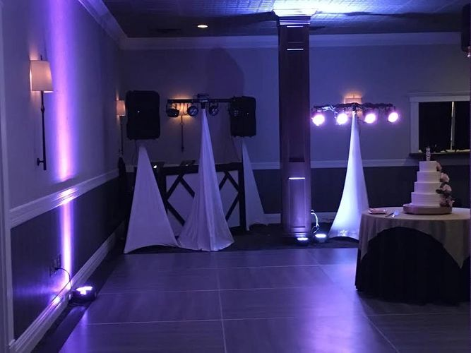

Premium Package
- $150 Per hour
- No setup or takedown charges
- No travel charges within the Milwaukee/Madison area
- 2-3 uplights at DJ booth with option to add more around the venue
- Smooth transitions between songs to create a smooth flowing night
- Dj Stand and Curtains to hide cords and create a chic presentation
- 2 high quality speakers
- Microphone/MC
- Choose between 4 LED Par Cans
- 4 “club-style” dancing lights (lights that move to the music)
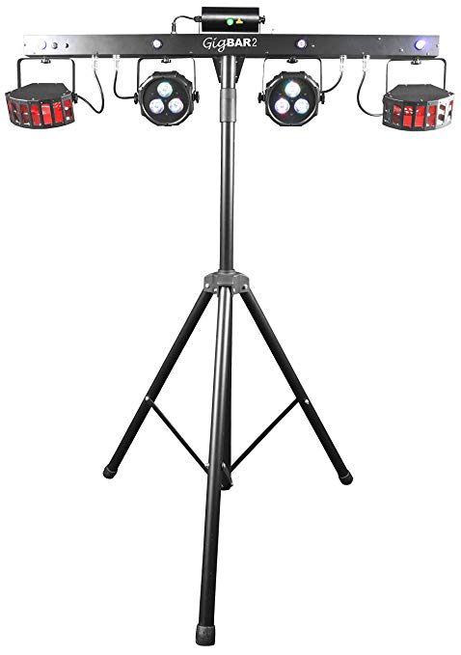
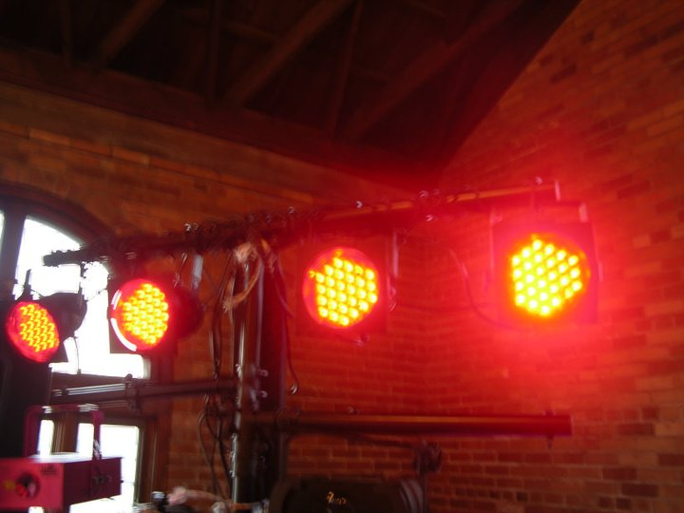

4 Led Par Cans
Standard Package

- $125 per hour
- No setup/takedown charges
- No travel charges between Milwaukee/Madison
- 2 Professional DJ Speakers
- Microphone/ MC
- 4 “club-style” dancing lights (lights that move to the music)
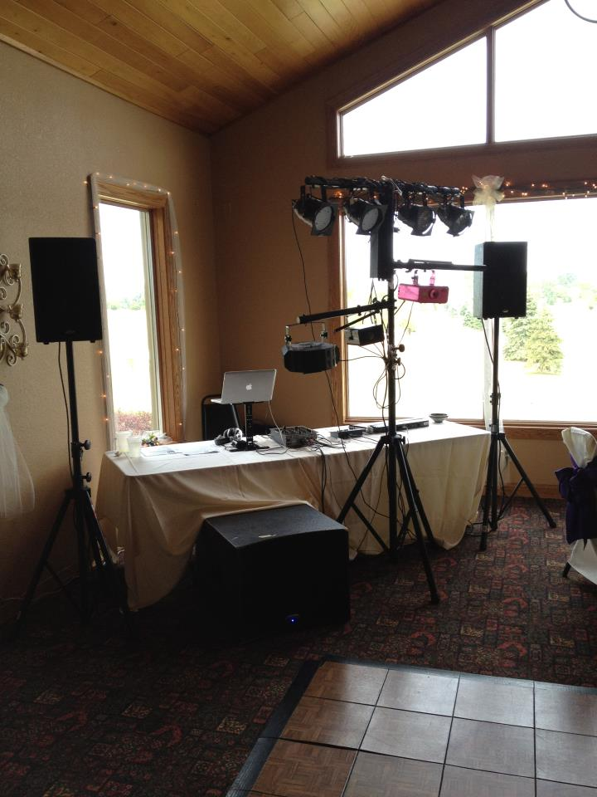

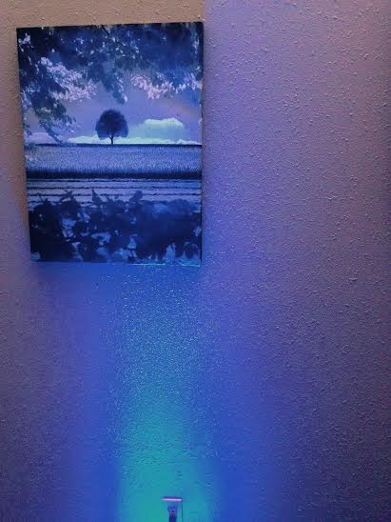
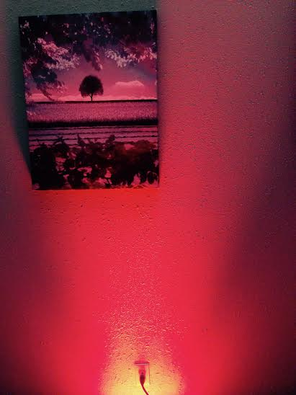
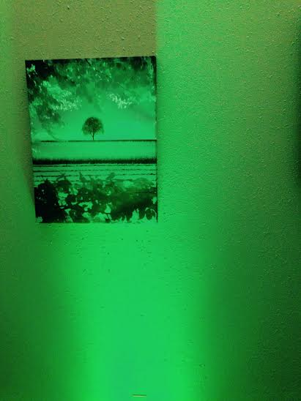
Uplight Color Options for room lighting
Red Green Blue

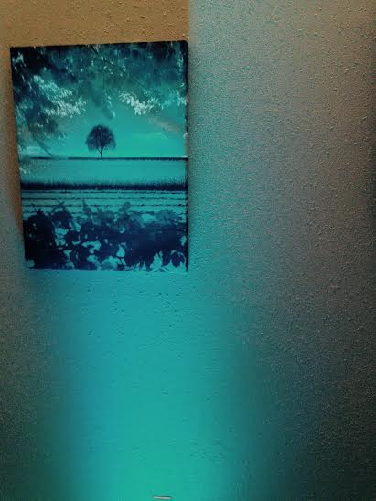
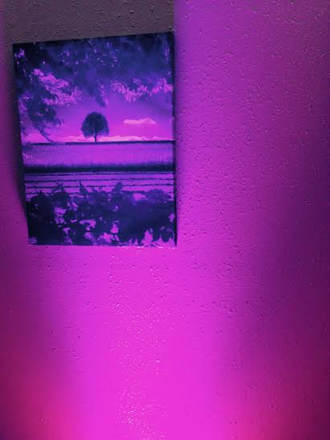
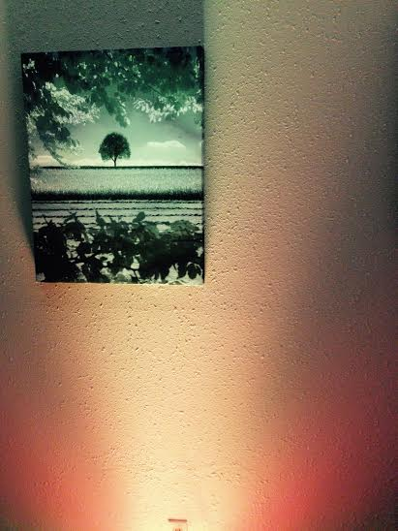

Yellow Magenta Cyan
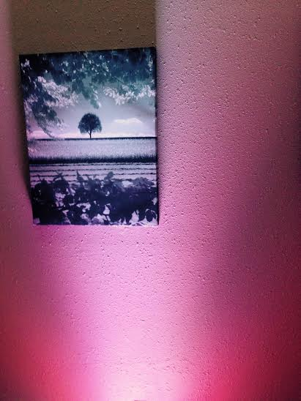

White
Wedding Information
Bride’s maiden name: _______________________________________________________

Groom’s name: ____________________________________________________________
Wedding Date: _____________________________________________________________

Reception Location: __________________________________________________________

DJ begins playing: ___________________(PM) Until: _____________________(AM/PM)

Which DJ package do you wish to choose (Please Circle): Premium Standard

____________________________________________________________________________________

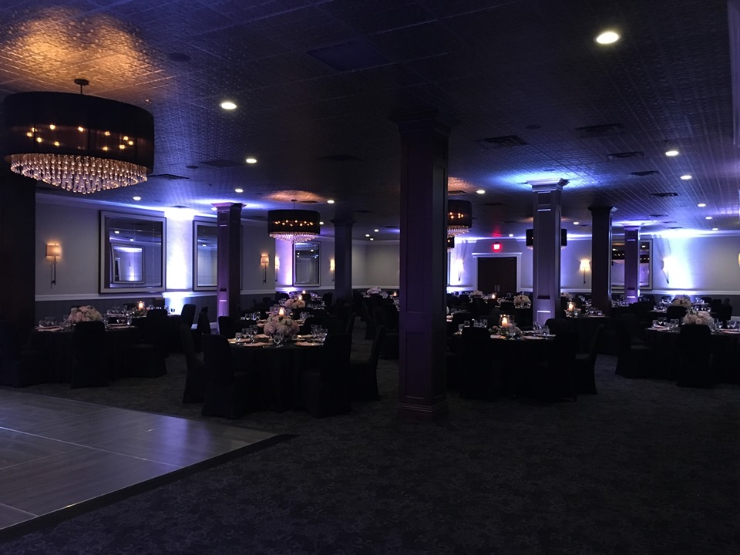
Room Lighting

Would you like Audio Trio to provide room lighting (y/n)
If yes, the lighting package is $15/light as a separate package.
How many lights would you like setup throughout the venue ( 15 20 30 )
What color would you like the lights to be set at?
Circle response ( red green blue yellow magenta cyan white )

------You’re Finished! Do the happy dance -----

