[MARKET TRENDS](https://www.propertyobserver.com.au/forward-planning/investment-strategy/market-trends.html)

Terry Ryder is the founder of hotspotting.com.au.

[**TERRY RYDER**](https://www.propertyobserver.com.au/terry-ryder.html)



31 JULY 2018

**The top 10 LGAs in Australia for property growth markets: Hotspotting's Terry Ryder**

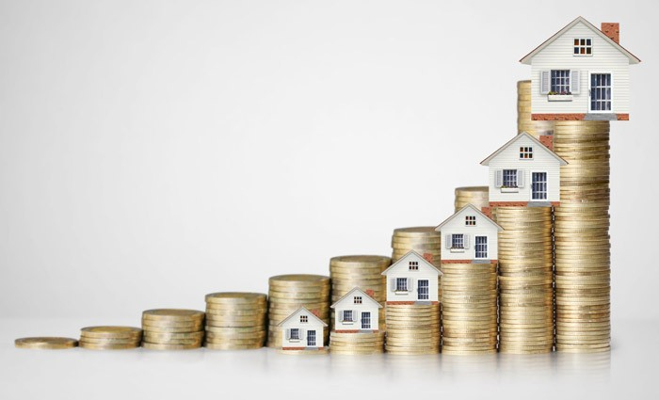

EXPERT OBSERVATION

The leading growth markets in Australia are now occurring in places you might not expect. With the end to the up-cycles in Sydney and Melbourne, the growth stories are now focusing on our smaller capital cities and the larger regional ones.

In Hotspotting’s quarterly surveys of sales activity for the Price Predictor Index, one of main focus points is finding clusters of suburbs where there’s growth momentum. Rather than highlight individual suburbs, we identify Local Government Areas where there are multiple growth suburbs.

In the winter survey, we have identified the Top 10 LGAs in the nation, in terms of the number of upwardly-mobile suburbs.

Municipalities in Melbourne and Sydney previously dominated these lists, but no more. It’s now about Adelaide, Perth, Brisbane, Canberra and some of the more notable regional cities.

Here’s our new National Top 10, (in alphabetical order):

* **BALLARAT, VIC**

The regional city of Ballarat has become the strongest market in Victoria, having overtaken the City of Greater Geelong which has led the state on busy sales activity for the past year or so. Ballarat is attracting large numbers of buyers out of Melbourne, drawn by its affordability and better rental yields compared to the capital city. Ballarat also appeals for its growth potential, driven by the strength and diversity of the local economy. Our winter survey has identified nine suburbs with rising sales activity and this is starting to translate into strong price growth.

* **BELCONNEN, ACT**

Canberra’s market is steadily rising and, as we have often observed, the strongest market activity in the national capital is happening in the northern suburbs, headed by the Districts of Belconnen and Gungahlin. Belconnen has seven suburbs with growing sales activity and is the market leader in a city characterised by low vacancies, strong rental growth and solid potential for prices to rise in 2018-19. Growth markets include Bruce, Florey, Flynn, Holt and Macgregor.

* **BENDIGO, VIC**

We’ve noted the rise of Ballarat in previous quarterly surveys, but the surge in Bendigo has emerged only recently. Like Ballarat, the city of Bendigo is rising because of its own inherent strengths and also because of its strong links to Melbourne. It has eight rising suburbs, including Kangaroo Flat where quarterly sales have been 52, 58, 64, 64, 68 and 71, while North Bendigo sales have been 14, 20, 25, 29 and 38. The median house price for both suburbs is $310,000, emphasising the city’s affordability.

* **GEELONG, VIC**

The City of Greater Geelong is no longer the market leader in Victoria but it remains strong. The Geelong LGA has seven growth suburbs, more than any of the Melbourne LGAs, but down on the levels we identified in previous surveys. There’s evidence that it may have passed its peak, as there are now more plateau and consistency markets than rising markets. The Geelong market continues to appeal as a cheaper alternative to Melbourne but may lose some gloss as 2018 progresses.

* **MARION, SA**

The City of Marion continues to be one of the leaders in the promising Adelaide market. This middle-market area in the south-west of Adelaide now has six suburbs with Rising Steadily markets, down on the nine we identified six months ago, but nevertheless a very steady market which is characterised by its value-for-money appeal and proximity to key infrastructure. This includes the Flinders university-medical precinct.

* **MELVILLE, WA**

One of the leaders of Perth’s fightback is the Melville LGA in the southern suburbs, with seven growth markets. Attadale, Bicton, Booragoon, Kardinya, Melville and Palmyra now have rising sales activity, while six other suburbs are consistent performers. Bicton sales have been 26, 31, 29, 44, 45, 54 and 60 in the past seven quarters and its median house price has risen 23% to $1.08 million in the past 12 months. Other locations have shown more moderate growth, such as Attadale which has risen 5% to $1.15 million.

* **MORETON BAY REGION, QLD**

Six months ago, Moreton Bay Region was the No.1 LGA in Australia for growth markets. It no longer has that title, but remains one of the nation’s leaders. Moreton Bay LGA, in Brisbane’s far north, has maintained its position as the No.1 market in the Greater Brisbane area but with a smaller number of growth markets. There are now eight Rising Steadily suburbs (down from 14 in our Spring 2017 survey). Growth locations include Bellara, Bellmere, Burpengary, Burpengary East, Caboolture, Caboolture South, Eatons Hill and Kippa-Ring, with affordability and solid infrastructure among the drivers of growth.

* **PORT ADELAIDE ENFIELD, SA**

The Port Adelaide Enfield LGA has emerged in 2018 as a market leader in the South Australian capital. Our latest survey reveals seven suburbs with growing sales activity. Upwardly-mobile markets in this LGA include Blair Athol, Broadview, Clearview, Greenacres, Hillcrest and Semaphore. This precinct is characterised by a number of smallish suburbs where turnover is steadily rising. The Port Adelaide sector is likely to attract growing interest as the massive long-term project to build vessels for the Navy unfolds.

* **ONKAPARINGA, SA**

The Onkaparinga LGA in Adelaide’s south is a regular feature in our reports, offering a mix of lifestyle and new growth suburbs, with improved transport links to central Adelaide. Rising suburbs include Woodcroft (median $395,000) where quarterly sales have been 40, 42, 47 and 55 in the past year. Other growth markets here include Aberfoyle Park, Noarlunga Downs, Old Reynella, Seaford and Seaford Rise. Most of these locations have median house prices in the $300,000s, emphasising that affordable dwellings amid an area with appealing lifestyle features is a core driver of growth.

* **STIRLING, WA**

The middle-market Stirling LGA in Perth is now the No.1 municipality in the nation for growth markets. I have often commented that the municipality of Stirling has stood out for “sterling performance” in the face of the Perth downturn - and its status has grown. Ten of its suburbs have Rising Steadily markets. Sales in the suburb of Innaloo (median house price $560,000) have been 61, 66, 73, 72, 78, 97, 83, 98 and 102 over the past two years.

***TERRY RYDER****is the founder of hotspotting.com.au*