
Leopard Print Blazer –- 100% Polyester
Machine Washable.
Ironing/steaming if required, use cool heat from inside out. Do not Tumble Dry.
Sizes S, M, L, XL, XXL, XXXL.
LC823BL – WS $149 RRP $372.50
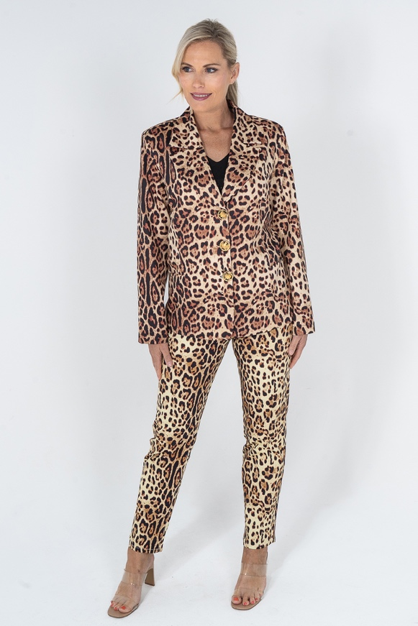
Leopard Print Jean - Poly Cotton Elastin
Machine Washable.
Ironing/steaming if required, use cool heat from inside out. Do not Tumble Dry.
Sizes S, M, L, XL, XXL, XXXL.
LC810PJL – WS $79 RRP $198
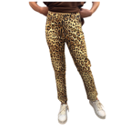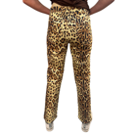
Safari Blazer –- 100% Polyester
Machine Washable.
Ironing/steaming if required, use cool heat from inside out. Do not Tumble Dry.
Sizes S, M, L, XL, XXL, XXXL.
LC823BS – WS $149 RRP $372.50
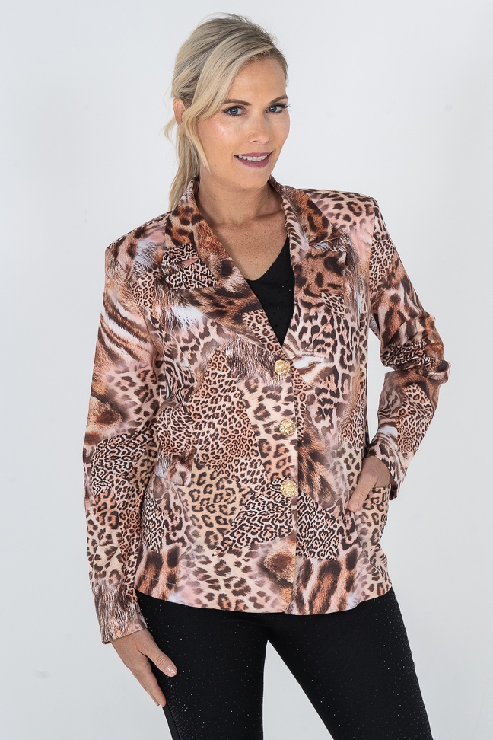

LOVE Print Blazer – 100% Polyester
Machine Washable.
Ironing/steaming if required, use cool heat from inside out. Do not Tumble Dry.
Sizes S, M, L, XL, XXL, XXXL.
LC823BLV – WS $149 RRP $372.50
LOVE Print Jean – Polyester Cotton
Machine Washable.
Ironing/steaming if required, use cool heat from inside out. Do not Tumble Dry.
Sizes S, M, L, XL, XXL, XXXL.
LC810PJLV – WS $79 RRP $198

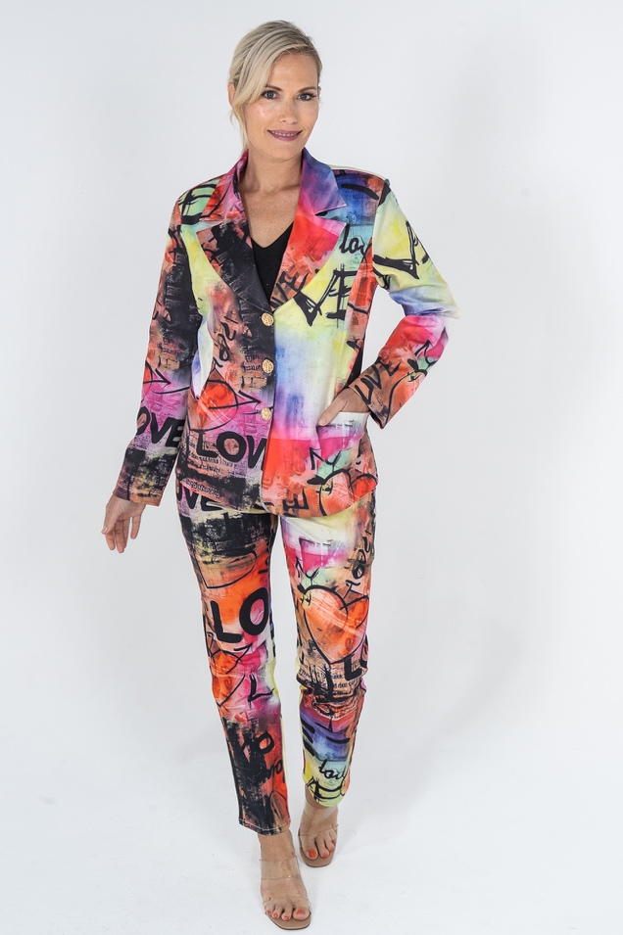

Nautical Print jacket –- Jacket 100% Polyester
Machine Washable.
Ironing/steaming if required, use cool heat from inside out. Do not Tumble Dry.
Sizes S, M, L, XL, XXL, XXXL.
LC810PJN – WS $149 RRP $372.50

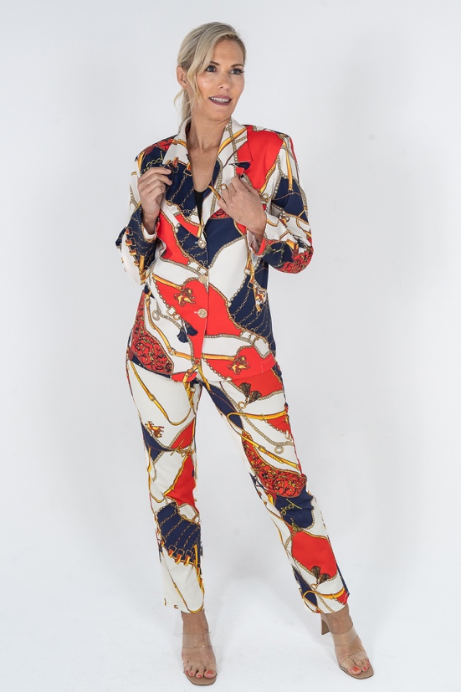

Princess Shirt – Poly Cotton
Machine Washable, crystal embellishments.
Ironing/steaming if required, use cool heat from inside out. Do not Tumble Dry.
Sizes S, M, L, XL, XXL, XXXL.
LCPrincessshirt WS $79 RRP $198
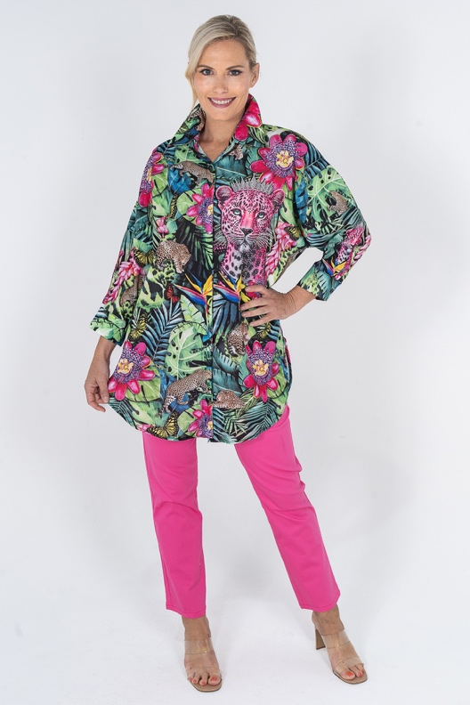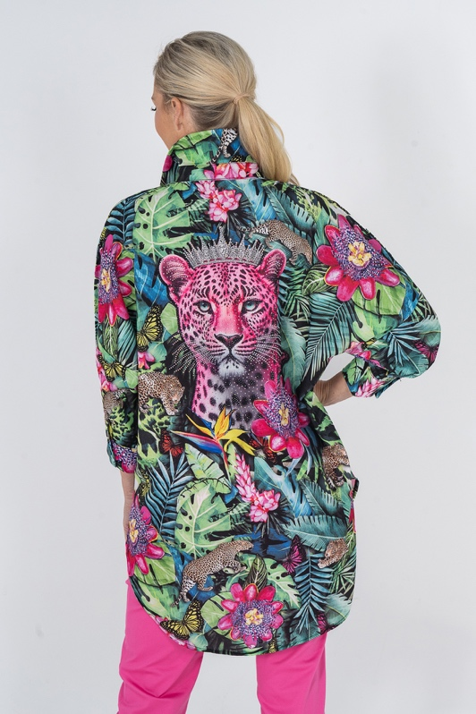
Neon Flash Shirt – Poly Cotton
Machine Washable, crystal embellishments.
Ironing/steaming if required, use cool heat from inside out. Do not Tumble Dry.
Sizes S, M, L, XL, XXL, XXXL.
LCNeonFlashshirt WS $79 RRP $198

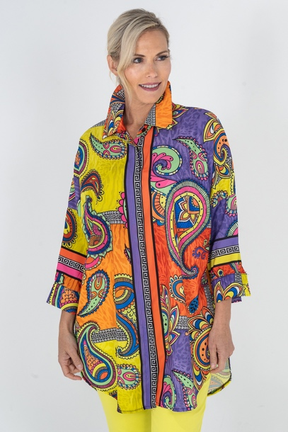
Calypso Shirt – Poly Cotton
Machine Washable, crystal embellishments.
Ironing/steaming if required, use cool heat from inside out. Do not Tumble Dry.
Sizes S, M, L, XL, XXL, XXXL.
LCCalypsoshirt WS $79 RRP $198
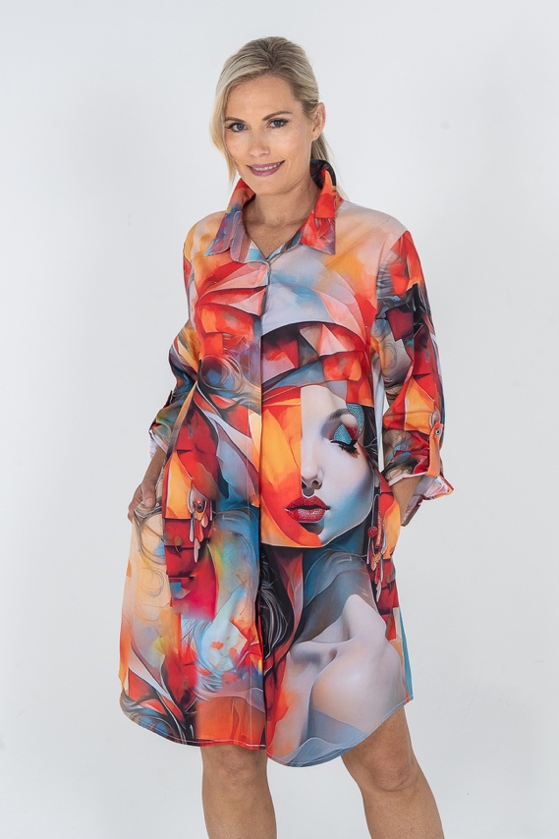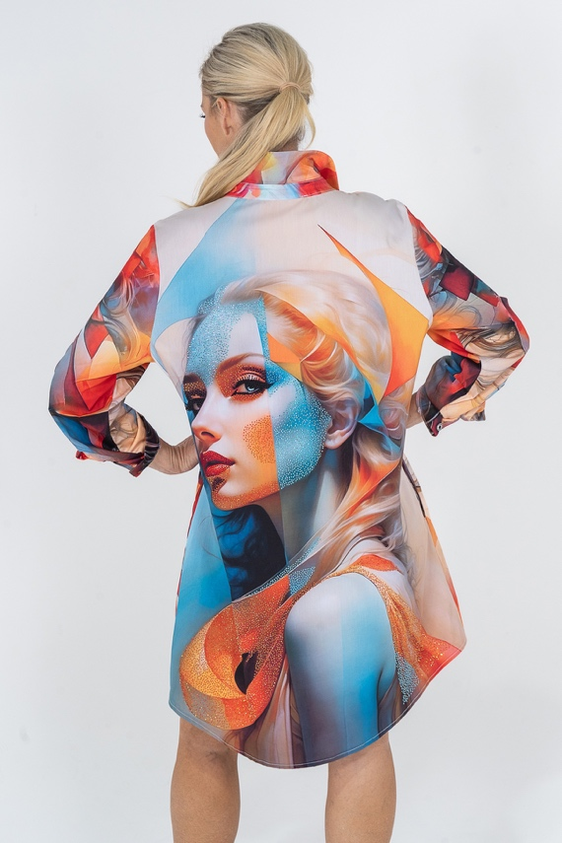
Fleur Shirt Poly Cotton
Machine Washable, crystal embellishments.
Ironing/steaming if required, use cool heat from inside out. Do not Tumble Dry.
Sizes S, M, L, XL, XXL, XXXL.
LCFleurshirt WS $79 RRP $198
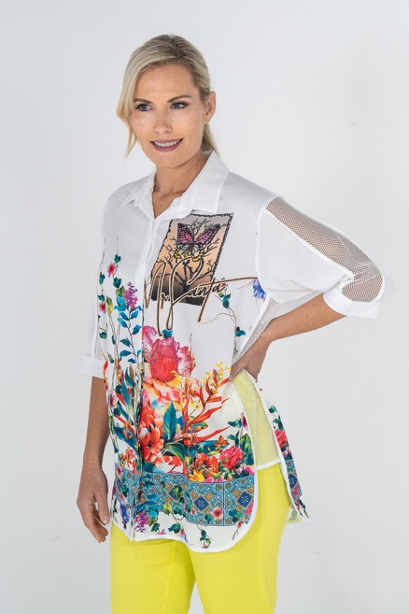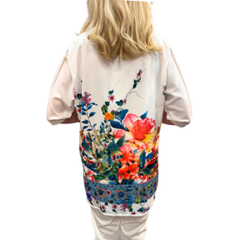
Zebra Chic Shirt - Poly Cotton
Machine Washable, crystal embellishments.
Ironing/steaming if required, use cool heat from inside out. Do not Tumble Dry.
Sizes S, M, L, XL, XXL, XXXL.
LCZebraChicShirt WS $79 RRP $198
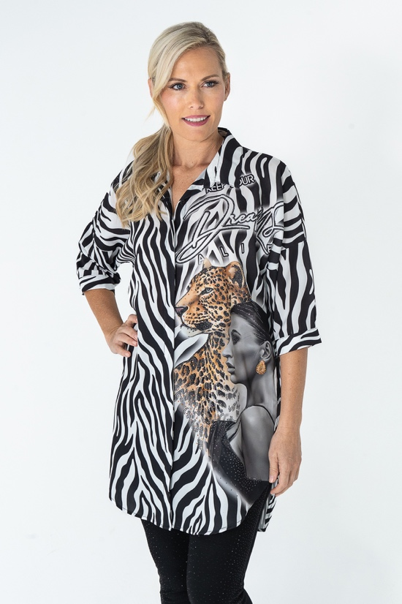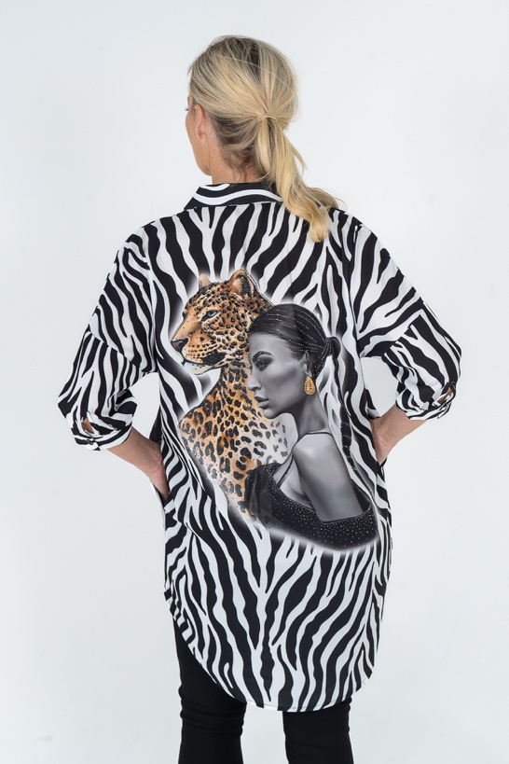
Venezia Shirt Poly Cotton
Machine Washable, crystal embellishments.
Ironing/steaming if required, use cool heat from inside out. Do not Tumble Dry.
Sizes S, M, L, XL, XXL, XXXL.
LCVeneziashirt WS $79 RRP $198
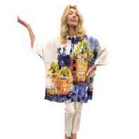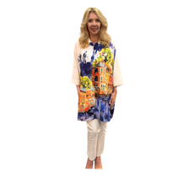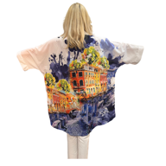

Paris Moon Shirt - Poly Cotton
Machine Washable, crystal embellishments.
Ironing/steaming if required, use cool heat from inside out. Do not Tumble Dry.
Sizes S, M, L, XL, XXL, XXXL.
LCParismoonshirt WS $79 RRP $198
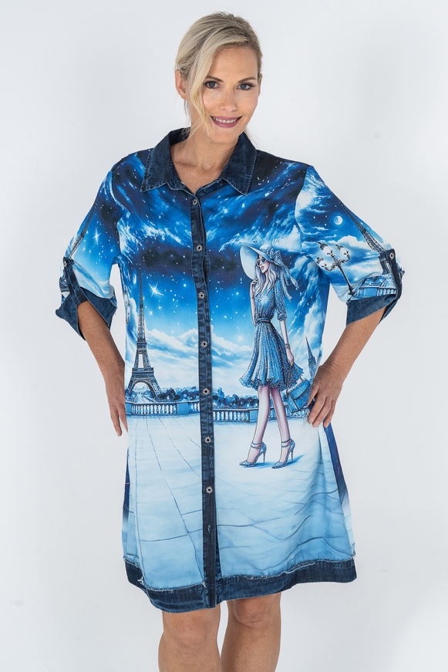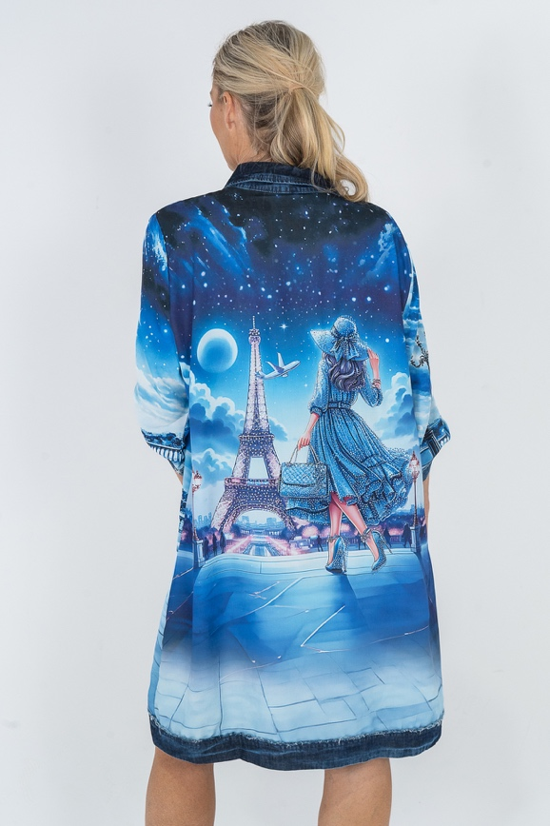

Serenade Shirt - Poly Cotton
Machine Washable, crystal embellishments.
Ironing/steaming if required, use cool heat from inside out. Do not Tumble Dry.
Sizes S, M, L, XL, XXL, XXXL.
LCSerenadeShirt WS $79 RRP $198
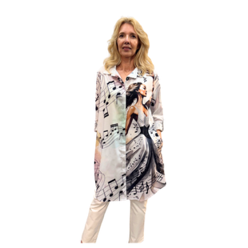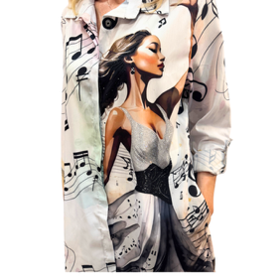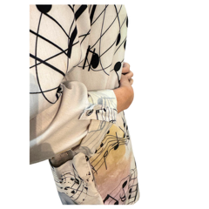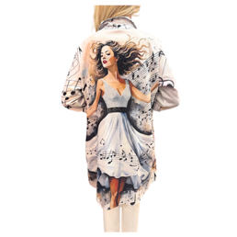

Zebra Temptess Shirt - Poly Cotton
Machine Washable, crystal embellishments.
Ironing/steaming if required, use cool heat from inside out. Do not Tumble Dry.
Sizes S, M, L, XL, XXL, XXXL.
LCZebraTemptressShirt WS $79 RRP $189
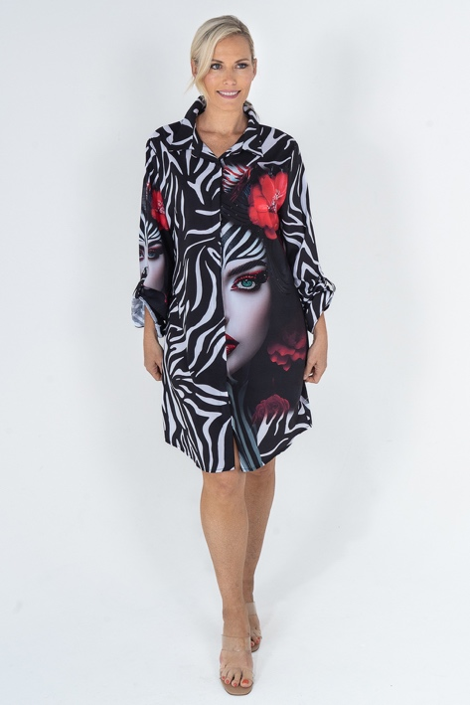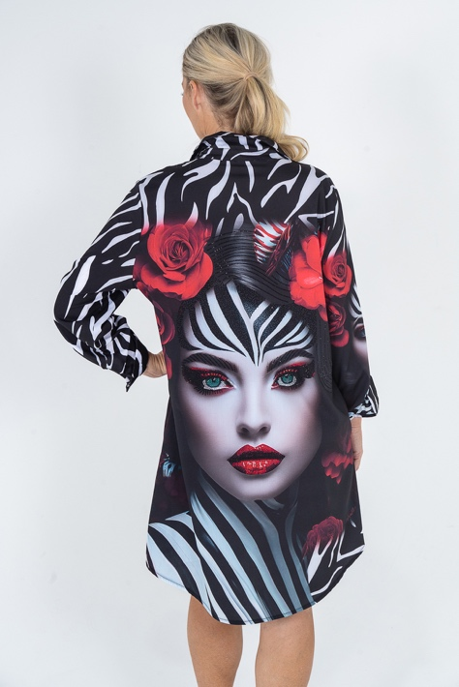
Tahiti Shirt/Dress - Poly Cotton
Machine Washable, crystal embellishments.
Ironing/steaming if required, use cool heat from inside out. Do not Tumble Dry.
Sizes S, M, L, XL, XXL, XXXL.
LCTahitiDress – WS $79 RRP $198
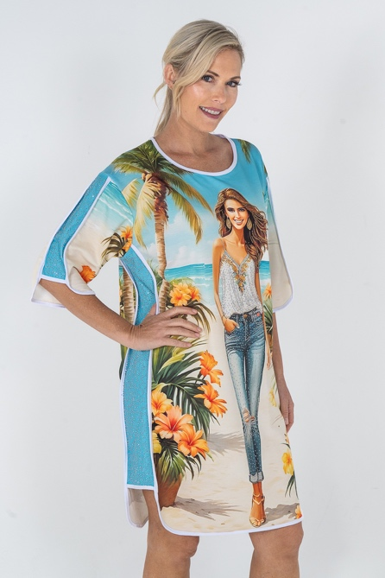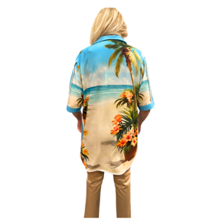

Denim Leopard Shirt - Poly Cotton
Machine Washable, crystal embellishments.
Ironing/steaming if required, use cool heat from inside out. Do not Tumble Dry.
Sizes S, M, L, XL, XXL, XXXL.
LCDenimLeopardshirt WS $79 RRP $198
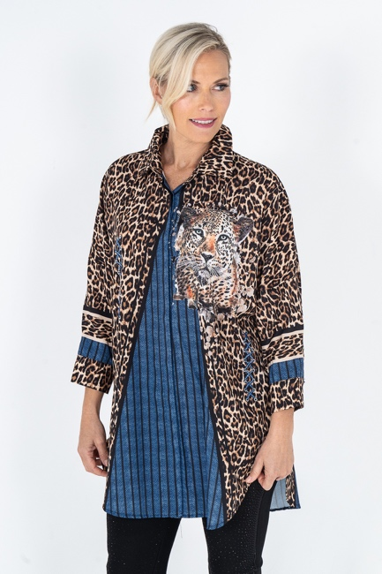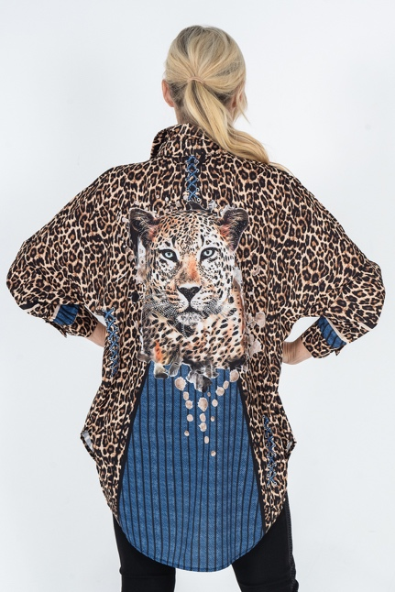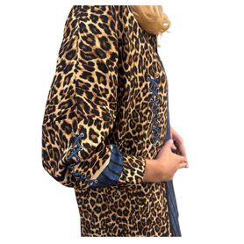
Eye Catching Shirt - Poly Cotton
Machine Washable, crystal embellishments.
Ironing/steaming if required, use cool heat from inside out. Do not Tumble Dry.
Sizes S, M, L, XL, XXL, XXXL.
LCEYECATCHshirt WS $79 RRP $198
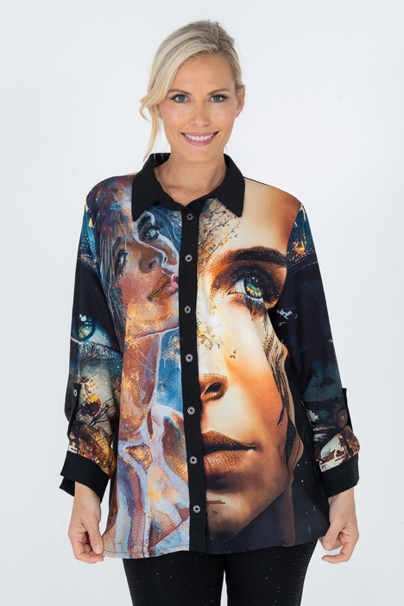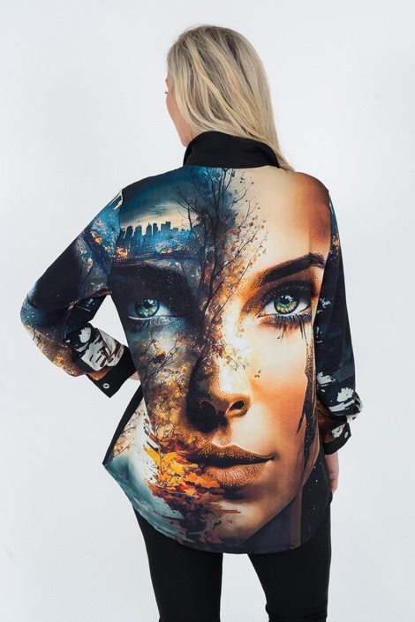

Stay Wild Shirt - Poly Cotton
Machine Washable, crystal embellishments.
Ironing/steaming if required, use cool heat from inside out. Do not Tumble Dry.
Sizes S, M, L, XL, XXL, XXXL.
LCSTAYWILDshirt WS $79 RRP $198
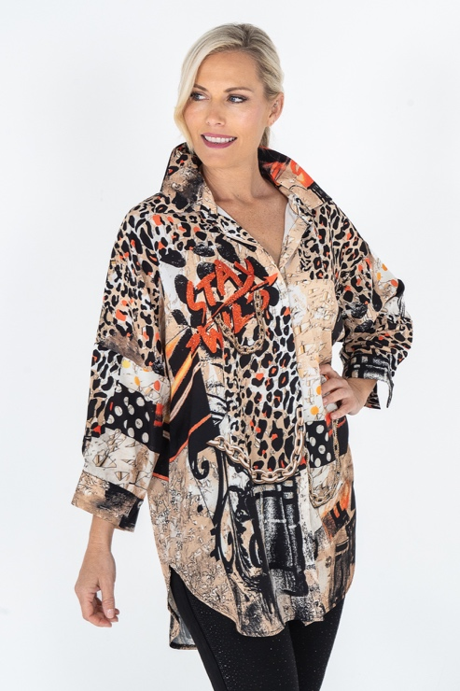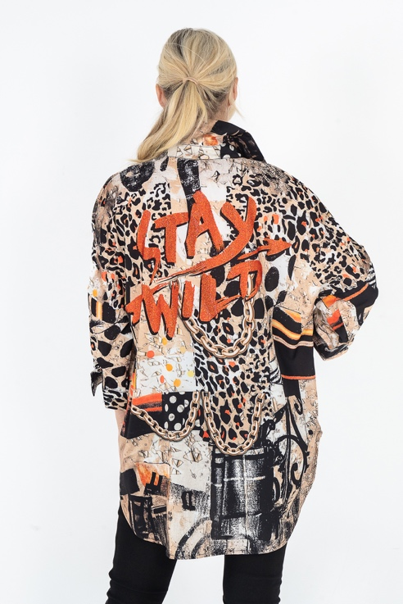
Leopard Blue Eyes Shirt - Poly Cotton
Machine Washable, crystal embellishments.
Ironing/steaming if required, use cool heat from inside out. Do not Tumble Dry.
Sizes S, M, L, XL, XXL, XXXL.
LCLEOPARDBEshirt WS $79 RRP $198
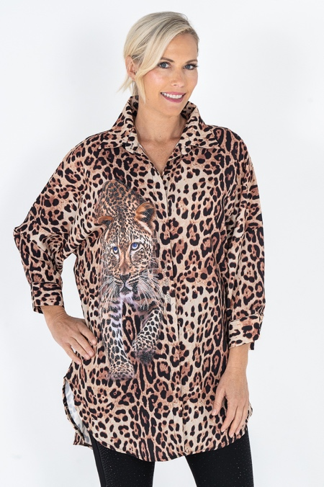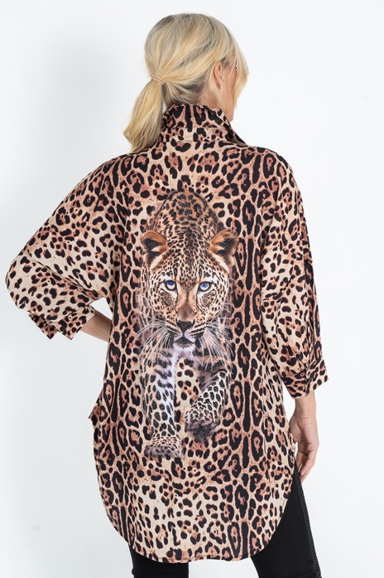
Postcard Shirt - Poly Cotton
Machine Washable, crystal embellishments.
Ironing/steaming if required, use cool heat from inside out. Do not Tumble Dry.
Sizes S, M, L, XL, XXL, XXXL.
LCPostcardshirt WS $79 RRP $198
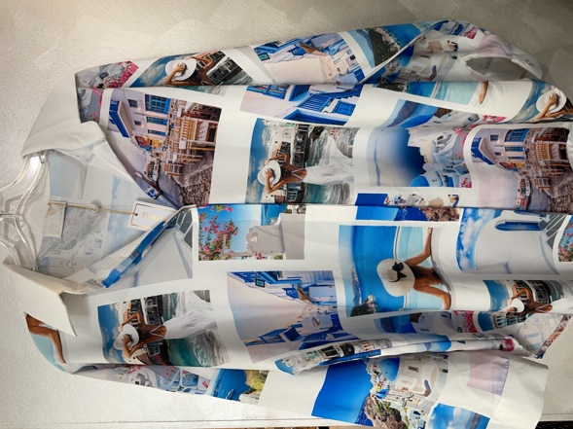
Liz Clift International – Isabella Blouse - Poly Cotton
Machine Washable, crystal embellishments.
Ironing/steaming if required, use cool heat from inside out. Do not Tumble Dry.
Sizes S, M, L, XL, XXL, XXXL.
LCISSAELLAB – WS $79 RRP $198

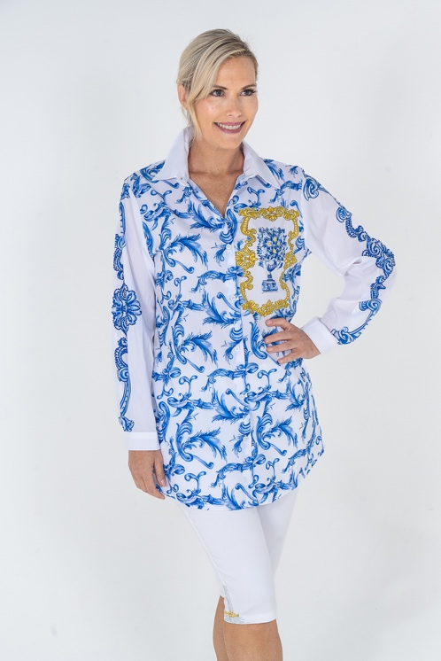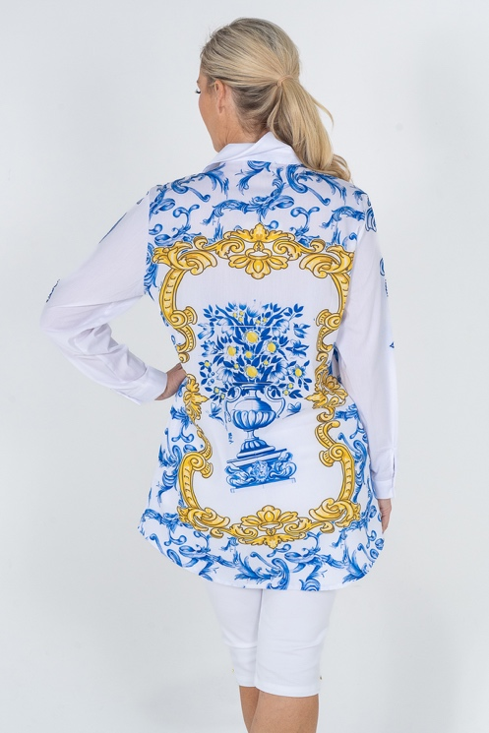

Liz Clift International – Mykonos Blouse - Poly Cotton
Machine Washable, crystal embellishments.
Ironing/steaming if required, use cool heat from inside out. Do not Tumble Dry.
Sizes S, M, L, XL, XXL, XXXL.
LCIMYKS – WS $79 RRP $198
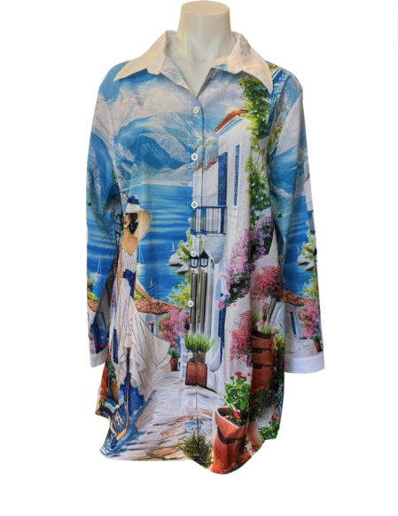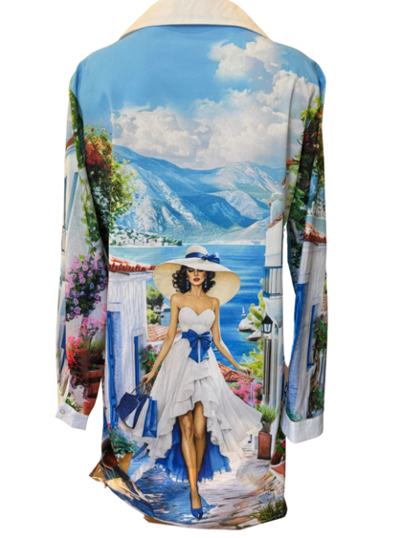

Liz Clift International – Rio de Janeiro Blouse - Poly Cotton
Machine Washable, crystal embellishments.
Ironing/steaming if required, use cool heat from inside out. Do not Tumble Dry.
Sizes S, M, L, XL, XXL, XXXL.
LCRDJS – WS $79 RRP $198
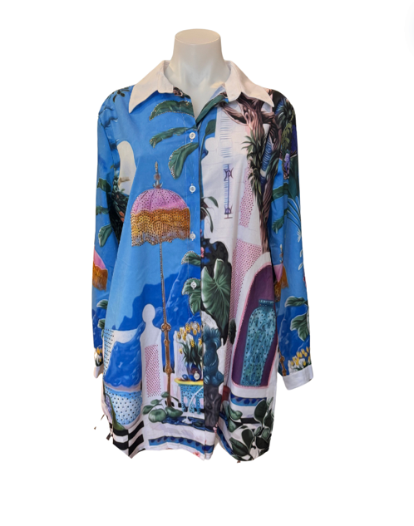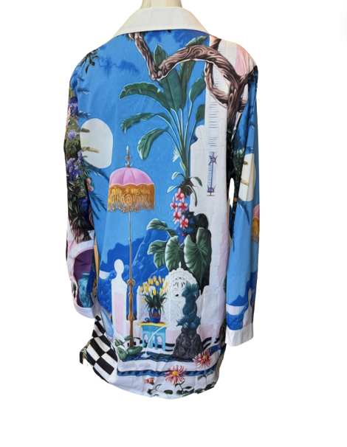

Liz Clift International – Cap d’Antibes Shirt - Poly Cotton
Machine Washable, do not tumble dry, crystal embellishments.
Ironing/steaming if required, use cool heat from inside out. Do not Tumble Dry.
Sizes S, M, L, XL, XXL, XXXL.
LCCDAS - WS $79 RRP $198
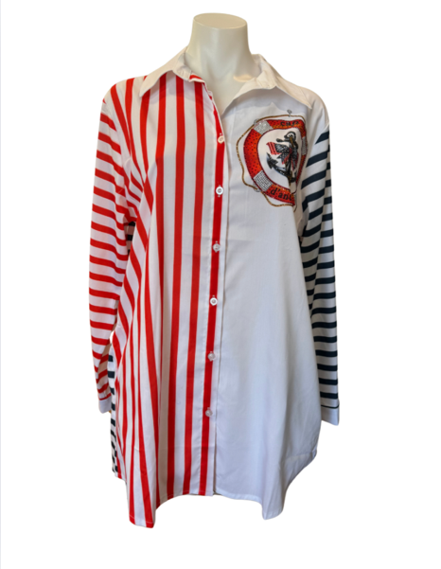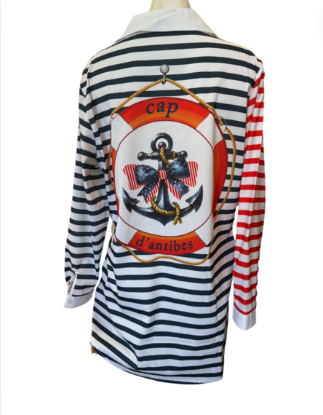

Liz Clift International – White Scroll Shirt - Poly Cotton
Machine Washable, do not tumble dry, crystal embellishments.
Ironing/steaming if required, use cool heat from inside out. Do not Tumble Dry.
Sizes S, M, L, XL, XXL, XXXL.
LCWSS - WS $79 RRP $198
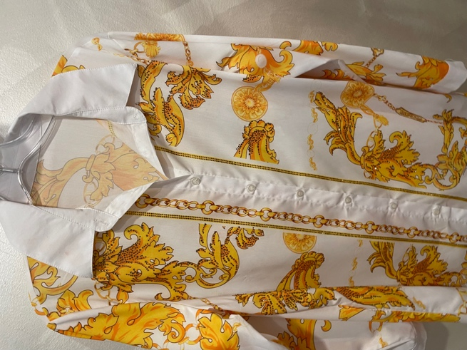

Liz Clift International – Red Scroll Shirt - Poly Cotton
Machine Washable, do not tumble dry, crystal embellishments.
Ironing/steaming if required, use cool heat from inside out. Do not Tumble Dry.
Sizes S, M, L, XL, XXL, XXXL.
LCRSS - Wholesale $79 RRP $198
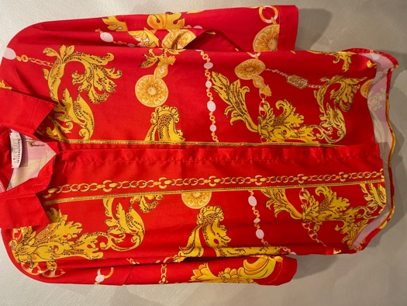
Cool Chics T-Shirt – Poly Cotton
Machine Washable, crystal embellishments.
Ironing/steaming if required, use cool heat from inside out. Do not Tumble Dry.
Sizes S, M, L, XL, XXL, XXXL.
LCCoolChicsT – WS $59 RRP $147.50
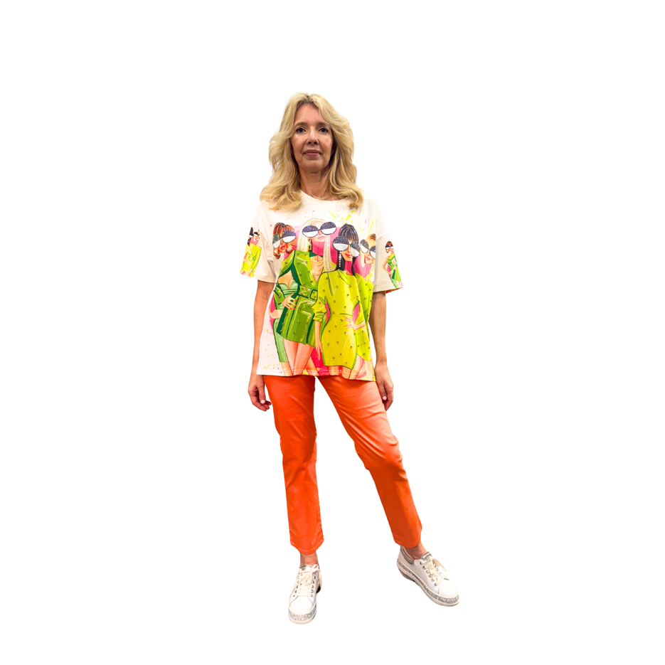
Animal Patch Tee - Polyester
Machine Washable, crystal embellishments.
Ironing/steaming if required, use cool heat from inside out. Do not Tumble Dry.
Sizes S, M, L, XL, XXL, XXXL.
LCAPTEE – WS $64 RRP $185
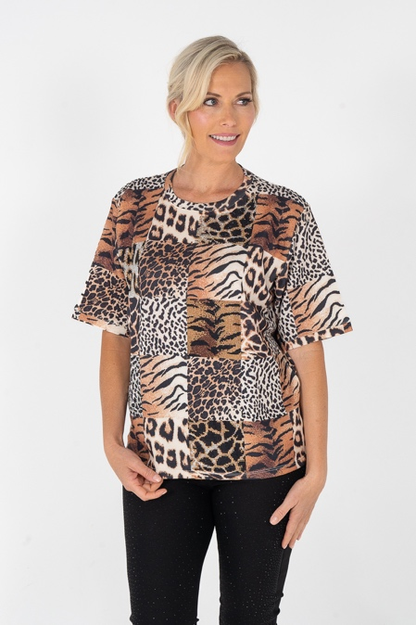
Fluttery Tee - Polyester
Machine Washable, crystal embellishments.
Ironing/steaming if required, use cool heat from inside out. Do not Tumble Dry.
Sizes S, M, L, XL, XXL, XXXL.
LCFLUTTEE – WS $74 RRP $185
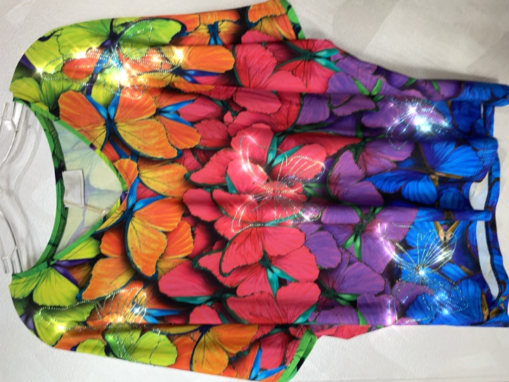
Rio Tee - Polyester
Machine Washable, crystal embellishments.
Ironing/steaming if required, use cool heat from inside out. Do not Tumble Dry.
Sizes S, M, L, XL, XXL, XXXL.
LCRIOTEE – WS $74 RRP $185
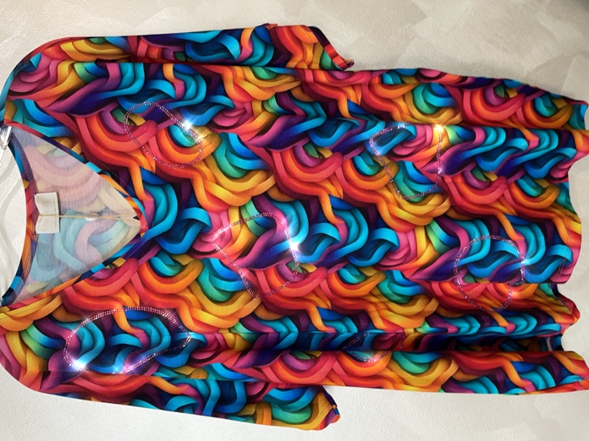
Graffiti Love Tee - Polyester
Machine Washable, crystal embellishments.
Ironing/steaming if required, use cool heat from inside out. Do not Tumble Dry.
Sizes S, M, L, XL, XXL, XXXL.
LCGLOVETEE – WS $89 RRP $222.50
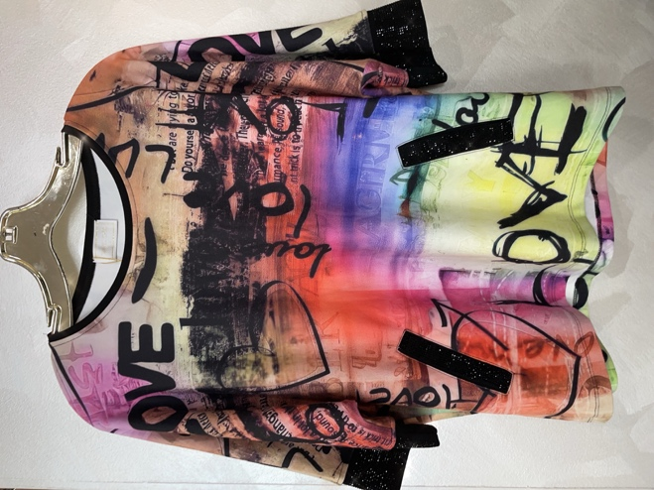

Palm Cove Tee Black - Polyester
Machine Washable, crystal embellishments.
Ironing/steaming if required, use cool heat from inside out. Do not Tumble Dry.
Sizes S, M, L, XL, XXL, XXXL.
LCPALMCOVETEEB – WS $79 RRP $198

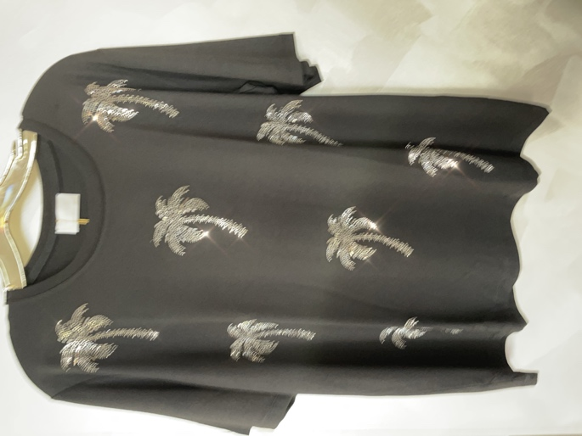
Palm Cove Tee Coffee - Polyester
Machine Washable, crystal embellishments.
Ironing/steaming if required, use cool heat from inside out. Do not Tumble Dry.
Sizes S, M, L, XL, XXL, XXXL.
LCPALMCOVETEEC – WS $79 RRP $198
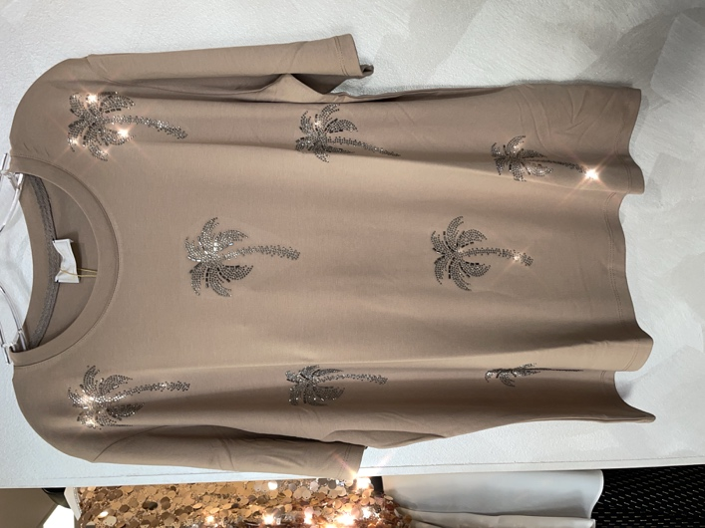
Leopard Belle Tee - Polyester
Machine Washable, crystal embellishments.
Ironing/steaming if required, use cool heat from inside out. Do not Tumble Dry.
Sizes S, M, L, XL, XXL, XXXL.
LCLeopardBelleTEE – WS $79 RRP $198
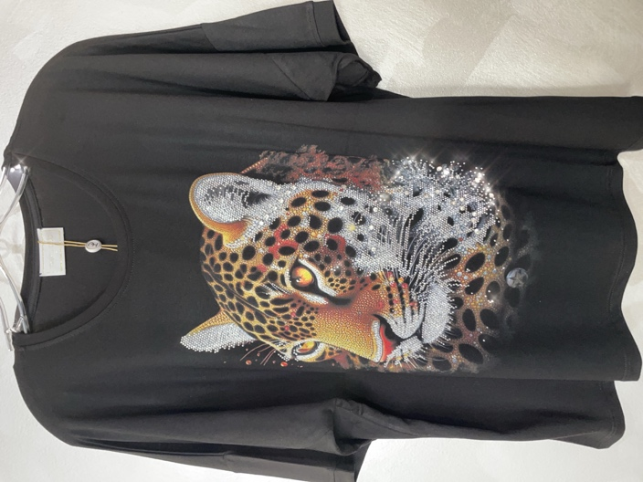
King Leopard Tee - Polyester
Machine Washable, crystal embellishments.
Ironing/steaming if required, use cool heat from inside out. Do not Tumble Dry.
Sizes S, M, L, XL, XXL, XXXL.
LCKingLeopardTEE – WS $79 RRP $198
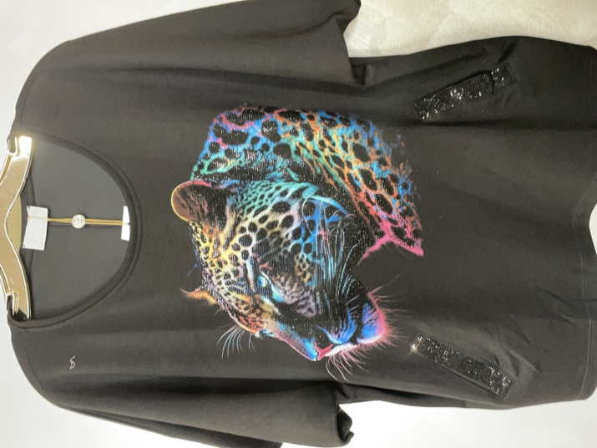
Blue Lilly Tee - Polyester
Machine Washable, crystal embellishments.
Ironing/steaming if required, use cool heat from inside out. Do not Tumble Dry.
Sizes S, M, L, XL, XXL, XXXL.
LCBlueLillyTEE – WS $79 RRP $198
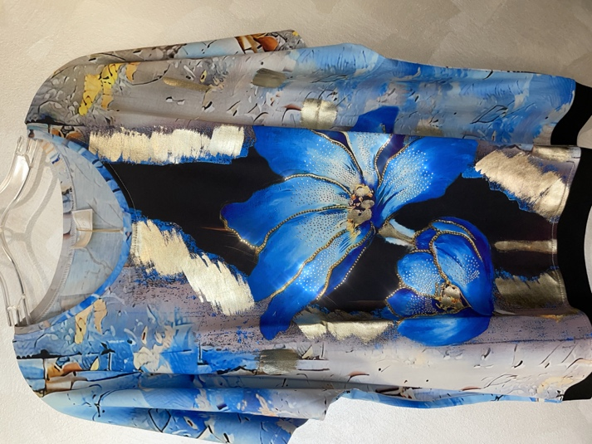
Pussy Galore Serotonin Dress - Polyester
Machine Washable, crystal embellishments.
Ironing/steaming if required, use cool heat from inside out. Do not Tumble Dry.
Sizes S, M, L, XL, XXL, XXXL.
LCPGSEROD – WS $98 RRP $245
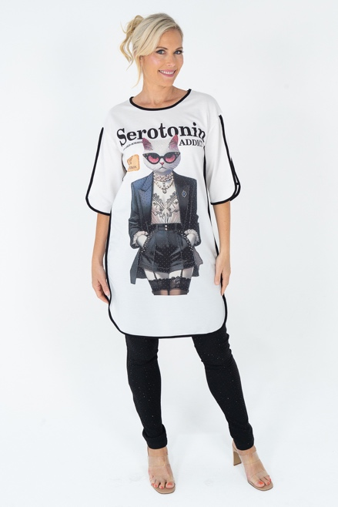

Paris Rose Dress - Polyester
Machine Washable, crystal embellishments.
Ironing/steaming if required, use cool heat from inside out. Do not Tumble Dry.
Sizes S, M, L, XL, XXL, XXXL.
LCPGSEROD – WS $79 RRP $198
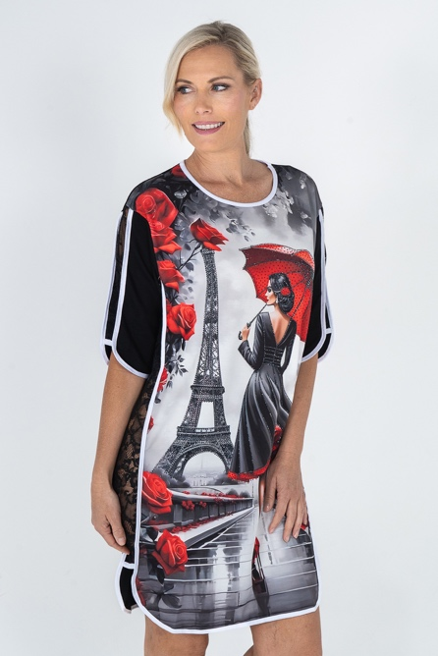

Babe Top - Polyester
Machine Washable, crystal embellishments.
Ironing/steaming if required, use cool heat from inside out. Do not Tumble Dry.
Sizes S, M, L, XL, XXL, XXXL.
LCBabetop – WS $74 RRP $185
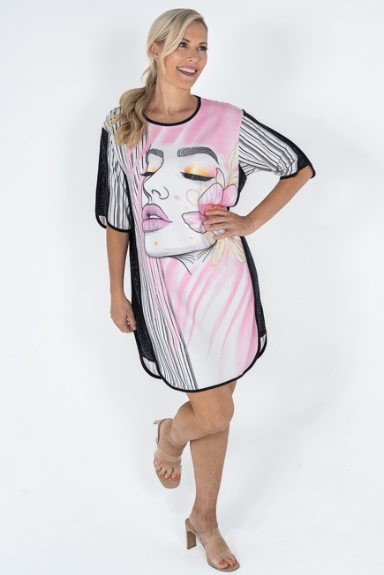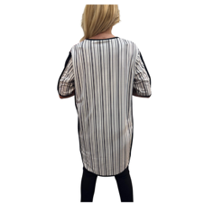

Design Life Top and pants set - Polyester spandex
Machine Washable, crystal embellishments.
Ironing/steaming if required, use cool heat from inside out. Do not Tumble Dry.
Sizes S, M, L, XL, XXL, XXXL.
LCDesignLife WS $102 set RRP $255
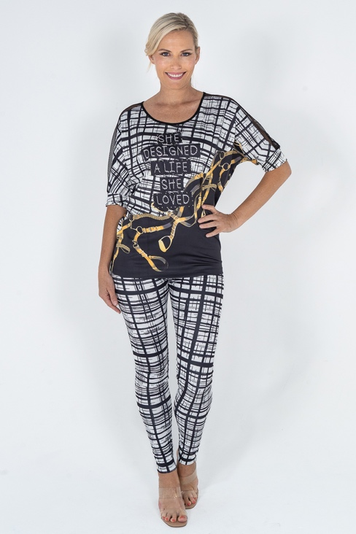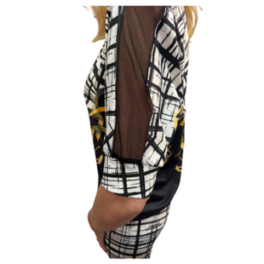
Pussy Cat Dress - Poly Cotton
Machine Washable, crystal embellishments.
Ironing/steaming if required, use cool heat from inside out. Do not Tumble Dry.
Sizes S, M, L, XL, XXL, XXXL.
LCPussyCatDress WS $98 RRP $245
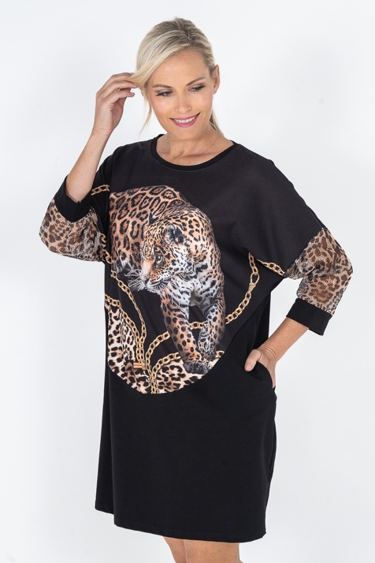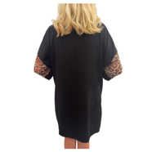
Majestic Dress - Poly Cotton
Machine Washable, crystal embellishments.
Ironing/steaming if required, use cool heat from inside out. Do not Tumble Dry.
Sizes S, M, L, XL, XXL, XXXL.
LCMajesticDress WS $98 RRP $245
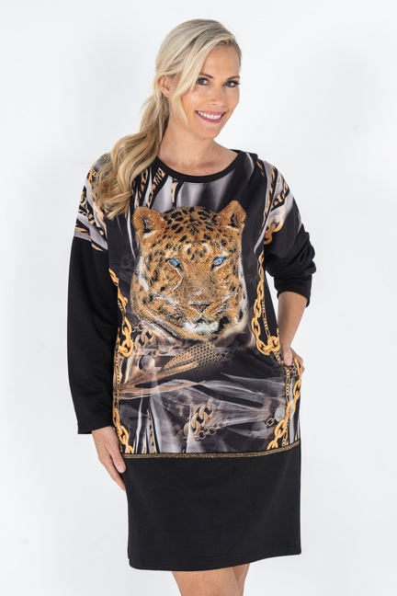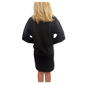

Star Leopard Dress - Poly Cotton
Machine Washable, crystal embellishments.
Ironing/steaming if required, use cool heat from inside out. Do not Tumble Dry.
Sizes S, M, L, XL, XXL, XXXL.
LCStarLeopardDress WS $79 RRP $198
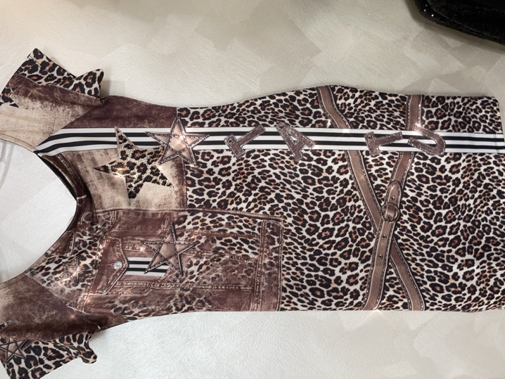
Wild Tiger Set B/W - Polyester
Machine Washable, crystal embellishments.
Ironing/steaming if required, use cool heat from inside out. Do not Tumble Dry.
Sizes S, M, L, XL, XXL, XXXL.
LCWildTigerSetB/W WS $112 RRP $280
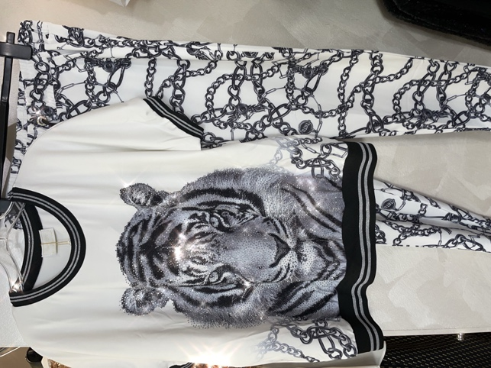

Wild Tiger Set B/Brown - Polyester
Machine Washable, crystal embellishments.
Ironing/steaming if required, use cool heat from inside out. Do not Tumble Dry.
Sizes S, M, L, XL, XXL, XXXL.
LCWildTigerSetB/BR WS $112 RRP $280
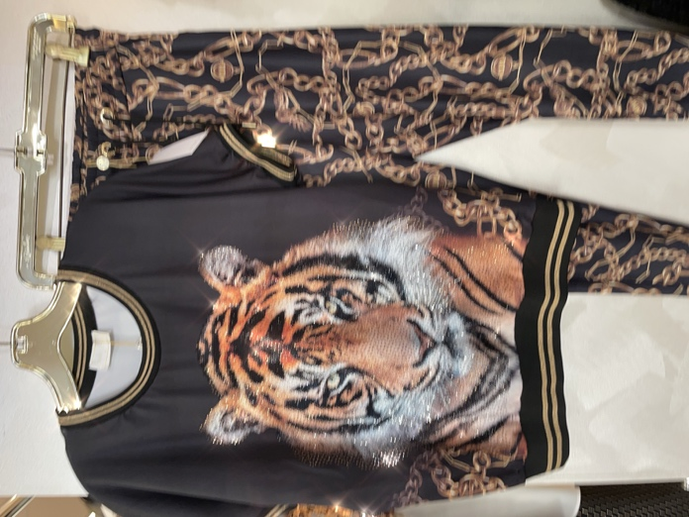
Leopard Eagle Set - Polyester
Machine Washable, crystal embellishments.
Ironing/steaming if required, use cool heat from inside out. Do not Tumble Dry.
Sizes S, M, L, XL, XXL, XXXL.
LCLeopardEagleSet WS $112 RRP $280
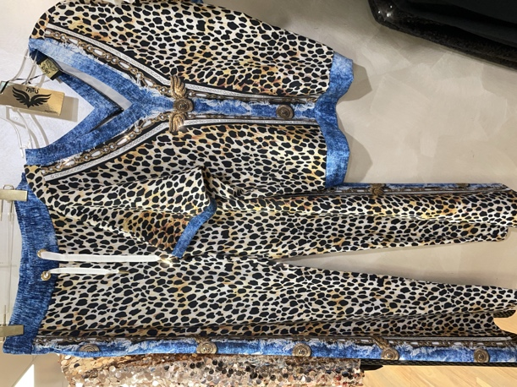
Scroll Tee - Polyester
Machine Washable, crystal embellishments.
Ironing/steaming if required, use cool heat from inside out. Do not Tumble Dry.
Sizes S, M, L, XL, XXL, XXXL.
LCScrollTee WS $79 RRP $197.50
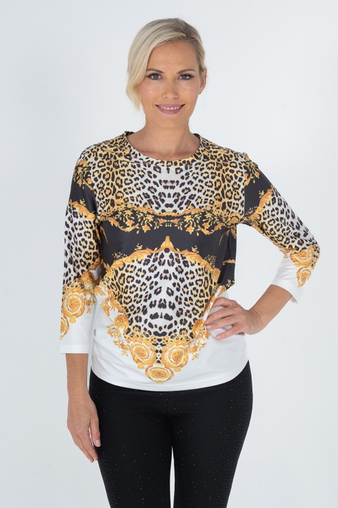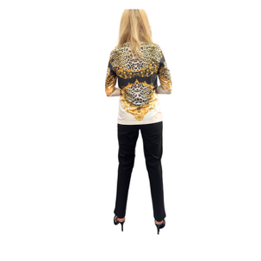

Keyhole Neckline Scroll Tee - Polyester
Machine Washable, crystal embellishments.
Ironing/steaming if required, use cool heat from inside out. Do not Tumble Dry.
Sizes S, M, L, XL, XXL, XXXL.
LCKNScrollTee WS $79 RRP $197.50
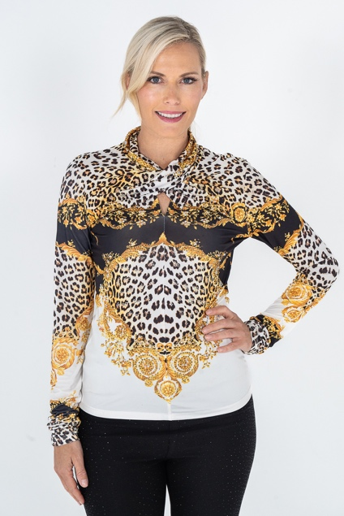
Scroll Blazer - Polyester
Machine Washable, crystal embellishments.
Ironing/steaming if required, use cool heat from inside out. Do not Tumble Dry.
Sizes S, M, L, XL, XXL, XXXL.
LC823XTSCScroll WS $98 RRP $245
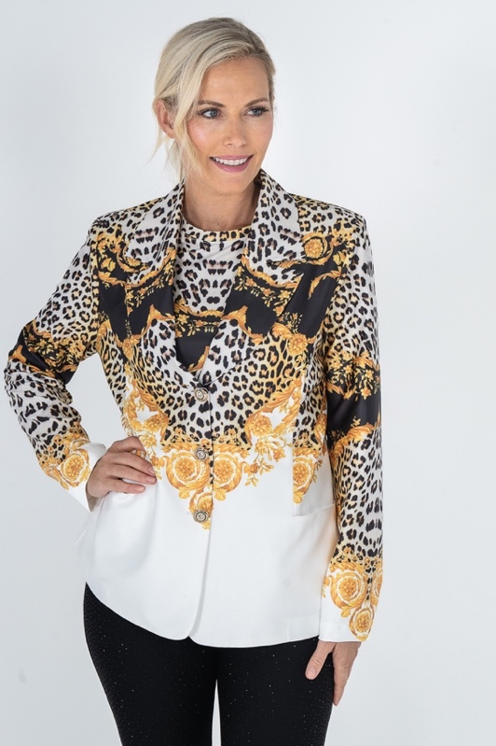
Scroll Leggings - Polyester
Machine Washable, crystal embellishments.
Ironing/steaming if required, use cool heat from inside out. Do not Tumble Dry.
Sizes S, M, L, XL, XXL, XXXL.
LCScrollLeggings WS $105 RRP $262
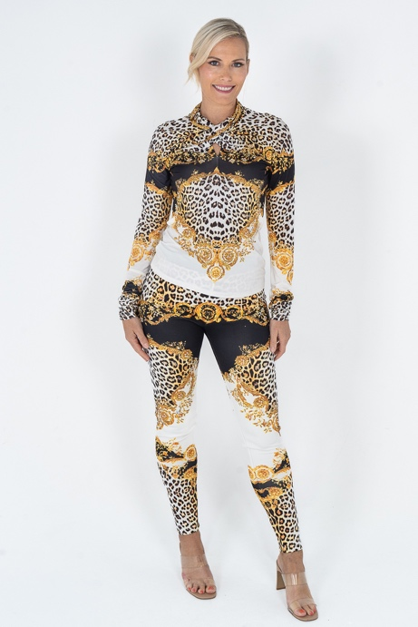
Black Camelia Top - Polyester
Machine Washable, crystal embellishments.
Ironing/steaming if required, use cool heat from inside out. Do not Tumble Dry.
Sizes S, M, L, XL, XXL, XXXL.
LCCameliaTopB WS $86 RRP $215
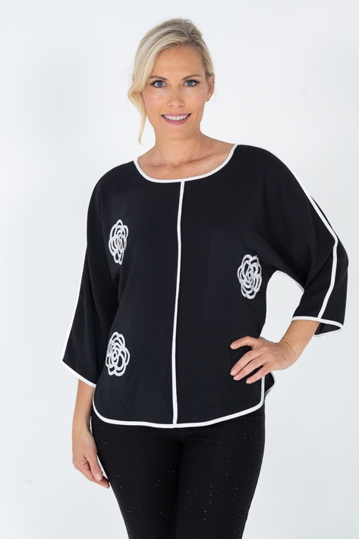
White Camelia Top - Polyester
Machine Washable, crystal embellishments.
Ironing/steaming if required, use cool heat from inside out. Do not Tumble Dry.
Sizes S, M, L, XL, XXL, XXXL.
LCCameliaTopW WS $86 RRP $215
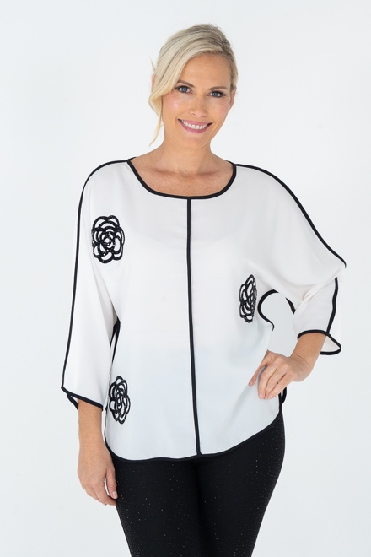
Dress Marine Frill - Polyester
Machine Washable, crystal embellishments.
Ironing/steaming if required, use cool heat from inside out. Do not Tumble Dry.
Sizes S, M, L, XL, XXL, XXXL.
LC817DressMarineFrill – WS $98 RRP $245
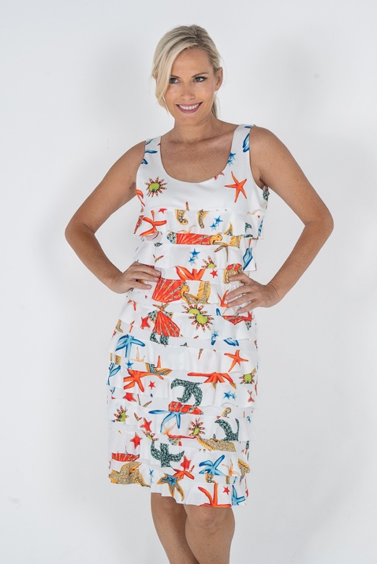

Dress Nautical Frill - Polyester
Machine Washable, crystal embellishments.
Ironing/steaming if required, use cool heat from inside out. Do not Tumble Dry.
Sizes S, M, L, XL, XXL, XXXL.
LC817DressNauticalFrill – WS $98 RRP $245
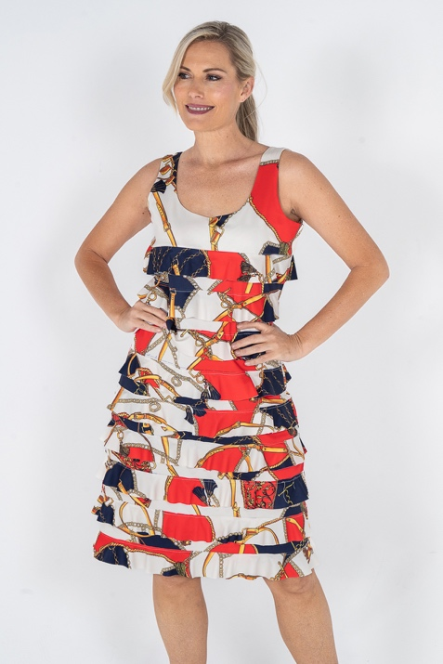
Safari Dress Frill Polyester
Machine Washable, crystal embellishments.
Ironing/steaming if required, use cool heat from inside out. Do not Tumble Dry.
Sizes S, M, L, XL, XXL, XXXL.
LC817DressSarfariFrill – WS $98 RRP $245
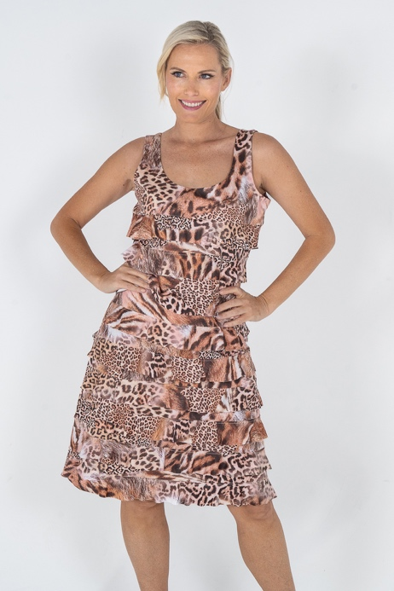
Love Dress Frill - Polyester
Machine Washable, crystal embellishments.
Ironing/steaming if required, use cool heat from inside out. Do not Tumble Dry.
Sizes S, M, L, XL, XXL, XXXL.
LC817DressLoveFrill – WS $98 RRP $245
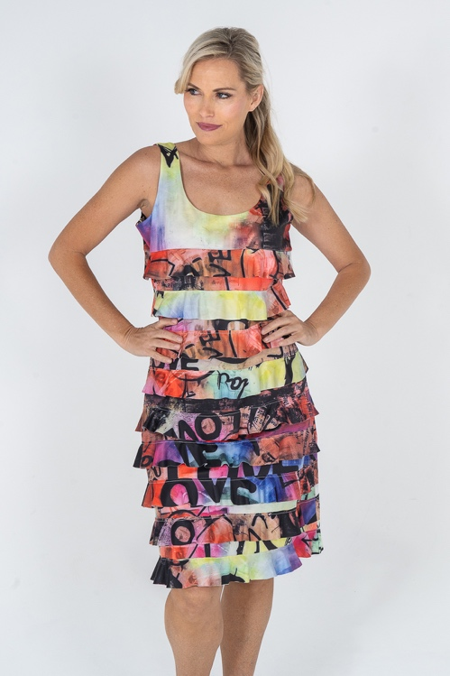
Keyhole Dress Love Polyester Spandex
Machine Washable, crystal embellishments.
Ironing/steaming if required, use cool heat from inside out. Do not Tumble Dry.
Sizes S, M, L, XL, XXL, XXXL.
LC825KDLV WS $98 RRP $245
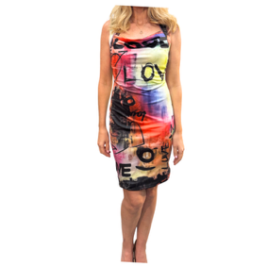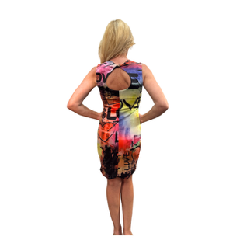
Little Safari Dress Polyester Spandex
Machine Washable.
Ironing/steaming if required, use cool heat from inside out. Do not Tumble Dry.
Sizes S, M, L, XL, XXL, XXXL.
LC811LittleSafariDress WS $98 RRP $245

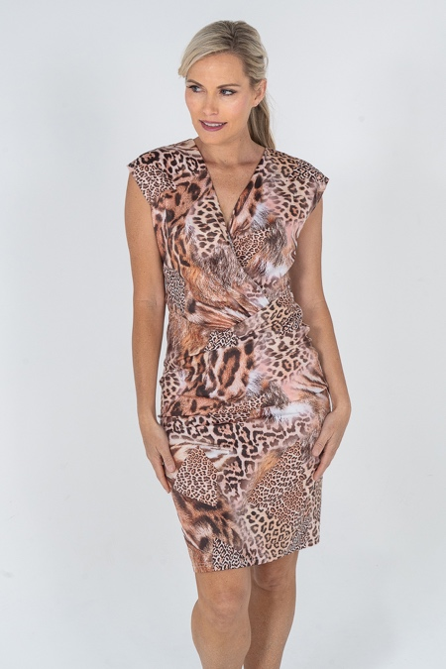
Floral Dress Polyester Spandex
Machine Washable.
Ironing/steaming if required, use cool heat from inside out. Do not Tumble Dry.
Sizes S, M, L, XL, XXL, XXXL.
LC811LFD WS $98 RRP $245
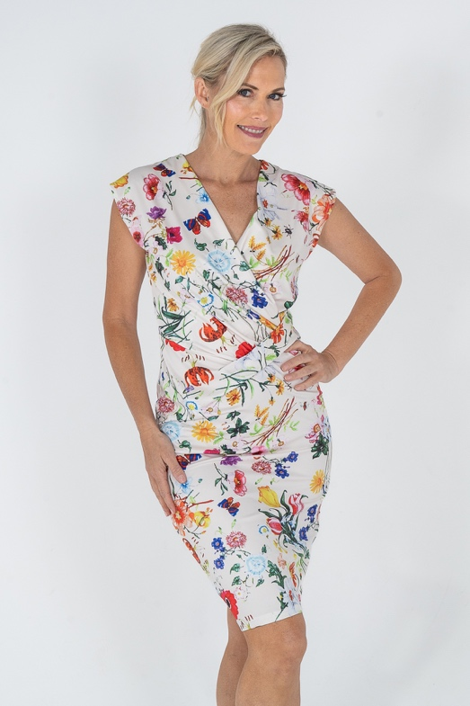
Little Black Dress Polyester Spandex
Machine Washable.
Ironing/steaming if required, use cool heat from inside out. Do not Tumble Dry.
Sizes S, M, L, XL, XXL, XXXL.
LC811LBD WS $98 RRP $245
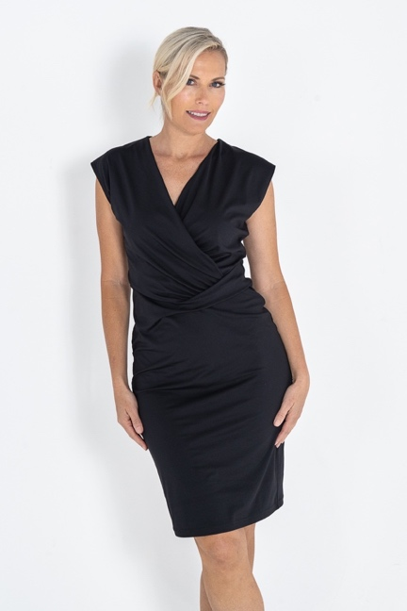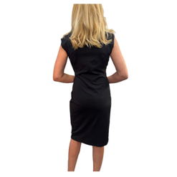

Keyhole Dress Nautical Polyester Spandex
Machine Washable.
Ironing/steaming if required, use cool heat from inside out. Do not Tumble Dry.
Sizes S, M, L, XL, XXL, XXXL.
LC811KDN WS $98 RRP $245

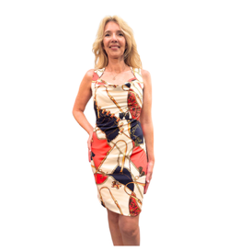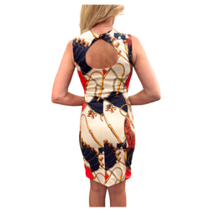

Keyhole Dress Leopard - Polyester Spandex
Machine Washable.
Ironing/steaming if required, use cool heat from inside out. Do not Tumble Dry.
Sizes S, M, L, XL, XXL, XXXL.
LC811KDL WS $98 RRP $245
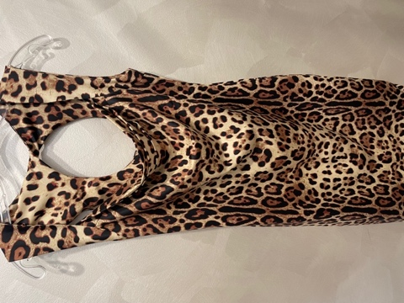
Long Black Crystal Dress - Polyester
Machine Washable, crystal Embellished
Ironing/steaming if required, use cool heat from inside out. Do not Tumble Dry.
Sizes S, M, L, XL, XXL, XXXL.
LC903LBCD WS $107 RRP $267
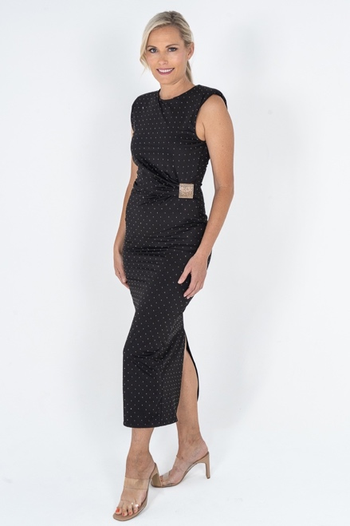
Long White Crystal Dress - Polyester
Machine Washable, crystal Embellished
Ironing/steaming if required, use cool heat from inside out. Do not Tumble Dry.
Sizes S, M, L, XL, XXL, XXXL.
LC903LWCD WS $107 RRP $267

Black Tight Crystal Singlet Dress - Polyester
Machine Washable, crystal Embellished
Ironing/steaming if required, use cool heat from inside out. Do not Tumble Dry.
Sizes S, M, L, XL, XXL, XXXL.
LC013CTDB WS $98 RRP $245
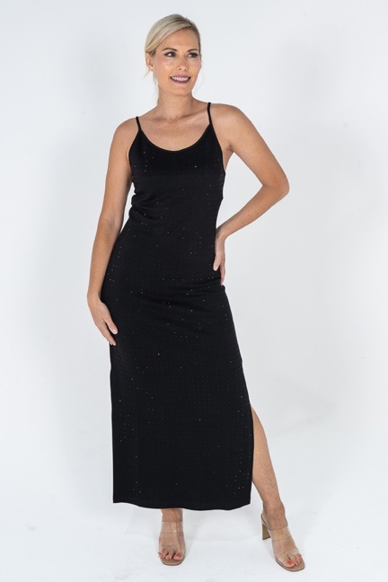
White Tight Crystal Dress - Polyester
Machine Washable, crystal Embellished
Ironing/steaming if required, use cool heat from inside out. Do not Tumble Dry.
Sizes S, M, L, XL, XXL, XXXL.
LC013CTDW $98 RRP $245
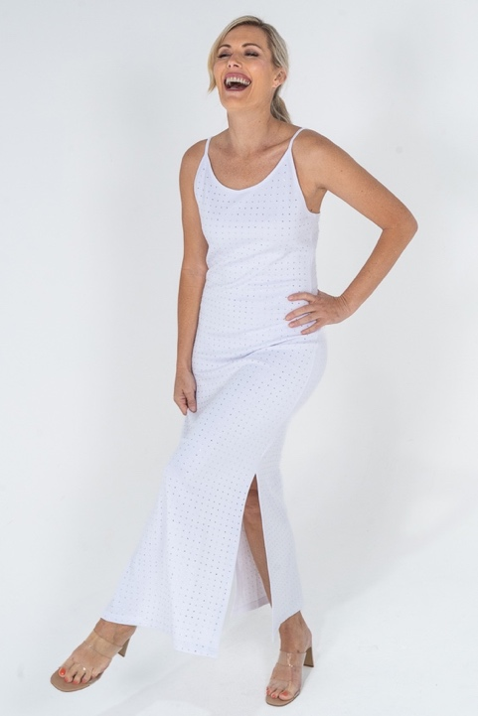

White Long Tee Crystal Dress - Polyester
Machine Washable, crystal Embellished
Ironing/steaming if required, use cool heat from inside out. Do not Tumble Dry.
Sizes S, M, L, XL, XXL, XXXL.
LCLTEECDW WS $99.50 RRP $245
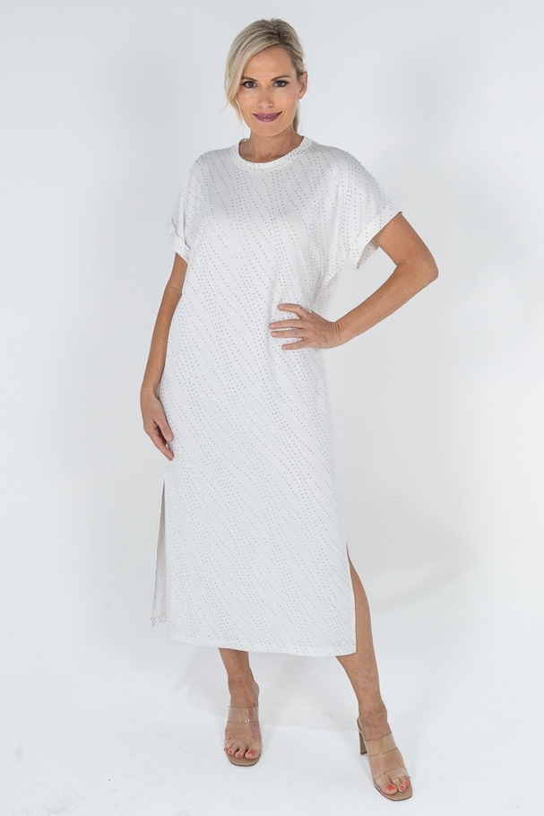

Tank Marine - Polyester
Machine Washable.
Ironing/steaming if required, use cool heat from inside out. Do not Tumble Dry.
Sizes S, M, L, XL, XXL, XXXL.
LC824TankMarine WS $79 RRP $195
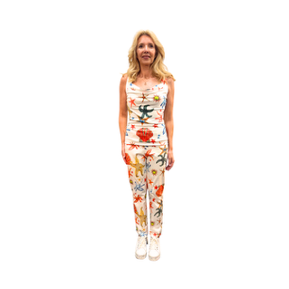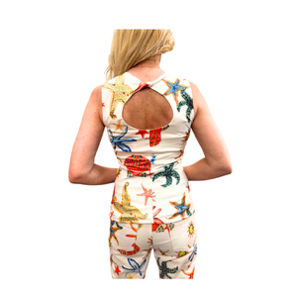
Print Jean Marine stretch – Poly Cotton
Machine Washable.
Ironing/steaming if required, use cool heat from inside out. Do not Tumble Dry.
Sizes S, M, L, XL, XXL, XXXL.
LC810PJM – WS $79 RRP $198
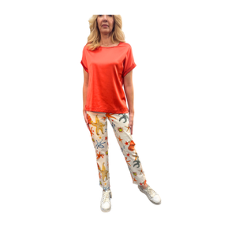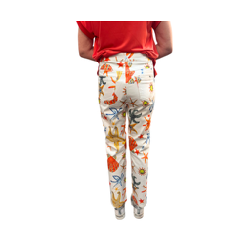

Print Jean Ropes Stretch – Poly Cotton
Machine Washable.
Ironing/steaming if required, use cool heat from inside out. Do not Tumble Dry.
Sizes S, M, L, XL, XXL, XXXL.
LC810PJR – WS $79 RRP $198
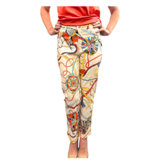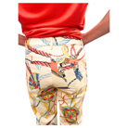
Print Jean Stretch Nautical – Poly Cotton
Machine Washable.
Ironing/steaming if required, use cool heat from inside out. Do not Tumble Dry.
Sizes S, M, L, XL, XXL, XXXL.
LC810PJN – WS $79 RRP $198
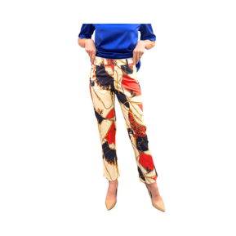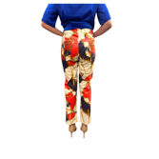

Jungle Print Jean Stretch – Poly Cotton
Machine Washable.
Ironing/steaming if required, use cool heat from inside out. Do not Tumble Dry.
Sizes S, M, L, XL, XXL, XXXL.
LC810PJJ – WS $79 RRP $198
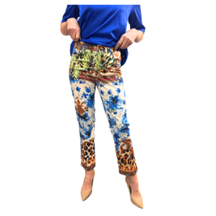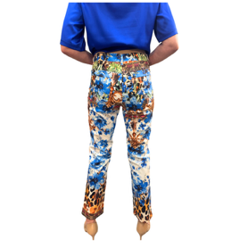
Graffiti Love Jean Stretch – Poly Cotton
Machine Washable.
Ironing/steaming if required, use cool heat from inside out. Do not Tumble Dry.
Sizes S, M, L, XL, XXL, XXXL.
LC810PJGLOVE – WS $79 RRP $198

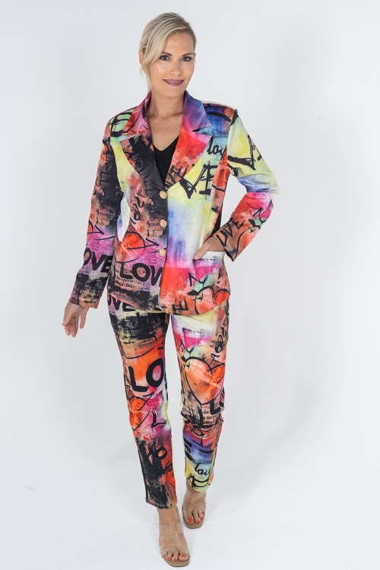
Liz Clift International - Crystal Embellished Pant in Black - Rayon 67%, Polyester 30%, Lycra 3%,
Machine Washable, crystal embellishments. Soft and stretchy pull up pants with belt tab. Crystal embellishment down the front and on the pockets at back. Faux front pockets.

Ironing/steaming if required, use cool heat from inside out. Do not Tumble Dry.
Sizes S, M, L, XL, XXL, XXXL.
LCCEP WS $70 RRP $220

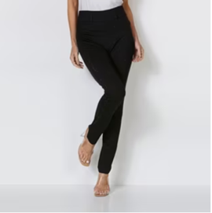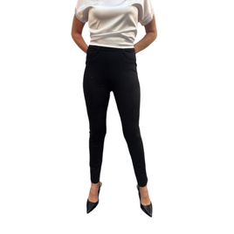
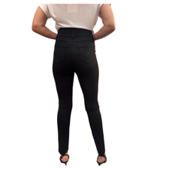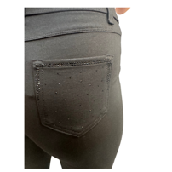

Plain Jeans – Poly Cotton Spandex
Machine Washable, Ironing/steaming if required, use cool heat from inside out. Do not Tumble Dry.
Sizes S, M, L, XL, XXL, XXXL.
White LC810JW, Black LC810JB, Yellow LC810JY, Lime LC810JL, Purple LC810JP, Orange LC810JO,
Pink LC810JHP, Camel LC810JC - WS $71 RRP$178

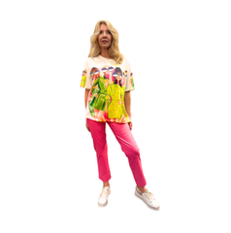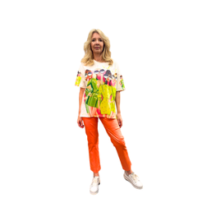
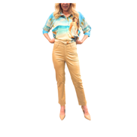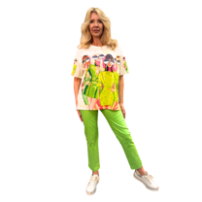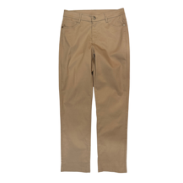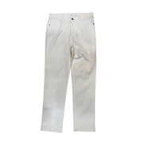

Elasticized Pull Up Pant - Polyester
Machine Washable.
Ironing/steaming if required, use cool heat from inside out. Do not Tumble Dry.
Sizes S, M, L, XL, XXL, XXXL.
Yellow LCLiorPY, Orange LCLiorPO, Turquoise LCLiorPT, Red LCLiorPR, Pale Pink LCLiorPPP, White LCLiorPW, LCLiorPB
WS $63.50 RRP $159
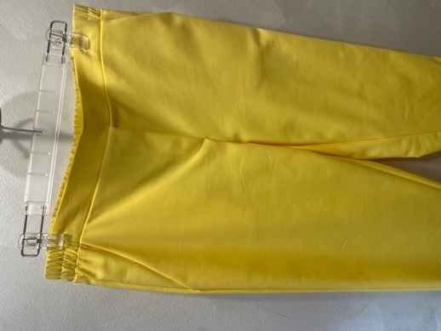
Cargo Pant – 62% Polyester , 35% Cotton, 3% Spandex
Machine Washable.
Ironing/steaming if required, use cool heat from inside out. Do not Tumble Dry.
Sizes S, M, L, XL, XXL, XXXL.
White LC011CargoPW, Black LC011CargoPB, Camel LC011camelPC –
WS $98, RRP $249

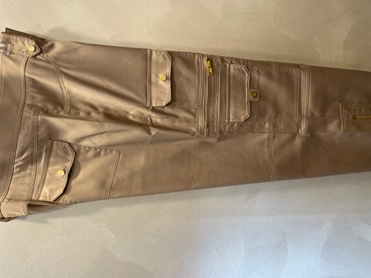

Chain Pant – 62% Polyester , 35% Cotton, 3% Spandex
Machine Washable.
Ironing/steaming if required, use cool heat from inside out. Do not Tumble Dry.
Sizes S, M, L, XL, XXL, XXXL.
White LC012ChainPW, Black LC012ChainPB, Camel LC012ChainPC, Navy LC012ChainPN, Orange LC012ChainPO –
WS $98, RRP $249
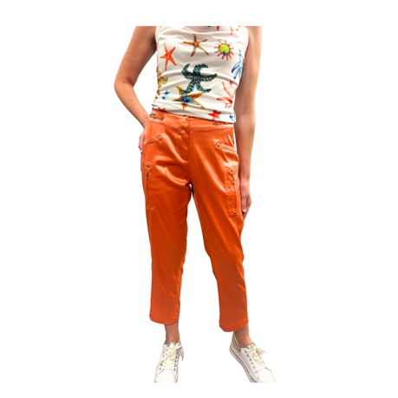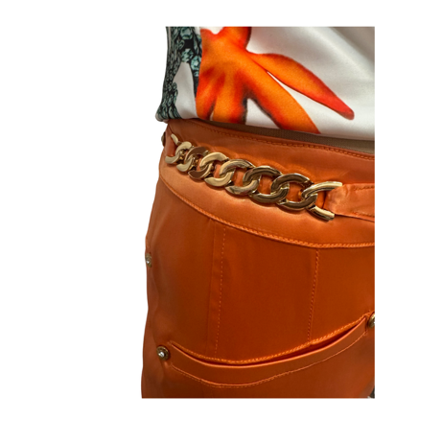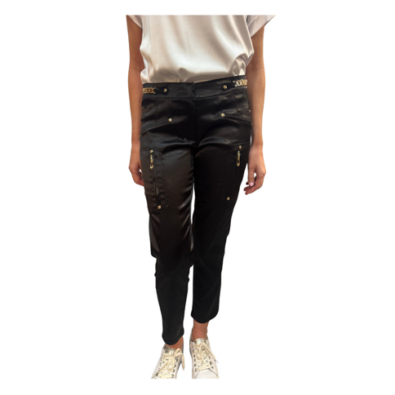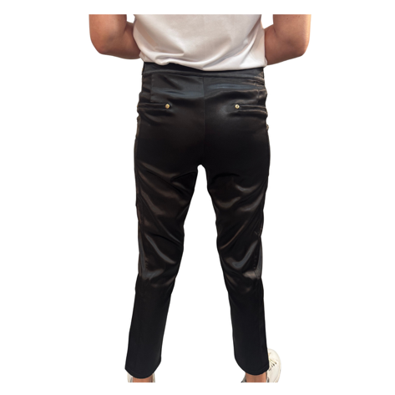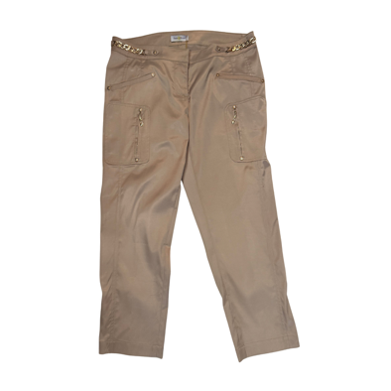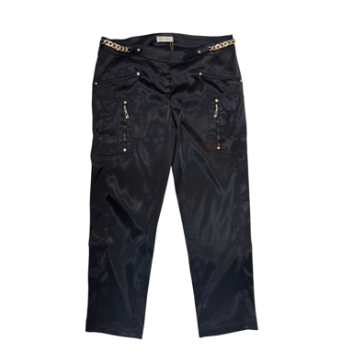

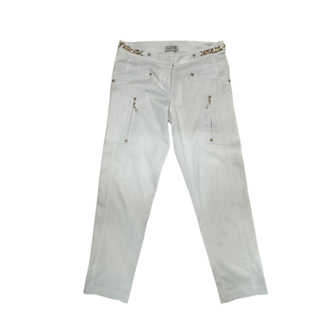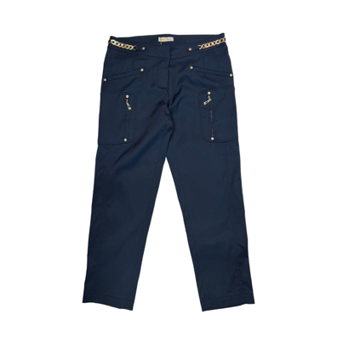

Top - Polyester Spandex
Machine Washable.
Ironing/steaming if required, use cool heat from inside out. Do not Tumble Dry.
Sizes S, M, L, XL, XXL, XXXL.
LC0632Pink, LC0632Orange, LC0632Yellow, WS $59 RRP $147
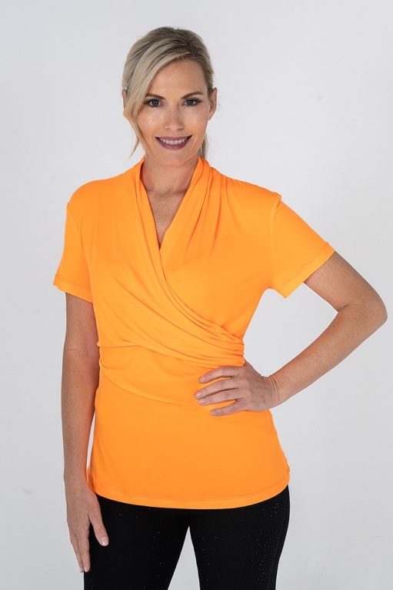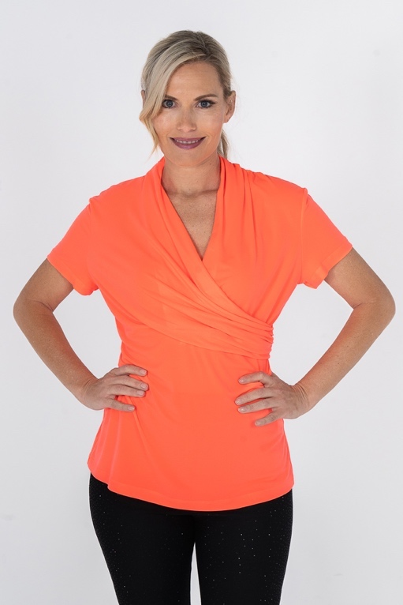
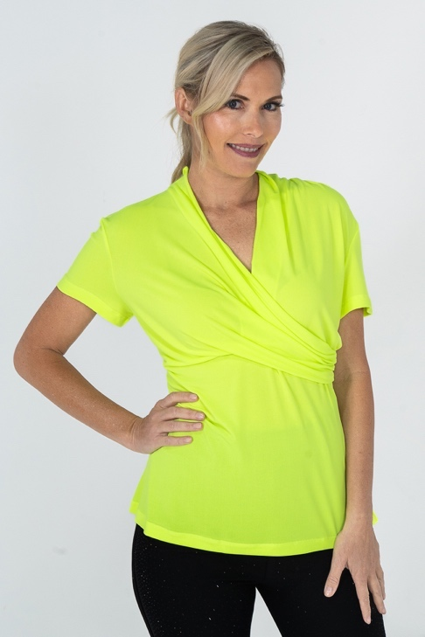

Liz Clift International - Crystal Embellished Tank - Rayon 67%, Polyester 30%, Lycra 3%,
Machine Washable, crystal embellishments. Soft and stretchy tanks. Crystal embellishment down the front, plain at the back.

Ironing/steaming if required, use cool heat from inside out. Do not Tumble Dry.
Sizes S, M, L, XL, XXL, XXXL.
LCCETT - RRP $130.90 WS $59.50

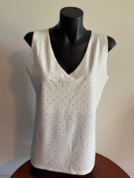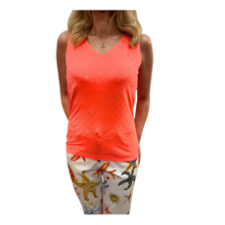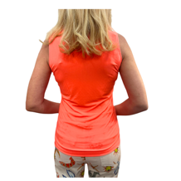
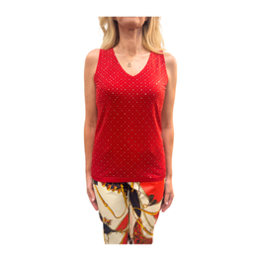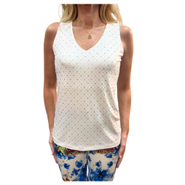

Cuffed TEE - Polyester Spandex
Machine Washable.
Ironing/steaming if required, use cool heat from inside out. Do not Tumble Dry.
Sizes S, M, L, XL, XXL, XXXL.
LCCTEE0630Purple, LCCTEE0630Pink, LCCTEE0630White, LCCTEE0630Red, LCCTEE0630Black WS $59, RRP $147
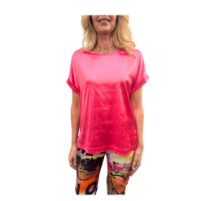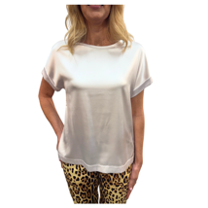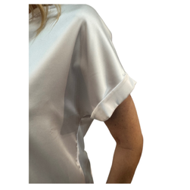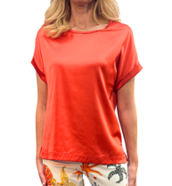

Top - Polyester
Machine Washable.
Ironing/steaming if required, use cool heat from inside out. Do not Tumble Dry.
Sizes S, M, L, XL, XXL, XXXL.
Black LC0628CowlTopB, White LC0628CowlTopW, Apricot LC0628CowlTopA, Purple LC0628CowlTopP WS $51.50, RRP $129
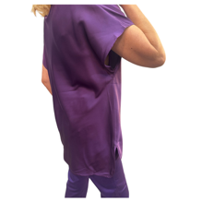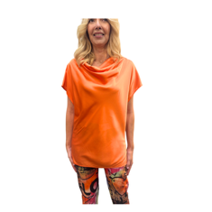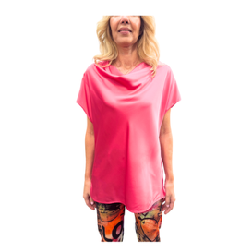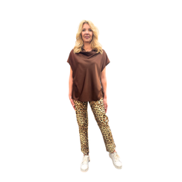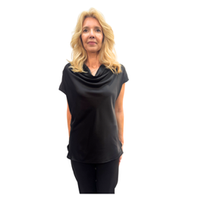

Marine Dress and Over shirt - Polyester
Machine Washable, Crystal Embellishments.
Ironing/steaming if required, use cool heat from inside out. Do not Tumble Dry.
Sizes S, M, L, XL, XXL, XXXL.
LC819Marineset WS $99.50 RRP $249 Set
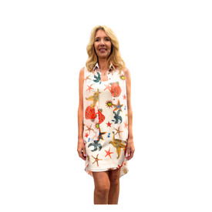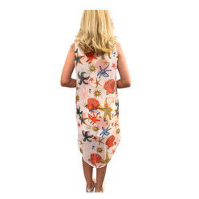

Crinkle Top - Polyester
Machine Washable.
Ironing/steaming if required, use cool heat from inside out. Do not Tumble Dry.
Sizes S, M, L, XL, XXL, XXXL.
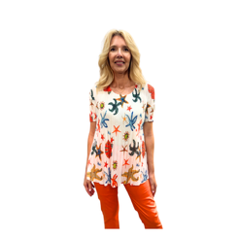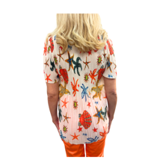

Crinkle Top Black - Polyester
Machine Washable.
Ironing/steaming if required, use cool heat from inside out. Do not Tumble Dry.
Sizes S, M, L, XL, XXL, XXXL.
LC845CTBB WS $65 RRP $162

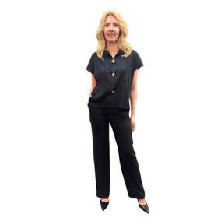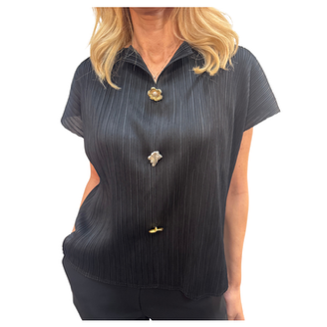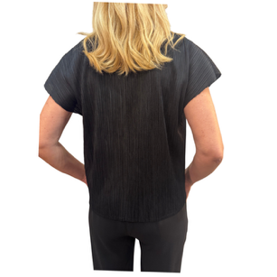

Crinkle Dress - Polyester
Machine Washable.
Ironing/steaming if required, use cool heat from inside out. Do not Tumble Dry.
Sizes S, M, L, XL, XXL, XXXL.
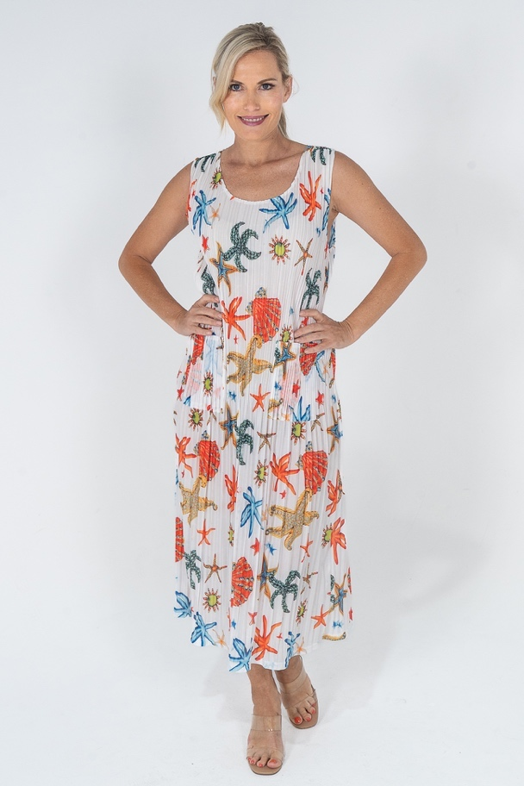
Crinkle Top - Polyester
Machine Washable.
Ironing/steaming if required, use cool heat from inside out. Do not Tumble Dry.
Sizes S, M, L, XL, XXL, XXXL.
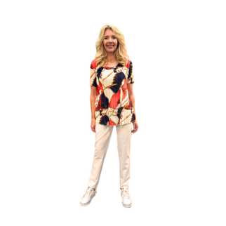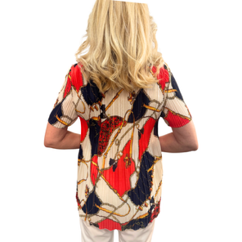

Crinkle Top - Polyester
Machine Washable.
Ironing/steaming if required, use cool heat from inside out. Do not Tumble Dry.
Sizes S, M, L, XL, XXL, XXXL.

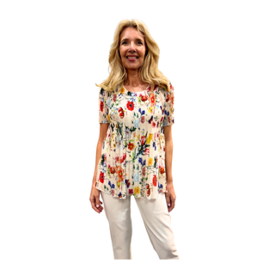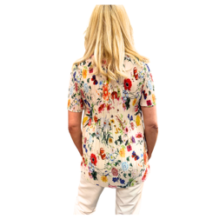
Crinkle Dress Black - Polyester
Machine Washable.
Ironing/steaming if required, use cool heat from inside out. Do not Tumble Dry.
Sizes S, M, L, XL, XXL, XXXL.
LC846BCD WS $69 RRP $173
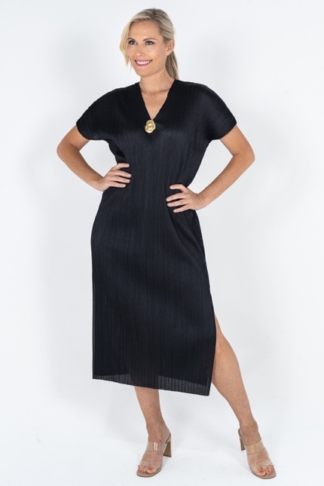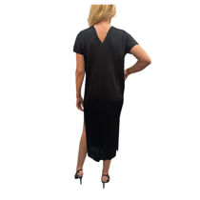

Crinkle Dress Nautical - Polyester
Machine Washable.
Ironing/steaming if required, use cool heat from inside out. Do not Tumble Dry.
Sizes S, M, L, XL, XXL, XXXL.
LCCDNautical WS $69 RRP $173
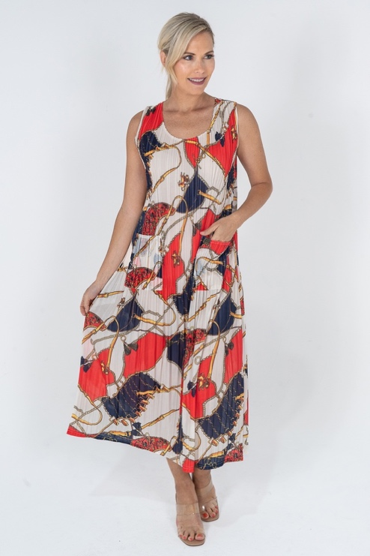
Crinkle Dress Floral - Polyester
Machine Washable.
Ironing/steaming if required, use cool heat from inside out. Do not Tumble Dry.
Sizes S, M, L, XL, XXL, XXXL.
LC851CDF WS $73 RRP $182.50
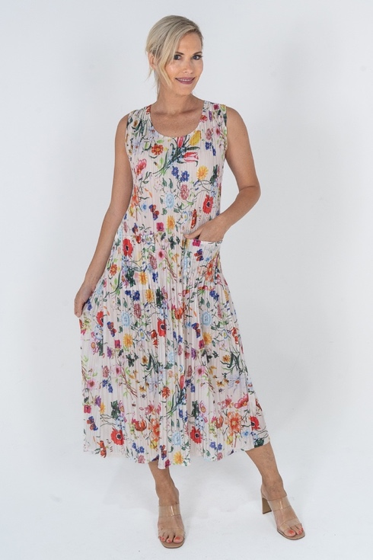
Crinkle Dress with sleeve Floral - Polyester
Machine Washable.
Ironing/steaming if required, use cool heat from inside out. Do not Tumble Dry.
Sizes S, M, L, XL, XXL, XXXL.
LCCDFSleeve WS $73 RRP $182.50?? check price
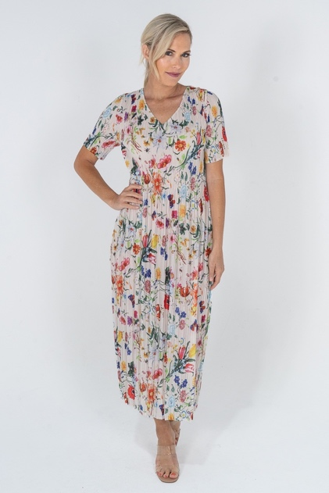

Pajamas - Polyester
Machine Washable.
Ironing/steaming if required, use cool heat from inside out. Do not Tumble Dry.
Sizes S, M, L, XL, XXL, XXXL.
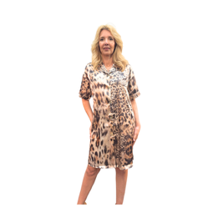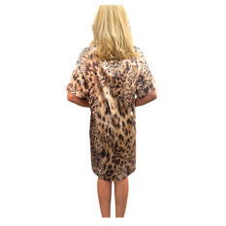

Pajamas - Polyester
Machine Washable.
Ironing/steaming if required, use cool heat from inside out. Do not Tumble Dry.
Sizes S, M, L, XL, XXL, XXXL.
