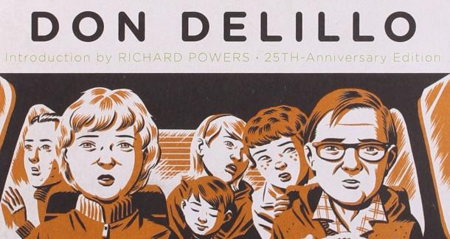
Image credit: Michael Cho

Image Credit: Sara Krulwich

DeLillo’s White Noise as Literary North Star
By Bill Yazbec

Don DeLillo’s White Noise (1985), a National Book Award winner, was assigned to me and a handful of other grad students in a class called The Small Town in American Literature taught by Dr. Tom Carlson at the University of Memphis in 2000. It knocked me on my ass.
“With its focus on the decentered subject and its playful highlighting of the American love of violence, the media, and commercialism, White Noise remains emblematic of the postmodernism of the early 1980s,” states Katrina Harack in the journal Contemporary Literature. It is a novel in three sections: Waves and Radiation, The Airborne Toxic Event, and Dylarama. Each section can stand alone though each are connected. The characters, a bit of a motley crew, led by Professor and progenitor of Hitler Studies Jack Gladney, his family, friends, and colleagues, appear in each section set on a Midwestern campus in a college town called Blacksmith. DeLillo meditates on consumerism and branding, the omnipresence of death, the comfortable quality and recognition of parts of ourselves in family, as well as the grotesque in everyday life, all adding up to the white noise that we are forced to struggle through to exist in a culture as ridiculous as ours can be.
Two scenes resonate. The opening scene when Gladney opines on the arrival of the college students to campus and the “communal recognition” celebrated and viewed from a narrative distance is as memorable and striking as the final scene in The Great Gatsby. It has always seemed to me that DeLillo’s opening is speaking to Fitzgerald’s end. “I pulled in at a place that specialized in chicken parts and brownies. In chapter 31, the author writes clinically in clipped sentences of our conditioned behavior to consume and mindlessly conform to cultural cues: “We decided to eat in the car. The car was sufficient for our needs. We wanted to eat, not look around at other people. We wanted to fill our stomachs and get it over with. We didn’t need light and space.”
The first year or two of graduate school in English is coming to terms with the fact that you don’t know anything. One may have excelled at their studies as an undergraduate, consumed everything put in front of them, and written astute analyses of the great books of the canon but graduate school is a different animal. Everything is about exposure and deep-dives into ideas, writing, and contexts that most normal people don’t take the time to bother with- perhaps to their benefit. I had never heard of Don DeLillo before I walked into that class. I walked out devoted to him and White Noise as much as any acolyte. I silently rejoiced at the dual genius of DeLillo and our understated prof, Dr. Carlson, for bringing it to me. We read other works of literature that I enjoyed- In the Heart of the Heart of the Country by William Gass and Winesburg, Ohio by Sherwood Anderson come to mind- but I read White Noise four times that semester, peeking at it whenever I had free time and devouring all the criticism I could find.
It is a book I buy whenever I see it at a used bookstore. I’ve given copies to more people than I can remember. I’d read Vonnegut, The Hitchhiker’s Guide to the Galaxy, and most of Tom Robbins so I had an affinity for the absurd that DeLillo took to another level. Perhaps that was because Dr. Carlson had brought it into a graduate classroom. This was serious literary fiction studied in a classroom! It was what I wanted to write and more importantly how I wanted to write. I was in Memphis for an MFA to get serious about my writing and DeLillo opened my eyes. I didn’t have to lose what I thought of as “my style,” I just needed to get better and practice to maybe someday sniff DeLillo’s greatness in my own work. I still haven’t gotten there nor do I expect to, but I sure as hell will keep trying.
In my fiction thesis I wrote two years later, a novel, I copped everything from White Noise stylistically I could. I had three stand-alone sections that characters ran through. I mused on consumerism and the grotesque. I wrote short chapters just like him. In a way, it was a tribute to DeLillo and White Noise. Alas, that novel sits on my hard drive turned down by probably twenty different publishers- one even said it was “too derivative of DeLillo”- which I took as a compliment.
It’s been said by someone smarter than me that the first novel you publish is the one you had to write and that was true for me. The third one I wrote got published by a small press and it is me laying bare the small traumas I have endured transposed on characters that are similar to people I’ve known. My White Noise tribute novel was about characters that were like DeLillo’s and probably not true to who I am as a writer. However, in the one that got published, I notice that I unconsciously kept a lot of the DeLillo mannerisms weaved into a story I was better equipped to write.
DeLillo first published a story in Epoch in 1960, has written seventeen novels and received accolades and awards too many to name. He’s a north star for many writers and mostly lets his work speak for itself, not appearing much in the media or giving many interviews. Dr. Carlson, who I had the honor later to consider as a friend that I could speak to using his first name, passed on in 2018 leaving a legacy of writing and multitudes of sharper students. I think Tom would agree with DeLillo who said in 2005: “Writers must oppose systems. It's important to write against power, corporations, the state, and the whole system of consumption and of debilitating entertainments.” I know I do.

