**Women That Hunt**

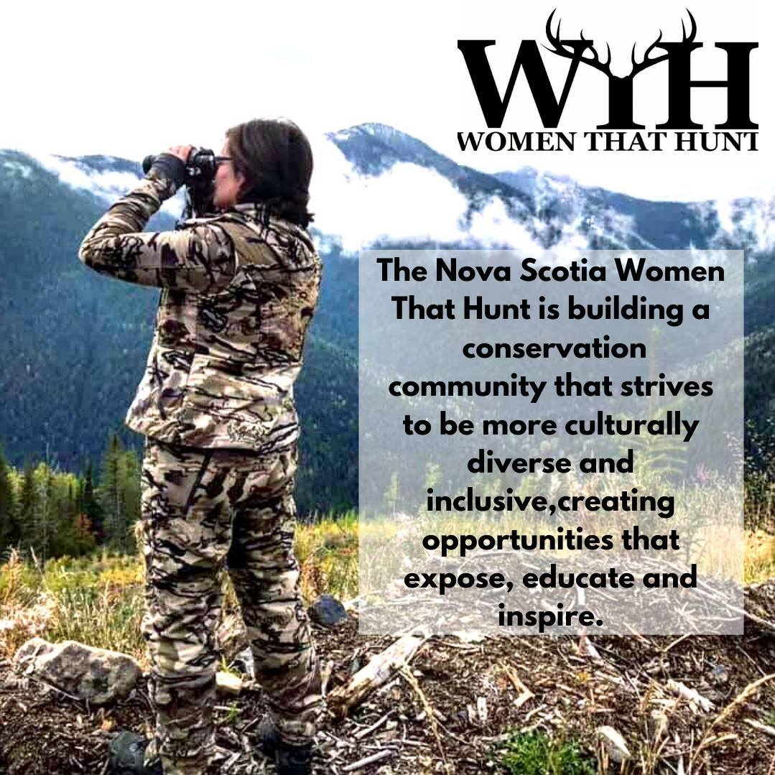

Our Sponsors

**Recipient of the 2020 Provincial Volunteer Award**

President Kelly Countway accepted on behalf of the NS Women That Hunt Association

**Started our WTH Youtube Channel**

Check out our Youtube channel for great ideas, how to’s and DIY

**Initiated our WTH Ambassador Program**

We now have 4 Ambassadors in Nova Scotia and New Brunswick to assist us in growing our mission and vision

**Implemented the NOAAH Registry**

Over 75 applicants with 17 successful matches taking place across NS and 18 pending matches

**Firearms Education/Hunters Safety Education**

WTH Instructors travelled the province hosting Canadian Firearms Safety and Hunters Education Courses. In 2020, 239 individuals were certified

|  |  |
| --- | --- |
| Stoeger Canada | Pilla Sport Canada |
| Beretta Canada | My Wilder Brand |
| Ursa Major Outfitters | Long Range Coffee |
| Big Ear Inc. | Tenth Legion Guides |
| Benelli | Fur & Feathers Outfitters |
| Tikka | Bite the bullet |
| Hirsch Precision Ltd. | Frug Survival Gear |
| Spypoint Trail Camera | Truro Struttin’ Gobblers |
| Hnatiuks Hunting and Fishing Ltd. | Traeger Grills – Vintage  Stove & Fireplace Ltd. |

**Youth Expo YTD**:

356 Exhibitors, 12,010 participants. Funded by the NS Habitat Conservation Fund and Municipality of Colchester

**Conservation Bursary YTD:**

10 graduating students received in total $10,000 in bursary funds

**Water N’ Woods YTD:**

120 youth have completed the program

Expanded to include trappers’ course

Certified 24 Trappers, 36 new hunters

Funded by NS Habitat Conservation Fund

**Membership**

Total number of Active Members: 177

**Member draws**

May 15, 2020: Clearwater 9’, 5wt, 4pc Fly Rod and

reel set.

**Winner: Darlene Wright Watters**

November 15, 2020: Francolin Single-shot

break action 20 Gauge shotgun

**Winner: Ashley Oxley**

**12 Annual Monthly Membership Draw winners**

**Other Contests winners:**

Mothers day sponsored by BecknBoosh & WTH: **Katelyn McGinley**

Fathers day sponsored by Bite the Bullet:

**Phillip Nelson**

WTH 50K Step Up sponsored by My Wilder Brand:

**Melissa Pulsifer & Shannon Cunningham**

WTH by Numbers

Achievements

**2020 Board**

|  |  |  |  |
| --- | --- | --- | --- |
| President :  Kelly Countway  image246 | Vice:  Kim Van de Vrie  image247 | Secretary :  Aschaelle Sill  image248 | Treasurer :  Megan Colpitts  image249 |
| Director:  Sali Sabean  image250 | Director:  Mary Atkinson  image252 | Director:  Jessica Proulx  image254 | Direcoor  Lila Gale  image255 |
|  | Director:  Theresa Langille  image251 | Director: Crustal Turko  image253 |  |

2021 Board

2021

February

2020 YEAR IN REVIEW:

January 26, 2020 – WTH Board meeting

Feb 15, 2020 – AGM, Banquet & Workshops

Feb 16, 2020 – Attended SCI Nova Scotia Hard Water Classic Ice Fishing

Feb 22, 2020 – Participated in the Fundy Female Leadership Network ACE awards

Feb 29, 2020 – Participated in Truro Delta Waterfowl Banquet, 12 youth sponsored for their CFSC and HE courses which will be instructed by the WTH

March 5-7, 2020 – Attended Trappers Association of NS convention and AGM

March 7, 2020 – Attended Fly tying workshop with Cobequid Salmon Association

March 9, 2020 – Participated in the International women’s day luncheon – WTH decorated a table and attended the luncheon

May 18, 2020 –WTH Board meeting

June 28, 2020 – Participated in the Delta Eastern Shore Committee BBQ

June 29, 2020 –WTH Board meeting

July 12, 2020 – Sporting clays workshop, Nova Sporting Clays

July 20, 2020 – WTH Board meeting

August 14, 2020 – Attended Trappers Rendezvous

August 22, 2020 – Attended Southwest Delta Women’s day, sporting clay, trap and skeet workshop

August 23, 2020 – Attended PEI Delta Waterfowl trap and skeet fundraiser for the Neonatal intensive care unit of Charlottetown

August 29/30, 2020 – Chainsaw workshop (ladies only and co-ed 12 and older)

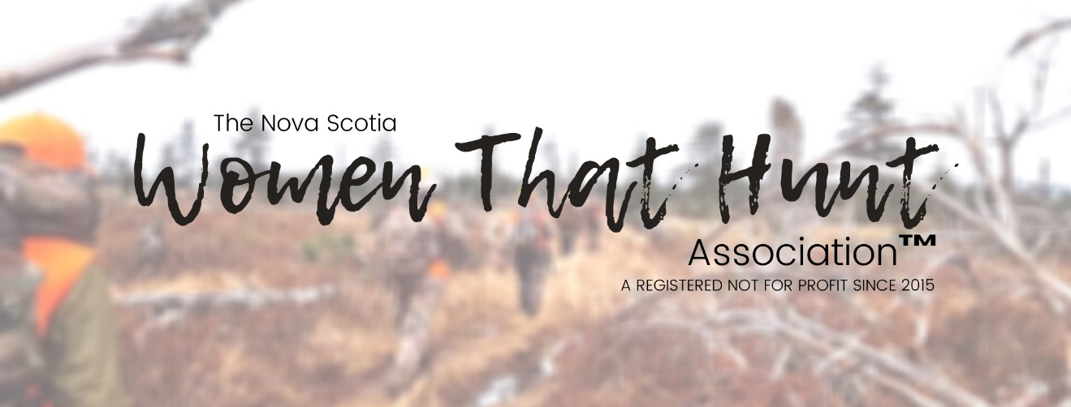

* July 4-6 Attend the PEI Cast & Blast with Womens Waterfowlers of Pei Delta Chapter & Women shooters of PEI
* July 11-12 Host a Canadian Firearms Safety Course & Hunters Education Course Brookfield
* July 19 Host a WTH Board meeting & Social Archery
* July 25 Community outreach collaboration Traeger Canada BBQ in partnership with Vintage Stoves
* August 1 Host the Intro to whitetail deer workshop
* August 19-21 Host the Water n’ Woods weekend
* September 12, 13 Participate in the Hunting Sports Atlantic Tradeshow Moncton
* September 18,19,20 – Community outreach collaboration with Girls & Gundogs CKC Field test and upland bird intro with Firefly Kennel & gundog
* September 21 Host/collaborate Youth Heritage Day Waterfowl Hunt
* September 26 Participate in the Woodlot Owner of the Year Field Day, Annapolis Valley
* September 28 Host the WTH meeting & social
* October 2 Host/collaborate Mentored Women’s & Children’s Turkey Hunt in Maine with 10th Legion Guides
* November 15 Host the WTH meeting & social hydro dipping & DIY taxidermy
* December 20 Host the Share the Harvest Dinner
* March 13-15 Participate in the Halifax Outdoor Sports and RV Show
* March 21 Attend the Intro to Archery Moncton Seminar
* March 21-22 Attend the Nova Scotia Federation of Anglers and Hunters AGM
* March 27-29 Participate in the NB Sportsmen & Fly fishing Show
* March 29 Ambassador Lead Bushcraft & Survival Skills Seminar Kentville
* April 18-19 Host a Canadian Firearms Safety Course & Hunters Education Course in Brookfield
* April 25th Attend the Ducks Unlimited Valley Chapter AGM & Banquet
* April 26 Host the Women that Hunt Meeting & Social
* May 16 Participate in Truro Struttin Gobblers Fisherama
* May 2 Participate/collaborate in Polaris ATV Ladies day in partnership with Pattersons Truro
* May 6-7 Participate in Sydney Mines Outdoor Show
* May 9 Host the Youth Expo
* May 23 Host the Intro to Waterfowl seminar
* May 29 Participate inTruro Struttin Gobblers AGM & Banquet
* June 6 & 7 Host the Washabuck, CB Women’s Mentor Fishing Trip
* June 21 Host the WTH intro to bass fishing social and board meeting
* July 4 Participate in the Welcome home Brookfield- Parade & pie eating contest

Unfortunately due to the state of emergency declared in March 2020 our many events and activities planned for 2020 which we had hoped to participate in came to a halt. Had this been a normal year we would have been just as busy as always. Here is the list of events we had planned that we were unable to host, attend or participate in:

Our 2020 Calendar of Events

September 5, 2020 – Participated in Shipwreck survival workshop (Ursa Major Outfitters event)

September 5, 2020 – Canadian Firearms Safety Course (non-restricted)

September 6, 2020 - Canadian Firearms Safety Course (non-restricted)

September 21, 2020 –WTH Board Meeting

September 26, 2020 - Canadian Firearms Safety Course (non-restricted)

September 27, 2020 - Canadian Firearms Safety Course (non-restricted)

September 28, 2020 – WTH sponsored bear hunt with Fur & Feather Outfitters

October 3, 2020 - Canadian Firearms Safety Course (non-restricted)

October 4, 2020 - Canadian Firearms Safety Course (non-restricted)

October 10, 2020 – Ladies pheasant hunt with First to Flight Game Birds

October 18, 2020 – Chainsaw workshop

November 11, 2020 – Youth Pheasant hunt with Truro Struttin Gobblers and First to Flight Game Birds

November 15, 2020 – Ladies only Restricted Canadian Firearms Safety Course

November 16, 2020 – WTH Board meeting

December 5, 2020 - Canadian Firearms Safety Course (non-restricted)

December 6, 2020 – Hunters Education Course