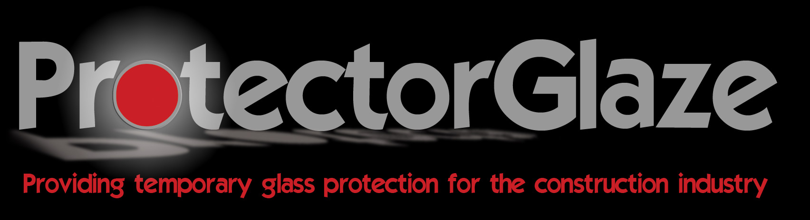

PROTECTORGLAZE - The clear peelable coating solution formulated for use on glass, ppc aluminium, PVCu, and most non-porous painted timber surfaces that require temporary protection from other building trades.

PROTECTION IN 3 EASY STEPS

Apply by roller.  The coating is clear when dry allowing diffused light into the building. |  | Simply peel to remove  at the end of the project revealing clean glass. |  | No bulk  and  Environmentally disposed.
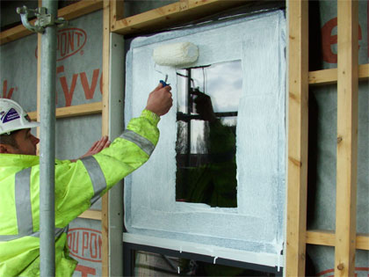 |  | 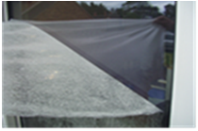 |  | 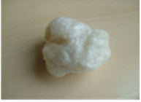

FINANCIAL ADVANTAGES
Considerably less labour time required to apply when compared to
polyethylene film-based products
Glass can remain dusty when applying our product, unlike adhesive film that will require the glass to be cleaned first
No waste factor with material as opposed to film that requires cutting and shaping
Leaves no residue that requires cleaning away
Reduces the time needed for final clean
Protectorglaze does not fall away from the protected surface and need re-applying on site

PRACTICAL ADVANTAGES

 | UV stable |  | 12 months when applied externally and 12+ months internally.
 | Leaves a clear  Dry-film. |  | Optimises visual space allowing light  penetration.
 | Product Longevity/Resistance to Weathering at  Correct Thickness |  | 12 months when applied externally and used with ProtectorGlaze Topcoat.
 | Non-Hazardous |  | Water-resistant when dry / Water- cleanable when wet.
 | Non-Flammable. |  | Fire- Resistant to BS 476 Part 7. Currently testing to EN13501-1.  Resistant to Hot Works grinder ‘flecks’ and welding ‘spatter’, associated with curtain walling fabrication and installation.
 | Less Waste  Volume. |  | 1sq m of dry film creates just 60mm diameter ball of waste.

For further information contact: Protectorglaze Ltd,
Tel: 0800 707 6711  Email: sales@protectorglaze.com  Web: www.protectorglaze.com | 