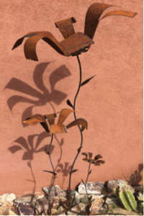
Plasma Cutting & Welding Workshop

CREATE MULTIPLE PLASMA-CUT WELDED PIECES, A FLOWER, & MORE. BEND, ROLL, TEXTURE & FOLLOW YOUR IMAGINATION AS YOU LEARN HOW TO USE A MILLER MIG WELDER, HYPOTHERM PLASMA CUTTER, ROLLER, BREAK, PLANNISHING HAMMER, SHEAR, AND OTHER AMAZING TOOLS. COME WITH IDEAS FOR PROJECTS & I WILL FIND THE MATERIALS AND EQUIP YOU WITH THE SKILLS TO MAKE SOMETHING YOU ARE PROUD OF AND EAGER TO SHOW OFF.

PLASMA CUTTING
LEARNING TO SLICE THROUGH METAL LIKE THOR AND LET YOUR CREATIVITY FLOW! SUGGESTIONS INCLUDE: ADDRESS SIGN, SCONCE, OUTDOORS SIGNAGE, BUTTERFLY, MASK, WHIMSICAL WALL HANGING, COLLAGE OR YARD ART
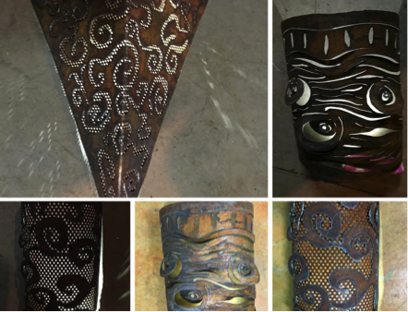
MIG WELDING – PRACTICE RUNNING “BEADS” AND JOINTS UNTIL COMFORTABLE AND PUT YOUR SKILLS TO USE MAKING A FLOWER AND MOUNTS FOR YOUR OTHER PROJECTS. Compare low and high-end welders.

WORKSHOP SUMMARY:
- Duration: 6+ hours, with break and snacks, ie: as long as your attention span
- 2-3 participant limit, to maximize the time each gets per machine
- Schedule: 520-271-2641 or emilyemann@gmail to schedule at your convenience. Bring a friend and come as a two-some!
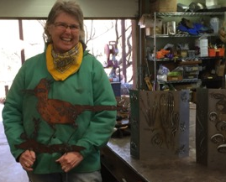
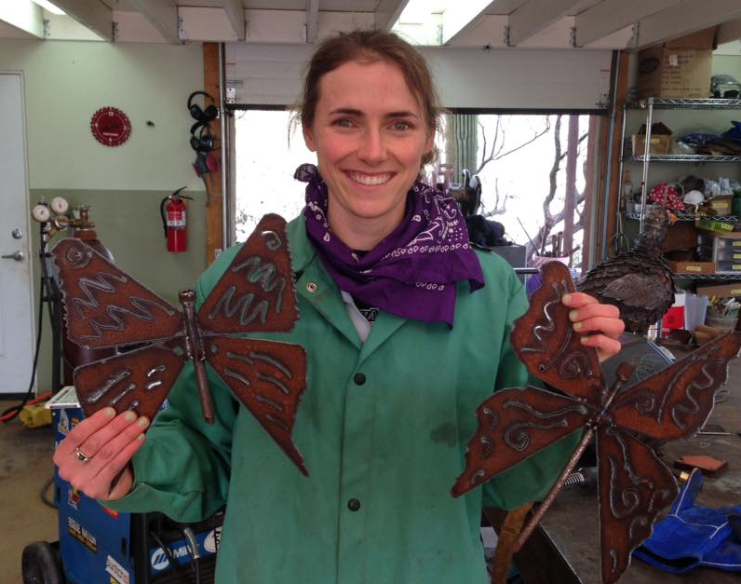
WORKSHOP STUDIO RATE: $32/HR PLUS MATERIALS WITH ACCESS TO MOST EQUIPMENT. –I WILL DO GRINDING FOR YOU ON THE BENCH GRINDER AND CUTTING WITH THE SAWS.
solaz.biz
520-271-2641

