 | Phoenix Tattoo & Removal  15 Hope Street  Bellshill  North Lanarkshire  ML4 1QA  Telephone – 07912 482506  Email –  info@phoenixtattoo.co.uk  *** Bepanthen used to be the industry  standard when recommending tattoo  aftercare until a change in ingredients  started to cause more harm than good.  An increase in the ingredient lanolin,  which is essentially sheep grease, meant  that pores were being blocked, resulting in  break-outs. More and more customers  began to complain about reacting to the  cream, as lanolin is also high on the list of  skin related allergies. The thickness of the  cream also caused people to over-rub their  fresh tattoos,aggravating their skin all the  more. Because aftercare is one of the most  important parts of the tattooing process, We  now recommend using a product which is  specifically designed for tattoo aftercare.  From Coconut King; made from coconut oil it has a natural antibacterial, antifungal and anti-inflammatory properties and is an excellent moisturizer. It’s also  vegan and cruelty free  … I know I’d prefer not to smear sheep  grease all over my new tattoo! | Work by Jordy Coyle  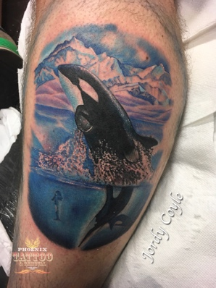  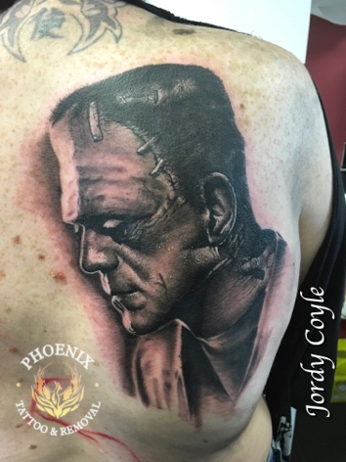  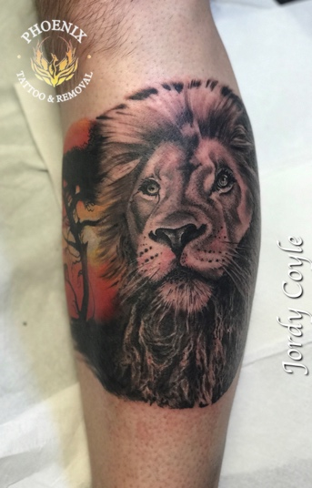 |  |  | Phoenix Tattoo & Removal  - Tattoo Aftercare Advice

Tattoo Aftercare Advice  Congrats! You have just received a new tattoo from Phoenix Tattoo & Removal. In order for your new tattoo to heal in the best possible manner, we recommend that you follow only these instructions;  Leave that bandage/cover alone -  Your artist took care to cover your new tattoo for a good reason, as pretty as your tattoo is, it is still an open wound and open flesh is a breeding ground for bacteria and infection. Leave the bandage/cover alone for a minimum of two hours.  Washing and Treatment -  After you remove your bandage/cover you’re going to need to wash your tattoo using luke-warm water and a mild, non-scented soap to remove any excess ink and blood – something like a Simple or Sanex soap..  DO NOT use a wash cloth or anything abrasive on your new tattoo, a clean hand is the best tool to use in this case. Let the area totally air dry before applying a very thin layer of tattoo aftercare. We stock our own aftercare from Coconut King, especially designed for tattoo aftercare. Alternatively the only other thing we recommend is Palmers unscented Coco Butter.  Use the tattoo aftercare 3-5 times per day for up to 10 days or until completely healed, whilst also ensuring that you are keeping the area clean.  DO NOT use Savlon or Bepanthan ** on your new tattoo. (See overleaf for details). |  | Scabbing and Peeling -  After a few days you will notice that the skin around the tattoo will start to peel and flake perhaps even scab. DO NOT SCRATCH, PICK OR PEEL AT YOUR NEW TATTOO! By this time your tattoo is almost done healing, now is not the time to ruin it by scratching or picking it.  Baths, Showers and Pools -  Yes, you can (and should) shower with a new tattoo, it is okay to get your new tattoo wet. However do not submerge your tattoo underwater for the first 2-3 weeks. We recommend short showers for the first week or so. Baths, hot tubs and pools can cause serious damage to your new tattoo and should be avoided.  Jewellery  DO NOT let jewelry come into contact with the tattooed area until the area is healed. Jewellery can irritate the area, slow the healing process and potentially cause infection.  Protection from the sun -  Do not sunbathe or use sunbeds whilst your tattoo is healing or for up to 6 weeks after your tattoo was done. Afterwards you will need to always protect it from the sun’s ultraviolet rays. The sun will fade a brilliant tattoo very quickly. Protect your tattoo with a minimum of 30 SPF sunblock.  Following these simple steps will keep your tattoo and investment looking bold and vibrant for many years to come. Please do not listen to friends, family, co-workers etc. on how to care for your new tattoo, our artists are the experts and their advice should be listened to.  If you have any soreness, redness or concerns, please do not hesitate to contact us. |  | Work by Sebastian Michta  