**Website - www.phoenixtattoo.co.uk**

**Email - info@phoenixtattoo.co.uk**

**Phone - 07912 482506**

**15 Hope Street, Bellshill,**

**North Lanarkshire, ML4 1QA**

**ALL CONSULTATIONS AND PATCH TESTS ARE FREE**

**Both male & female laser technician’s available**

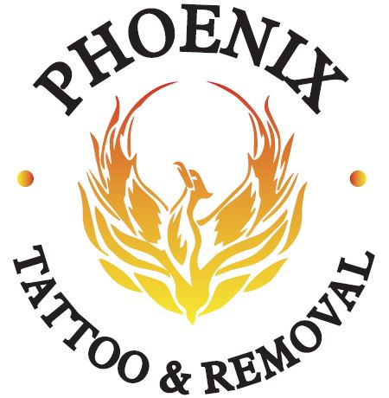

 

**TATTOO LASER REMOVAL**

**Information & Aftercare**

1. Keep the treated area clean and dry whilst it’s healing, particularly while there is scabbing present. Remove your sterile dressing, leaving it on no longer than 1 hour after treatment and wash with warm water. We suggest using Savlon, which although it has now been stopped for the healing of fresh tattoos, there is evidence of the components withdrawing ink from them. Hence why we suggest Savlon to help our removal process. You may find your scabs contain colours of the ink from your tattoo.
2. Blistering can happen, if this does apply a cool compress to take the heat from the blister. Do not pop the blister as it is keeping out bacteria which could potentially cause infection.
3. Do not pick at the scabbing or allow the skin to become scraped, as this could cause either infection or scaring. Avoid shaving the treated area whilst it’s healing.
4. Feel free to shower a couple of hours after the treatment, but take care to avoid high pressure water hitting the treated area. **Baths, hot tubs, swimming or any form of soaking the area are not recommended until all the scabbing is completely healed**. This will avoid cross contamination and infection.
5. Use your Savlon at least 3 times per day whilst scabbing is present.
6. Wear a sun block with an **SPF 50+ or even total sun block** over the area during the treatments and for 3 months following your very last treatment. This protects the skins protective layer and melanin production from being damaged and causing hypo/hyper pigmentation (light or dark patches).
7. Itching is very common due to the dehydrating effect of the laser treatment. We suggest that you can either use a Vitamin E, Bio-oil or E45 cream; these are available cheaply at all good chemists or grocery stores.
8. If the area looks infected (honey coloured and oozing or a spreading redness) or if you experience an unusual discomfort, bleeding, if any other complications develop or simply if you have any questions, please contact us immediately.

.

**Homecare – between laser sessions;**

**Aftercare – the first 24-48 hours after treatment;**

