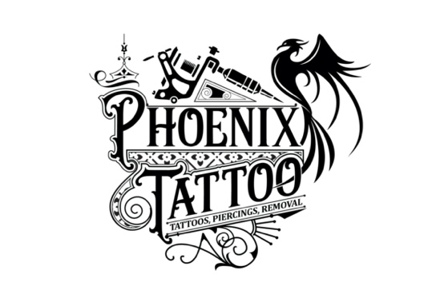
HEALING TIMES

Dermal implants 3 months
Lobe(s) 6 weeks
Ear cartilage which includes Rook, Tragus, Helix,
Snug, Daith, Conch, industrial 3-6 months
Navel 6 months
Nipple 3-6 months
Lip/labret 6 weeks
Philtrum 6 weeks
Inverted/vertical lip 6-12 weeks
Eyebrow 2-3 month
Nostril 3-6 weeks
Septum 4-6 weeks
Bridge 3-6 months
Tongue 4-6 weeks
PA (Prince Albert) 4-6 weeks
Dydoe 2-3 months
Hafada/scrotum 2-3 months
Pubic 6 months
VCH (vertical clit hood) 2-6 weeks
outer labia 2-3 months
Inner labia 4-6 months
All Surface around 6 months

Please note that healing times are based upon the average times experienced by most clients. Expect some piercings to take up to 1 year healing time, this includes nipple & some cartilage piercings such as industrial & nose, etc.
Tongue piercings are most difficult for the first couple of weeks.
Everyone is different & the rate at which your piercing(s) heal will differ for each individual.

Don't worry if your piercing heals quicker or slower than the guide given - if you have ANY queries about the healing of your piercing then please don't hesitate to contact us on 01698 451391

Remember there is no such thing as a “stupid question”. You can never be too careful when it comes to your body!

