South Dakota State University
Department of Economics

BADM 280: Personal Finance
Spring 2013, 3 credits
Tuesday & Thursday, 12:30 -1:45, Room 041 Avera Health & Science Center

Instructor: Bruce Johnson, MBA
Office: By appointment, Scobey Hall
Phone: 605-695-8415
E-mail: Bruce.Johnson@sdstate.edu

Course Description:
This course is a survey of individual investment opportunities. Topics include common and preferred stocks and corporate bonds, auto, life, and health insurance, home ownership, and will and estate planning.

Course Prerequisites
There are no prerequisite courses for BADM 280. Students should be comfortable utilizing Microsoft Word, Excel, and PowerPoint. Students will need to access various online resources throughout the class.

Description of Instructional Methods
The instructor will utilize lecture, media, and practical application. Students are strongly encouraged to bring internet accessible laptop computers if possible. Students should note that abuse of technological privileges will be met with serious consequences including a significant grade deduction.

Course Requirements
- Required Text: Beth Kobliner (2009). Get a Financial Life. 3rd Ed. Simon & Schuster
  - ISBN-10: 0743264363
  - ISBN-13: 978-0743264365
- Class Handouts: These can be found on D2L. Students will have access to these prior to class.

- Attendance- Due to the nature of this class, attendance is imperative. Failing to attend will result in a 1 point deduction from your grade. In case of family emergency, death, illness, etc. the student must inform the instructor as soon as possible, and arrangements must be made for make-up work to be completed. If an absence is anticipated, all work must be submitted before the absence. Verified medical reasons, death of family member or significant other, or verified extenuating circumstances judged acceptable by the instructor or the institution, will be honored. But, any absence, excused or unexcused, will result in a 1 point deduction from your total grade. This will be further explained the first day of class.

- Late Work-Late work will not be accepted.

- Academic Honesty- Any instance of cheating will be handled in accordance with established University procedures. WARNING: copying or paraphrasing another student's homework will be treated as any other form of academic misconduct. Both will result in students receiving a score of zero for their work. Students failing to contribute in group activities will receive zero points for that assignment.

- Add/Drop dates

Last day to add or drop a course | See Academic Calendar
Last day to withdraw | See Academic Calendar

Course Goals and Student Learning Outcomes
The instructor will deliver information intended to align with the following outcomes. Having successfully completed this course, students should be able to:

- Understand personal finance terminology (financial literacy)
- Gain an understanding of financial decisions they may encounter
- Evaluate large purchasing decisions and their various intricacies
- Obtain tools and resources to help manage their finances
- Gain an appreciation for managing financial risk
- Increase their wealth via investing in various asset classes

Evaluation Procedures
Each assignment (and Exams) will be graded on a point basis as outlined in the assignments. Please note that participation counts for more than 28% of your grade.

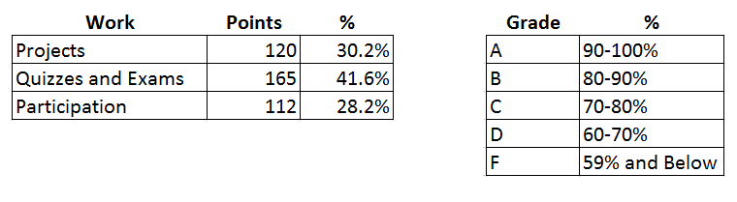
ADA Statement
Any student who feels s/he may need an accommodation based on the impact of a disability should contact Nancy Hartenhoff-Crooks, Coordinator of Disability Services (605-688-4504 or Fax, 605-688-4987) to privately discuss your specific needs. The Office of Disability Services is located in room 065, the Student Union.

If you are a student with a disability that makes the use of a standard “clicker” device difficult or impossible please do not buy a device at the campus bookstore. Instead please contact Instructional Design Services at 605.688.6312. IDS will assist you in obtaining an accessible version of the technology to fit your needs.

Course Schedule/Matrix
I reserve the right to make adjustments to the course schedule and syllabus but will take into account many considerations before doing so.

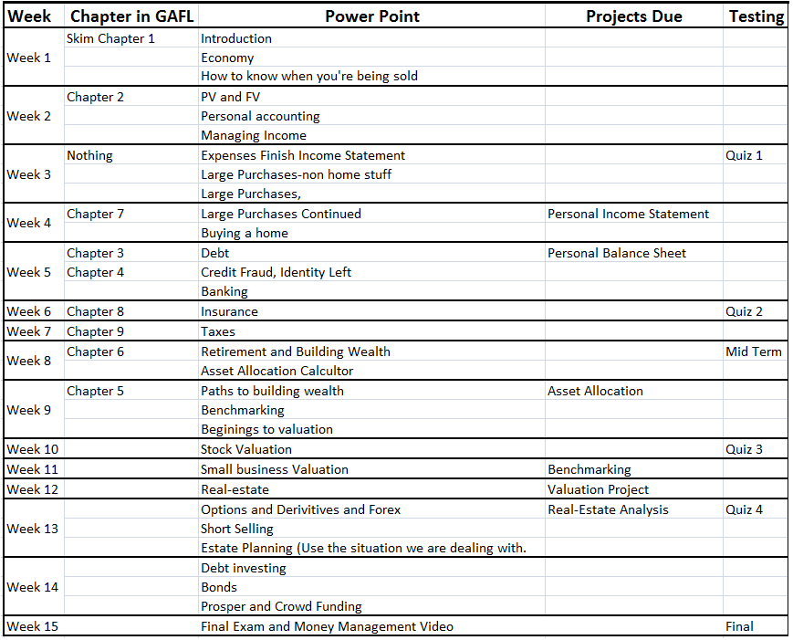

Freedom in Learning
Students are responsible for learning the content of any course of study in which they are enrolled. Under Board of Regents and University policy, student academic performance shall be evaluated solely on an academic basis and students should be free to take reasoned exception to the data or views offered in any courses of study. Students who believe that an academic evaluation is unrelated to academic standards but is related instead to judgment of their personal opinion or conduct should first contact the instructor of the course. If the student remains unsatisfied, the student may contact the department head.

Instructor’s Disclaimer
I reserve the right to make adjustments to the course and coursework. Occasionally, circumstances may arise where a change in the course and coursework is warranted. Students should not manage their grade (E.G. determining what it takes to get an ‘A’, and then doing the minimum work required to get that grade).

