* **Nickster AQHA #5444898**

**2023 Breeding Season Contract**

**$1500 Stallion Fee + $300 Booking/Chute Fee**

This certifies that ___________________ (recorded owner of mare at time of breeding) herein referred to as the Mare Owner, has engaged one breeding to Nickster for the 2023 breeding season for the following mare:

Registered name:____________________Registration#_______________________

Chelsea Driedger, owner of the above named stallion, will herein be referred to as breeder. This service is engaged subject to the following:

1. This contract is good for only one foal.

2. Stallion fees for the 2023 breeding season will be $1500.00 (plus 5% gst for Canadian Mares) A non-refundable booking fee of $300 (booking/chute fee) must be returned with this contract to ensure your mare will be added to stallion’s roster.

3. SHIPMENTS - Shipping fee will be as follows:

**$200 per shipment for FED EX and UPS.**

**$400 per shipment for WESTJET – WE MUST KNOW BY 2PM CST DAY PRIOR IF NEEDED SAME DAY**

**$50 for PICKUP**

4. Cooled Semen Disclaimer: Semen is shipped on a first call, first serve basis with farm mares receiving 1st priority. Please remember that a cooled semen contract does not guarantee semen will be available. Semen order is first come first serve basis; if cooled semen is unavailable frozen semen will be offered.

**5.a. We will collect/ship Monday, Wednesday, Friday.**

**ORDERS MUST BE PLACED DAY PRIOR TO COLLECTION DAY. ORDERS after 12 p.m. C.S.T. day prior to collection days will be subject to an extra $50 fee.**

**Cancellations must be made prior to 8 a.m. on collection days or regular collection/shipping fees will apply.**

**To order call or text 204-851-0331**

6. Container Return fee is the responsibility of the mare owner. Equitainer must be returned in 7 business days or else there will be a $20.00 a day charge until container is returned.

7. Stallion Owner will make every attempt to deliver the cooled/frozen semen in a timely manner and in good condition; however, Mare Owner acknowledges the Stallion Owner cannot guarantee delivery within a specific time period due to any reason or that the cooled/frozen transported semen will safely reach the insemination destination. Stallion Owner cannot guarantee cooled/frozen semen will not lose some or all of its integrity, quality or characteristics due to, but not limited to, mishandling, mislabelling, and improper storage or poor techniques, once it has left the Stallion Owner’s care.

8. Mare Owners must provide feed for their mares on site.

9. Release/Hold Harmless: Breeder, Stallion Owner, its agents, employees, representatives, or guests, shall not be responsible for any disease, illness, theft, accident, loss, or death to the mare or foal. Mare Owner agrees to hold Stallion Owner blameless if Mare fails to settle for any reason.

10. Live foal guarantee accompanies this contract. Live foal described as a foal that stands and nurses within 24 hours of foaling. Mare owner must provide a written notification from a licensed veterinarian of foal’s death. This transaction is not transferable with the sale of mare without prior consent from breeder.

11. Embryo Transfers – if (2) embryos are obtained from a single flush; another breeding fee must be paid in order to receive another “Breeders Certificate”. This contract is for (1) “Breeders Certificate”.

12. Mare owner should administer appropriate vaccinations to the mare at various stages of her pregnancy. In the result of a lost pregnancy, if the mare owner does not provide adequate evidence that the vaccinations were administered; the stallion owner may refuse to honor the live foal guarantee.

13. Third year rebreeds are subject to an additional booking fee, plus any increases in shipping charges. No live foal guarantee on third year rebreeds.

14. Should the above named stallion die, or become unfit for breeding, mare owner will be guaranteed 2 frozen doses of semen.

15. Should above mare die or become unfit for breeding a substitute mare will be accepted.

16. The mare’s health condition is the responsibility of the Mare Owner. **If requested** by Stallion Owner Mare Owner’s vet will examine and test mare and provide Stallion Owner with a negative uterine culture/cytology verification 30 days prior to shipping semen.

17. When mare owner, or authorized representative, signs and returns copy of this contract to stallion owner, it will then be a binding contract on both parties subject to the above terms and conditions.

18. Breeding Season: For purposes of this agreement, unless otherwise specified, the breeding season shall begin February 1st and close July 1st of 2023 on this agreement. February 1st till April 15th Frozen Semen only in Canada. After July 1st Frozen Only.

19. Breeder’s Certificate: A Breeder’s Certificate will be issued only after mare owner has notified stallion owner that the mare has produced a live foal and all bills on the mare have been paid in full.

20. For all STALLION AUCTIONS, Booking/Chute and Shipping fees and AI on site fees applies.

21. Please make cheques payable to Chelsea Driedger.

22. All NSF cheques will be subject to a $50.00 fee and the retaining of Breeders Certificate and or pending Shipments until fee is paid.

Mare owner information

Owner/Agent: _ _________________________________________________

Address: ________________________________________________________

City/State or Province/Zip Code or Postal Code ______________________________________________________

Home Phone ________________________________________________________

Other Phone _____________________________________________

Email _____________________________________________

Signature of Mare Owner:__________________________________

Date ___________________________________________________

**Return Contracts To:** [**Nicksteraqha@gmail.com**](mailto:Nicksteraqha@gmail.com) **or**

**Chelsea Driedger**

**Box 822**

**Virden Manitoba Canada**

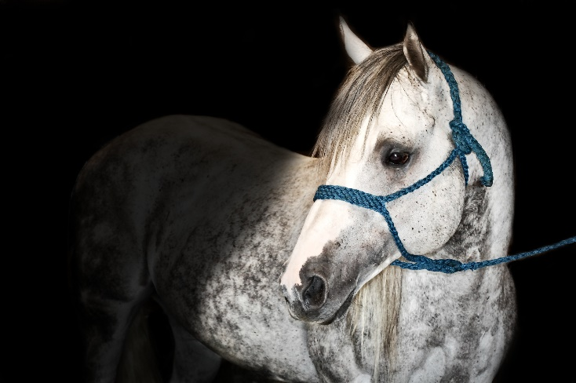**R0M 2C0**

**NICKSTER**

**SHIPPING INFORMATION**

Please provide this sheet to your reproduction specialists or veterinarian.

PLEASE remember, you need to call or text 204-851-0331 to be put on the collection list the **DAY PRIOR** to needing the shipment.

Cancellations must be made by 8am CST the day of collection.

We will try to do our best to help you out if something occurs, but we cannot guarantee you semen unless you are on the list.

We collect **MONDAY, WEDNESDAY, and FRIDAY.**

As a mare owner, it is your **RESPONSIBILITY** to know where to ship to. I will try to do my best to help out with logistics, but some days we have too many shipments and mares to breed to have the time to figure this out.

**For CANADIAN shipments**

**Overnight** - We drive to Brandon, Manitoba to either ship via FedEx, UPS, or Purolator.

**Counter to Counter** - There is a possibility to ship via West Jet as well, but we MUST know by 2:00 pm CST the day prior as early morning shuttle arrangements have to be made.

**For USA shipments**

**Overnight** - We drive to Minot, ND to either ship via Fed Ex or UPS.

**Counter to counter** - currently unavailable.

**FROZEN SEMEN**

Orders must be done a minimum of 7 days prior to needing it. We will not be overnighting frozen unless it is to fill a cooled semen contract. If your vet does not have the capabilities to store the frozen, please contact us and we can discuss changing contracts.

**TO ORDER TEXT OR CALL – 204-851-0331**