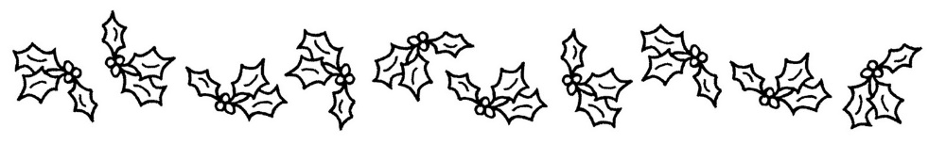
Parade of Lights
Our Lady of Lourdes CCD teamed up with the Knights of Columbus and St. Vincent de Paul to create a float that won 1st prize! We won a Smoker as well as $150. We wish to thank all who helped in the construction, decoration, and participation as well as the youth and parents who were on the float and those whom walked alongside. Father joined us and a joyful noise was made with the caroling.
