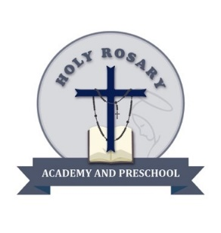

**Holy Rosary Academy and Preschool**

**2620 N. Arrowhead Avenue**

**San Bernardino, CA 92405**

**(909) 886-1088**

**License #364830628**

**Educating the Mind, Reaching the Heart**

Parent iPad Contract

2025-2026

# __________________________ in grade ____is being given the exclusive use of an iPad during class time. The iPad is the property of Holy Rosary Academy and must be returned in the same condition that it was issued in. I understand that my child is responsible for the proper care and usage of this iPad at all times. The iPad will have internet access and your child must use the iPad and internet appropriately at all times.

Your child will be given the proper procedures and guidelines for handling and taking care of their iPad. Please talk to your child and emphasize the responsibility they will have with the iPad.

I understand the responsibility involved for me and my child in the use of the iPad and agree to the terms outlined. The use of the iPad is a privilege that can be taken away if the rules and procedures of the iPad are not followed. If your child drops, breaks, loses, or damages the iPad in any way, you will be responsible for the repair or replacement of the iPad and accessories. If your child is responsible for the damage to another student's iPad, you will be responsible for a portion of, or the full amount of the repair or replacement of the iPad.

Costs include:

* $50 Case
* $50 screen protector
* $50 for the charger port and cord
* $500 iPad

Student signature Date

Parent Signature Date