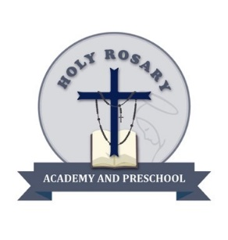

**Holy Rosary Academy and Preschool**

**2620 N. Arrowhead Avenue**

**San Bernardino, CA 92405**

**(909) 886-1088**

**License #364830628**

**Educating the Mind, Reaching the Heart**

Student iPad Contract

2025-2026

, am being given the exclusive use of an iPad for the school year. The iPad is the property of Holy Rosary Academy and must remain in my care at all times. I understand that I am responsible for the proper care and usage of this iPad and will use the internet appropriately at all times. I am in charge of bringing my iPad to school each day charged and ready to use.

The use of the iPad is a privilege that can be taken away if the rules and procedures of the iPad are not followed. If I drop, break, lose, or damage the iPad in any way, my parents will be responsible for the repair or replacement of the iPad and accessories. If I am responsible for the damage to another student's iPad, my parents will be responsible for a portion of, or the full amount of the repair or replacement of the iPad.

Costs include:

* $50 Case
* $50 screen protector
* $50 for the charger port and cord
* $500 iPad

Student signature Date

Parent Signature Date