Fresno Flight Training Inc.
  - 2801 Airport Drive Madera, Ca. 93637
we are open 7 days a week!
Suzie Bevill | 559-797-7268
Loren Bluhm | 360-918-3602
Megan Gonzalez | 907-987-8706
Jacob Park | 714-651-7582

Digital Welcome Package Update 6/2022

Thank you for taking the time to contact Fresno Flight Training Inc. We would like to welcome you to our facility at your earliest convenience, until then please browse the following information:
If you wish to fly for fun or are taking the first step toward a career as a pilot, there is much for you to learn both on the ground and in the air, but it is not too difficult! If you can ride a bicycle or drive a car, you can probably fly an airplane.
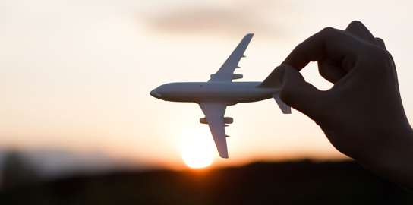

Top Reasons to Train at Fresno Flight Training INC.

- Experienced Staff
Our instructors have a vast amount of knowledge and training to help you in your goals to become a pilot!

- Large Fleet
Our fleet expands as needed and currently consists of 14 airplanes.

Piper Cherokee Warrior Garmin 430 WAAS PA-28-151

Piper Cherokee 180 Garmin G5 & 430/530 WAAS PA-28-180

Cessna Skyhawk 172M 180hp w/ Horton STOL Kit C172M

Cessna Skyhawk 172N 180hp Garmin G5 & 430 WAAS C172N

Cessna Skyhawk 172SP G1000 C172SP

Piper Arrow Complex Garmin 530 WAAS PA-28R-180

Cessna Skylane 182T G1000 C182T

Beech Bonanza F-33A F-33A

Beech Baron E-55 E-55

- In-House Maintenance
Having in-house maintenance services allows us to keep our planes in top shape and helps minimize any down time of our fleet.

- Commercial Pilot/ CFI Employment Opportunities
There are employment opportunities for some of our top students! We seek Commercial Pilots annually and are always looking to add CFIs to staff!

- Dedicated School Building and Study Areas
Fresno Flight Training has a dedicated building just for our flight training sector. There is an open lobby area, 3 private briefing rooms, and large classroom open to all students for studying and flight planning. High speed internet and a very good collection of study materials are always available to our students.

- Practice Areas Nearby
The Madera Municipal Airport is located in an ideal location for flight training. We are near many practice areas without the inconvenience of having to fly in heavy traffic to get your training done.
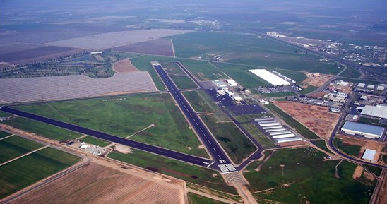
At the same time our neighbor Fresno International Airport (class C) and their professional controllers provide us with a good opportunity to operate and practice at their area. It is an outstanding opportunity for our students.

Medical
Individuals desiring a private pilot certificate must obtain at least a third-class medical certificate. The FAA medical examination is a routine exam administered by FAA designated doctors called aviation medical examiners (AMEs), who will issue your medical certificate after the exam.
Even if you have a physical handicap, medical certificates can be issued in many cases. Operating limitations may be imposed depending upon the nature of the disability.
This step is HIGHLY recommended to be taken before flight training is conducted. It can be unfortunate for a potential pilot to begin flight training, invest several thousand dollars only to find out they will never medically qualify to be a pilot. There are 3 different classes of medical certificates, each of which dictates what privileges you can exercise as a pilot:
- 1st class medical allows an Airline transport Pilot to act as a Pilot in Command.
- 2nd class medical allows a pilot to exercise the privileges of a commercial certificate.
- 3rd class medical allows individuals to exercise privileges to act as a private pilot, student pilot, or recreational pilot in command of an aircraft.
If your goal is to only attain your private pilot license, all you will need is a 3rd class medical. There are some situations which may potentially be a disqualifier for a medical certificate. If any of the following apply to you, consult your local AME for more details on obtaining a medical certificate.
- DUI’s
- Color blindness (requires special issuance)
- High Blood Pressure (controlled)
- Anti-Depressant prescriptions
- Diabetes (controlled)
Visit: https://medxpress.faa.gov/
- Call your AME to make an appointment. Ask any medical questions you have over the phone before you submit the application
- Make an account
- Fill out the application for at least a 3rd class medical.
  - Our Local AME
Ron Lichtenstein | 2210 E Illinois #406, Fresno, CA. 559-486-8888 (let him know Fresno Flight Training sent you)

Pricing Sheet
Club membership yearly (required to fly a/c) | $500 **
VFR Flight Instruction | $75/hr.
IFR Flight Instruction | $85/hr.
Multi Engine Instruction | $100/hr.
Instruction in your A/C | $100/hr.
Piper Cherokee Warrior | $170/hr.
Cessna 172M w/STOL kit | $190/hr.
Cessna 172K IFR WAAS 530 Garmin | $190/hr.
Piper Cherokee 180 w/coupled 2 axis A/P | $180/hr.
Cessna 172N w/coupled 2 axis A/P | $200/hr.
Cessna 172SP G1000 glass w/coupled 2 axis A/P | $210/hr.
Piper Arrow Complex w/coupled 2 axis A/P | $200/hr.
Cessna 182T G1000 glass w/coupled 2 axis A/P | $300/hr.
Beechcraft Bonanza F-33A Complex | $300/hr.
Beechcraft Baron E-55 Multi Engine | $600/hr.
Flight Review | $300
Discovery Flight (1-person ½ hour) | $100
All Ground instruction | $75/hr.

** Any overnight flights are subject to 3 hours per weekday calendar day of use, 4 hours per day on weekends. Fuel reimbursed at KMAE rate for out of town refueling. A 500-dollar (non-refundable) club fee for membership is required prior to the first lesson. This is an annual fee for being a part of the flight training club.
***There is also a user agreement for customers wishing to fly Fresno Flight Training Club Aircraft. The annual club fee puts the pilot on the commercial insurance policy with a deductible of $5000. All customers are required to have a debit/credit card on file. You do not have to use this debit card each time but the card on file will be used to pay an invoice if there is a balance on your flight account.

  - Private Pilot Startup Estimate
- Demo Discovery Flight - $100
- Medical Exam - $100
- Annual Club fee - $500
- Gold Seal Ground School – $229
- Various Books (explained later) - $400
- Other required equipment - $300
- Headset - $200-$1100
- FAA Written Test - $96
- Practical Test Examiner Fee - $800
- https://finance.aopa.org/flight-training-finance for Flight Training Financing

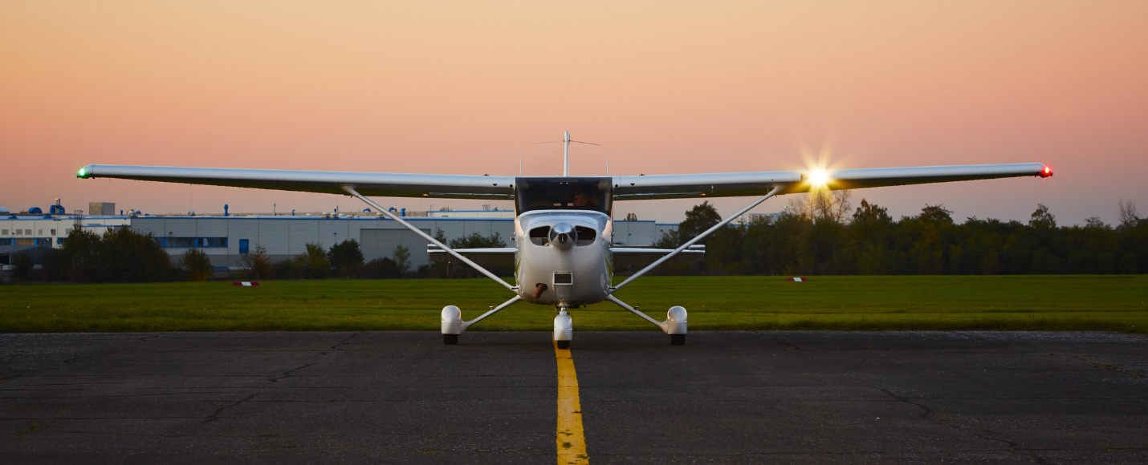

Required Materials
  - Equipment
- Kneeboard (preferably with a clipboard)
- Plotter
- Flight Computer (E6-B or handheld)
- Aviation red/white flashlight
- Aviation Headset
- View Limiting Device
  - Books & Charts
- 8083-25B – Pilot Handbook of Aeronautical Knowledge
- 8083-3B – Airplane Flying Handbook
- Aeronautical Chart users Guide
- AC 00-45F – Aviation Weather Services
- AC 00-6 – Aviation Weather
- 2022 FAR/AIM
- San Francisco Sectional Chart
- San Francisco Terminal Area Chart
- Los Angles Sectional Chart
- Los Angeles Terminal Area Chart
- Chart Supplement SW US
- Private Pilot Airmen Certification Standards
- ASA Private Pilot Oral Exam Guide

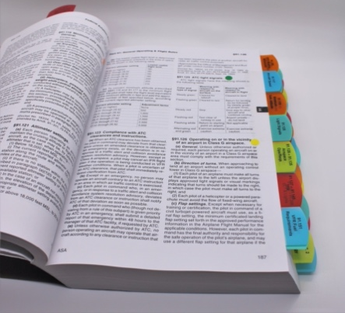

Resources
  - IACRA: Student Pilot License
Once you begin your flight training, your Certified Flight Instructor should have you make an account on IACRA (Integrated Airmen Certification and Rating Application) to get you a student pilot license (required for solo flight). This process takes anywhere from 15-30 minutes. You will need a driver’s license and copy of your U.S. Birth Certificate or U.S. Passport.
https://iacra.faa.gov/IACRA/default.aspx

ALIENS AND NON-U.S. CITIZENS SEEKING FLIGHT TRAINING
Foreign Nationals or aliens should call for instructions on how to apply. For more information, please visit the following websites:
https://www.aopa.org
https://www.flightschoolcandidates.gov/home
  - Online Ground School Program through Gold Seal
The online ground school is one of the most vital pieces for the private pilot course. Many students often fly too much and get behind on their ground study. This will make the cost of flight training EXPONENTIALLY greater than anticipated. The recommended methodology is to double or triple the amount of flight time and dedicate it to ground school/study. As one can imagine, this makes flying more than 3-4 times a week a challenge. By using Gold Seal or Bold Method for Instrument students, your flight instructor has the ability to monitor your progress and see quiz results as you take them in real-time. Your FIRST PRIORITY when beginning flight training should be to finish Gold Seal Ground School and take your FAA written exam (70% is required to pass). The knowledge exam is required prior to solo flight. The link for ground school is listed below:
https://fresnoflighttraining.groundschool.com/
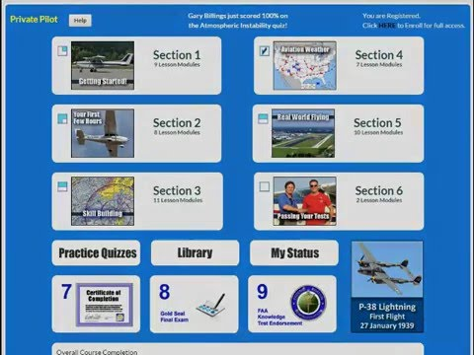
  - Flight School Website
The online website has a lot of great tools to help you succeed. This includes pricing, resources, and the Welcome Package just in case you lose it.
www.fresnoflighttraining.com

  - Online Scheduling System
The online scheduling system is a convenient tool you will use to schedule with your instructor. Simply make an account on Flight Circle and get approved by one of our CFIs. It is recommended to save this as a bookmark on your browser to make scheduling simple. To make an appointment, click on the schedule tab, day, and set the time by selecting your lesson number, name, departure time, return (always 2-hour block), aircraft, and instructor. Then hit save and confirm the proper entry once complete.
Most instructors are around most days of the week. Specific scheduling expectations will be covered when you begin training. We are quite flexible with scheduling. If your flight needs to be rescheduled, cancelled, or modified in any way, do not hesitate to ask Suzie or your instructor. We respectfully ask for at least a 24-hour notice for cancellations. Your reserved slot potentially prevents other students from reserving the instructor, time, and plane so please be courteous.
https://flightcircle.com/associate/104fca3507ab
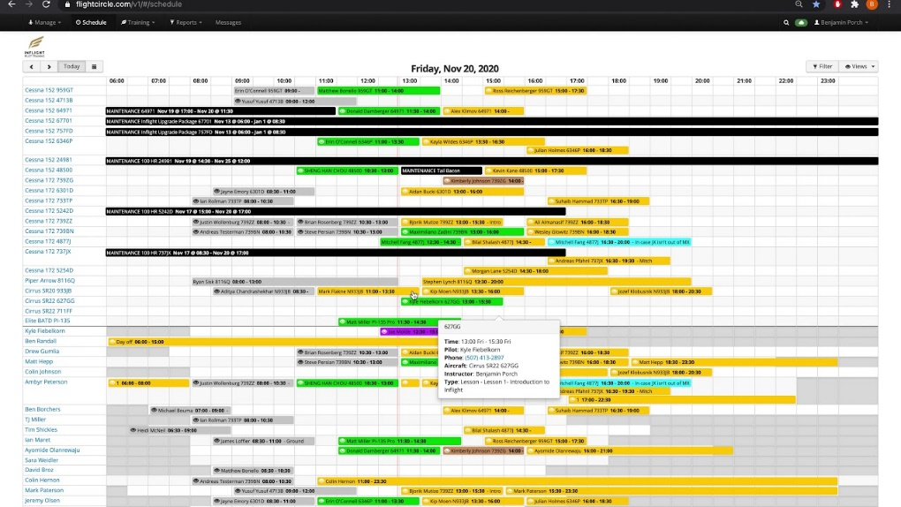
  - Dashboard and Training
In addition to using Flight Circle as an online scheduling service, you can also view aircraft documents and review your training progress.
For aircraft documents go to Dashboard > Files > Your Aircraft. These include checklists, weight and balance spreadsheets, POH/AFM, private pilot maneuvers, and the required preflight and takeoff briefings.
After several lessons, the student should be able to obtain a weather briefing, fill out weight and balance, and preflight the aircraft prior to the scheduled lesson time. The student should arrive 20-30 minutes before the departure time to complete these tasks. Aircraft can arrive late, or plane reservations can switch due to maintenance or other factors. Please be patient and understanding if your reservation changes. Our instructors do their best to provide quality instruction which can come at the cost of longer pre & post briefs but rest assured that the same service will be given to you when you train with our instructors.
For your training progress, go to the training tab and view lessons. Here you can review previous lesson notes and look ahead to the next flight lesson.
***Reading the Airplane Flying Handbook on the next lesson’s curriculum is a great way to make training efficient and cost effective. Instruction is taught in accordance with the Airmen Certification Standards in addition to FAA published material (meaning you have the potential to learn all certificate requirements prior to taking any flight lessons). Reading each maneuver in the Airplane Flying Handbook prior to each lesson makes the learning process easy, fun, and productive.

PART 61 PROGRAMS
  - Private Pilot Program
- Be English Proficient – read, write, & speak the English language.
- Be at least 16 years of age to solo and 17 years of age for your pilot’s license.
- Provide proof of U.S. Citizenship OR apply for and receive TSA approval prior to training.
- Obtain a First-, Second- or Third-Class Medical Certificate prior to first solo.
- Hold a Student Pilot License
- A minimum of 40 hours of training, consisting of:
- 20 hours dual instruction
- 10 hours solo (5 of cross country)
- 3 hours night flight
- 3 hours basic instrument work

- Average completion time is approximately 65 hours
- Pass the FAA written exam with a minimum of 70%
- Pass a Practical Test from FAA Designated Pilot Examiner - Oral and Practical Flight portions.
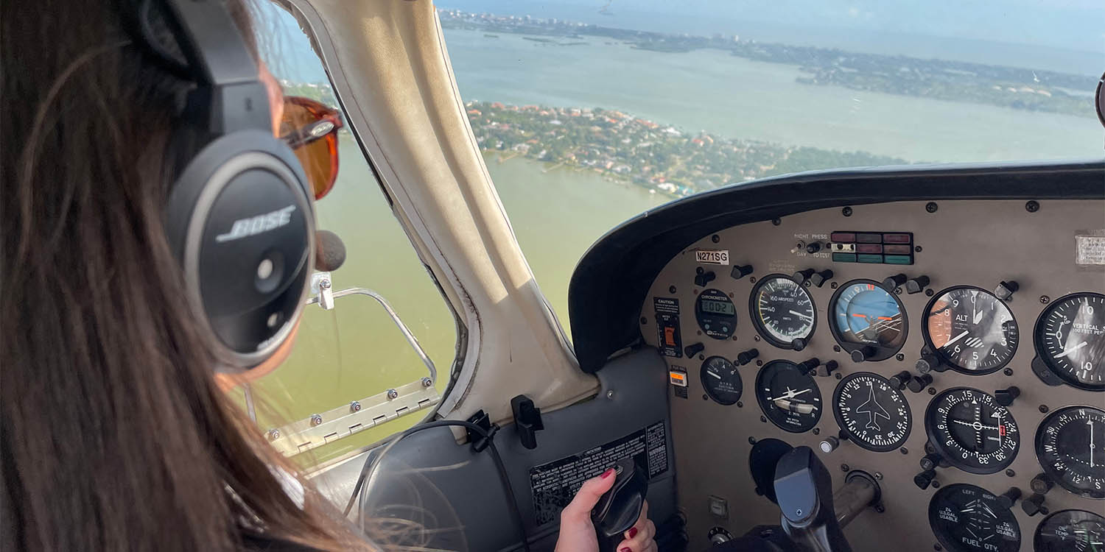
  - Instrument Rating
- Hold a Private Pilot Certificate
- Obtain a First-, Second- or Third-Class Medical Certificate
- Proof of Citizenship OR TSA approval prior to training
- 50 hours of PIC cross-country
- 40 hours of actual or simulated instrument time
- 250 NM cross-country under simulated instrument conditions
- Pass the written exam with a minimum of 70%
- Typical completion time: 50 hours
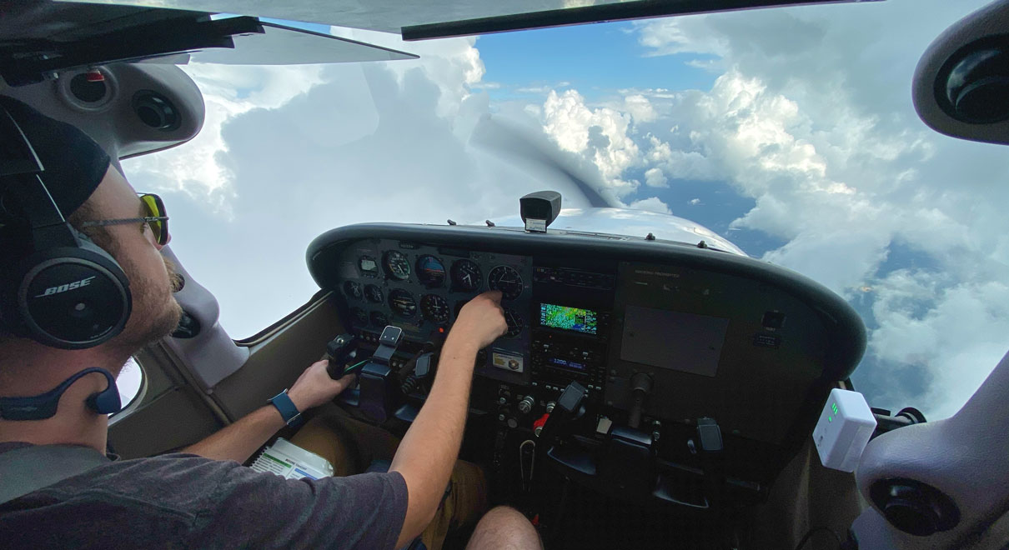
  - Commercial Pilot Certificate
- Hold a Private Pilot Certificate
- Obtain a First or Second Medical Certificate
- Proof of Citizenship OR TSA approval prior to training
- Must have at least 250 hours of total time:
- 100 hours of PIC
- 10 hours instrument
- 10 hours complex aircraft
- 300 NM cross-country
- Pass the written exam with a minimum of 70%
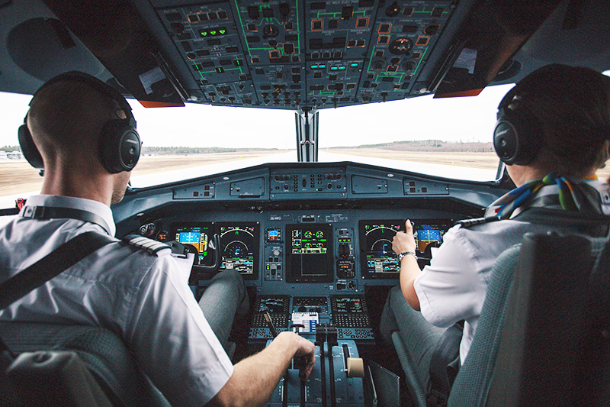

FAQ’s
- How much does it cost to learn to fly and get a pilot certificate?
There are a lot of variables that affect the cost of learning to fly, including the frequency of flight lessons, weather conditions, the type of aircraft in which you are training, and individual aptitude. A rough estimate would range between $10,000 and $13,000 depending on the certificate being sought and student proficiency.

- How long does it take to learn to fly and get a pilot certificate?
The same variables that affect the cost of learning to fly will affect the time it takes to earn your certificate. The FAA has established the minimum number of flight hours needed to obtain a certificate. The minimum is 40 hours of training for a private pilot certificate. However, the national average is approximately 65 hours. These flight hours can be spread over a time span of several months to a year or more depending on various factors.
- What are the age requirements for flight lessons?
You do not have to be a particular age before you can begin to take flying lessons. However, you do have to be at least 16 years old before you can solo an airplane and 17 before you can be issued a pilot certificate. Therefore, it may not be particularly efficient from the standpoint of cost and flight hours to begin lessons too early. There is no age limit on taking flight lessons, so long as you can qualify for a 3rd class medical.

- What does “ground” instruction mean vs. “flight” instruction?
There are 2 types of training involved with getting your licenses / ratings. The first is “ground” instruction, which is essentially classroom / book work; this is where you will gain aeronautical knowledge to apply in flight. Ground instruction can be done through online training programs, one-on-one instructor lessons, group ground sessions, etc. “Flight” instruction is the practical or hands-on part of flight training with the aircraft. This is where you will gain aeronautical experience and train in the aircraft according to FAA minimum standards.

We look forward to seeing you at our Madera location!

