**Studies in American Literature II: Speculative Fiction of the African Diaspora**

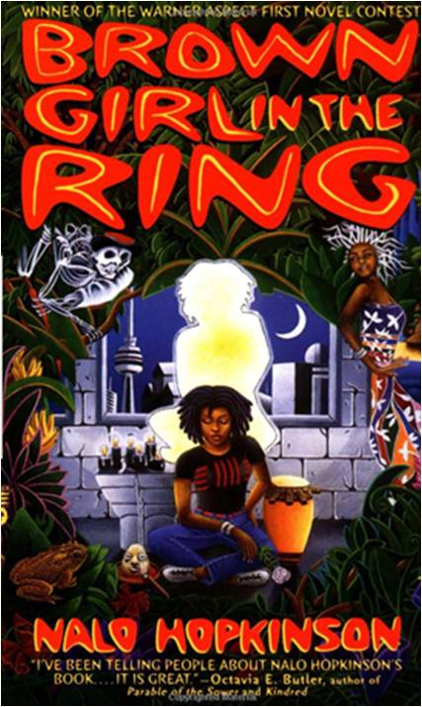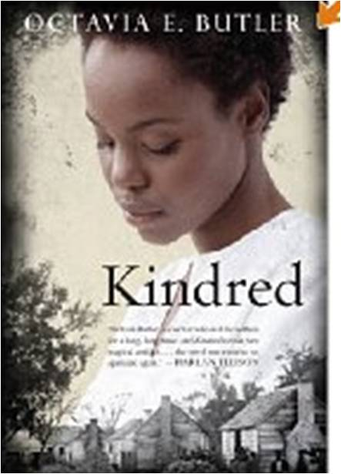This course is a senior level 3 credit study of the rich tradition of speculative fiction. Speculative fiction is what is also commonly known as “fantastic” or “Science” fiction, dealing with, as our anthology defines it, “worlds within worlds and beyond”. We will define a genre that many people are not even aware of existing, and explore essays and fiction from writers as early as W.E.B. DuBois to Octavia Butler and Nalo Hopkinson and N.K. Jemisin.

Early Warning System: This class is READING INTENSIVE. I recommend starting early to get a jump on the larger chunks of reading we have. If you cannot keep up, please see me as soon as you possibly can. Dates are pretty important here, so an awareness of the historical period in which the text was written is crucial. Bone up on your American history—at least know the broad trends.

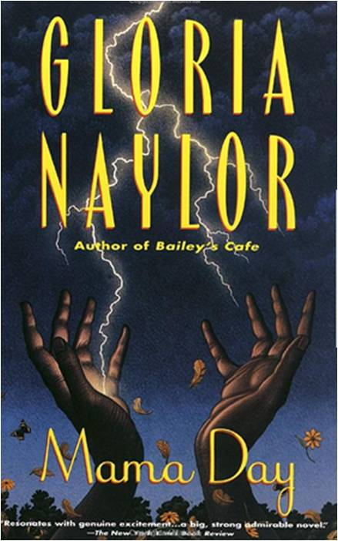

**Course Goals:**

* An appreciation for the broad scope of African-Diasporic writing in the 19th to 21st centuries from which to draw in future learning activities (inside and beyond school)
* The ability to make connection between a literary text (its themes, plot, characters, setting) and one's own life
* Increased vocabulary and strengthened writing and critical thinking abilities
* Increased facility in classroom discussion (listening and speaking)

**Grading:**

Annotated Bibliography & Proposal 10%

Critical Essay: 30%

In-class report of critical article with handout: 20%

Daily Reading Journals: 20%

Attendance/Participation: 10%

Final Week Oral Reports: 10%

**Final Project: Original Research Project, Critical Essay**

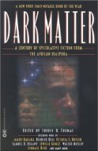Your final assignment for this class will be an essay on your research for the semester. The purpose of this assignment is to give you an opportunity to produce a potentially publishable essay reporting on research that you have conducted this semester. The final paper should be at least 15 pages in length (double-spaced, typewritten, 1" margins, 12-point font, and documented using the 6th edition of the *MLA Guide*). The draft of this paper must include a recognizable beginning, middle, and end; be proofread carefully; and be at least 12 pages in length.

**Daily Reports:**

A one-page summary of a scholarly article or book chapter is due each day. Sign up for your report in the first class meeting. You should bring a print copy AND post your summary on your Blog. You should have a handout for each member of the class summarizing the main points of the article/chapter you read/report.

**Required Texts**

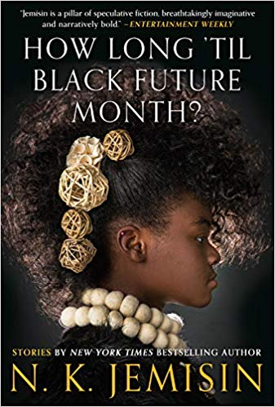Thomas, Sheree, Editor. *Dark Matter: A Century of Speculative Fiction From the African Diaspora.* New York: Warner Books. 2000.

Hopkinson, Nalo. *Brown Girl in the Ring.* New York: Warner Books. 1998.

Naylor, Gloria. *Mama Day.* New York: Random House, 1998*.*

Butler, Octavia. *Kindred.*  Boston: Beacon Press, 1979.

Jemison, N.K. *How Long 'til Black Future Month*?: Stories. Orbit: 2018.

**Reading Order:**

**Week 1** “Introduction: Looking for the Invisible. pp. ix-xiv.” “Racism and Science Fiction” by Samuel R. Delaney. pp. 383-397.

**Week 2** “Why Blacks Should Read (and Write) Science Fiction” by Charles R. Saunders. pp. 398-404. “Sister Lilith” by Honoree Fanonne Jeffers. pp. 1-5.

**Week 3** “Black to the Future” by Walter Mosle pp. 405-407. “The Comet” by W.E.B. DuBois pp. 5-18.

**Week 4** “Yet I Do Wonder” by Paul D. Miller pp. 408-414. “Chicago 1927” by Jewelle Gomez, pp. 19-34.

**Week 5** “The Monophobic Response” by Octavia E. Butler, pp. 415-416. “Like Daughter” by Tananarive Due, pp. 91-102.

**Week 6** “Greedy Choke Puppy” by Nalo Hopkinson, pp. 103-112. “Interview with Nalo Hopkinson” <http://www.locusmag.com/2007/Issue06_Hopkinson.html>

**Week 7** *Brown Girl in the Ring*

**Week 8** finish *Brown Girl in the Ring*

**Week 9** “Rhythm Travel” Amiri Baraka pp. 113-115 & “Aye, and Gomorrah” by Samuel R. Delany.

**Week 10** “The Goophered Grapevine” by Charles W. Chesnutt

**Week 11** *Mama Day*

**Week 12** finish *Mama Day*

**Week 13** “The Evening and the Morning and the Night” by Octavia E. Butler pp. 171-190 & “The Woman in the Wall” by Steven Barnes 235-259.

**Week 14** *Kindred*

**Week 15** Selections from *How Long til Black Future Month*?

**Week 16** student reports

**Supplemental Texts, Suggested Critical Reading**

Baker, Houston A. *Long Black Song: Essays in Black American*

*Literature and Culture*. Charlottesville: University Press of

Virginia, 1972. (C, 917.30696, B167).

Bell, Bernard W. *The Afro-American Novel and Its Tradition*. Amherst:

The University of Massachusetts Press, 1987. (C, 813.009896,

B433, 88-63345).

Fox, Robert Elliot. *Conscientious Sorcerers: The Black Postmodernist*

*Fiction of LeRoi Jones/Amiri Baraka, Ishmael Reed, and Samuel*

*R. Delany*. Contributions in Afro-American and African Studies,

no. 106. New York: Greenwood, 1987. (C, 813.5409896, F793,

87-054457).

Gates, Henry Louis. *Figures in Black: Words, Signs, and the "Racial"*

*Self.* New York: Oxford University Press, 1987. (C, 810.9896073,

G259, 87-035675).

_____. *The Signifying Monkey: A Theory of Afro-American Literary*

*Criticism*. New York: Oxford University Press, 1988. (C,

810.9896073, G259, 88-63655).

_____. ed. *Black Literature and Literary Theory*. New York: Methuen,

1984. (C, 813.009896, B627, 85-31392).

_____. and Evelyn B. Higginbotham. *African American Lives*. NY: Oxford UP, 2004.

Gay, Geneva, and Willie L. Baber, eds. *Expressively Black: The*

*Cultural Basis of Ethnic Identity*. New York: Praeger, 1987. (C,

700.8996073, E96, 88-015851).

Gayle, Addison, comp. *Black Aesthetic*. Garden City, NY: Doubleday,

1971. (Z, 709.73, G287).

Gayle, Addis*on. The Way of the New World: The Black Novel in*

*America*. Garden City, NY: Anchor Press, 1975. (C, 813.03,

G287, 75-8099).

Morrison, Toni. *Playing in the Dark: Whiteness and the Literary* Imagination. Cambridge: Harvard UP, 1992.

Pryse, Marjorie, and Hortense J. Spillers, ed. *Conjuring: Black Women, Fiction, and Literary Tradition.* Bloomington: Indiana UP, 1985.

**Helpful Websites/Resources:**

Slavery & Yale: <http://www.yaleslavery.org/>

A Crash Course in the History of Black Science Fiction: <http://nisishawl.com/CCHBSF.html>

Women of Color in Speculative Fiction: An Annotated Bibliography of Authors: <https://cedar.wwu.edu/cgi/viewcontent.cgi?article=1007&context=cedarbooks>

Chronological Bibliography of Science Fiction History, Theory, and Criticism: <https://www.depauw.edu/sfs/biblio.htm>