ENG 1010   
Fall 2019  
Instructor: Dr. Wells

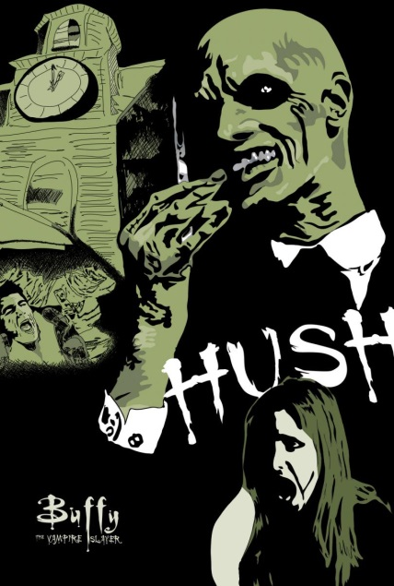Writing about Communication: “Hush”

**Daily/In class writing points available: 20.   
10 out of 20 is a failed assignment.**

*This assignment is due next Monday, November 10.* It is a semi-formal essay.Consider it a step above an in-class writing, but not quite as hard as a formal essay.

It should be typed & double-spaced.

At the beginning of the episode “Hush,” a college professor discusses communication and language, including “thoughts and experiences that we don’t have a word for.” The entire episode, for the most part, then takes place in silence. When the characters DO talk, at the end, (Riley and Buffy) they actually *stop communicating*.

Think about that, and write a 1-2 page discussion where you identify how facial expressions, body language, music, actions, and even scenery **helped to define the plot which is substantially about the way we communicate, the importance of communication** of the *Buffy the Vampire Slayer* episode “Hush” in terms of visual storytelling. **Think beyond what is literally said**. Do NOT just summarize the episode’s plot, however!

What constitutes communication? Write a draft of this discussion today in class, and if you need to re-watch, you can get it online at Hulu: <http://www.hulu.com/watch/158788>

or at VUDU.com <http://www.vudu.com/movies/#!content/129622/Buffy-the-Vampire-Slayer-Hush>, as well as Netflix (you’ll have to search for it).

It is season four, episode 10.

**Include in your final paper a works cited page with a citation that looks like this:**

[*Buffy The Vampire Slayer*. “Hush.” Season 4, Episode 10. Dir. Joss Whedon. Perf. Sarah Michelle Geller, Allison Hannigan, Marc Blucas. Twentieth Century Fox Home Entertainment, 1999. DVD.](http://www.bibme.org/)

Note: this assignment was inspired by the excellent essay “Using Joss Whedon in the Composition Classroom” By Erin Waggoner, available: <http://ojs.library.dal.ca/C2/article/download/3837/3507>