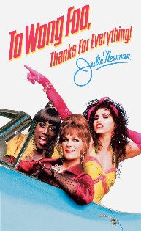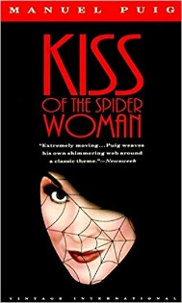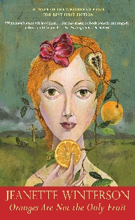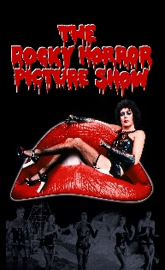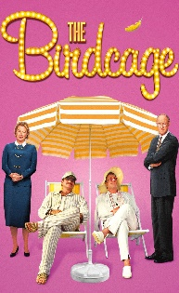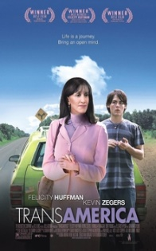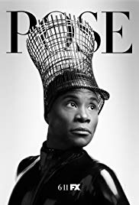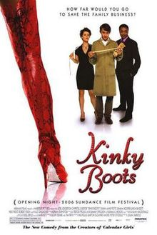

**Queering & Dragging the 21st Century: LGBTQ+ and the History of Drag in Literature & Film**

This course will explore the nature of gender-fluid performance, focusing on the concepts of queer sexual identity (made vs. born), homoerotics, homosocial, “butch,” “Femme” and all the in betweens, non-binary culture vs. dominant culture, race, class, socioeconomics, region,-- all intersectional categories of sexual “norms.” We will look to the history of drag within normative and queer culture, reading foundational and emerging theorists. Then we will explore the burgeoning world of drag pop culture through movies and pop culture, and whether transgressive appropriation of drag and queer culture shapes or challenges dominant modes.   
**Aims and Objectives**

* To provide a safe and open forum for the discussion of gender & sexual identity.
* To interrogate the intersections of history of LGBTQ+ figures.
* To foster an understanding of the political, historical and cultural contexts from which these texts have emerged.
* To explore questions of style, genre, and voice, and the connections between them.
* To explore concepts of “acting up” and social advocacy.

**On completion of this course, students will be able:**

* To analyze and evaluate in an increasingly sophisticated manner a wide range of complex analytical/pop culture, literary texts and critical materials.
* To demonstrate their ability to analyze the meaning and formal qualities of individual texts, their relationship to queer, non-binary, and performative identity.
* To engage with and interrogate a number of the feminist theoretical models that have been applied to LGBTQ+ literature, and to reflect on their application.
* To recognize and communicate knowledge of the significance of the particular cultural, political and historical contexts in which texts have been produced.
* To use critically and reflectively an appropriate scholarly discourse in order to convey their ideas in writing and oral communication
* To define the ways in which the fluid nature of drag in contemporary pop culture acts as a touchpoint for discussions of multiple lenses of minority and oppressed cultures, and to see this as a troubled AND joyful space.

**Grades:**

1. Assignment 1—a short précis on a piece of Queer criticism/theory, 500 words (20%)
2. Assignment 2—an essay focusing on one particular text in relation to the main theoretical and generic foci of the course, 1500 words (20%)
3. Assignment 3—a comparative essay, referring to at least two module texts, that will examine aspects of the literary works which might be said to link them, 2000 words (30%)
4. Book Report—a short book report on one novel, group of poems, or film read/watched in addition to course readings.  List is restrictive, oral presentation required. (10%)
5. Class Blog—Writing/Reading Journals (10%) Details will follow
6. Attendance/Participation (10%) pretty self-explanatory. Miss more than 2 unexcused classes and you should drop.

**Note:**It is a requirement for the assessment of this course that students must attempt and pass each project.  Students are reminded that written work should be close-read, as well as carefully proof-read, with close attention to technical accuracy in the use of English. All work, other than in exceptional circumstances, must be word-processed with a Times New Roman, 12 pt font.   
**An *MLA works cited, and parenthetical citation of sources is required*.**  
**Student Obligations and Course Policies:** You are responsible to read these policies carefully and understand and observe them: Attendance; Class Participation; Class Decorum; The “Ouch” Rule, Academic Integrity; Collaborative Learning.  These policies are on a supplemental handout/the class website/blog. By the end of the term, YOU will choose the essays we discuss in Abelove, based on your continued understandings of what we’ve already studied.  **Required Texts:**Buy These:   
Abelove, Henry, Ed. *The Gay and Lesbian Studies Reader*, Routledge, 1993.   
Kushner, Toni. *Angels in America, Revised 20th Anniversary Edition,* Theatre Communications Group, 2013.   
Winterson, Jeanette. *Oranges Are Not the Only Fruit*. 1985.  
Puig, Manuel. *Kiss of the Spider Woman*, 1976.  
Bornstein, Kate. *Gender Outlaw*, 1994.  
**On Reserve/Packet:**   
Selections from *Drag Queens at the 801 Cabaret* by Leila J. Rupp & Verta Taylor  
Selections from *Butch Queens Up in Pumps: Gender, Performance, and Ballroom Culture in Detroit* by Marlon M. Bailey  
Stone, Sandy. *The Empire Strikes Back: A Posttranssexual Manifesto.* 1987.  
Selections from *Female Perversions: The Temptations of Emma Bovary,* 1991.  
Selections from *Does Your Mama Know*? 1998  
Selections from *Portland Diary*, 2017Poetry from: Walt Whitman, Emily Dickinson, Gertrude Stein, Hart Crane, James Baldwin, Langston Hughes, Countee Cullen, Elizabeth Bishop, Adrienne Rich, Allen Ginsberg, Frank O’Hara, Audra Lorde, Nikki Giovanni, Essex Hemphill, and others.

**Movies:***Rocky Horror Picture Show*, 1975 *To Wong Foo, Thanks for Everything, Julie Newmar*, 1995 *The Birdcage*, 1996  
*Female Perversions*, 1997  
*Boys Don’t Cry,* 1999 *Venus Boyz,* 2003 *Kinky Boots,* 2005  
*TransAmerica*, 2005  
Selected Episodes, *Pose* 2018-?

(Note—these movies will be scheduled for home viewing—but we will have one screening night a week for you on campus).

**Reading Schedule:**

**Week One: Introductory Queer Theory**

Theory:   Reading: Judith Butler “Imitation and Gender Insubordination” in Abelove 307-320. Stone, Sandy. *The Empire Strikes Back: A Posttranssexual Manifesto.*   
Novel: *Kiss of the Spider Woman*Movie: *Rocky Horror Picture Show*

**Week Two:  What is “Sex”?**

Theory:  Monique Wittig “One is Not Born a Woman” in Abelove 103-109 Martha Vicinus “They Wonder to Which Sex I Belong” in Abelove 432-452 Danae Clark “Commodity Lesbianism” in Abelove 186-201  
Novel: *Orange is Not the Only Fruit*

**Week Three: Poetry**

Theory:Reading: Gayle Rubin “Thinking Sex” in Abelove 3-44

Poetry: Selections from the Packet   
Movie: *Priscilla, Queen of the Desert*

**Week Four: the 80s, AIDS & Drag**

Theory: John D’Emilio “Capitalism and Gay Identity” in Abelove 467-476 Stuart Hall “Deviance, Politics, and the Media” in Abelove 62-90 Ana Alonso and Maria Koreck “Silences” in Abelove 110-126 Simon Watney “The Spectacle of AIDS” in Abelove 202-211     
Fiction: *Angels in America*Movie: *The Birdcage*

**Week Five: The 90s—It’s Not All In Vogue**

Reading: Readings from *Butch Queens at the 801* and *Drag Queens*Selections from Abelove, TBA  
Movie: Selections from *Pose*

**Week Six:  2000s**

Theory:   Readings: Bornstein, Kate. *Gender Outlaw*, 1994 & Selection from *Female Perversions*.   
Movie: *Female Perversions*

**Week Seven: Coming Out/Staying In**

Theory: Sedgewick, “Epistemology of the Closet,” 45,   
Short Fiction: Selections from *Does Your Mama Know*? & *Portland Diary*Movie: *Boys Don’t Cry*

**Week Eight: Butch & Femme**

Theory: Readings from Abelove, TBA.  
Movie: *Venus Boyz*

**Week Nine: Spectacle**

Theory: Readings from Abelove, TBA.  
Movie: *To Wong Foo*

**Week Ten:**

Theory:  Readings from Abelove, TBA.   
Movie: *Kinky Boots*

**Week Eleven:**

Theory: Readings from Abelove, TBA.  
Movie: *TransAmerica*