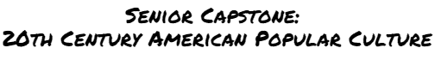

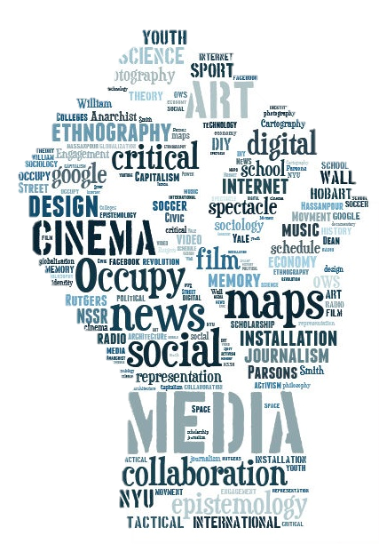**Dr. Kim Wells** [kimberly.wells@basised.com](mailto:kimberly.wells@basised.com)   
and some helpful resources are on <http://drkimwells.com>

**Student Hours: Parent Hours:**

James Baldwin once said: ***History, as nearly no one seems to know, is not merely something to be read. And it does not refer merely, or even principally, to the past. On the contrary, the great force of history comes from the fact that we carry it within us, are unconsciously controlled by it in many ways, and history is literally present in all that we do. It could scarcely be otherwise, since it is to history that we owe our frames of reference, our identities, and our aspirations.*** This quote helps explain a fundamental concept of this course.

**Course Description:** This course investigates the rise and evolution of popular culture in America beginning in the early 20th Century, moving towards today, and finally predicting the future. We will study this as a formal cultural studies course, which is highly theory-based, politically engaged, and interdisciplinary. This is NOT a history course: it’s a cultural studies liberal arts course. We will look at the history surrounding many kinds of texts, but timely **close-reading, writing, and presenting are crucial to successful completion of the course**.

We will explore the social and cultural contexts in which influential forms of popular culture emerged—with particular attention to popular music, film, and television—and **especially analyze their impact on issues of race, gender, and class**. In addition, we will consider audience and critical reactions to popular culture and appraise how popular cultural forms have impacted the political landscape. This course will look at specific decades of the 20th century and analyze one major film of that decade **as a text** that highly influenced the popular landscape during and after its appearance. Those films might have been fun family films, comedies, dramas, or action flicks, but they made a significant impact on the films, filmmakers, and culture that followed them.

The general goals of a BASIS Capstone course are to:

* **Prepare** for a Senior Research Project in final trimester;
* **Train** with online and physical research tools, including MLA and APA citation styles;
* **Investigate** a particular topic or issue in groups or individually;
* **Articulate** original arguments or create original works that are purposeful, that engage with published scholarship, and that adhere to the conventions of collegiate-level research in all fields;
* **Interrogate** accepted arguments within a subset of critical thinking.

We will pursue and rigorously discuss/debate ALL of these goals. In addition to these generic goals, I want you to start thinking of POPULAR culture as something to constantly question/review/critique. WHY is that meme “hot right now?” What is that game teaching you? And what’s with all the dancing?

I bring a few assumptions to teaching this class and **expect you to understand them**:

1) A movie is **never** “just a movie” (you can substitute “song,” “cartoon,” “advertisement,” “sitcom,” or whatever text you choose for “movie” and this axiom still holds!)

2) All cultural products (such as, for example, films, novels, TV shows, fashion trends, toys) have something to tell us about the people who made them, the people who see/use/read them and the times in which they were created. There is never one “right” answer, but there’s almost always a few wrong ones.

**Course Organization/Requirements**   
This course requires a good deal of reading, writing, some outside of class movie watching, and listening along with your active participation in class discussions. For each class, you should arrive prepared to discuss the assigned readings, songs, and films.

Class meetings will mix lectures with discussions of assigned readings, songs, and films and occasionally introduce additional primary and secondary sources. I encourage you to email me interesting news items related to the course topic so that I can share them with the class.

Specific course requirements are as follows:

* Weekly Assignments, including Reading Response Journals, Homework, Quizzes, Daily Work **20%**
* Decades Exams (Multiple Choice & Essay) **20%**
* Analytic Paper (Major themes in popular culture) **20%**
* Final Group Presentations **20%**
* Attendance and active participation in class discussions **10%**
* Student individual presentations: one pop culture item **10%**

Further details about each of these requirements will be provided in class.

**A special note about texts, films, TV, songs:** As a senior level, college-style study of popular culture, we will sometimes look at texts that include (within reason) some provocative language, slightly more mature situations/themes, and potentially some contemporary controversies. I expect every student to behave as the mature, well-rounded BASIS students that you are. Parents will be required to sign permission slips for the movies.

**Homework/Daily class work**Daily work will be given out periodically that you will be required to read and/or do in class, and finish at home. If a student has an excused absence, they can turn the assignment in with no penalty the day after they return from their absence. Students MUST **come to me** to get work. I will not find you; you are responsible for making sure you get the late work. Late assignments will be accepted for a 50% deduction the second day after they are due, and will receive a zero on the third day. Handouts will be collected in a file slot in the blue mailbox in the classroom, labeled Pop Culture.

**Review/Critical Journals**You will write an engaged “review” of articles each week that we read. This is like a reading journal, but with a short focus on critical engagement. These will be completed and turned in via Google Documents, and we will learn/practice the online “edit/review” system in Google Docs. You should prepare a school-ready email account for this process. This system is increasingly used in college courses; while we will not have an all online syllabus/course, familiarity with this online system is going to help you succeed in college level work.

**Individual Projects/Analytic Research Paper**Each student will independently choose a popular culture topic to research and present to the class. This will include a written research paper, as well as an oral and visual component (Powerpoint slides recommended—other kinds of visuals are open to use with advance permission). We have the *Encycolpedia of Popular Culture* books available to choose a topic from—review those books to find a topic if you are uncertain of your focus/scope.

**Multiple Choice Decades Exams**  
We will have several periodic exams that cover the major events of specific decades, including critical interpretations of the continuing impact of those decades. This is somewhat of a “history” component to the class, but it also will need to be analytical debate, not just recalling dates & details.

**Final Group Project**  
Each team will research extensive details of one particular popular culture item/event/trend. You will present as a group, TED talk style, with an extensive visual aid and memorized notes. This can include any decade and any type of popular culture trend from art to TV to music to trends/fads, but must also include analysis and critical debate. More details will be provided on specific assignment rubrics.

**Requirements**The basics of classroom supplies: A notebook/folder dedicated to this class. Loose leaf, college ruled paper. Pen(s). Computer access (willingness to learn). Highlighters of your choice. Bring the textbooks/articles to class on the day we will discuss them.

**Phones  
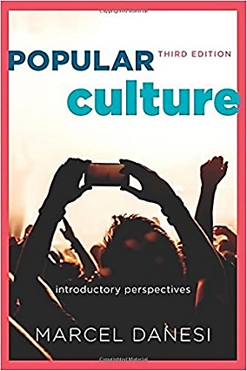**As a popular culture course, we may sometimes actually use technology in our class. However, your phone “tuned” to Snapchat or YouTube during discussion or lecture is NOT appropriate. You will get one warning if I see a phone when it is not explicitly allowed; after that, you will place your phone in the charging station for the rest of class. Repeat violations will result in your phone being turned in to the dean.

**Critical textbook**Danesi, Marcel. *Popular Culture: Introductory Perspectives*. 3rd Edition. (NOTE: **It’s very important to get the THIRD edition with the cover shown here**

Do NOT get the new 4th edition! ISBN: 1442242175 / ISBN-13: 9781442242173.Available used online in a number of places:

* <https://www.amazon.com/Popular-Culture-Introductory-Marcel-Danesi/dp/1442242175>
* <https://tinyurl.com/yc39v9jw>
* <https://tinyurl.com/yd87gwrc>
* <https://www.alibris.com/search/books/isbn/9781442242173>

**Movies & TV** Note: We will watch important clips of these movies in class every other week, and a screening of the movie will be shown on campus, free to students of the class, every other week on Friday (Thursday?) evening for the next week’s movie. You do not have to attend the screening, but **will be held responsible** for watching the movie IN FULL on your own if you do not attend the free screening.

* *Metropolis,* 1927 (week 5)
* *The Wizard of Oz,* 1939 (week 7)
* *Casablanca,* 1942 (week 9)
* *A Rebel Without a Cause,* 1955 (week 11)
* *Guess Who’s Coming to Dinner*, 1967
* *Rocky,* 1976 (week 15)
* *The Breakfast Club,* 1985 (week 17)
* *Clueless,* 1995 (Week 19)
* *The Matrix,* 1999 (week 23)
* *Ready Player One,* 2018 (week 24)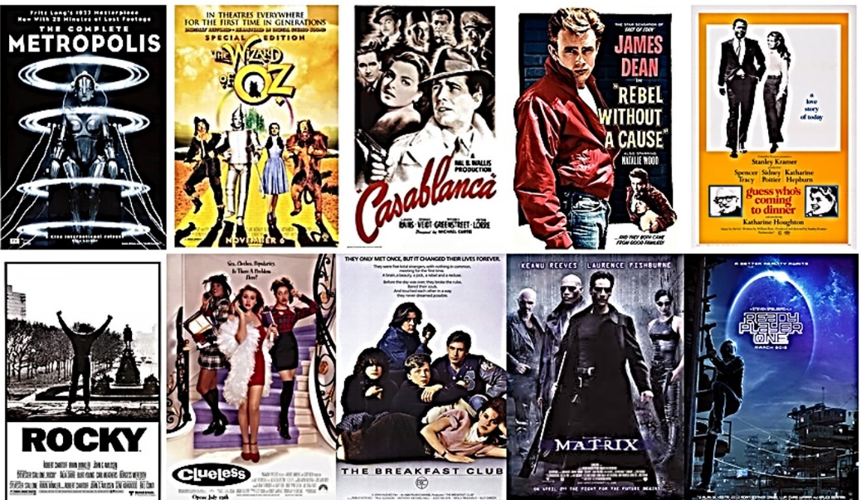

**We will read some of the following selected texts as a class** (copies will be provided to each student), some will be assigned as homework/individual work. These are also texts you can choose for your individual reviews.

Absher, Amy. Selection from “The Black Musician and the White City: Race and Music in Chicago: 1900-1967. 2014.

Ansari, Aziz. “Aziz Ansari on Acting, Race, and Hollywood,” *New York Times* 10 Nov., 2015.

Applerouth, Scott. “Constructing the Meaning of Early Jazz, 1917-1930.” Poetics 31 (2003): 117-131.

Bates, Karen Grigsby. “Octavia Butler: Writing Herself Into The Story.” *NPR*, 10 July 2017, [www.npr.org/sections/codeswitch/2017/07/10/535879364/octavia-butler-writing-herself-into-the-story](http://www.npr.org/sections/codeswitch/2017/07/10/535879364/octavia-butler-writing-herself-into-the-story).

Binder, Amy. “Constructing Racial Rhetoric: Media Depictions of Harm in Heavy Metal and Rap Music,” American Sociological Review 58 (1993) 757-767.

Brodessor-Anker, Taffy. “Turning Microcelebrity Into a Big Business.” *New York Times* 19 Sept. 2014.

Chalmers, David J. “*The Matrix* as Metaphysics.” in Christopher Grau (ed.), Philosophers Explore the Matrix. 2005: Oxford University Press. pp. 132-.

Clifford, Stephanie. “A Product’s Place is on the Set.” *New York Times* 22 July 2008.

Collins, Jane L. Selection from:  *Threads: Gender, Labor, and Power in the Global Apparel Industry.*

Collins, Patricia Hill. Selection from *Black Sexual Politics; African Americans, Gender, and the New Racism.* 2005.

Crawford, Margaret. “The World in a Shopping Mall,” from *Variations on a Theme Park: The New American City and the End of Public Space,* Michael Sorkin, Ed. (New York: Hill and Wang, 1992).

Durkay, Laura. “*Homeland* is the Most Bigoted Show on Television,” *Washington Post* 2 Oct. 2014.

Ellison, Ralph. “The Golden Age, Time Past,” in *Shadows and Act* (New York: Vintage, [1964] 1995).

Erickson, Bonnie. “Culture, Class, and Connections.” *American Journal of Sociology* 102 (1996): 217-251.

Fish, Stanley. “Is There a Text in this Class?” *The Authority of Interpretive Communities* (Cambridge, MA: Harvard UP, 1980.)

Gabler, Neal. Selection from *Life the Movie: How Entertainment Conquered Reality* (NY: Vintage, 2000).

Gitlin, Todd. Selection from *The Sixties: Years of Hope, Days of* *Rage* (NY: Bantam, 1987).

Guan, Frank. “What It Means When Childish Gambino Says ‘This Is America.’” *Vulture*, 7 May, 2018. Avail: <http://www.vulture.com/2018/05/what-it-means-when-childish-gambino-says-this-is-america.html>.

Hunter, James Davison. Selection from *Culture Wars: The Struggle to Define America* (NY: Basic, 1991).

Jefferson, J’Na. “Childish Gambino’s Manager Denies ‘This Is America’ Plagiarism Rumors. *Vibe*, 25 June 2018. <https://www.vibe.com/2018/06/this-is-america-plagiarism-rumors/>

Johnson, Steven. Selection from *Everything Bad is Good for You: How Today’s Popular Culture is Actually Making Us Smarter* (NY: Riverhead Books, 2006).

MacDonald, Dwight. “A Theory of Mass Culture,” in *Mass Culture: The Popular Arts in America*, Bernard Rosenberg & David Manning White, Eds. (NY: Free Press, 1957).

Scholosser, Eric. Selection from *Fast Food Nation: The Dark Side of the All-American Meal* (NY: Perennial, 2002).

Simon, Bryant. Selection from *Everything but the Coffee: Learning about America from Starbucks* (Berkeley: UCPress 2009).

Simon, Richard K. Selection from *Trash Culture: Popular Culture and the Great Tradition*. (Berkely UCPress, 1999).

Tillet, Salamishah. “The Return of the Protest Song,” *Atlantic* 20 Jan. 2015.

Yaszek, Lisa. “‘A Grim Fantasy’: Remaking American History in Octavia Butler’s *Kindred.*” *Signs: Journal of Women in Culture and Society*. 2003 28:4, 1053-1066.

Zeisler, Andi. Selection from *Feminism and Pop Culture*. Berkely: Seal Press, 2008.

Some TED Talks we may watch:

TED list: <https://www.ted.com/playlists/402/pop_culture_obsessions>

“Why Pop Culture?” <https://www.youtube.com/watch?v=u_3UYncNwz4>

**Approximate Schedule** (Subject to change at instructor’s discretion).   
More information will be provided as time goes by.

Week One: Getting oriented, select readings/TED talks.

Week Two: “Everything Counts: The Social Organization of Popular Culture” & “We are the Champions: A Functionalist Approach to Popular Culture” from *Mix It Up*.

Week Three: Chapters 1 & 2, “What is Pop Culture” & “Explaining Pop Culture.”

Week Four: Chapters 3 & 4, “The Business of Pop Culture” & “Popular Print Culture.”

Week Five: Chapters 5 & 6, “Radio Culture” & “Pop Music.”

Week Six: Chapters 7 & 8, “Cinema and Video” & “Television.”

Week Seven: Chapters 9 & 10, “Advertising and Branding” & “Pop Language.”

Week Eight: Chapters 11 & 12, “Online Pop Culture” & “Forever Pop.”

Week Ten & Eleven: *Kindred.*

Weeks 12-23: the Decades/MOAR Critical Articles. MEME culture.

Week 24: final movie: *Ready Player One* & the Pop Culture Future.

Week 25: Student Research Group Project Final Presentations.

Last week of Capstone: February 18- 22, 2019.

