Texas Aces Cheer
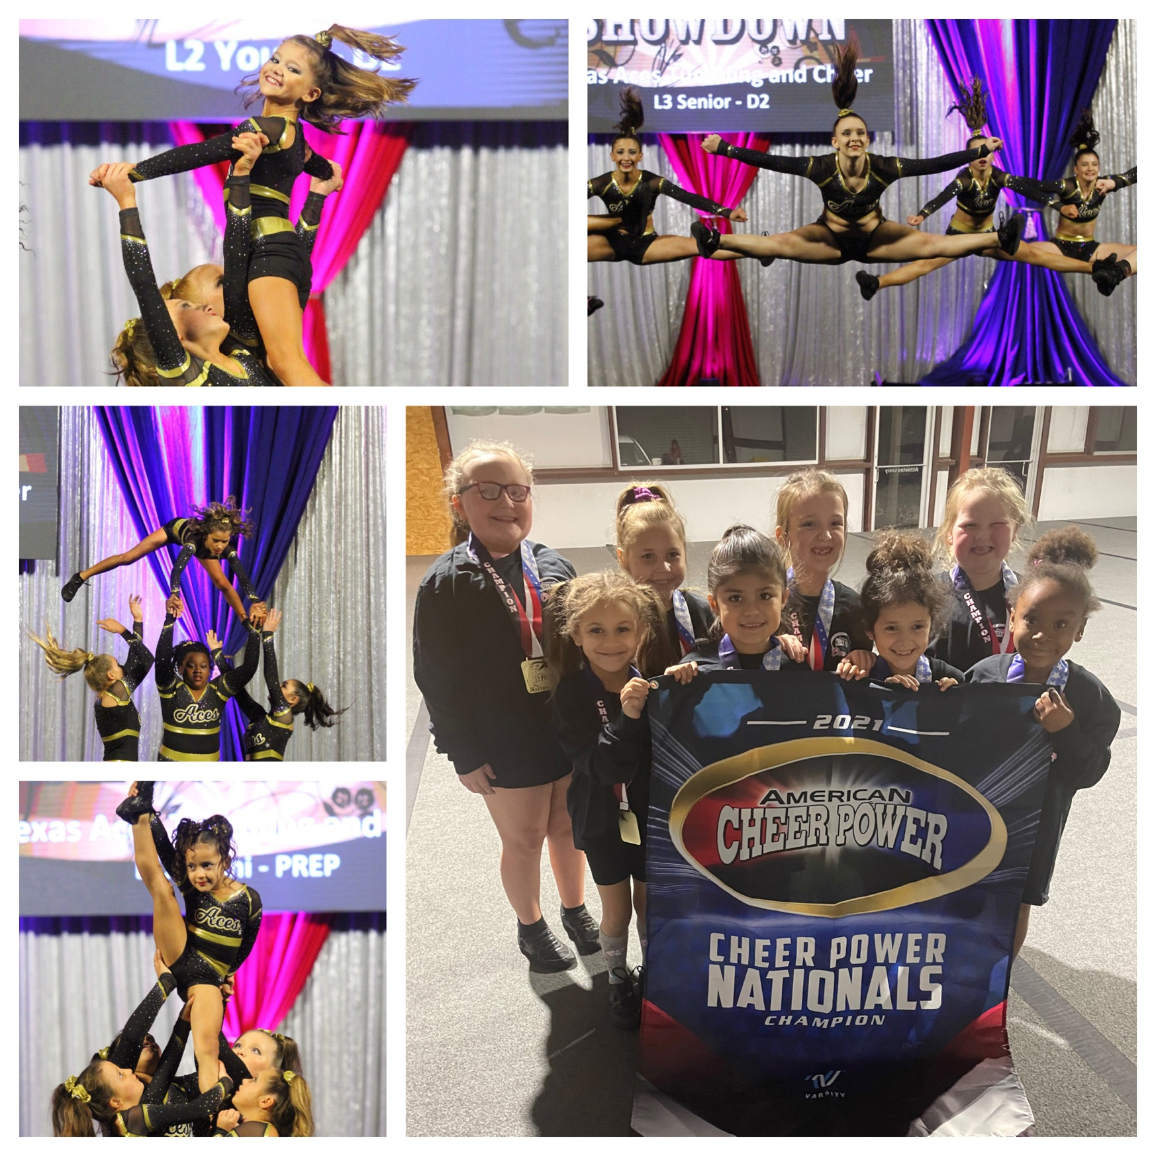
2021-2022 Season
Welcome to the 2nd Season at Texas Aces!

Our first season was full of obstacles, trials, unprecedented events, and much more. We survived COVID, ice storms and anything else thrown our way. We even finished our season with several National Championship titles! Even if it was a trying year, it was more rewarding than anything!

We would like to thank all of our current athletes and their families that are returning for another season at Texas Aces. We truly appreciate the loyalty and support.
If you are new to the Texas Aces family, Welcome! We are beyond excited that you have decided to embark on this journey with us!

Respectfully,
Cadie Marrs
Owner/Coach

What is All-Star Elite?
​ All-star Cheerleading, also known as Competitive Cheerleading, is a competition sport where boys and girls of various ages perform a 2 minute and 30 second routine composed of tumbling, stunts, pyramid, jumps and a dance. Our teams will compete against other teams from all over the state, country, and even the world. Divisions are divided into levels and then further divided into age groups. Teams are judged based on difficulty and execution by a panel of experienced judges.

What is All-Star Prep?
All-Star Prep is a simpler version of All-Star Elite. It is still a very competitive sport with the same performance structure as elite. However, prep teams only perform once at competitions and only perform 2 minute routines. Prep teams will still compete against teams from all over the state and country. This division is great for those who are still very new or who may need more experience before competing at the elite level.

Competitions
We will have a competition schedule by the end of June of 2021. The majority of competitions will require overnight stays. Competitions can be two days or a single day, Friday-Sunday. Competition season can be described as November-April. Competitions will take place all over Texas, as well as one out of state competition. Competitions are 100% mandatory. Any missed competitions, without valid excuse, will result in your athlete’s removal from the team.

Hotels
All hotel and travel expenses for the athletes and their families are NOT included in the tuition charges. All hotel and travel expenses are paid for by the athlete’s families. Booking hotels and making travel arrangements are solely the parent or guardian’s responsibility. We will do our best to find affordable group rates!

Financial Obligations
​Texas Aces will use a balanced billing method for each month. Meaning there will be a monthly charge to your account that will include tuition, shoes, bows, lipstick, music, choreography, competition fees, and coaches travel fees. Many programs may bill differently, but you will find that are program is extremely competitive with the surrounding All-Star gyms. Our monthly billing will begin in June of 2021 and end in May of 2022. The way we bill will cover the entire season and not change based upon extra practices or any changes made to our schedule. Billing will begin on June 1st and your card will be automatically charged by the 8th. If you wish to pay in another form, cash/check, it must be done before the 8th. There will be a strict rule that if you don’t pay, your son or daughter will not compete.

Breakdown of Fees
Elite Teams $250
Elite Double Teams (two teams) $325
Prep Teams $225

*Families with more than one athlete will receive a $50 discount off their monthly tuition for each additional athlete.*

Additional Expenses
Tryout Fee $20
Uniforms $300 - $425
Practice Wear $75 - $100
USASF Membership Fee $30

Optional
Bomber Jacket $150
Backpack $125

Tryout Process
Tryouts might seem like a scary process but should be viewed more as an “evaluation.” Typically everyone will make a team. However, the tryout process is to evaluate which team will best fit the needs of the gym and the athlete’s skill level. The tryout process will be separated into two days. Saturday will be for ages 5-11 and Sunday will be for ages 12 and up.

Tryout Dates
Saturday, May 22nd - 12pm – 2pm (5-11 yrs)
Sunday, May 23rd - 12pm – 2pm (12+ yrs)

Team Placements
Team placements will be made by Sunday, May 23rd in the evening. Teams will be formed based on who we believe will give us the highest scores in difficulty and execution in all aspects of the scoresheet. Families will be contacted directly by one of our coaches to let them know what team, practice times/days, and any additional information that may need to be given. We will have an introductory meeting at the beginning of the 1st practice for each team. Every athlete should have a parent or guardian present at this meeting. Please reach out if you have any questions about team placements.

Practice and Attendance
Teams will be scheduled to practice twice a week for roughly 1.5-2.5 hours each practice. Most teams will practice on Sunday and once during the week. All teams members are expected to attend every practice. We do understand that life happens and can work around any conflicts if they are brought to our attention in a timely manner. During competition season, extra practices will be called and we will give everyone at least a two weeks notice before doing so. You will receive a calendar at the beginning of the season, June/July, that has mandatory practice dates, competition schedules and gym closure dates. There will be an attendance policy stating if you have more than 2 unexcused absences there will be consequences with the possibility of removal from the team.

Choreography
We will have choreography for the majority of our teams at the beginning of August. This will be 100% mandatory. We will give those dates to parents ASAP so that we can avoid any vacation conflicts.

Tumbling Skills

Level 1 Level 2
Forward roll Back handspring
Backward roll Roundoff back handspring
Cartwheel Back walkover back handspring
Round off Front walkover roundoff back handspring
Bridge kick over Round off back handspring series
Back walkover Back handspring step out combination
Cartwheel back walkover
Back walkover series
Front walkover

Level 3
Standing 3 back handsprings
Jump to back handspring
Back handspring step out back handspring
Round off tuck
Round off back handspring tuck
Aerial
Punch front
Front walkover to round off back tuck

Level 4
Standing tuck
Standing backhand springs to a tuck
Jump to back handspring to a tuck
Round off layout
Round off back handspring layout
Round off whip to layout
Front punch step out to layout

Tryout Form
Form must be filled out and turned in by Wednesday, May 19th

Students Name: _____________________________ Date of Birth: ___________
Willing to double team (be on 2 teams): ________________
Billing Email: ________________________________ Students Sex: M__ F__
Mother’s Name: _____________________________ Cell: __________________
Father’s Name: ______________________________Cell: __________________
Emergency Contact: __________________________ Cell: __________________
Medical Conditions/Allergies: __________________________________________
CODE OF CONDUCT
- I will not participate in any activity that would disrespect any member, coach, staff, parents or students at Texas Aces Tumbling and Cheer.
- I understand that every athlete is required to wear appropriate practice wear to every practice.
- I will conduct myself with respect and display great sportsmanship at all times.
- I understand that I must maintain a positive attitude while in the parent room or at Texas Aces facility.
- I will NOT post any of Texas Aces Tumbling and Cheer’s routine, choreography, music, stunts, etc. on any kind of social media platform or website.
- I understand that all of Texas Aces’ athletes are to arrive on time and with a positive attitude to every practice and competition.
- Anyone who threatens to remove their child from team or withhold them from practice, will be dismissed immediately from all Texas Aces programs and activities.
- I will NOT threaten to remove my child from the squad or withhold them from practices as a form of punishment.
- I will NOT partake in any negative gossip that would adversely effect Texas Aces Tumbling and Cheer.
- I understand that I am making a 12 MONTH commitment and will honor my commitment.
- I understand that if I were to quit or be removed from the team, I am not entitled to any kind of refund. This includes all monies paid to Texas Aces including prepaid expenses.
- No parent, guardian, friend, family member etc. is allowed to reach out to any competition or vendors for Texas Aces. If you have ANY questions, please reach out to the director at Texas Aces.
- I understand that Texas Aces has the right to dismiss or remove my child from the team at any time.
- I understand that my child may be moved to a different team if needed.
- I will NOT use inappropriate language.
- I have read all of the 2021/2022 Texas Aces All-Star Cheer packet and will abide by all of its contents.

X ___________________________________________________________ Date: _______________

