2021 CRSK Apparel Sizing Charts

CRSK T-shirt

ATC 1000 Adult sizing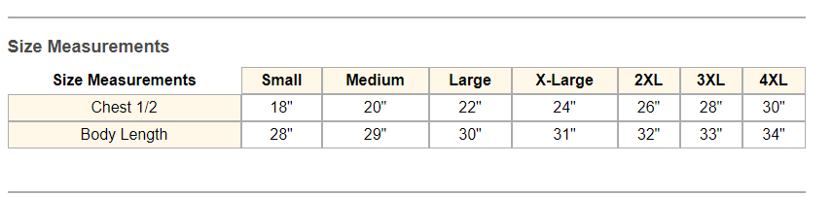

ATC1000Y (kids)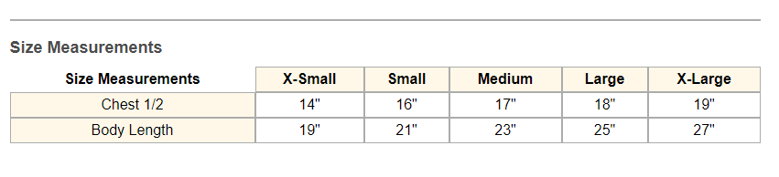

**Swimsuits**

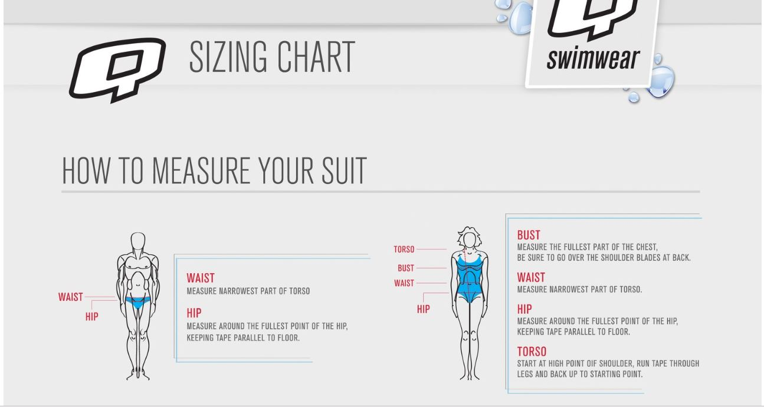

Women’s suits

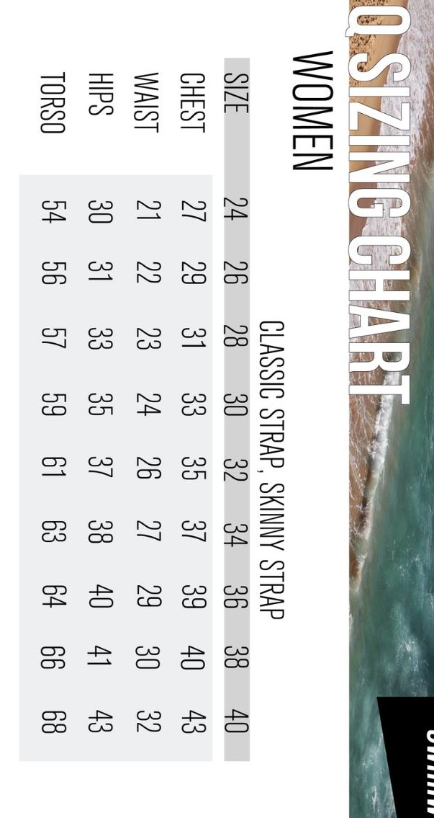

Jammers/Briefs

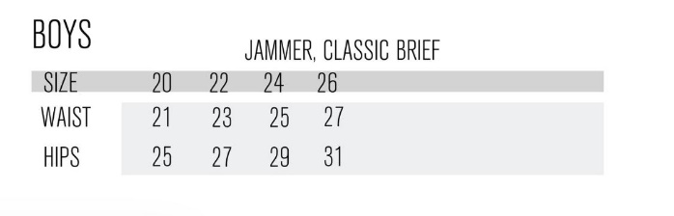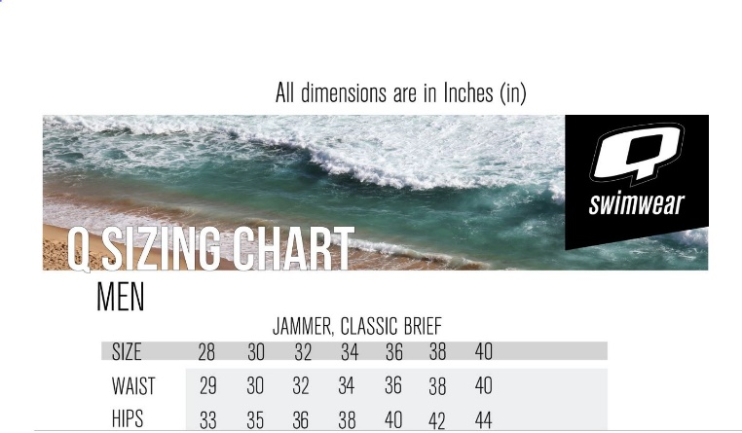

Tank Tops

Mens

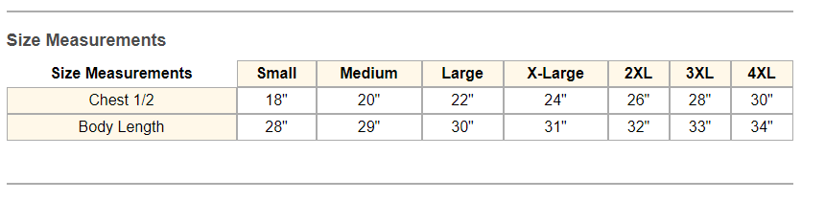

Ladies

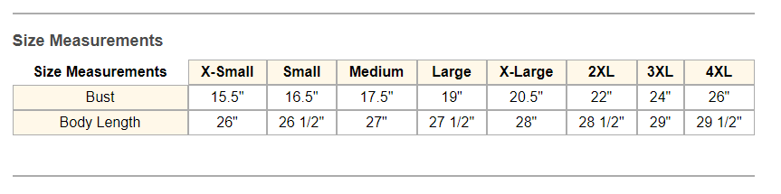

Baseball T-shirts

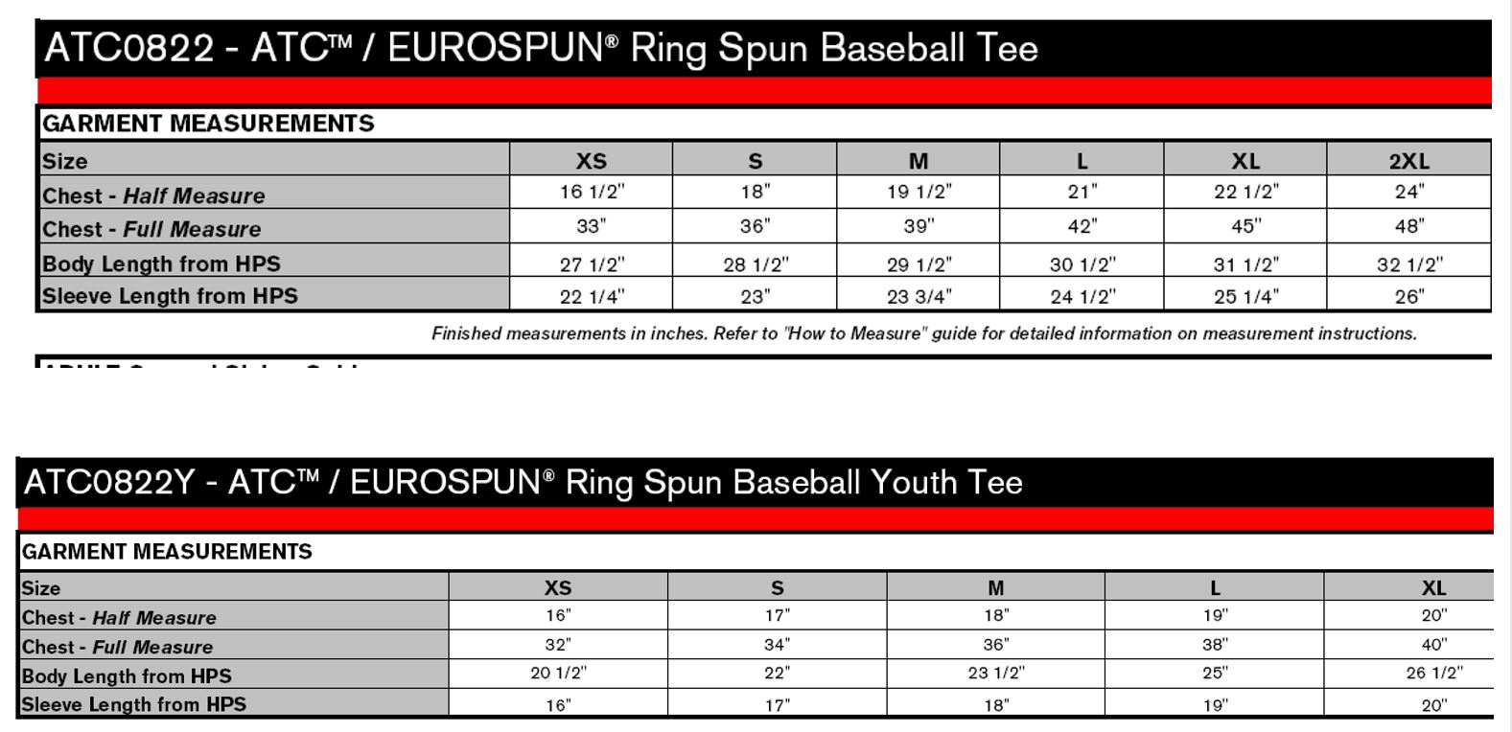

Long Sleeved T shirts

Youth

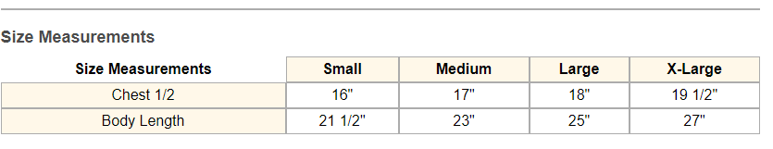mens

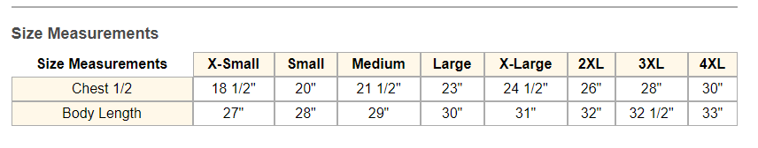

Ladies

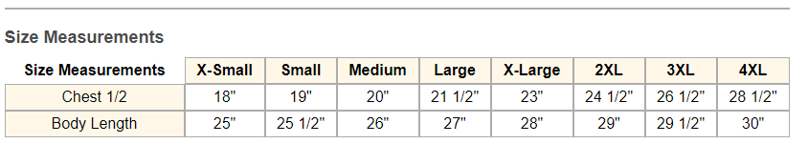

Hoodies

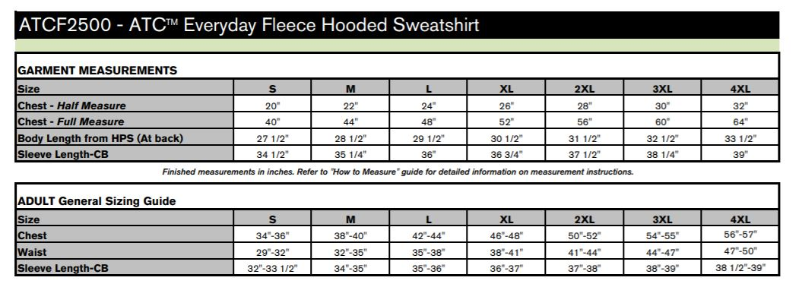

Speedo Parka

