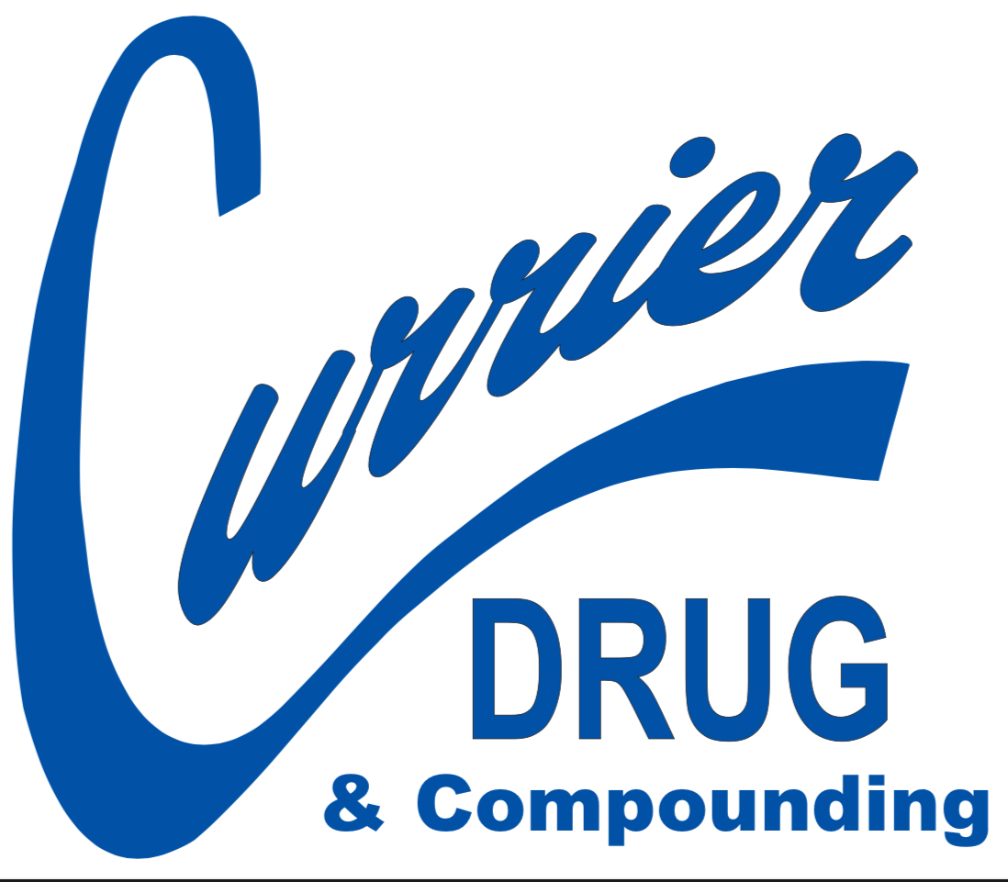

Phone: 785-626-3214

Fax: 785-626-3306

Dear Physicians:

Our pharmacy has identified an opportunity to provide a cost-effective GLP-agonist that is not injectable, but rather, absorbed through the sublingual route. This is done by utilizing a commercially available product, Rybelsus, and PCCA Submagna SL HMW. The mechanism by which Submagna increases SL bioavailability of the Rybelsus derived Semaglutide can be found in the attached supporting documentation. The cost-effectiveness of this compound will allow uninsured or uncovered patients in need to be initiated on a GLP-1 agonist with less red tape.

This compounded product will help reduce dosing errors which have occurred from the use of subcutaneously injectable compounded semaglutide from various sterile compounding pharmacies, online pharmacies, and foreign pharmacies. It could also result in a more tailored dose to each individual in order to reduce side effect potential while maximizing therapeutic response. Dosing errors are still not an impossibility, but with proper dispensing with 1mL or ½ mL syringes, the resulting dose would be expected to be cleared from the blood within a much shorter timeframe than the subcutaneous formulation that continues to be absorbed into the bloodstream for many days after initial dosing.

An exact dosing guide is not available at this time. A desired regimen should always be started low and should be tailored to the individual based upon response. It is estimated, based on the prescription template attached, that the sublingual formulation will provide a bioavailability of 33% vs 89% with subcutaneous injection and 0.4-1% with Rybelsus tablet through the oral route. This would be based on proper use and leaving the product undisturbed in the mouth for adequate absorption. This should be accomplished by clearing the mouth of any excess saliva or fluid, placing the prescribed amount of product under the tongue and not swallowing, rinsing, or eating for 15 to 30 minutes.

For more information prior to prescribing, please read the attached supplements including:

“Evalution of SubMagna SL HMW Liposomal Formation Using Fluorescence Microscopy,” our compounding ingredient worksheet, and the prescription template. This prescription template was derived from a partner pharmacy which has had several patients initiated on the product and adjusted based on side effects and therapeutic results. Please use it as a guide and feel free to call me with any questions, concerns, or more specific dosage inquiries.

Thank you,

Derek Chambers, Pharm.D.

Pharmacist-in-Charge

Currier Drug

Atwood, KS