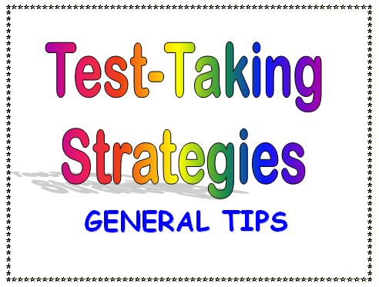

When you receive your test, **READ THE DIRECTIONS FIRST.**Then do an overview of the entire test by quickly reading each question.

* When you receive your test, immediately write down any information that you needed to memorize, such as formulas, specific dates, names.

* Use your watch or school wall clock to **pace yourself**. Don't rush, but be aware of the maximum time to spend on a question.

* Always **read the whole question carefully.**

* Do the **easiest problems first,** and the problems with the greatest point value.

* If you get to a question you don't know, don't waste time. **Mark it with a "?" and move on.** Don't forget to go back to the question when you have completed the test.

* With multiple choice questions, **try to think of the correct answer before you read your options. Read all answers first.** **Cross out items you know are wrong**, and choose your answer from the remaining options. **Use clues** if you are completely stuck and have to guess, such as, phrases like "All of the above" and "both a and b" are likely correct. The longest and most precise answer is likely to be correct. Beware of questions with "no", "not", and "none." These words easily change the meaning of questions. Reject answers that use specific determiners such as: everyone, always, never, etc. Choose answers which use qualifying terms such as: often, most, etc.

* With fill in the blank questions, **look for grammar clues and hints.**For example, the word "an" will indicate that the answer begins with a vowel. Look at verb tenses and plurals in the question.

*  When answering essay questions, try to **make an outline in the margin** before you begin writing. Organization, clear thinking, and good writing is important, but so is neatness. Be sure to make your writing legible. Also, begin your answer by restating the question. Remember to get to the point quickly.

* If you have time left when you are finished, **look over your test.** **Make sure that you have answered all the questions.** **Make an "educated guess" if you absolutely don't know the answer.** Only change an answer if you misread or misinterpreted the question because the first answer that you put is usually the correct one. Watch out for careless mistakes and proofread your essay and/or short answer questions.

* Write neatly and double check to make sure that you put your first and last name on the test and the date.