Condensed 5-Man Mechanics, 11 Man
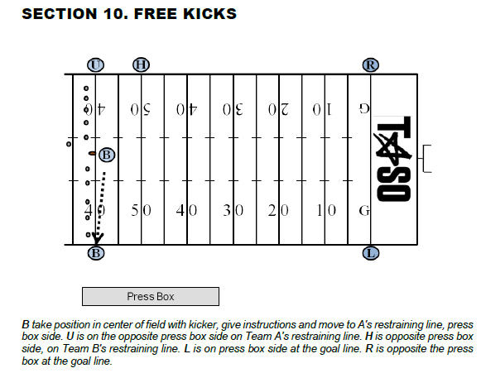
ARTICLE 1. KICKOFFS

B A. After giving instructions and handing ball to kicker, move to Team A’s restraining line on press box side. Take position on A's restraining line, press box side, at the back of the restricted area. Check sidelines to make sure all non-players are out of the restricted area. Make sure Team A players have complied with the 9-yard mark requirements and all but the kicker are within five yards of their restraining line. When all are ready, indicate by raising and keeping one arm aloft until R drops arm and sounds his whistle. Be alert for Team A offside. Count Team A players. Following the kick, maintain a cushion of space and cover the side line with L, keying on the three Team A players on your side. Be prepared to cover goal line should the runner break.

L B. Take position on press box side at the goal line. Count Team B players. Be ready to rule on the legality of the formation at the time of the kick. Remain at the pylon until the ball is possessed by the receiving team. Following the kick, you have the ball carrier if the ball is caught in your zone. Give the wind the clock signal when the ball is touched legally in the field of play. Work with B to bracket the ball carrier and be prepared to mark the dead ball spot. If the ball is caught in the Referee’s zone, your key is the lead blocker.

H C. Take position opposite the press box at Team B's restraining line at the back of the restricted area. Count Team B players. Following the kick, maintain a cushion of space and cover the side line with R, keying on the three Team A players on your side. Be prepared to cover goal line should the runner break.

R D. Take position opposite the press box at the goal line. Count Team B players. Be ready to rule on the legality of the formation at the time of the kick. Remain at the pylon until the ball is possessed by the receiving team. Following the kick, you have the ball carrier if the ball is caught in your zone. Give the wind the clock signal when the ball is touched legally in the field of play. Work with H to bracket the ball carrier and be prepared to mark the dead ball spot. If the ball is caught in the L’s zone, your key is the lead blocker.

U E. Take position on Team A's restraining line, opposite press box, at the back of the restricted area. Check sidelines to make sure all non-players are out of the restricted area. Make sure Team A players have complied with the 9-yard mark requirements and all but the kicker are within five yards of their restraining line. Be alert for Team A offside. Following the kick move toward inbounds line and key on the kicker and the five Team A players in the middle of the formation.

R F. Obtain all crew members’ ready signals and after the B reaches and clears the sideline and turns to face the field, sound your whistle as you give the ready for play signal. Assist L to ensure the correct numbers of players are on each side of the kicker when ball is kicked.

ALL G. Mark the out of bounds spot, with flag if appropriate, if kick goes out of bounds between goal lines. Maintain position enabling coverage of your sideline at all times. If kicked in your area, cover any muff, advance, or any Team B player who catches or recovers the ball.

H. Observe any player who is out of bounds before or during the kick, including Team A players who enter the field after the ball is declared ready for play.

I. Observe legality of blocks and action away from the ball when not covering the runner.

J. Be alert for short and “pooch” kicks.

R, L K. Adjust position to observe actions involving the goal line, sideline or end line. R will take the ball only if in his side zone. The official who does not have the ball is responsible for action in front of runner. If touchback occurs, move into field of play to stop any late or illegal actions but do not ignore players behind you.

B, H, U L. Watch for infractions involving restraining lines. Watch for short kick and whether it is touched or recovered legally or illegally.

ALL M. Be alert for fair catch signal and interference with the opportunity to catch a kick. NOTE: Maintain position in front of player attempting to catch the ball. When you do not have the ball, take a position to observe action in your area ahead of the runner.

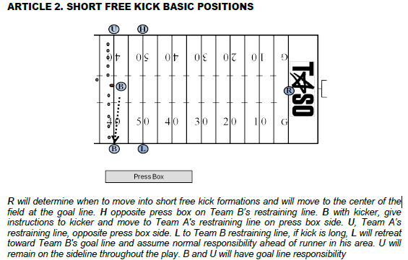
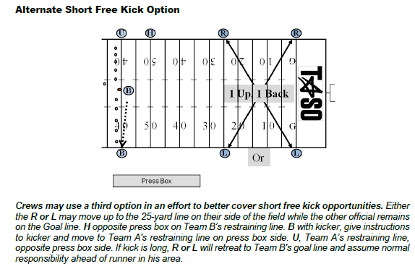
ARTICLE 3. FREE KICK AFTER SAFETY

ALL A. Assume same relative positions and duties as on kickoff when ball is put in play by place kick, drop kick or punt.

ARTICLE 4. AFTER TRY OR SUCCESSFUL FIELD GOAL

B A. Obtain football from team next to kick off and proceed up press box sideline to the 40-yard line of team next to kick off. At 40 seconds after the previous play, sound your whistle and take football onto field and give to kicker. Return to kicking teams sideline line on the press box side.

R,U,L,H B. Proceed directly to your sideline and then to your free kick position. Clear your sideline after B sounds the 20 second whistle.

ALL Assume same relative positions and duties as stated for Free Kicks in Section 10, Article 1

SECTION 11. PLAYS FROM SCRIMMAGE

ARTICLE 1. BASIC POSITIONS

ALL A. Basic positions may vary, depending upon play situations, team formations, the field and weather conditions. Always box in the play. Avoid positions that may cause scrambling to avoid interference with players.

R B. Be in a position 12 to 14 yards deep and 12 to 14 yards wide of the original position of the ball, where you may comfortably see the ball and backs except flankers, or a man in motion toward you. Usual position should be on the throwing arm side of the quarterback.
C. Check the offensive formation and count the offensive players.
D. Check the backs and quarterback for illegal motion, the ball at the snap; and assist the U if there is movement of restricted linemen.

U E. Alignment is variable according to formations of both teams avoiding position that may interfere with players. Adjust distance behind the defensive line according to width of Team A's formation and, except on goal line or try situations be at least five, but no more than ten yards deep. Whenever possible coordinate your position with that of the R for best coverage of interior line play. Read point of attack and your interior linemen. Know the ineligibles and where a forward pass first strikes anything.

H, L F. In the neutral zone extended and WIDE, out of bounds, off the sideline. Do not setup inside the 9-yard marks on your side. Adjust to the formation. Indicate offensive line of scrimmage by an extended foot, don't exaggerate. Take final position astride the neutral zone. Hand signals shall be used to indicate when the Team A player closest to you, on your side, is off the line of scrimmage. If Team A has an unbalanced line, the flank official who has four (or more) linemen on his side may so indicate by putting his open hand to the side of his face.
H, L H. Responsible for legality of motion man whenever he is on your side of the snapper (in any direction), until the snap. DOES NOT RELIEVE OPPOSITE OFFICIAL FROM MAKING OBVIOUS CALL!

I. Be aware of the importance of assisting R in marking forward progress behind the neutral zone, particularly when goal line is involved.

B J. Take position slightly behind deepest defensive back, approximately 20 to 25 yards beyond scrimmage line. Favor the open side or middle of the field. Adjust to flankers and possible receivers. Be on the side of the tight end if only one.
ARTICLE 2. DETERMINING KEYS AND GENERAL COVERAGE

A. In providing effective officiating coverage for pass plays, TASO officials will utilize the “Man, Zone, Ball” concept. At the beginning of each play, the B, the H and the L are in Man coverage. Each eligible receiver outside the tackles will be assigned to an official who is responsible for observing the action on (and by) that receiver as he attempts to get into a pass route. It is essential that TASO officials know their keys to the point that they can identify their key instantly. Problems arise when two officials are keying the same receiver and leave another receiver uncovered. Following plays with unusual formations, the officials should check with each other to verify that they each keyed the appropriate receiver.

Prior to the snap, officials will determine the strength to determine their key. They will note their key’s jersey number, as well as the jersey number of any defender in “press coverage”. During the initial aspect of the play, the goal is to observe the action of the key and any defender in “press coverage”.

Once the receivers have gotten off of the Line of Scrimmage and into their pass routes, the officials must switch to Zone coverage. If the receivers are not pressed, the officials will switch to Zone coverage more quickly. B is responsible for any receivers who run deep routes. H and L are responsible for shorter routes as well as routes in their side zone. H and L must be aware of routes take B deep and must be prepared to adjust their zones accordingly. While in Zone coverage, officials should pay particular attention to Team B players who hold Team A receivers as they are running past them or are making cuts during their route.

Once the pass is in the air, officials will switch to Ball coverage. That is to say, they will observe the action of the defenders and the receiver in the area where the ball is thrown. While the official in that zone will be primarily responsible for ruling on interference by either team, an official in another zone may have the only clear look at a foul and may need to throw their flag.

The concept of “Man, Zone, and Ball” is essential to effective officiating at any level. Skilled TASO officials will know how to begin with the appropriate key in “Man” coverage before shifting to “Zone” coverage in a timely, synchronized manner.

B. In determining keys, the following definitions are needed for clarification purposes:
1. STRENGTH OF THE FORMATION: Determined by the number of eligible receivers outside the Offensive Tackles on each side of the offensive formation. If there is no strong side (“balanced formation”), strength is declared to L's side.

2. SNAPSHOT AT THE SNAP: The position of the receivers is determined by their location, whether set or in motion, when the ball is snapped. It is as if we took a snapshot of the formation when the ball was snapped. This is particularly significant if there is a receiver in motion.

3. BACK IN BACKFIELD: A player in the backfield between the tackles at the snap. If he is lined up outside the tackles, we consider him a receiver.

4. TWINS: Two receivers outside the offensive tackle on both sides of formation.

5. TRIPS: Three or more receivers outside the offensive tackle on the same side of the ball.

6. QUADS: Four receivers outside the tackle on the same side of the ball.
7. PRESS COVERAGE: When a defender lines up in a position where he is close enough that he can touch the receiver as he leaves the line of scrimmage.
C. Receivers are numbered from each sideline. The widest receiver on the L’s or the H’s side is #1. The second receiver in is #2 and so on. If the two widest receivers are stacked, the one closest to the Line of Scrimmage is #1 and the receiver behind him is #2.

- B’s normal assignment is the #2 receiver on the strong side. H and L will have the #1 receiver to their side. When there is only one receiver on each side, B will key #1 on the L’s side and L will observe backs coming out of the backfield.

2. When there are “twins,” H and L will have the #1 receiver to their side. B’s primary key is the #2 receiver on the L’s side. B’s secondary key is the receiver (#1 or #2) entering middle zone from the H’s side. B must observe primary key, then shift attention to secondary key as soon as possible.

3. When there are "trips" (triple receivers) on one side, H and L will have the #1 receiver to their side. B’s is responsible for the #3 receiver. The #2 receiver is assigned based on how close he is to #1 or #3. If he is closer to #1, he belongs to H or L. If he is closer to #3, he belongs to B. When in question, the L will key #1 and #2. The Flank official opposite the trips will be responsible for #1 on his side and #2 if there is one. In trips formation, the officials must be prepared to go to zone quickly. The R will take the tackle on the trips side.

4. When there are quads, the B and the flank to that side will work zone. The flank on the other side has the lone receiver to that side.

5. If there is a motion back, strength may change by the motion back’s location at the snap. Officials will take a ‘snapshot’ of the formation at the snap and key the appropriate receivers as indicated herein. Again, we are only counting receivers who are outside the tackles at the snap.

6. Flank officials must be aware of all wide players to their sides blocking back toward the ball (possible illegal block below waist, clip, etc.).

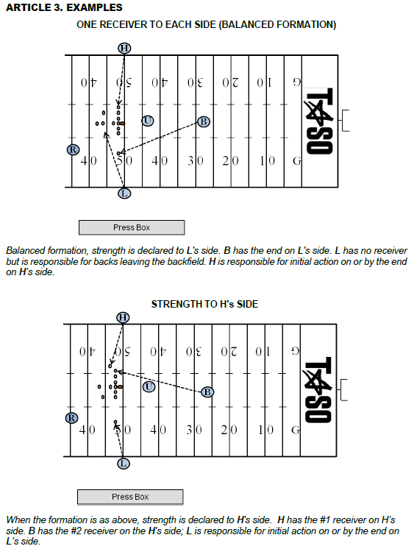

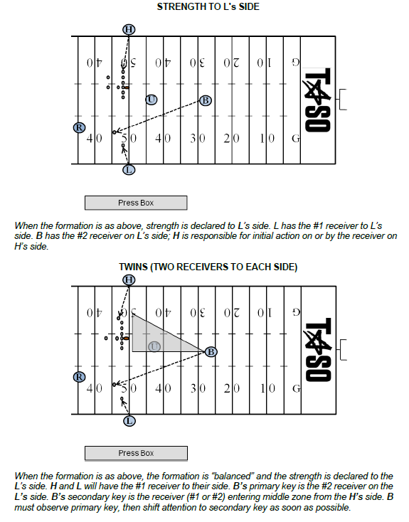

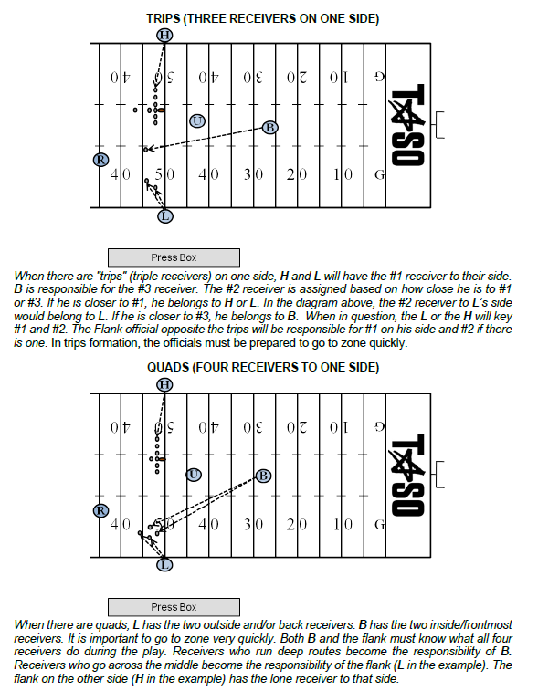
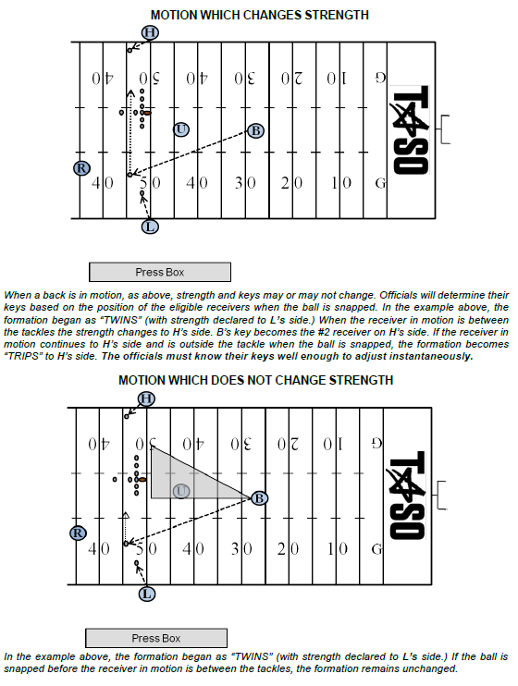

SECTION 12. RUNNING PLAYS

ARTICLE 1. REFEREE

R A. Responsible for the ball and the runner and action around him to the neutral zone. If the action is not in the direction of your original position move toward or parallel to the scrimmage line, maintaining position approximately in line with the runner’s progress. Close in on the ball when it becomes dead. If the runner is moving in toward your position, be deep enough to allow necessary clearance and then move toward or parallel to the scrimmage line, maintaining a position approximately in line with the runner’s progress. Close in on the ball when it becomes dead and there is no threat of a foul.

B. When the runner in the side zone reaches the neutral zone, turn him over to the L or H.

Responsible for forward progress spot behind the neutral zone and out of bounds spot behind the neutral zone. Observe players and give support on sideline plays. Cooperate with U on spotting ball. Quick handoffs that result in short yardage gains will be the responsibility of the U or wing officials with the R concentrating on action behind the ball. When the quarterback turns up field with the ball, assume responsibility for player(s) in position to receive a backwards pass until there is no longer a threat of a foul.

C. On plays into the line, if runner is driven back after forward progress is stopped, retrieve ball from runner and relay to official covering spot.

ARTICLE 2. UMPIRE

U A. Position prior to the snap is dictated by the formation however, you must be in a position to see the snap. Under normal circumstances U should be opposite the tight end. U is responsible for the legality of the snap with assistance from the R and wing officials.

B. Just prior to and at the snap U will be certain the defensive team does not use words or signals which obviously disconcert their opponents when they are preparing to put the ball in play. U should be in position to see the snap and rule on illegal movement of lineman or ball. U continues to observe his area of responsibility as long as there is a threat of action.

C. When play develops in his direction and a hole opens, he should move away from it as nearly laterally as possible. U should check for illegal use of the hands and holding and other fouls by both offensive and defensive players in his area.

D. As the play develops between the tackles, U's primary responsibility to cover the action of players at the point of attack, then behind the ball and finally around the runner.

E. On short, quick runs through the line, between tackles in close formation, U generally will sound his whistle when the runner’s forward progress stops directly in front of him, on his side of the line of scrimmage. L and H will indicate forward progress for U to use as assistance.
F. When the runner moves into the side zone, U will clean-up the area between his position and the ball. U may, if necessary, move in near the sideline when he is needed to give proper coverage of the action go where the play makes you go. When the ball is in the side zone, U is in position to observe action away from the ball and around the runner from an inside out position. When the play is over, all officials have responsibility to rule on late blocks and other illegal acts.

ARTICLE 3. HEAD LINE-JUDGE, LINE JUDGE, BACK JUDGE

H, L A. Initial position should be out of bounds, off the sideline. Cover the runner in your side zone beyond the line of scrimmage and out of bounds. Mark forward progress with down field foot, extended slightly toward the spot; don't exaggerate. When marking forward progress, converge rapidly on the dead ball spot when play in your area permits. Be alert to cover forward progress spot when runner has been thrown back. Opposite side officials should assist with forward progress spot if the covering official is not in position to rule.

B. Observe initial charge on your side. You are responsible for blockers and action on ends and linebackers on your side. Pick up runner when he crosses the neutral zone in your area. Spot ball on quick thrusts and close line plays. If play goes away from you, observe action behind runner and assist with action on player(s) in position to receive a backward pass if they do not receive the ball. Maintain a position in relation to the runner's progress observing the play behind the U and in front of the B. Be alert for the runner returning to your area.

C. After the play is over, assist the R or B in getting the ball back to the U.

B D. Cover plays from behind defensive backs. Watch for action by and on your key(s). Bracket runner between yourself and either H or L, depending on the side zone runner is occupying. Maintain enough depth to keep players boxed in. Cover continuing action in advance of the runner.

E. On out of bounds runs, especially in team areas, move into dead ball area and assist flank officials and R with maintaining order. The presence of another official stops most dead ball fouls in the team areas. Some out of bounds runs may necessitate coming rapidly into the team area while observing all action. Go where the play makes you go.

ARTICLE 4. GENERAL

ALL A. Watch for fouls by blockers leading the runner and for fouls after ball is declared dead. The use of signal #7 to indicate dead ball fouls should be used only by R when fouls are involved.

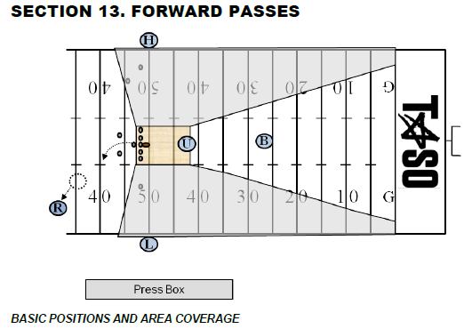

ARTICLE 1. REFEREE, UMPIRE

R A. When passer retreats, remain wide and deeper than the potential passer. If passer is not threatened, observe legality of blocks in the offensive backfield and by line keys. R is solely responsible for intentional grounding and should use bean bag to mark the spot of the pass if needed to confer with other officials. He may consult with other officials on the position of eligible receivers. Remain behind line to observe legality of the throw and action against the passer. After the passer throws the ball, continue to observe him until there is no threat of a foul. Ensure that passer is not roughed or thrown roughly to the ground. Verbally alert defenders when passer has released the ball. Continue to observe offensive and defensive action behind the line before moving out of the area. Other officials will cover play downfield. With help from the H, L, determine whether pass is forward or backward and give appropriate signal. Move to spot of pass. If illegal, drop flag while continuing to officiate. (Note, if the pass is thrown immediately after the snap, the appropriate Wing official will be primarily responsible to determine legality and ensuing action.

U B. Check legality of numbers of interior offensive linemen at the snap. Observe action of players on and directly behind the neutral zone, illegal advance of ineligibles and assist with trapped and buttonhook passes. When U reads a forward pass play, he should step toward the line of scrimmage. This removes him as a target and opens up his area for shallow drag- pass patterns. This position permits U to observe linemen moving illegally downfield. After observing play of linemen and their contact with up blocking backs, pivot to assist on low trajectory and short passes over the center of the line. Know where ball first touches anything on forward pass. Use signal #11 when appropriate. Assist R in determining legality of forward passer.

ARTICLE 2. HEAD LINE-JUDGE, LINE JUDGE, BACK JUDGE

H, L A. Assist U in checking the legality of numbers of offensive interior linemen. Check legality of positions for players with eligible numbers. After initial charge of linemen, move into position to check blocking and contact of eligible receivers and linebackers. Be ready to rule on the direction of a quick quarterback pass. The covering official, toward whom the ball is thrown, should signal, by extending one arm horizontally in the direction of the passing team’s goal line, if the pass is ruled backward. Drift downfield cautiously for the first 5-7 yards, approximately halfway between flat zone and deepest receiver. While pass is in flight, move to the most advantageous position to judge the play. If the receiver is driven backward after the catch, the opposite sideline official should assist in marking the forward progress spot. Always be prepared to come back to rule on play near the neutral zone in addition to sideline action. Observing the wide initial position is helpful in covering any pass. If potential passer decides to run, you must cover him beyond the neutral zone. Entire sideline is your responsibility.

B. After an incompletion, obtain ball from Ball Person and form a relay to return the ball to official nearest the previous spot.

C. If an airborne player receives a pass near the sideline and first returns to the ground out of bounds, after giving the incomplete signal, the covering official may, with both arms, give a sweeping motion toward out of bounds.

B D. Cover plays from behind deepest receivers. Initial focus on your key(s) as they leave the Line of Scrimmage. Once receivers are no longer threatened at the Line of Scrimmage, the B should transition quickly into zone coverage. Bracket pass receivers between yourself and either H or L, depending on location.

ARTICLE 3.

ALL A. Be alert for an illegal pass, especially after a completion, observe touching or catching by an ineligible player. Watch particularly for holding or illegally contacting eligible receivers and all contact beyond the neutral zone both before and after the pass is thrown. Observe action when opposing players contest for the pass. When ruling on pass reception involving the sideline, only the signal governing should be used. Repeat signal three times. After an incompletion, obtain a ball from a Ball Person and form a relay to return ball to official nearest the previous spot.

B. When contact occurs on a pass that is uncatchable, and the covering official does not drop his penalty marker, the covering official will give the uncatchable pass signal. (S17)

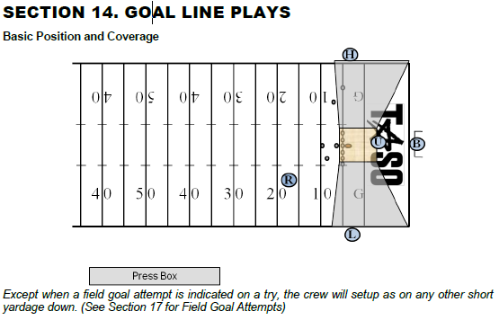
ARTICLE 1. GOAL LINE

R A. Position and coverage the same as for other scrimmages with the forward point of advancement usually determined by the wing official.

U B. Adjust your position to account for proximity to the goal line, but never directly on the line. When runner has made quick thrust into the line at your feet, be sure the ball is not moved forward after it is declared dead. Never signal score but assist the H, L, verbally or visually if necessary.

H, L C. Initial position must be wide, out of bounds, off the sideline. When snapped at or inside the 5-yard line, move toward the goal line at the snap and rule on the score or on accurate forward point when you see the ball. Be alert for a forward pass. If ball's forward progress stops short of the goal line, move in on the ball, mark and hold the dead-ball spot until ball is spotted for the next play. Use “Reverse Goal Line” mechanic to provide goal line coverage when Team A snaps the ball on or behind its 3-yard line. At the snap move immediately to the goal line.

B D. Ordinarily need not be as deep as for other scrimmage plays. Start on the end line if snap is from on or inside the 10-yard line. Assume complete responsibility of end line coverage. In short yardage situations, i.e. running plays, be alert for illegal activities in the fringe areas.

ALL F. Indicate score by touchdown signal only when in position to determine same, being positive that requirements are met.

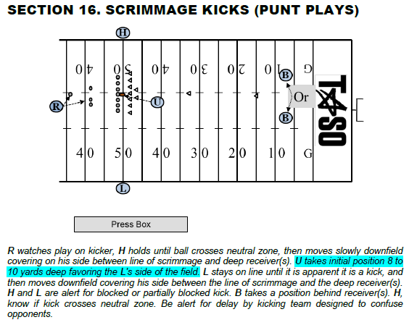
ARTICLE 1. BASIC POSITIONS AND COVERAGE

R A. Be in position slightly behind (no more than 5-yards) and to the kicking foot side of the kicker, wide enough to observe the snap and the flight of the ball to the kicker. Be in position to see the blockers and kicker at the same time and be prepared to rule on any contact with the kicker when the ball is kicked. If the kicker is near the end line, take position on the end line and remind the kicker if he is on or outside the end line prior to the snap. Adjust to the situation.

B. When it is obvious a kick will take place and there is not a player 10 or more yards behind the neutral zone, the R will place an open hand on his chest, indicating to the U that Team A is not in a legal scrimmage kick formation.

R, U C. Count offensive players. If Team A “rushes” substitutes on the field, insure the defense has an opportunity to adjust. U should cover the ball or stand near the snapper, preventing the snap, until motioned off by the R.

D. Be alert for delay by kicking team to confuse opponents.

U E. Adjust to field position 8 to 10 yards deep favoring the L's side of the field. Face the offensive line during the initial charge, observing the action of Team A and Team B players.
H, L F. Same for runs and passes. Check offensive linemen for on or behind the line and for an unbalanced line.
B G. Take position outside and behind the deep receivers. Position yourself on either side so that you may have the best view on the catch. Adjust to play area and assume responsibility for coverage into either sideline. If necessary to retreat, move backward at a 45°angle.

ARTICLE 2. AFTER THE SNAP

R A. Watch blocking and illegal action by players behind the line. Observe action of and against the kicker, using signal #11 if appropriate, and observe players while proceeding slowly downfield if the kick remains inbounds. If the flight of the kick is toward a sideline, move quickly to position in line with the flight and use arm signals to direct the official covering that sideline to out of bounds spot. When correctly aligned, drop your arm as indication that the official hold the spot until ball is spotted for next down.

B. If the kick is caught or recovered downfield, be conscious of coverage of either sideline. Be prepared to take over the runner.

R, U, H, L C. Be alert for blocked kick. Be alert for recovery and advance.

U D. Look down the line at the initial charge, checking blocks of offense and action by defensive players. Observe defensive linemen over snapper to avoid serious injury to snapper. Shift observations to contact between defensive players. After the first wave of players advance down field, move toward the return area. Observe the center area for illegal action by players of either team.

H, L E. If the kick is short or partially blocked, know if it crossed the neutral zone.

H F. Primary responsibility to know if kicked ball crosses neutral zone.

H G. After initial line charge, observe offensive backs for holding, and defensive holding in the line area. When the kick has clearly crossed and will not threaten the neutral zone, release and move downfield. If the kick is short to your side, observe first touching, legal or illegal, kick catch interference, valid or invalid signal for fair catch. Maintain position to cover in front of the runner after catch or recovery of the kick, maintain coverage until the runner cuts toward the opposite side or, if on your side, is picked up by you. You have responsibility for the entire sideline on your side.

L H. After initial line charge, observe offensive backs for holding, and defensive holding in the line area. Stay on line until it is apparent it is a kick, immediately move downfield in an easy run. If the kick is short to your side, observe first touching, legal or illegal, kick catch interference, valid or invalid signal for fair catch. Maintain position to cover in front of the runner after catch or recovery of the kick, maintain coverage until the runner cuts toward the opposite side or, if on your side, is picked up by you. You have responsibility for the entire sideline on your side.

H, L I. During the kick, observe action on and by the ‘flyers’ (Team A players charging the receiver) and receivers positioned close to the line of scrimmage. When the ball is not in your area, take a position to observe action in your area ahead of the runner.

ARTICLE 3. AFTER THE KICK

B A. If kick is short to either sideline, the sideline official will assume responsibility for the ball. Observe action in front of the ball. On all other kicks cover the receiver, taking a position ahead of the receiver if possible. Observe first touching, interference, and fair catch situations. Cover kicks on ground or in air which go 25 yards or more. If in doubt as to spot of out of bounds kick in the air, raise hand and R will assist. If there is any question regarding covering official, communicate verbally.

H, L B. If kick goes to side opposite you, drift downfield while kick is in flight, observing all action and be alert for a sudden cut toward your side and possible exchange in coverage of the runner. When you do not have the ball, take a position to observe action in your area ahead of the runner.

C. Mark and hold out of bounds spot of rolling kick on your side. Be alert to cover and accept R's signal in spotting out of bounds kick in flight.

B D. B will be primarily responsible for ruling on fair catch signal in his area. L and H observe other action surrounding the ball. If player signaling fair catch does not touch the ball, L and H must observe legality of his actions until the ball becomes dead. Be ready to rule on kick in end zone. Be alert for batting. Use a bean bag to mark the spot where kick ends.

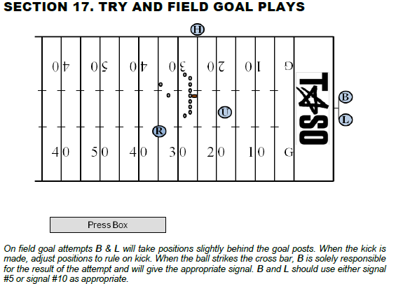

ARTICLE 1. BASIC POSITIONS AND COVERAGE

R A. On a try or field goal, R's position is a yard or so to the rear and several yards to the side of the potential kicker, (favoring the L sideline), facing the kicker where R can see the ball when spotted for the kick. Covers as usual if a run or pass. Assist in sideline coverage if run develops to L's vacated side. Signal score after being positive that requirements are met. Rule on roughing or running into the kicker and/or holder.

B. When it is obvious a kick will take place and a potential holder and potential kicker are not seven or more yards behind the neutral zone, the R will place an open hand on his chest, indicating to the U that Team A is not in a legal scrimmage kick formation.

U C. Adjust position to favor vacated L side. Adjust depth based on length of kick. Look down the line at the initial charge, checking blocks of offense and action by defensive players. Observe defensive linemen over snapper to avoid serious injury to snapper. Shift observations to contact between offensive and defensive players. Assist in goal line coverage if run develops to L's vacated side.

H D. Responsible for legality of snap and entire line of scrimmage. Quickly move to goal line if run develops. After the kick, move onto the field to observe dead ball action by players on the line of scrimmage.

H E. If the kick is short or partially blocked, know if it crossed the neutral zone.

L F. Responsible for your upright goal post. If run develops to your vacated side, quickly move along back line to back pylon to rule on the sideline. Next move is toward goal line to assist. If run situations develop to L's side, L has primary sideline responsibility with R's assistance. If attempt is short and ball remains alive, officiate as a scrimmage kick.

G. If the kicking team’s initial formation is the “Swinging Gate,” remain on the line of scrimmage until the team shifts into scrimmage kick formation with an obvious kicker and holder. If the kicking team originally lines up in scrimmage kick formation and then shifts to another formation, move to the end line corner of the end zone during the shift and then down the sideline toward your normal scrimmage play formation. Be ready to rule on the goal line.

B H. Responsible for your upright goal post and rule if ball hits cross bar on kick. If run develops, move to goal line to assist in ruling. If attempt is short and ball remains alive, officiate as a scrimmage kick. Sound whistle when ball becomes dead on attempted field goals and kick tries.

L, B I. When the field goal or try attempt narrowly passes outside an upright, the official nearer the ball may give a sweeping motion with both arms away from the upright.

ALL J. All officials should be alert for runbacks. Assist each other in getting ball spotted for next down.

K. Officiate all try downs as a normal scrimmage down and do not sound whistle until ball is dead.

